**Art Masterpiece: *The Mona Lisa*, by Leonardo da Vinci**

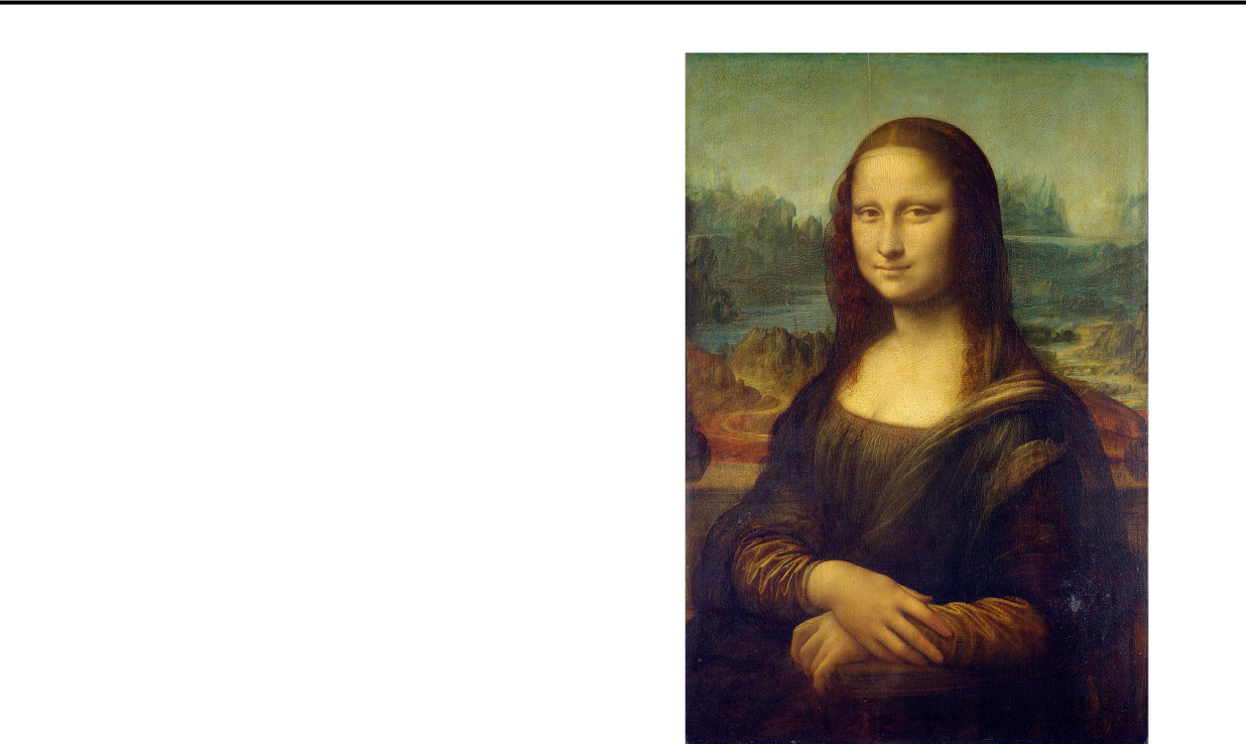

**Keywords:** Renaissance, sfumato, portrait

**Grade(s):** 5th & 6th

**Activity:** Portrait proportions

**About the Artist:**

* Leonardo da Vinci was born in 1452 in a little town named Vinci (near Florence) Italy. His name translates to Leonardo from the town of Vinci.
* As a boy he loved to study and draw things he found outdoors in nature. He was from a wealthy family but had very little formal education.
* At 15 he worked as an apprentice to a famous Italian artist but Leonardo’s talent soon surpassed him. At 25 he left his mentor and set up his own business.
* Although we usually think of da Vinci as an artist, in truth he had considerable talents in almost anything he did. He was an artist, inventor, musician, scientist, mathematician, physicist and botanist.
* Because da Vinci was so interested in different subjects; painting was not usually his main focus. He was also a procrastinator! There are only 17 paintings attributed to him and many of them are unfinished.

Chandler Unified School District **Art Masterpiece Program**, Chandler, Arizona, USA

* Leonardo da Vinci is considered a Renaissance artist. The Renaissance is a period of European history that bridges the end of the Middle Ages and the beginning of the Modern world. One of the distinguishing features of Renaissance art was its development of highly realistic artwork and linear perspective. Artists also developed other techniques, studying light, shadow, and, famously in the case of Leonardo da Vinci, human anatomy. Renaissance artists wanted to show the beauty of nature.
* Da Vinci painted mostly portraits and religious paintings and used his scientific knowledge to depict nature and to paint realistically.
* Later in life he became more focused on science and began to keep in-depth journals on various subjects. In these journals historians found plans for a hang glider, a bicycle, parachute and submarine. This was hundreds of years before these things were actually created.
* They also found detailed anatomy sketches that Leonardo made after studying cadavers. His drawings are so exact they are still used in medical schools today.
* For unknown reasons, Leonardo wrote backwards in these journals so they could only be read if held up to a mirror. This may have been because he was protective of the information he discovered or because he was left handed and didn’t want to smudge the ink as he wrote. No one knows for sure.
* Leonardo da Vinci died May 2, 1519 and was buried in the Chapel of Saint-Hubert in Château d'Amboise, in Cloux, France.

**About the Artwork:** (Be mindful of your time and only discuss a few things.) *The Mona Lisa* is the most famous portrait in the art world. A portrait is a

painting, drawing, photograph, or engraving of a person, especially one depicting only the face or head and shoulders.

In this painting, the woman sits upright with her arms folded. She seems to look directly at us (the audience) and seems calm and pleasant. Her face is painted to be brightly lit and is surrounded by much darker elements like her hair, veil, and shadows. She is painted very realistically, which da Vinci achieved by his new method not to draw the outlines. This is an art technique called sfumato, which means the technique of allowing tones and colors to shade gradually into

Chandler Unified School District **Art Masterpiece Program**, Chandler, Arizona, USA

one another, producing softened outlines or hazy forms. You can see this technique most clearly in the corners of her mouth, and the corners of the eyes. It was a groundbreaking technique. Da Vinci decided that people do not come with outlines in real life, so instead of drawing an outline of her shape, he painted her form emerging from the canvas by using a contrast of light and shadow. Look at her hands for example, lines were not drawn between her fingers but created through gradually applying color to form light and shadow. Sfumato makes the subject look more three-dimensional. Look at the texture of the mountainous background; Da Vinci did not create actual texture by building up paint. Instead, he used this light and shadow technique to show us the soft texture of velvet, the smoothness of her skin and the rugged terrain behind her. Even the transparent veil that covers her face-Can you distinguish it from the texture of her hair?

Who was Mona Lisa?

*The Mona Lisa* is a half-length portrait of a woman, Lisa del Giocondo, a member of the Gherardini family of Florence and Tuscany, and the wife of wealthy Florentine silk merchant Francesco del Giocondo. The painting is thought to have been commissioned for their new home, and to celebrate the birth of their second son, Andrea.

“Mona” in Italian is a polite form of addressing a woman, originating as “ma donna”. It is similar to Ma’am, Madam, or “my lady” in English.

Leonardo da Vinci began painting the Mona Lisa in 1503 or 1504 and continued to paint, on and off, until about 1516 or 1517. When he was finished, da Vinci had grown so fond of his painting that he kept it!

What is it made out of?

The paint used by da Vinci is oil paint. He painted on a piece of smooth wood made out of a white Lombardy poplar (a type of tree.) The Mona Lisa is smaller than you might think, panel, and is approximately 21 inches by 30 inches.

Why doesn’t she have eyebrows?

Mona Lisa has no clearly visible eyebrows or eyelashes. Some researchers claim that it was common at this time for genteel women to pluck these hairs, as they were considered unsightly. In 2007, French engineer Pascal Cotte announced that his ultra-high resolution scans of the painting provide evidence that Mona Lisa

Chandler Unified School District **Art Masterpiece Program**, Chandler, Arizona, USA

was originally painted with eyelashes and with better visible eyebrows, but that these had gradually disappeared over time, perhaps as a result of over cleaning.

How much is it worth?

It is believed that Francis I (the King of France at the time) bought *The Mona Lisa* for $9,200. This was in 1504 or possibly 1506. Nowadays it isconsidered to be literally priceless, as it is irreplaceable. However, insurance estimates its worth (in 2012) at $760 million, making it by far the most valued painting in the world.

**Possible Questions:**

1. What do we call a painting of a person, group or people or animal? (A portrait.)
2. Describe Mona Lisa, who do you think she is? What time and place is she from? What clues in the painting can you find to help you decide? (See above)
3. Where can you find texture in this painting? Texture is one of the elements of art. It means the way an object art looks as though it feels, such as rough or smooth. (Smooth texture of face, velvety texture of cloth, rugged texture of the background landscape)
4. How is the texture of her clothes different from her skin? Does the brushstrokes show texture or did Leonardo imply it by using light and shadows?
5. What is the background? Do you think the landscape was real or imagined by the artist? Why? (It is most likely a real place, but da Vinci painted *The Mona Lisa* over many years, wherever he went. Therefore it is paintedfrom his memory. So, technically, it is a real place, painted from his imagination!)
6. Did the artist use mostly light colors or dark ones? How does that affect the mood or feeling of the painting?
7. Where do you see the most shadowing in the painting? (Mona’s face and neck, folds of cloth and her fingers.) How do these shadows affect how the painting looks? (It looks three-dimensional. See “sfumato” above.)
8. What feeling do you get from this picture?

Chandler Unified School District **Art Masterpiece Program**, Chandler, Arizona, USA

1. One of the world’s greatest mysteries is, what was Mona Lisa smiling about? What do you think?

**Activity:** Learn proper portrait proportions and then draw a portrait

**Materials Needed:**

* PowerPoint presentation: “Portraits: How to Draw a Face”
* White construction paper, 9” X 12”, one per student
* Colored pencils, one set per student
* Regular pencils, one per student (students will have their own.)
* Art erasers or other good quality erasers, one per student (optional)
* Rulers, one per student (optional)

**Troubleshooting –** *Some students will be slower than others.* While the class is doing the step-by-step drawing, a good rule of thumb is wait until at least 90 % of the class is finished with each step before moving on to the next. (Rather than 100%.) This will assure that the majority of the students finish the hour with a portrait.

*Reassure the slower students* that you will be happy to go back to any part that they didn’t finish, that they just need to wait a minute or two while the rest of the class finishes.

Explain, a few times, that the important part of this lesson is that students have an opportunity to learn the proportions of a portrait, not that they turn out a work of art like *The Mona Lisa*! If they don’t get to color in the portrait at the end, (or add individual details), but they did get the basics of a face down on the page, that is the main goal.

**Process:**

1. Pass out white paper. Tell students to get a pencil with a good eraser (alternately, pass out erasers.) Remind them to write their name on their papers.
2. Ask students if they’ve ever tried to draw a face. Were they disappointed that it didn’t look “right?” The human face is one of the hardest things for anyone, even great artists, to render effectively. Tell them that there are a

Chandler Unified School District **Art Masterpiece Program**, Chandler, Arizona, USA

couple of “tricks” that they can use that will help them to draw a face more realistically. The “tricks” are really just a series of guidelines on where to place facial features.

1. Start the PowerPoint. If you are unsure how to do this, enlist the teacher’s help. Have students draw their portraits by going step-by-step along with the PowerPoint. There are 10 steps total. Have them lightly, *lightly* draw each step with their pencils because they will be later erasing many of the guide lines that they draw. See “Troubleshooting” (above) for information on how to pace this project.
2. By the end of the PowerPoint, most students will have finished with the basic face. (Again, see “Troubleshooting” above to see how to handle the small number of slower students who might not have finished.
3. Pass out the colored pencils.
4. Encourage students to add individual details – braces, eyeglasses, earrings – as well as add color with the colored pencils.
5. While most of the students are doing step #6, you can go back to the

PowerPoint and ask which step students who didn’t quite finish would like you to start from.

1. When students are finished, hang to display!

Chandler Unified School District **Art Masterpiece Program**, Chandler, Arizona, USA

**Examples:**

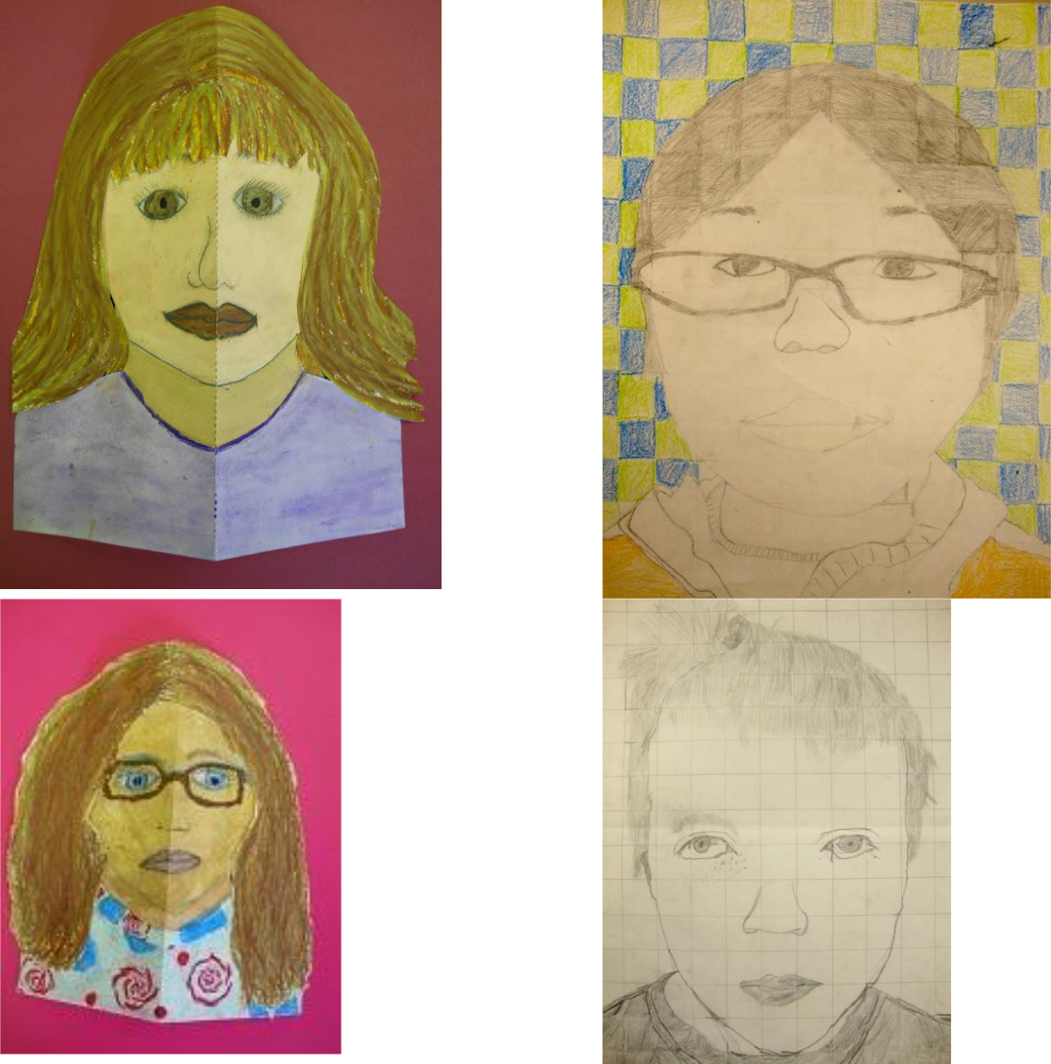

Chandler Unified School District **Art Masterpiece Program**, Chandler, Arizona, USA

**Parent Note:**

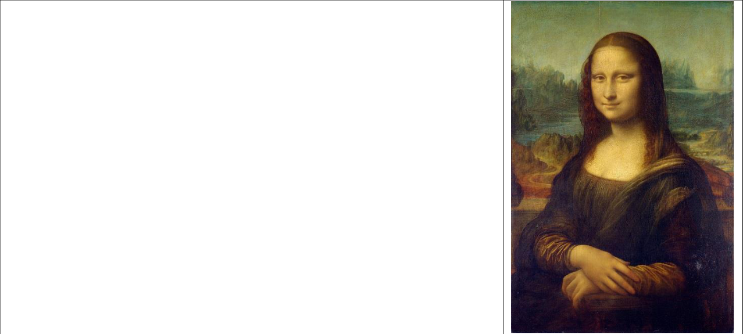

Leonardo da Vinci (1452 – 1519) was an Italian polymath, painter, sculptor, architect, musician, mathematician, engineer, inventor, anatomist, geologist, cartographer, botanist, and writer. He is widely considered to be one of the greatest painters of all time and perhaps the most diversely talented person ever to have lived

Today in Art Masterpiece, students learned about da Vinci’s most famous painting, *The Mona Lisa*. Students were taught facial proportions and then created portraits of their own.

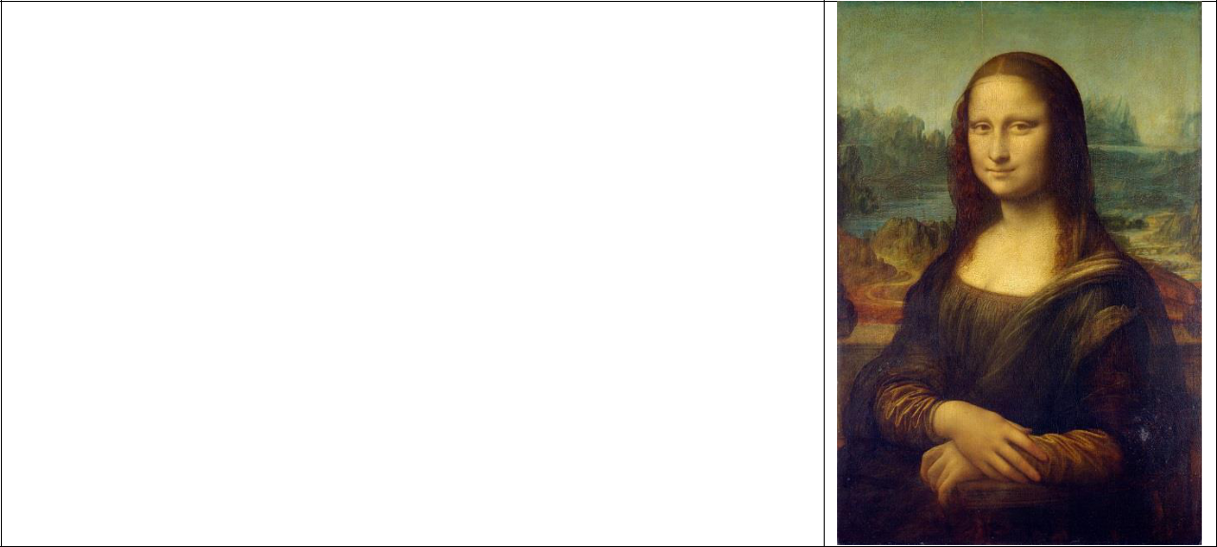

Leonardo da Vinci (1452 – 1519) was an Italian polymath, painter, sculptor, architect, musician, mathematician, engineer, inventor, anatomist, geologist, cartographer, botanist, and writer. He is widely considered to be one of the greatest painters of all time and perhaps the most diversely talented person ever to have lived

Today in Art Masterpiece, students learned about da Vinci’s most famous painting, *The Mona Lisa*. Students were taught facial proportions and then created portraits of their own.

Chandler Unified School District **Art Masterpiece Program**, Chandler, Arizona, USA