Register Allocation on SSA for AMDGPU
An optimal, decoupled allocator built on Hack's thesis
Team kick-off overview — July 2026
Notes: Welcome. This is a kick-off for our new SSA-based register allocator for AMDGPU. Big picture: register allocation is usually treated as hard and iterative — we're building one that's optimal and single-pass by exploiting SSA. I'll cover the theory, our four-pass stack, the one fragile dependency, and where the team comes in.

The idea in one line
Classic graph-coloring RA (Chaitin/Briggs) treats coloring as NP-hard and iterates build -> color -> spill -> rebuild.
On SSA form the problem becomes easy and separable:
- The interference graph is chordal -> optimal coloring in polynomial time.
- Spilling, coloring, and coalescing decouple into a single pass — no iteration.
- Register demand is known up front: it is just the maximum register pressure.
Foundation: Hack, Grund & Goos, "Register Allocation for Programs in SSA-Form" (CC'06), and Sebastian Hack's PhD thesis (2007).
Notes: The one thing to remember. Classic Chaitin/Briggs coloring is NP-hard, so it guesses, spills, and retries in a loop. On SSA the graph is chordal, so coloring is polynomial and optimal; spill/color/coalesce stop fighting each other and separate into one pass; and we know the exact register demand up front — it's just peak pressure. Everything today follows from these three facts.

Hack's theorem
Theorem (Hack, Grund & Goos, CC'06): the interference graph of a program in strict SSA form is chordal. Every chordal graph has a perfect elimination order (PEO), and greedy coloring along a PEO uses the minimum number of colors (= chromatic number = clique number).
Two consequences we exploit directly:
- chi(G) = omega(G) — colors needed = size of the largest clique.
- For SSA, a PEO is free: it is a walk of the dominance tree (no MCS/LexBFS).
Why chordal? In strict SSA every value has one definition, so its live range is a connected subtree of the dominance tree — and intersection graphs of subtrees of a tree are chordal (a theorem, not a heuristic).
Notes: This is the theorem the whole project rests on. Chordal graphs have a perfect elimination order, and greedy coloring along it uses the minimum number of colors. Two payoffs: colors needed equals the largest clique (chi = omega), and for SSA the elimination order is free — just walk the dominance tree, no expensive MCS/LexBFS. The intuition for why chordal: one def per value ⇒ live range is a subtree ⇒ subtree intersection graphs are provably chordal.

Illustration — live ranges on SSA
Straight-line SSA; single def => each value's live range is one interval (def -> last use). Two values interfere iff their intervals overlap.
line 1 a = def live {a}
line 2 b = def live {a,b}
line 3 c = def live {a,b,c} <- peak, RP = 3
line 4 .. = f(a) live {a,b,c} (a dies)
line 5 .. = f(b) live {b,c} (b dies)
line 6 d = def live {c,d}
line 7 .. = f(c) live {c,d} (c dies)
line 8 .. = f(d) live {d} (d dies)
Overlaps => edges a-b, a-c, b-c, c-d. At the busiest point (lines 3-4) three values are simultaneously live.
Notes: A concrete picture of the abstract claim. Single def means each value is one interval from def to last use. Two values interfere exactly when their intervals overlap. Walk the live-set column: peak is lines 3-4 with {a,b,c} — three values at once. That '3' is the number to carry to the next slide.

RP = max clique (demand known before we color)
The three values live at the peak form a clique; d overlaps only c.
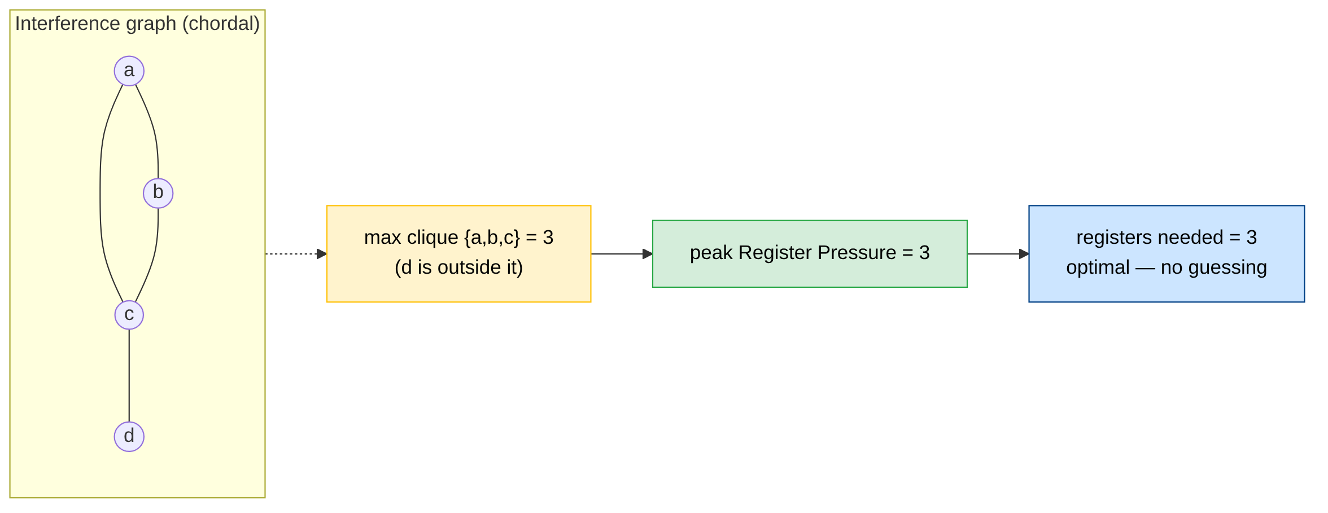
- RP at a point = values live there = clique size; peak RP = max clique.
- Peak RP = the colors greedy-PEO needs, so we spill first to bring peak RP to the hardware limit k — then coloring is guaranteed to succeed with k.
Notes: Same example as a graph. {a,b,c} form a clique (max clique = 3); d hangs off c and isn't part of it. So peak pressure = 3 = registers needed, known before we color — no guessing. The key inversion vs classic RA: because peak RP tells us the exact demand, we spill FIRST to get peak down to k hardware registers, and then coloring is guaranteed to succeed. Spilling drives coloring, not the other way round.

What this buys us: a decoupled, single-pass allocator
Classic allocators couple coloring and spilling and iterate. On SSA the three tasks separate cleanly and run once:
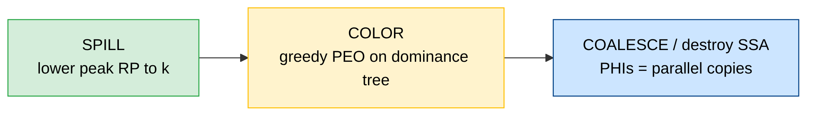
- Spill = a program transformation (Belady next-use), not a graph repair.
- Color = one dominance-tree walk; provably optimal, never fails after spill.
- Coalesce / SSA-destruction = PHIs are register permutations (swaps/moves).
No build-color-spill-rebuild loop.
Notes: The architecture in three boxes, run once. Spill is a program transformation using Belady's next-use heuristic (evict what's used farthest in the future), not graph surgery. Color is a single dominance-tree walk that can't fail once pressure is at k. Coalesce/SSA-destruction handles PHIs as parallel copies — swaps and moves. Contrast with classic: no build-color-spill-rebuild loop at all. That's the win.

Our RA stack — four passes behind -amdgpu-ssa-regalloc
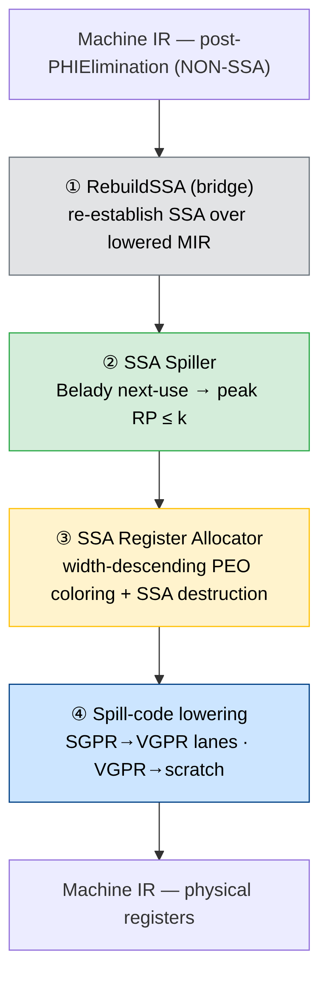
- SSA is preserved throughout; the spiller repairs SSA inline after reloads.
- Lane-aware everywhere — values tracked as (VReg, LaneBitmask) for subregisters.
Notes: Our actual implementation, four passes behind the -amdgpu-ssa-regalloc flag. (1) RebuildSSA re-establishes SSA over already-lowered MIR — that's the bridge, more on it shortly. (2) Spiller: Belady, gets peak RP to k. (3) Register allocator: the PEO coloring plus SSA destruction. (4) Spill-code lowering: SGPR->VGPR lanes, VGPR->scratch. Two things carry through all of it: SSA stays intact end to end, and everything is lane-aware — values are (VReg, LaneBitmask) so subregisters work.

The critical dependency: SSA in, SSA out
The theory needs strict SSA input — but LLVM's pre-RA pipeline (PHIElimination, TwoAddress, coalescing) has already destroyed SSA before we run. Today a temporary bridge, RebuildSSA, reconstructs it:
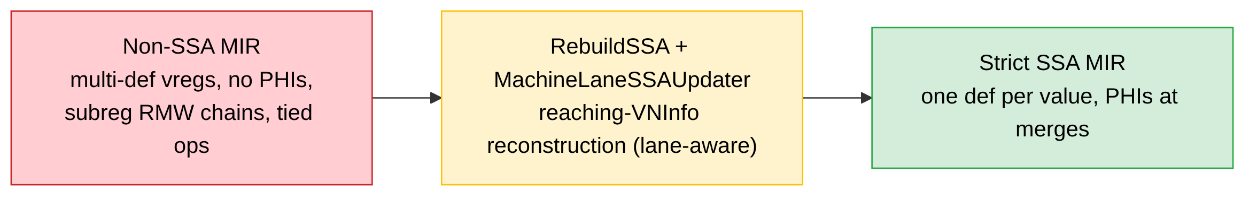
- Why it's hard on AMDGPU: wide tuples, subregister/lane liveness, early-clobber two-address ops (WMMA), oversized register classes with undef padding lanes.
- Reconstructing SSA from lowered MIR is fragile and expensive — a scaffold, not the destination. Which is exactly where the team comes in.
Notes: The catch. The theory needs strict SSA input, but LLVM's pre-RA pipeline — PHIElimination, TwoAddress, coalescing — has already destroyed SSA before we run. So today we bolt on RebuildSSA to reconstruct it. On AMDGPU that's genuinely hard: wide register tuples, subregister/lane liveness, early-clobber two-address ops like WMMA, oversized classes with undef padding lanes. It works, but it's fragile and expensive — scaffolding, not the destination. That sets up the team's mission.

The team's mission — make SSA the native form
Goal: teach the pre-RA machine passes to preserve SSA instead of destroying it — so the bridge disappears and SSA is the pipeline's native form end to end.
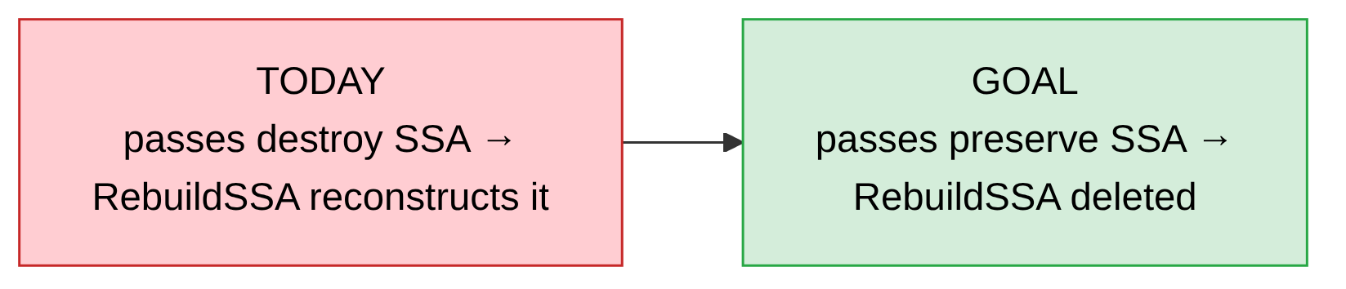
Why it matters: the optimal-coloring guarantee assumes strict SSA input. Preserving it upstream removes a fragile reconstruction step, cuts compile time, and is the key to the hardest AMDGPU cases (subreg/lane liveness, WMMA, wide tuples).
Who does what: allocator / spiller / coloring core — Alex; the shared lane-aware SSA-repair engine (MachineLaneSSAUpdater) is common ground; the pre-RA pass -> SSA-preserving conversion is the team's charter.
Notes: The ask for the room. Instead of reconstructing SSA after the fact, teach the pre-RA passes to preserve it — then RebuildSSA gets deleted and SSA is the native form end to end. Why it's worth it: the optimality guarantee assumes strict SSA input, so preserving it removes the fragile step, cuts compile time, and unlocks the hardest AMDGPU cases. Division of labor: I own allocator/spiller/coloring core, the lane-aware SSA-repair engine is shared, and making the pre-RA passes SSA-preserving is the team's charter — the main thing I want people to leave thinking about.

Status & what's next
Working today — full pipeline wired behind -amdgpu-ssa-regalloc, run end-to-end across the 3060-test AMDGPU LIT corpus.
- Pipeline (RebuildSSA -> Spiller -> RA -> lowering): live, corpus-tested
- Chordal PEO coloring, SSA destruction: implemented
- Lane-aware SSA reconstruction (WMMA, padding, tied): hardened this cycle
- Corpus crashes: 103 / 3060 (from ~850)
Next:
- PHI coalescer (paper §4.3) — the durable fix for cross-call physreg pressure.
- Per-class / fragmentation-aware spilling + feasibility gate.
- Reconcile spiller vs RA register-budget accounting.
Notes: Where we stand. Full pipeline is live behind the flag and runs end to end on the whole 3060-test AMDGPU LIT corpus — not a toy. Coloring and SSA destruction are in; lane-aware reconstruction got hardened this cycle. Headline number: crashes down to 103 from ~850, so trajectory is good. Next up: the real PHI coalescer from paper section 4.3 (durable fix for cross-call pressure), smarter per-class/fragmentation-aware spilling, and reconciling budget accounting between spiller and RA. Corpus is our real gate, not local lit.

Questions?
SSARA — optimal SSA-based register allocation for AMDGPU
Design docs: SSARA/04-Design/ · Foundation: Hack, Grund & Goos (CC'06) + Hack PhD (2007)
Notes: Thanks — happy to take questions. Likely ones: How is this different from greedy RA today? (optimal coloring, no iteration, once SSA holds). What's the compile-time story? (deleting RebuildSSA is a big part of it). Why AMDGPU first? (lane/subreg complexity is where SSA pays off most). Point people at the design docs in 04-Design and the Hack paper for depth.

