**ALEX THOMAS**

**MCA A**

**Roll.**

**SQL QUERIES**

create table BRANCH (BNAME VARCHAR(20), CITY VARCHAR(30) NOT NULL,PRIMARY KEY(BNAME));

insert into BRANCH values ('VRCE' ,'NAGPUR');

insert into BRANCH values ('AJNI','NAGPUR');

insert into BRANCH values ('KAROLBAGH','DELHI');

insert into BRANCH values ('CHANDNI', 'DELHI');

insert into BRANCH values ('DHARAMPETH','NAGPUR');

insert into BRANCH values ('MG ROAD','BANGALORE');

insert into BRANCH values ('ANDHERI', 'BOMBAY');

insert into BRANCH values ('NEHRU PALACE','DELHI');

insert into BRANCH values ('POWAI','BOMBAY');

select * from BRANCH;

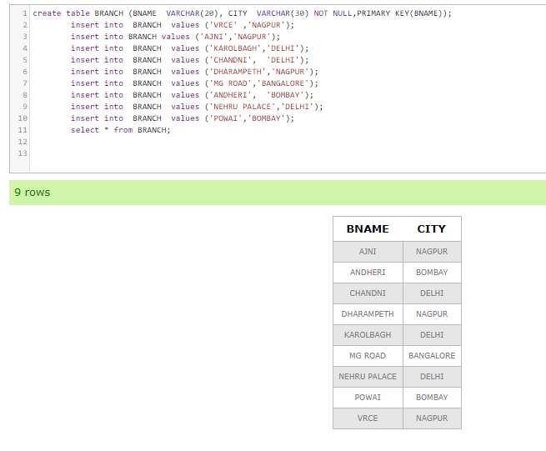

create table CUSTOMER (CNAME VARCHAR(15), CITY VARCHAR(20) NOT NULL,PRIMARY KEY(CNAME));

insert into CUSTOMER values ('ANIL','CALCUTTA');

insert into CUSTOMER values ('SUNIL' ,'DELHI');

insert into CUSTOMER values ('MEHUL','BARODA');

insert into CUSTOMER values ('MANDAR','PATNA');

insert into CUSTOMER values ('MADHURI','NAGPUR');

insert into CUSTOMER values ('PRAMOD','NAGPUR');

insert into CUSTOMER values ('SANDIP','SURAT');

insert into CUSTOMER values ('SHIVANI','BOMBAY');

insert into CUSTOMER values ('KRANTI','BOMBAY');

insert into CUSTOMER values ('NAREN','BOMBAY');

select * from CUSTOMER;

