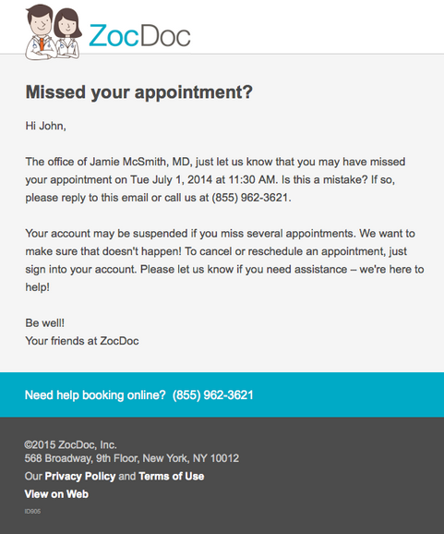

1. **Missed your appointment?**
2. **Need help booking online? (855) 962-3621**

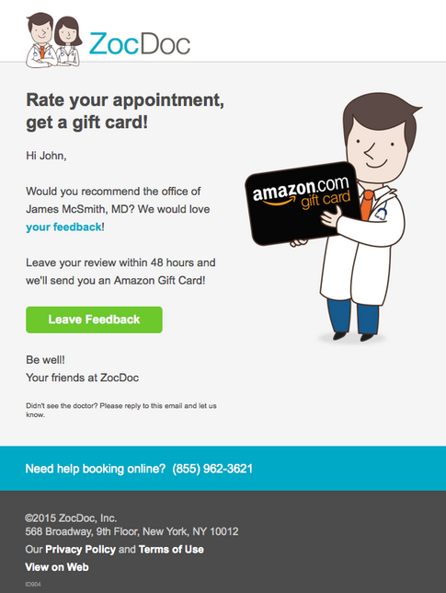

1. Rate your appointment, get a gift card!
2. Would you recommend the office of {{Model.PractitionerFirstLastName}}, {{Model.PractitionerTitle}}? We would love **your feedback**!
3. Button: Leave Feedback
4. Didn’t see the doctor? Please reply to this email and let us know.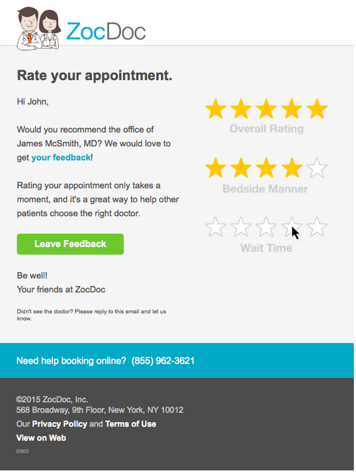
5. Rate your appointment.
6. Would you recommend the office of {{Model.PractitionerFirstLastName}}, {{Model.PractitionerTitle}}? We would love to get **your feedback**!

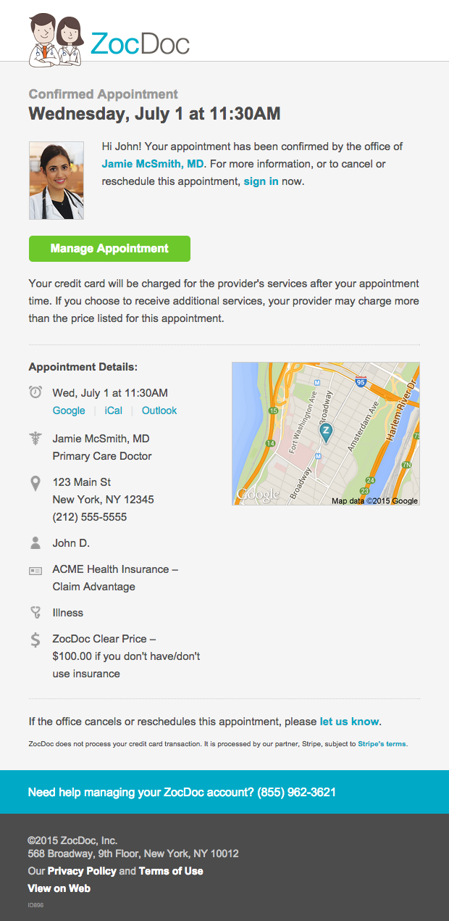

1. $100.00 if you don’t have/don’t use insurance