Bug report for [BUG ID 001]

Title: Transfer funds to the same account is allowed
Description:
Transfer Funds allows the same account to be selected as both From and To. The transfer is processed and debit/credit transactions are recorded, instead of being rejected.
Severity: Medium
Priority: Medium
Preconditions:
- User ‘johndoe’ is logged in.
- User has account 17229 with a balance greater than 100.

Steps to reproduce:
1. Log in as user ‘johndoe’.
2. Navigate to Transfer Funds.
3. Enter 200 in the ‘Amount’ field.
4. Select account 17229 in ‘From Account’.
5. Select account 17229 in ‘To Account’.
6. Click Transfer.
Expected result: The transfer is rejected with a validation message (e.g. "From and To accounts must be different").
No transactions are recorded.
(Note: requirement not documented – confirm with PO.)
Actual result: "Transfer Complete!" is displayed. The balance of account 17229 is unchanged, but a debit (#20692) and a credit (#20803) transaction of 200 are recorded in its transaction history.

Reproducibility: Always (5/5)

Environment:
- URL: http://localhost:8080/parabank/
- Build/version: [n/a]
- Browser/OS: [Chrome 155.0.8059.86 / Windows 11]

Attachments/Media:
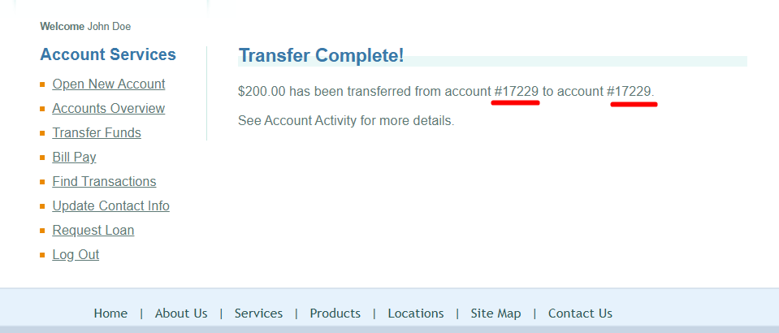
Figure 1 Message for successful transfer funds
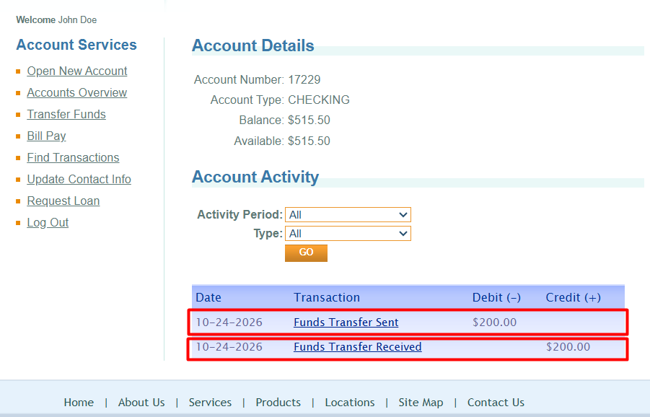
Figure 2 Debit and Credit transactions recorded for the same account

