Bug report for [BUG ID 002]

Title: Find Transactions by ID ignores the selected account
Description:
The selected account is not used as a search filter, so the same transaction is returned regardless of which account is selected.
Severity: Medium
Priority: Medium
Preconditions:
- User "test3 est4" is logged in and has at least two accounts (16563 and 17118).
- Transaction #19693 exists and belongs only to account 16563.

Steps to reproduce:
- Log in as user "test3 est4"
- Go to Find Transactions.
- Select account 16563 in the ‘Select an account’ drop-down menu.
- In the ‘Find by Transaction ID:’ field, input value ‘19693’ for ID of the transaction and click ‘FIND TRANSACTIONS’.
- Select account 17118 in ‘Select an account’.
- Enter 19693 in ‘Find by Transaction ID’ and click ‘FIND TRANSACTIONS’.

Expected result: No transaction is returned for account 17118, and a message indicates no matching transaction was found for the selected account.
Actual result: Transaction #19693 (belongs to account 16563) is returned when account 17118 is selected.
Reproducibility: Always (5/5)

Environment:
- URL: http://localhost:8080/parabank/
- Build/version: [n/a]
- Browser/OS: [Chrome 155.0.8059.86 / Windows 11]

Attachments/Media:
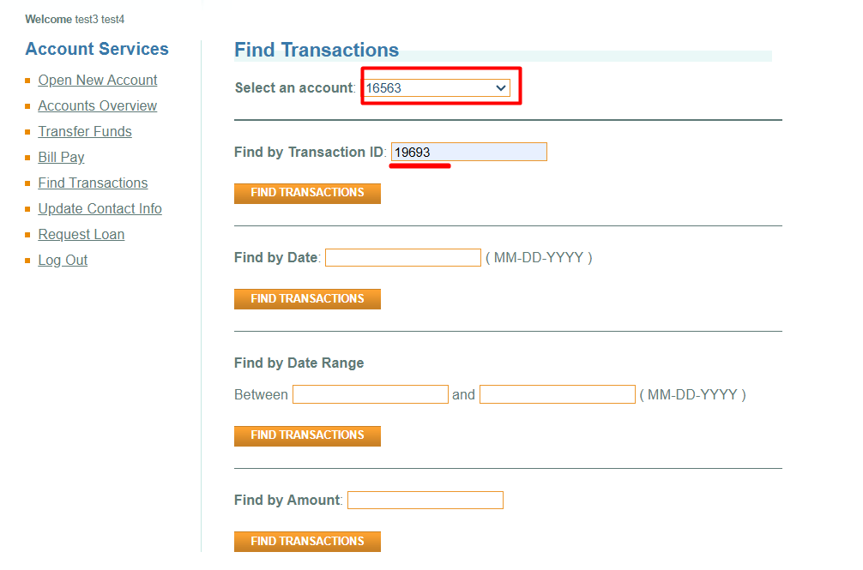
Figure 1Transaction ID entered for account 16563
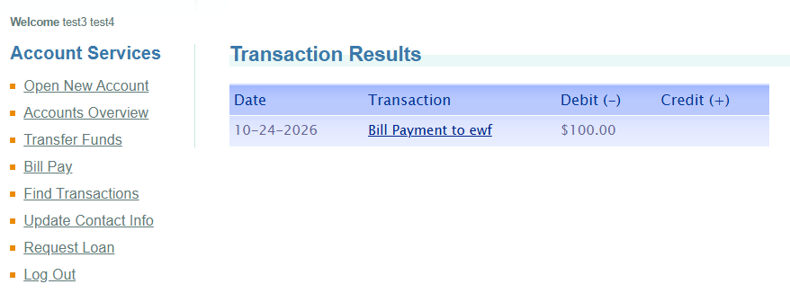
Figure 2 Result from the search for account 16563
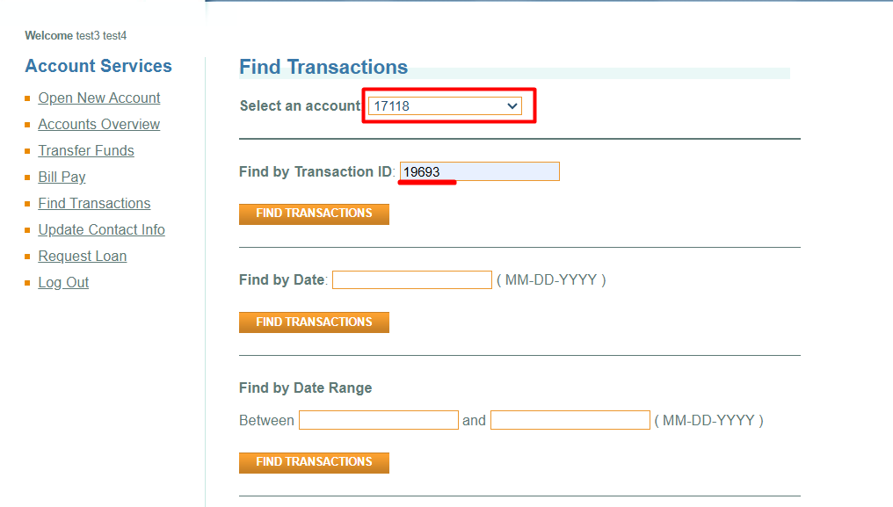
Figure 3 Transaction ID entered for account 17118
Figure 4 Result from the search for account 17118

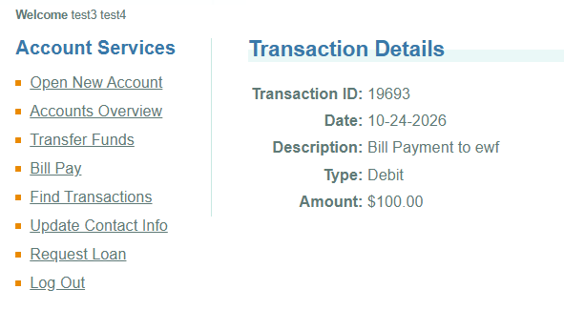
Figure 5 Details for the transaction #19693

