MODELLING ADOPTION OF MEAT-REDUCED DIETS USING CELLULAR AUTOMATA, IN THE CONTEXT OF THE CLIMATE AND ECOLOGICAL EMERGENCY

by

Student number 100368172

Thesis presented in part-fulfilment of the degree of Master of Science/Master of Research in accordance with the regulations of the University of East Anglia

Word count:

School of Environmental Sciences
University of East Anglia
University Plain
Norwich
NR4 7TJ

© 2022 MSc. Student

This copy of the dissertation has been supplied on condition that anyone who consults it is understood to recognise that its copyright rests with the author and that no quotation from the dissertation, nor any information derived there from, may be published without the author’s prior written consent. Moreover, it is supplied on the understanding that it represents an internal University document and that neither the University nor the author are responsible for the factual or interpretative correctness of the dissertation.
Abstract
Max 300 words
Table of Contents
1 List of Accompanying Material 1
2 Preface - optional 1
3 Introduction 1
4 Literature Review 1
5 Methods 1
5.1 Generation of Social Graph 2
5.2 Use of Data from Hielkema & Lund Study 6
5.3 Implementation of CA Model 8
5.4 Processing Model Runs Output 12
6 Results 13
7 Discussion 14
8 Conclusions 14
9 References 14
10 Appendices 14

List of Accompanying Material
git repo for scripts

Preface - optional

Introduction
1000 words

Literature Review
3000 words

Methods
The Hielkema & Lund study (2021) was used as a starting point for this investigation. The model they provide was found to be necessary but not sufficient for the creation of a CA model for the spread of meat-reduced diets, and therefore each run of the CA model required additional parameters to be supplied. These additional parameters will be described in the following sections.
Hielkema & Lund collected stratified data for the whole of Denmark via an online questionnaire, and used the results to build a quantitative model. Their model predicts a categorical variable, called “stage of change” which comprises the categories “NO intention”, “Intention”, and “Reducer”. (The “stage of change” concept comes from Prochaska & Di Clemente’s “Transtheoretical” model (1982), which describes how individuals make behavioural changes, such as quitting smoking, by progressing and relapsing through stages nominally lasting 6 months.) The explanatory variables Hielkema & Lund studied included a categorical variable describing the number of ties to meat-reducers and the strength of those ties. Their model enables the creation of a stochastic CA algorithm in which each agent’s “stage of change” can be updated every time step, using probabilities derived from real-world data.

Generation of Social Graph
Creation of large social graphs (or networks) is a slow process. To avoid the need to regenerate the same graphs multiple times, these were created in advance, and saved to local files named after the parameters used.
Although the Hielkema & Lund model is for the whole of Denmark, creating social graphs for a country of 5.9 million people (Statistics Denmark, 2021) would result in excessive file sizes. Each edge requires 3 values (source, destination, and strength), and so if the average individual is involved in 10 ties, and values are stored in 64bit integers, a graph for 5.9 million individuals would require over 700MB of disk space. Therefore just one region was selected, specifically North Jutland, as this had approximately 1/10th of the population of the whole of Denmark. For convenience, it was assumed North Jutland was representative of the country as a whole.
Open source population density data collected by Meta (originally Facebook) was downloaded (Meta, 2020), and polygons for Danish administrative regions were downloaded from GADM (2022). A python script was written to combine these to produce gridded population density data for North Jutland, with a small correction to scale to the correct population size provided by Statistics Denmark (2021). The grids divided the region (8.213°E-11.199°E) x (56.555°N-57.749°N) into 1000x1000 equal latitude and longitude cells. The resulting population density map is shown in Figure 1.
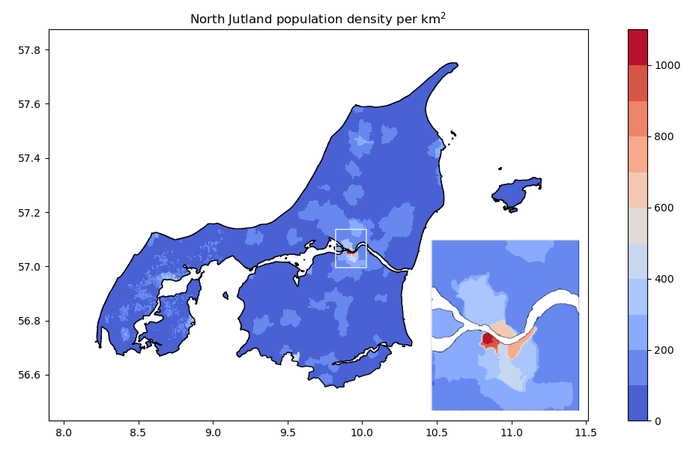Figure 1: Population density for North Jutland, Denmark, with area around Aalborg expanded
Hielkema & Lund’s questionnaire specifies two types of social tie, namely weak and strong, but does not define these terms (Hielkema & Lund, 2021b). Given the context (dietary influences), this study takes “strong tie” to indicate cohabitation (as cohabitants usually dine together every day), and “weak tie” to indicate any other person with whom one dines frequently.
The distribution of household sizes for Denmark was downloaded from Statistica (2021) and used in combination with the gridded population density data to randomly place households, and thereby individuals, adding strong links between household members in the process. A close up of the result of this placement algorithm is shown in Figure 2.
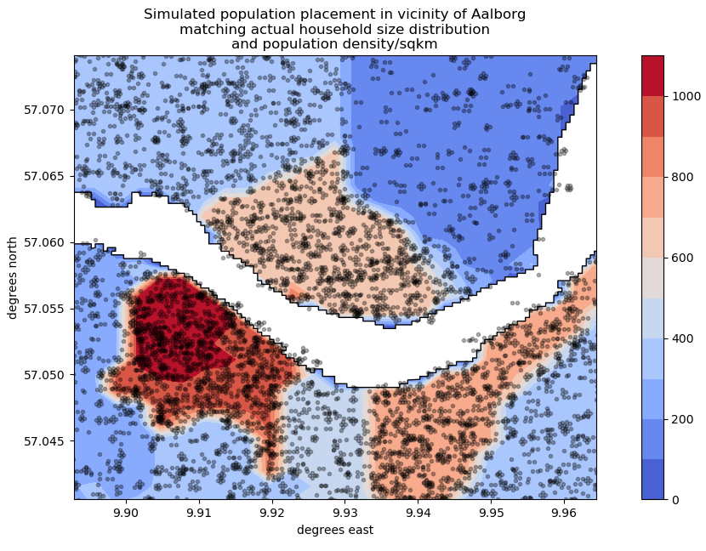Figure 2: Population placement with multiple-occupant households clearly visible
No data supporting a specific allocation of weak links was found in the literature, so a novel algorithm was used, based on a method by Watts-Strogatz (1998) for building Small World Networks. In the Watts-Strogatz Model, nodes are arranged in a ring and each pair of nodes within a specified range form a link with a specified probability. This is often used to generate realistic social networks. However, using this without modification would ignore the geographical information previously obtained. The novel algorithm used here adapts Watts-Strogatz to a situation in which nodes come with 2D location data:
- The caller specifies the following values when building a social graph:
  - The mean number of weak ties per person, mean_n_weak_ties
  - The modal distance between individuals in a weak tie, modal_weak_tie_km
- Individuals are processed sequentially and added to N/2 weak ties, where N is chosen from the Poisson distribution with mean mean_n_weak_ties. This simulates a situation where weak ties are assigned to individuals at random.
- The peer is chosen at random using a normal distribution, i.e. a probability proportional to

where is the distance to the peer, and is modal_weak_tie_km. (It was confirmed that this led to normally distributed x-displacements and y-displacements with mean zero and s.d. . )
An example of the resulting graph is shown in Figure 3, where the population density has been thinned by a factor of 100 to make the result more clear.
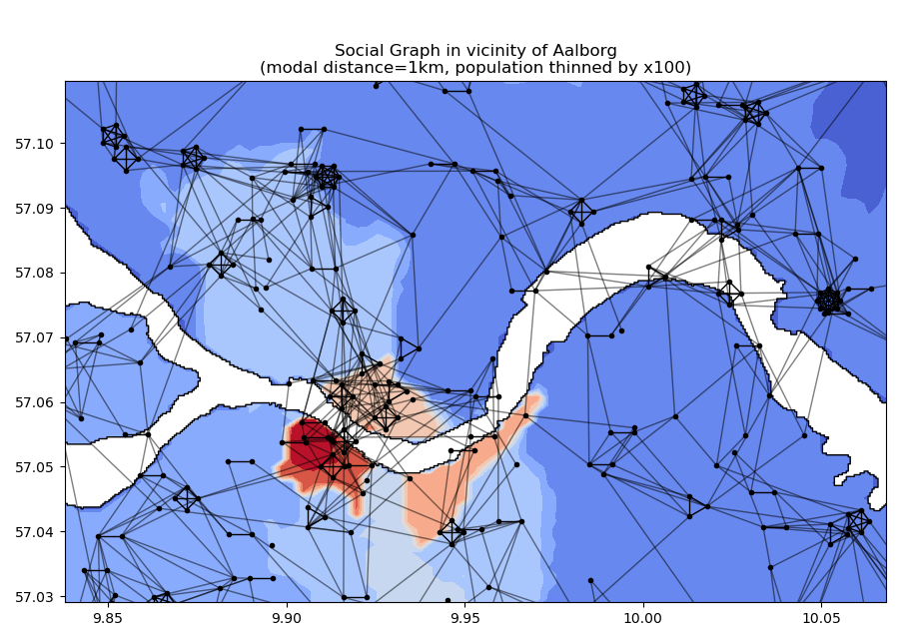Figure 3: Example social graph with strong ties (intra-household) in bold
The script was invoked with every combination of mean_n_weak_ties=2,3,4,5,6,7,8 and modal_weak_tie_km=1,2,3,4,5 to produce 35 files varying between 28MB and 57MB in size.

Use of Data from Hielkema & Lund Study
The Hielkema & Lund model is a “multinomial logistic regression” model which predicts “stage of change”, or Y. This study will focus on just one of their predictor variables, the categorical variable “social networks”, or X. Table 1, is reproduced from Hielkema & Lund (2021) with additional annotations identifying the categories of X and Y.
Table 1: Social networks: Type and number of social ties with those who have reduced or stopped eating meat (reference group: knowing no one (X=0))
 | Intention (Y=1) vs  NO intention (Y=0)  OR (CI) | Meat reducers (Y=2) vs NO intention (Y=0)  OR (CI)
(X=1): 1-2 weak ties | 0.69 (0.27–1.81) | 0.73 (0.36–1.45)
(X=2): 1-2 strong ties | 2.78 (1.47–5.26)** | 2.54 (1.55–4.16)**
(X=3): 1-2 strong and weak ties | 3.81 (1.70–8.57)** | 3.19 (1.65–6.17)**
(X=4): 3+ strong and/or weak ties | 0.65 (0.16–2.65) | 3.30 (1.56–6.98)**
* 10% significance (p < 0.10)
** 5% significance (p < 0.05)

The multinomial logistic model uses the numbers above to calculate an expected probability using the equation

where are the values in Table 1, where should be read as “the probability of A given that B”, and where the are some constants. For example, if a person has “1-2 strong and weak ties” then , then substituting and produces an equation indicating the probability of them being a “Meat reducer” vs that of having “NO intention”.
The above equation can be extended to work for and . (Since knowing no one (X=0) is the reference group, by definition. Substituting shows that , which forces .) This enables an absolute form of the probabilities to be obtained

In the formula above, there are two unknown values . The information present in the paper was insufficient to to determine them. The authors were contacted for additional data but no response was obtained, so it was necessary for these values to be treated as parameters in the cellular automata model. Fortunately these two values are equivalent to (as in “may be derived from”) two alternative parameters with a more a meaningful interpretation. These are shown in Table 2.
Table 2: Additional parameters needed to complete predictive "stages of change" model
Name | Description | Formula
awareness_pc | % of no-ties population either intending to reduce meat consumption, or actively reducing.
facility_pc | % of “aware” no-ties population that are active reducers

An individual with no ties to meat reducers who is actively reducing their meat intake or contemplating doing so, cannot be doing so as a result of direct peer influence. It is therefore reasonable to attribute this behaviour to a society-wide level of awareness. For this reason the first of the parameters above is named awareness_pc.
The proportion of these individuals that then go on to become meat reducers, reflects the ease of that transition. Since these people have no meat-reducer peers it is reasonable to consider this as reflecting how easy society in general makes meat reduction (e.g. by providing meat alternatives in shops and restaurants). For this reason the second of the parameters above is named facility_pc.
The two parameters will be referred to frequently throughout this study. The above table serves as a reference for their technical definitions.

Implementation of CA Model
The model was implemented in python, and the matplotlib package was used for illustrations. It was originally intended to use the networkx package to support graph creation, but this was found to be slow and have a large memory footprint, so numpy arrays were used instead.
The script took five parameters, the first four of which have already been described
- mean_n_weak_ties
- modal_weak_tie_km
- awareness_pc
- facility_pc
- p_update_logit_normal_sigma
The parameters mean_n_weak_ties and modal_weak_tie_km selected a pre-built social graph to be loaded into memory from file. The parameters awareness_pc and facility_pc allowed the probabilities for each “stage of change” (Y) to be calculated given an individual’s “social network” (X). The last parameter will be described later.
The script initialized the Y-states using the probabilities for “no-ties”. It then updated all individuals’ Y-states in a loop, with iterations nominally representing 6 months, as in the Transtheoretical model of Prochaska & Di Clemente (1982). This involved identifying which of the 5 “X” categories each individual belonged to at the end of the previous iteration, and then using the probabilities to randomly assign a new “Y” value.
Unfortunately the Hielkema & Lund paper is ambiguous about the precise definition of each “social network” category, and it is difficult to reconcile the descriptions they give with mutually exclusive and exhaustive interpretations. For completeness, the interpretations used in this study are shown in Table 3.
Table 3: Names given by H&L and interpretations used in this study. The interpretations correspond to a strict ordering by number of strong ties, followed by number of weak ties.
H&L description | Interpretation used in model
(X=0): knowing no one | 0 strong ties, 0 weak ties
(X=1): 1-2 weak ties | 0 strong ties, 1+ weak ties
(X=2): 1-2 strong ties | 1-2 strong ties, 0 weak ties
(X=3): 1-2 strong and weak ties | 1-2 strong ties, 1+ weak ties
(X=4): 3+ strong and/or weak ties | 3+ strong ties

In addition to the ambiguity in the definition of the predictive categories there is also of course some ambiguity in the meanings of each category in Y. This was of no concern in terms of implementation as the model simply treated these as a per-individual states. However, for completeness Hielkema & Lund asked respondents to choose from
- “no plan to reduce in the next six months”
- “planning to reduce within the next six months”
- “planning to reduce within the next month”
- “already reduced within the last six months”
- “reduced for longer than six months”
(Hielkema & Lund, 2021)
The authors then identified 1 with the category “NO intention”, combined 2&3 into the category “Intention”, and combined 4&5 into “Reducer”. The multinomial logistic model referred to earlier was built after excluding vegetarians and vegans.
Real individuals do not all re-assess their life choices equally frequently: some are more resistant to change than others. It was therefore decided to assign to each individual a “resistance to change” in the form of a number . This defined the probability that a new Y-state would be chosen (at random) each iteration. For example, if the individual would have their state updated on 25% of all iterations, on average. Since is bounded by 0 and 1, a logit-normal distribution of p-values was assumed (i.e. it was assumed that , or equivalently , was normally distributed). It was also assumed that the mean value of was 0.5, an assumption that can be justified by dropping the requirement that the iteration period represents exactly 6 months. The standard deviation of was set by the parameter p_update_logit_normal_sigma.
Figure 4 shows the distributions of for different values of p_update_logit_normal_sigma. It is evident that at around p_update_logit_normal_sigma=1.5 the distribution changes from unimodal to bimodal (representing a population with a “conservative” peak and an “open-to-change” peak).
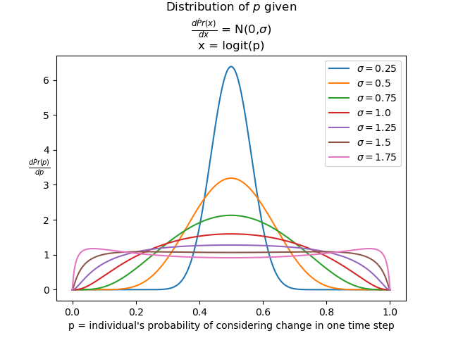Figure 4: Logit normal distributions with mean 0.5
Finally a script was written to invoke the CA model script thousands of times with randomly selected values for each of 5 parameters, as shown in the code snippet below:
mean_n_weak_ties = np.random.choice(range(2,9))

modal_weak_tie_km = np.random.choice(range(1,6))

awareness_pc = np.random.uniform(10,90)

facility_pc = np.random.uniform(10,90)

p_update_logit_normal_sigma = np.random.uniform(0.25,3)

Sensitivity Analysis
In Table 1 the -values are followed by 95% confidence intervals, for example “0.69 (0.27 – 1.81)”. The central estimate is the geometric mean of the upper and lower estimates. These upper and lower estimates can therefore be used to obtain the standard deviation of which the multinomial logistic model assumes to be normally distributed. A sensitivity analysis was conducted by randomly perturbing each from its central estimate in each of several thousand runs.

Processing Model Runs Output
It was observed that numbers of individuals in each “stage of change” converged rapidly to a limit as shown in Figure 5. This limit was usually reached within 5-10 “generations”. Since this was a stable feature of the model, irrespective of the parameters, the calling script was configured to request 20 iterations on each call of the model, and output the final values for the number of individuals in each category.
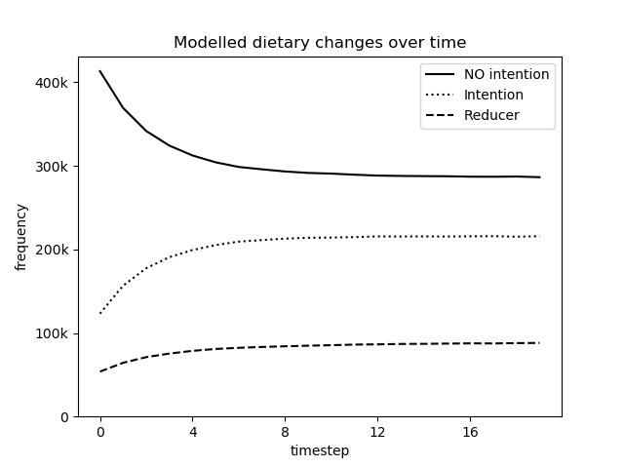Figure 5: Typical convergence of "stage of change" distribution over time
The results of the model runs were collected into a .csv file alongside the parameters used. This was then loaded into stats package R.
Within R the numbers that end up in each “stage of change” category were converted into percentages, and a model was constructed for how percent_reducer, and percent_intention depend on each of the 5 parameters.
Linear models
A linear model is a mathematical equation which predicts a response variable from one or more explanatory variables. An example of a simple linear model for the effect of the parameters on percent_reducer might be

Given a dataset and a formula like the one above, the R function lm() finds the that minimize the sum of the squares of the errors.
Although the formula above is simple it is often better to transform variables prior to building a model. Variables representing percentages were transformed into which is neither bounded above nor below, and therefore more appropriate for use in a linear model. After this step a visual inspection of relationships was performed to check for non-linear relationships, and square terms were added where necessary. Finally, terms that did not contribute significantly to the model were dropped using Akaike Information Criterion, a standard method for finding a balance between parsimony and explanatory power in a linear model.
This process produced a formula, which was passed to lm() to produce confidence intervals for the coefficients and an estimate for the amount of variation in the results “explained” by the model. The entire process was repeated for the both the normal dataset (which used central estimates for the ) and for the sensitivity analysis dataset (which used randomized ).

Results
2000 words
The CA runs were performed on a 2GHz quad core Intel PC with 8GB RAM. The script was initially run for about 24 hours which resulted in a .csv file containing the results of 2963 CA runs. This process was repeated for the sensitivity analysis resulting in a second .csv file containing the results of 4669 CA runs.

Observations
The final distribution of individuals in each stage of change appeared to be homogenous rather than showing a geographic correlation to population density. This homogeneity feature appeared to be independent of the parameters used. The results for the default parameters (mean_n_weak_ties=6, modal_weak_tie_km=1, awareness_pc=30, facility_pc=30.33, p_update_logit_normal_sigma=0.5) are shown in Figure 6.
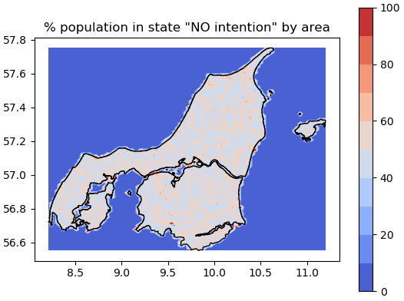
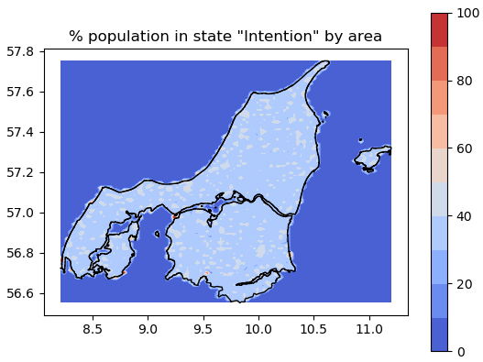
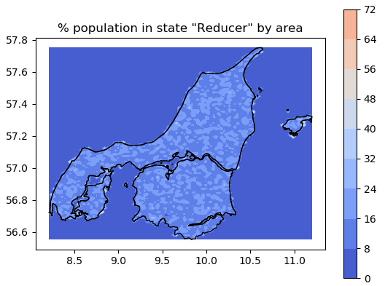Figure 6: Distribution of individuals in each final state (using default parameters)
This homogeneity is supported by the fact that the proportions within grid squares appear to be normally distributed as shown in Figure 7.
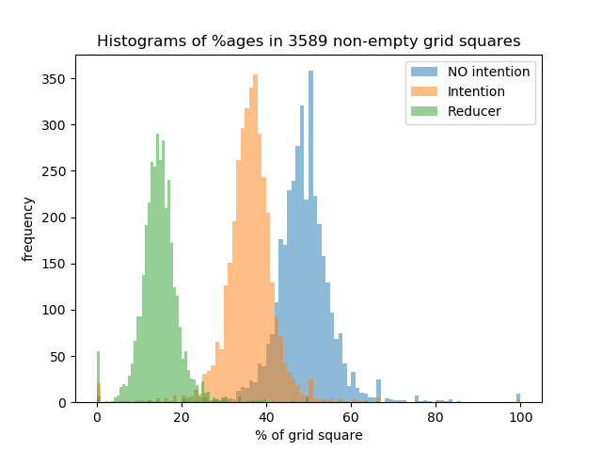Figure 7: Proportions of each stage of change in grid squares seem normally distributed (default parameters)
Although homogeneity is the rule on the large scale, it is apparent from a visual inspection that at a smaller scale households (which consist of complete graphs of strong links) can be characterized as mostly meat-reducer, or mostly non-meat-reducer. In particular, many large households appear to contain a disproportionate number of meat-reducers relative to the population as a whole, see Figure 8.
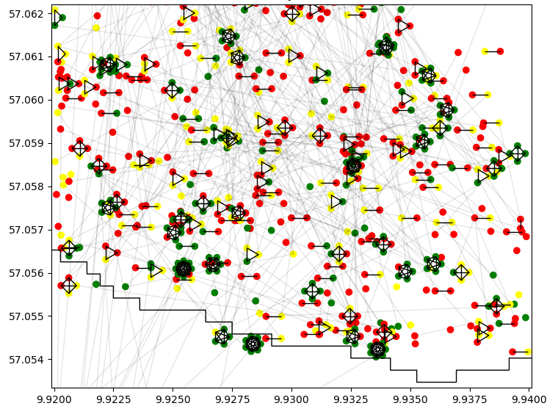Figure 8: Close up of final stage-of-change distribution with Red="NO intention", Yellow="Intention", Green="Reducer". Large households appear to be more likely to be all reducer.

Linear Models
900 words
The results of the 2963 runs were loaded into R, and processed to obtain a model for the percentage of reducers after convergence in terms of the explanatory variables.

Percentage of Reducers Model
The response variable percent_reducers was plotted against each explanatory variable and a histogram of percent_reducers was also plotted. The results are shown in Figure 9.
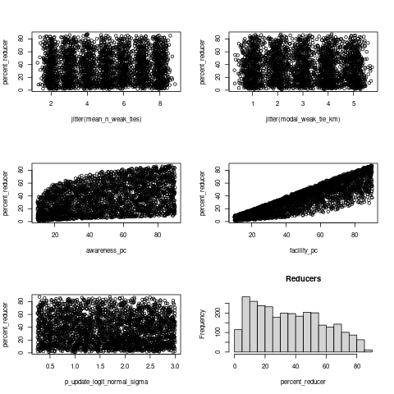Figure 9: Histogram of percent_reducer and scatter plots against each explanatory variable
These charts show a clear positive relationship with awareness_pc and facility_pc, although the relationship with other parameters is less clear. The histogram shows a positive skew (the median is much higher than the mean) which suggests transforming the response variable. Since the response variable percent_reducer is a percentage it is appropriate to use a logistic transform to obtain a new response variable that is neither bounded above nor below. The new response variable was named logit_reducer and set to . The explanatory variables awareness_pc and facility_pc were likewise transformed into new explanatory variables logit_awareness and logit_facility. After transforming the variables the histogram and scatter plots were recreated, as shown in Figure 10.
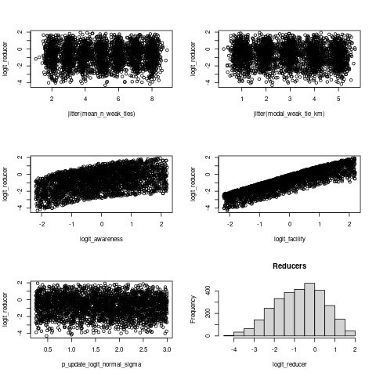Figure 10: Histogram of logit_reducer and scatter plots against transformed explanatory variables
After transforming the response variable the histogram appeared much closer to a normal distribution, indicating that the transformation made the data more appropriate for use in a linear model. From visual inspection, it was apparent there were positive correlations with logit_awareness and logit_facility. It was also clear from the graphs that these relationships are non linear, and so the 2nd the order terms logit_awareness² and logit_facility² were included in the model.
A linear model for logit_reducer was created using all 5 transformed explanatory variables including the two 2nd order terms. Akaike Information Criterion was used to determine that the only modal_weak_tie_km could be dropped without reducing the explanatory power of the model.
The final model, generated by the R function lm(), is reproduced in Table 4.
Table 4: Results of model for logit_reducer
Coefficients: | Estimate | Std. Error | t value | Pr(>|t|)
(Intercept) | -0.4464706 | 0.0041644 | -107.21 | <2e-16 ***
mean_n_weak_ties | 0.0105095 | 0.0005616 | 18.71 | <2e-16 ***
logit_awareness | 0.4697890 | 0.0010208 | 460.23 | <2e-16 ***
I(logit_awareness^2) | -0.1230449 | 0.0008832 | -139.31 | <2e-16 ***
logit_facility | 0.9568436 | 0.0010377 | 922.04 | <2e-16 ***
I(logit_facility^2) | -0.0684336 | 0.0008842 | -77.40 | <2e-16 ***
p_update_logit_normal_sigma | -0.0594041 | 0.0014540 | -40.85 | <2e-16 ***

Signif. codes: 0 ‘***’ 0.001 ‘**’ 0.01 ‘*’ 0.05 ‘.’ 0.1 ‘ ’ 1
Residual standard error: 0.06239 on 2956 degrees of freedom
Multiple R-squared: 0.9973, Adjusted R-squared: 0.9973
F-statistic: 1.832e+05 on 6 and 2956 DF, p-value: < 2.2e-16

The R-squared value indicates that 99.7% of the variation in logit_reducer is explained by this model, making the model extremely accurate. Figure 11 shows that the residuals are more or less normally distributed, and not significantly correlated with the fitted values, which confirms the assumptions made by lm(). It also gives a visual indication of how close the predictions are to the actual values of logit_reducer.
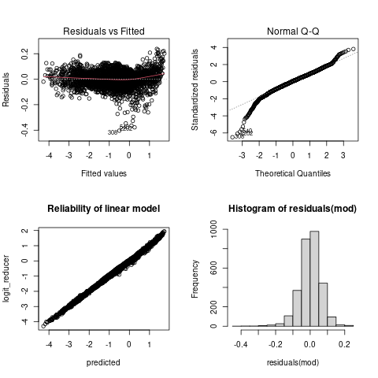Figure 11: Visual confirmation of model assumptions
The model can be rearranged into an equation for percent_reducer as shown below

The model was regenerated using scaled and centred explanatory variables in order to determine the relative importance of each. When this was done it was found that logit_facility was approximately twice as important as and logit_awareness which was more than 10 times as important as any other variable.

Percentage of Intenders Model

Sensitivity Analysis
900 words
say about proportions converging
pictures of convergence
non-linearity
equation of model (reducer and intention)
amount of variation explained
final section on sensitivity analysis
equation of model
amount of variation explained

Discussion
3000 words

Conclusions
1000 words

References
Meta, 2020 https://data.humdata.org/dataset/c846d97b-4363-469a-b66b-1ac2674913b0/resource/cd2c4503-053a-4006-9d0f-efd985e2188f/download/dnk_general_2020_csv.zip
Statistics Denmark, 2021 https://www.statistikbanken.dk/FOLK1AM
GADM, 2022 https://gadm.org/download_country_v3.html
Hielkema & Lund, 2021b additional data
https://ars-els-cdn-com.uea.idm.oclc.org/content/image/1-s2.0-S0950329321001403-mmc1.pdf
Statistica (2021), “Number of households in Denmark as of January 2021, by household size”, available at https://www.statista.com/statistics/582641/households-by-household-size-in-denmark>, last accessed 2nd Mar 2022
Watts, D. J.; Strogatz, S. H. (1998). "Collective dynamics of 'small-world' networks" (PDF). Nature. 393 (6684): 440–442. Bibcode:1998Natur.393..440W. doi:10.1038/30918. PMID 9623998.

Appendices

