Instructions for using the shared Azure Databricks Cluster

1. Provision all resources in the East US region, as this is where the ADB cluster resides
   1. Azure SQL DB
   2. Blob storage containers (the first nine slides of the workshop deck lays this out)
2. You don’t have access to create clusters or access to Spark config, so skip slide 11
3. In an in-private window, go to: <https://eastus.azuredatabricks.net/platinumbricks> and sign in with the userid/password supplied (you will be asked to change your password on first login)
4. Then, from the in-private window, import the notebook, outlined on slide 12
5. When you reach slide 15, you attach to the cluster from the notebook, by hitting the ***Detached*** drop-down list in the notebook and selecting a the aidiscoveryday cluster to run your notebook:
   1. 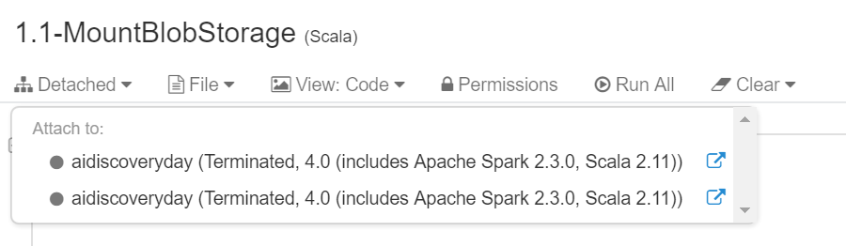
6. And then in the Define Credentials section of the notebook, enter your storage account name and hardcode the storageAccountKey, instead of pulling it from the Spark conf, as follows:
   1. 