# Fortnight Review

1. All kinds of preparation for Bitrun Hackathon
   1. Simple examples of deploying smart contract, calling contract and sending raw transaction for hackathon
   2. Beginner-oriented quick start to install prerequisite dependencies and deploy smart contract in a brand-new Linux
   3. Curated fusion APIs for hackathon participants
   4. Faucet page for Mainnet Beta
   5. Migrate solidity docs to CPChain docs
2. Bugs fixed
   1. An unexpected suspense occasionally occurs when syncing over 20000 blocks for a civilian
   2. The chain halts after sending too many blocks in a block
   3. An unexpected impeach block is inserted after a block with a very large number of transactions
3. Optimize heap efficiency in transaction pool
   1. A high frequency of big.Int comparision results in a large computing overhead
   2. We switch it to int type to gain a large boost in tps at a small cost of precision
4. Stress test
   1. 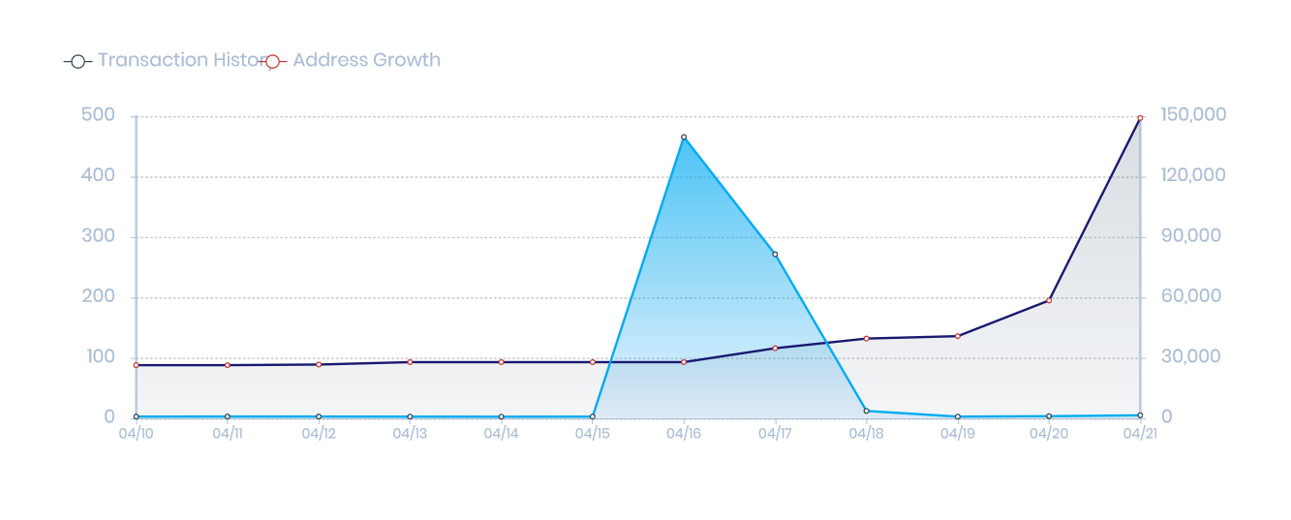
   2. High transaction history on 16 Apr for stress test
   3. Rapid Increasing of addresses from hackathon participants