# Fortnight Review

1. All kinds of preparation for Beta Test
   1. Published new binary releases with some bugs fixed
   2. Published the instruction for participant to join our Beta Test
   3. Refined RPT calculation.
2. Bugs fixed
   1. A panic error reported by Beta Test participants
   2. Rearranged some log hierarchies to avoid misunderstanding
   3. *Invalid gas used* error message
3. Optimize synchronization
   1. We designed two sync model, full sync and fast sync
   2. Fast sync speed sync by omit hash checking. Civilian node can use this mode safely.
   3. Full sync is also improved.
4. Refining test automation process, and design test cases
   1. We designed dozens of test cases which fall into 7 categories
5. Stress test
   1. 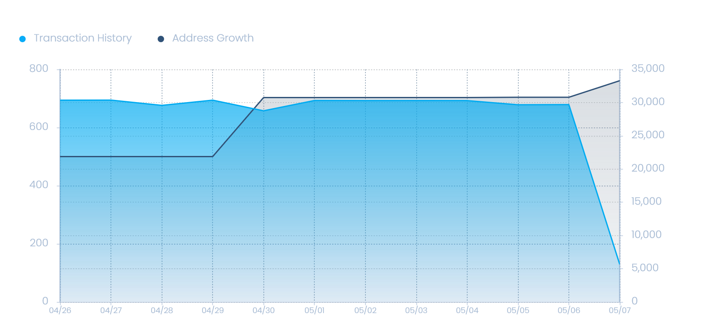
   2. We continue working on stress test