# Fortnight Review

1. Evaluating the Mainnet
   1. Continuing overseeing 12 default proposers and one community node that have been running on the chain
      1. Eight of these twelve default proposers is going to stop auto campaign in a few days.
2. Industry nodes and RNodes from Spark program have been participating in the Mainnet.
   1. Now there are 65 Nodes in total campaigning for election
   2. You can see the increasement of nodes and transactions below
   3. 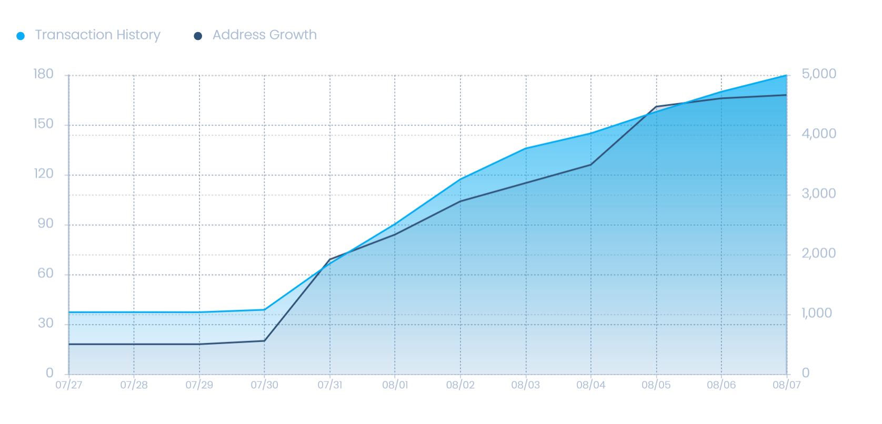
3. Fix a bug, such that number of the impeached block decreases significantly
4. CPC wallet
   1. Block box testing conducted by various crew member.
   2. Bug fix.
   3. Improve security of various phone malwares, like hacked keyboard, rooted OS.