# Fortnight Review

## How do we monitor CPChain

The two main tool we use to monitor CPChain is Prometheus, Grafana and IM bot.

### Prometheus

Prometheus is a time series database for event monitoring and alerting. The term “time series” refers to a series of data pointes indexed in time order. In CPChain, we gain a block each 10 seconds, which fits in the concept of time series.

Each record in Prometheus is a triplet of a timestamp, and a metric name and an optional key-value pairs called labels. The metric name specifies the general feature of a system, while the label is for Prometheus’s dimensional data model.

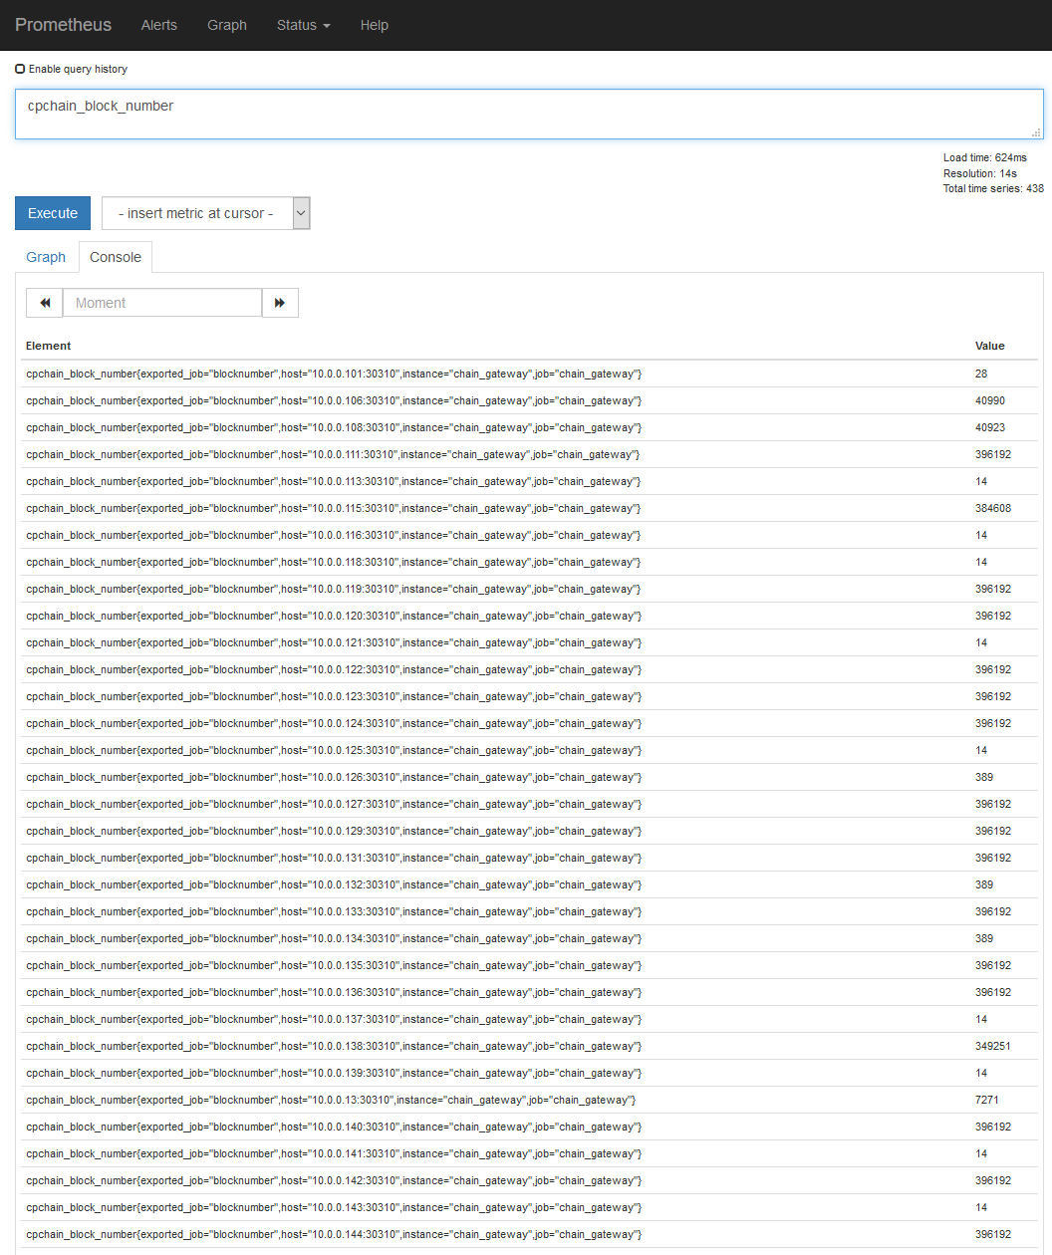

Query results in Prometheus

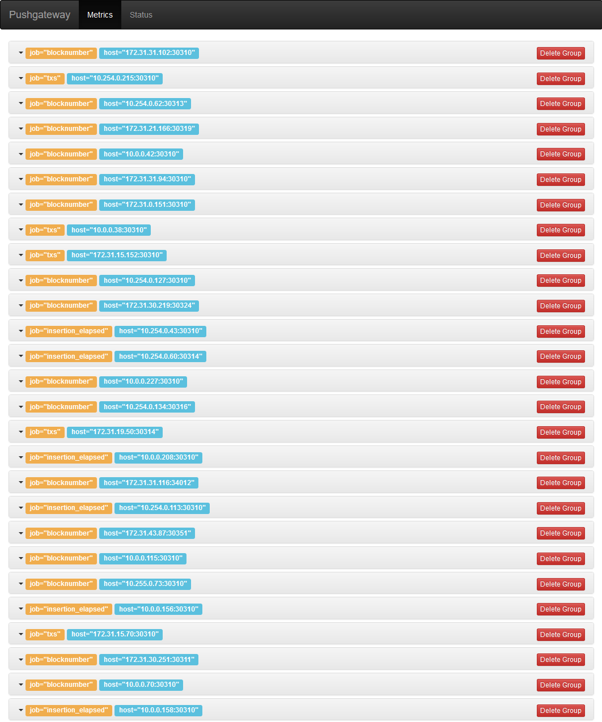

Metrics in Pushgateway (a tool of Prometheus)

### Grafana

Grafana is a data visualization tool that can querying on various database including Prometheus.

### IM bot

To inform us once the monitoring system finds any abnormality as soon as possible, we deployed bot in two instant message tools, DingTalk and WeChat.

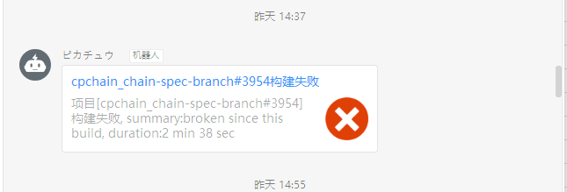

The bot of DingTalk bot pushed a notification on a failure on a branch

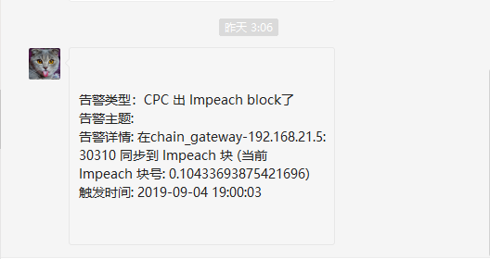

A bot of WeChat pushed a notification on an impeached block