# Fortnight Review

1. Improving RPT calculation
   1. The motivation is that to reduce the impact of impeached block on the MainNet. During Oct 21 to 23, over 250 impeached blocks have been proposed mainly by two accounts. Thus, we are wishing to temporally lower the RPT with this kind of accounts.
   2. The basic idea is that:
      1. The node count the latest N blocks (N is probably set to 10000)
      2. Any node making impeached blocks gets its RPT lowered proportional to the number of impeached blocks from it.
2. DID white paper
   1. We have finished the draft of CPChain DID white paper, which now contains 23 pages
3. More Jepsen test cases have been added
4. 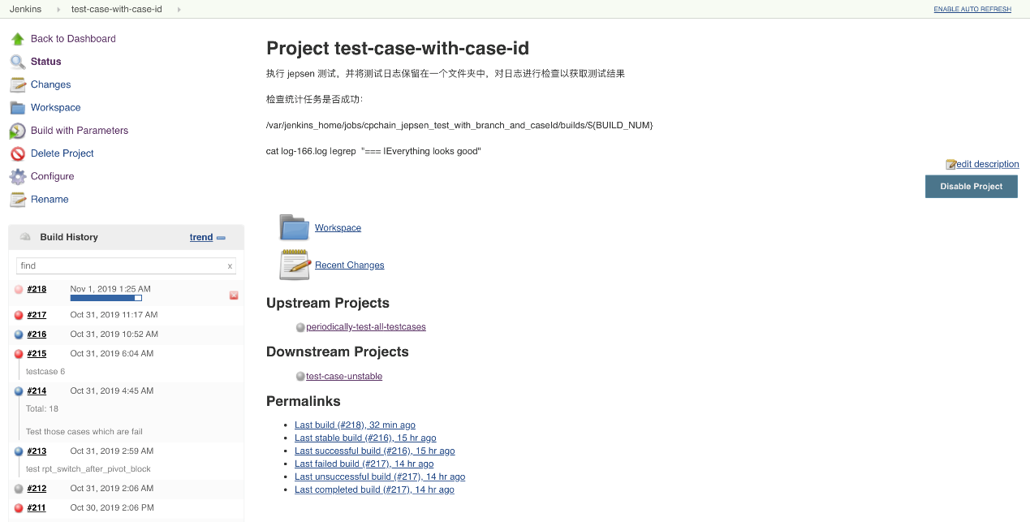

The figure above indicates that are constantly testing the chain as shown in “Build History”

1. 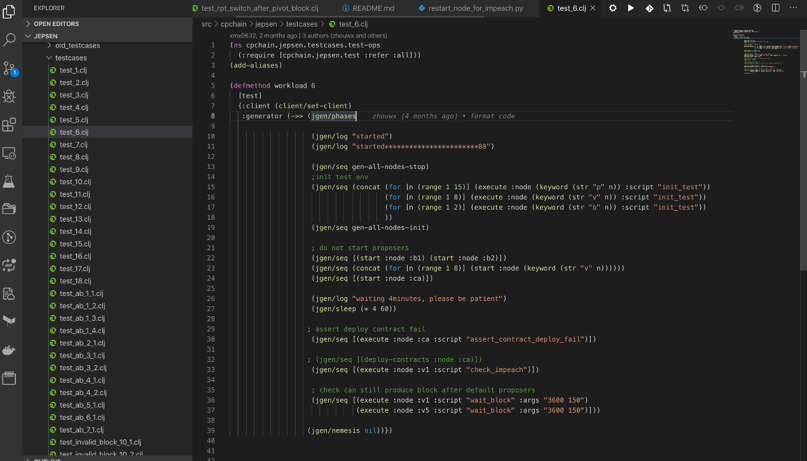

This figure illustrate the index of Jepsen test cases which are written in Clojure language.