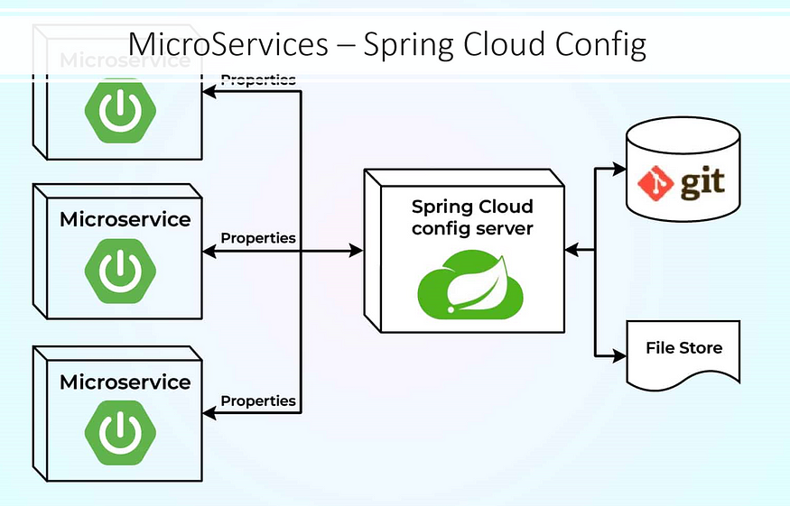

When you are adopting the Microservices ecosystem, it is highly recommended to externalize the configurations from your code so that you can manage the configurations more efficiently. 12-factor app principles suggest externalizing the configurations of your application. If you are unfamiliar with the 12-factor principles, please refer to this link.

**What is a configuration?**

A configuration is anything that varies between multiple environments, like the DEV, TEST, UAT, and PROD environments. This includes your database credentials, external API URLs, and app-specific configurations.

**Spring Cloud Config**

Spring Cloud Config enables you to externalize the configurations of your application in a distributed ecosystem. It has server and client modules. With the Config server, you have a central place to manage all your application configurations across multiple environments.

Spring cloud config supports file systems, git, AWS CodeCommit, and Google Cloud Store. In this article, we will configure our application to read the configurations from the GIT.