TrpB, Metadynamics, and Generative Enzyme Design
An English technical briefing, concept guide, and hands-on roadmap
Prepared for rapid onboarding into the TrpB / COMM-domain / design-to-wet-lab workflow
Version date: 2026-03-18
This document is written for a reader who is new to nearly all of the concepts. It therefore does three things at once: (i) explains every key concept in plain language, (ii) reconstructs the technical pipeline that the Osuna line of work has built around TrpB, and (iii) makes explicit what your likely role is in this project—namely, to turn metadynamics-derived conformational information into a design-useful signal.
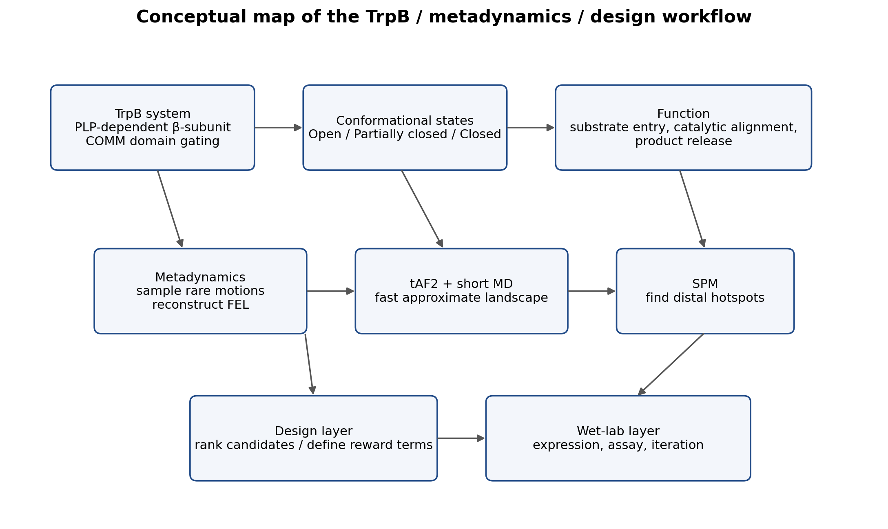
Figure 1. Derived schematic summarizing the conceptual links among the TrpB system, conformational states, metadynamics, cheaper proxy methods, and wet-lab feedback. This figure is an explanatory reconstruction based on the literature, not a reproduced figure from a publisher PDF.

1. Executive interpretation: what your mentor probably wants you to do
The most likely expectation is not “just learn a new MD method” and not “only reproduce an old TrpB paper.” The real goal is to understand how conformational landscapes control TrpB function, then ask whether metadynamics can provide quantities that are useful for enzyme design: for example, stabilization of a catalytically competent closed state, barriers between open and closed ensembles, or the population of productive pre-reactive states.
In practical terms, your job is likely to have three layers. First, learn the TrpB system and the Osuna framework well enough that you can read their papers without being lost. Second, learn the mechanics of metadynamics well enough to understand how a free-energy landscape is set up, sampled, and interpreted. Third, connect those landscapes to the lab’s design workflow so that the output is not “a simulation for its own sake” but a ranked, interpretable, experimentally actionable signal.

2. Every key concept, explained from scratch
Concept | Plain-language meaning
TrpS / TrpB | Tryptophan synthase is a multi-subunit enzyme complex. TrpB is the beta subunit, a PLP-dependent catalytic unit that carries out the final step leading to L-tryptophan.
PLP | Pyridoxal phosphate is a vitamin-B6-derived cofactor used by many enzymes. In TrpB it participates directly in the catalytic chemistry.
COMM domain | A mobile domain in TrpB that opens and closes over the active site. Its motion is not cosmetic; it strongly affects catalysis, substrate access, and productive alignment.
Conformational ensemble | A protein is not one single structure. It occupies a distribution of interconverting structures in solution. Function depends on the whole distribution, not only one crystal snapshot.
Free-energy landscape (FEL) | A compact way to describe which conformations are stable, which are unstable, and how hard it is to move between them. Valleys are stable states; hills are barriers.
Open / partially closed / closed states | These are coarse descriptions of COMM-domain configurations in TrpB. Closed states are often closer to catalytically competent arrangements, while open states can favor substrate entry or product release.
Allostery | A change at one site—or by binding of another partner—alters function elsewhere in the protein. In TrpS, the interaction between TrpA and TrpB is a classic allosteric case.
Stand-alone activity | How well TrpB works on its own, without the partner subunit that normally helps regulate it.
Distal mutation | A mutation far from the active site that still changes activity by reshaping conformational coupling or dynamics.
Molecular dynamics (MD) | A simulation method that integrates atomic motions over time. It is useful but often too slow to capture rare transitions by brute force alone.
Metadynamics | An enhanced-sampling method that adds history-dependent bias along chosen collective variables to push the system out of already visited states and reconstruct a free-energy surface.
Collective variable (CV) | A low-dimensional coordinate chosen to represent the motion you care about, such as domain closure, a distance, an angle, or a path variable.
Well-tempered metadynamics | A stabilized variant of metadynamics that gradually reduces bias deposition and helps convergence.
Multiple walkers | Several simulations exploring the same bias space in parallel, often improving sampling efficiency.
SPM | Shortest Path Map. An Osuna-lab method that uses correlated motions and distances from MD to identify communication pathways and distal hotspots relevant to conformational change.
tAF2 | Template-based AlphaFold2. An approach that biases AF2 toward alternative conformational states using chosen templates, then combines those structures with MD.
Generative model in enzyme design | A model that proposes new structures or sequences. In your mentor’s context, it sounds like candidate enzymes are first generated computationally and then sent to wet lab for expression and assay.
Reward term / ranking feature | A quantitative score used to compare candidates. The lab’s interest may be whether metadynamics-derived quantities can serve as such scores.

3. The TrpB system: why this enzyme is so dynamics-heavy
TrpS is a classic model for substrate channeling, allostery, and catalysis-dynamics coupling. In the canonical alpha-beta-beta-alpha architecture, TrpA generates indole from indole-3-glycerol phosphate, and TrpB then uses PLP-dependent chemistry to couple indole with serine and form tryptophan. That overall description sounds straightforward, but the key point is that TrpB function depends strongly on motion, especially motion of the COMM domain.
Across the catalytic itinerary, TrpB does not simply stay in one rigid shape. Different intermediates are associated with different conformational preferences, and the domain that covers the active site tends to sample open, partially closed, and closed states. This is why the Osuna line treats TrpB as a free-energy-landscape problem rather than a one-structure geometry problem.
The most important mechanistic lesson from this literature is that improving TrpB often means reshaping populations and transition paths between states. A mutation may increase activity not because it directly edits one catalytic atom, but because it stabilizes the right basin or lowers the cost of reaching a productive conformation.

4. What Osuna’s TrpB program is actually doing
Osuna’s work on TrpB is best understood as a sequence of linked ideas rather than a single paper. The 2019 JACS study established that laboratory-evolved stand-alone TrpB variants recover an allosterically relevant conformational ensemble: open, partially closed, and closed COMM-domain states are redistributed in a way that supports catalysis. This paper is the conceptual anchor: the design problem is framed as an ensemble-reshaping problem, not merely a local active-site problem [1].
The next layer is methodological. Once conformational landscapes matter, one needs tools to estimate or approximate them. Osuna’s group therefore combined more expensive enhanced-sampling calculations with cheaper proxy methods. The 2022 Protein Science paper tested a template-based AlphaFold2 strategy to estimate conformational heterogeneity in TrpB and argued that AF2, especially when coupled to MD, can be used as a reduced-cost landscape estimator [2].
The 2024 Faraday Discussions paper then integrated this logic with SPM and short MD. Its key message is not that metadynamics becomes irrelevant, but that metadynamics can function as a high-quality landscape reference while tAF2 + short MD + SPM provide a faster screening layer. That is exactly the kind of architecture your mentor seems to be pointing toward: heavy physics at the top, cheaper pre-screening in the middle, and experiment at the end [3].

5. How metadynamics operates in this workflow
Metadynamics is not simply “another MD package.” It is an enhanced-sampling strategy for rare events. Standard MD often gets trapped in local minima and may not observe important transitions on accessible timescales. Metadynamics addresses that by adding a time-dependent bias along selected collective variables, effectively discouraging the system from revisiting already sampled regions and forcing exploration of new ones [4,5].
In a TrpB context, the typical logic is: choose CVs that describe the catalytically relevant motion—often some representation of COMM-domain closure or a path from open to closed states—then run well-tempered or multiple-walker metadynamics, and finally reconstruct the free-energy landscape. What comes out is not only a movie. The meaningful outputs are basin locations, state stability, state populations, and barriers between them.
Those outputs matter because they can be interpreted in design language. If a mutant stabilizes a catalytically competent closed state, lowers the barrier into that state, or preserves flexibility needed for entry and release, it may be a better design candidate. This is why your real value is likely to be in converting FEL information into a design signal.

6. What is the “desired configuration” and why does it matter?
From your mentor’s description, the project is not merely about reproducing wild-type chemistry. The lab appears to be interested in steering the system toward a less naturally favored stereochemical or conformational outcome—your earlier notes mention a desired form contrasted with the natural preference. Even if the exact chemistry differs from canonical L-tryptophan production, the important design principle is the same: you are trying to bias the enzyme toward an otherwise disfavored productive ensemble.
That “desired configuration” could mean one of several closely related things. It could mean a substrate pose, a catalytic intermediate geometry, a loop/domain arrangement, or a stereochemistry-selective pre-reactive arrangement. Your mentor’s interest in metadynamics suggests that the lab suspects this preference is encoded in dynamics and state populations, not only in a single static side-chain placement.
Why is that important? Because if the unwanted-versus-wanted outcome is controlled by which pre-reactive state is easier to reach or hold, then a static docking score may miss the mechanism. Metadynamics, in contrast, can ask which path is lower in free energy, which state is more populated, and which design shifts the balance toward the desired productive geometry.

7. Current methods landscape: what people do today
Method | What it gives you | Main limitation
Crystal structures / cryo-EM | Define structural states and catalytic intermediates | Static snapshots; may miss ensemble logic
Conventional MD | Observe local fluctuations and short-timescale dynamics | Often too slow for rare conformational transitions
Metadynamics / enhanced sampling | Map rare motions and reconstruct FELs | More computationally expensive; CV choice is critical
SPM | Identify conformationally relevant communication pathways and distal positions | Depends on good underlying dynamics
tAF2 + short MD | Approximate conformational heterogeneity at lower cost | Approximate; best used as a screening layer
Generative structure or sequence design | Propose new candidates at scale | Needs physically meaningful ranking and experimental validation
Wet-lab screening | Measure expression, stability, and activity | Low throughput relative to in silico generation; costly iterations

8. The technical route, end to end
Below is the full technical route implied by the literature and by your mentor’s comments.
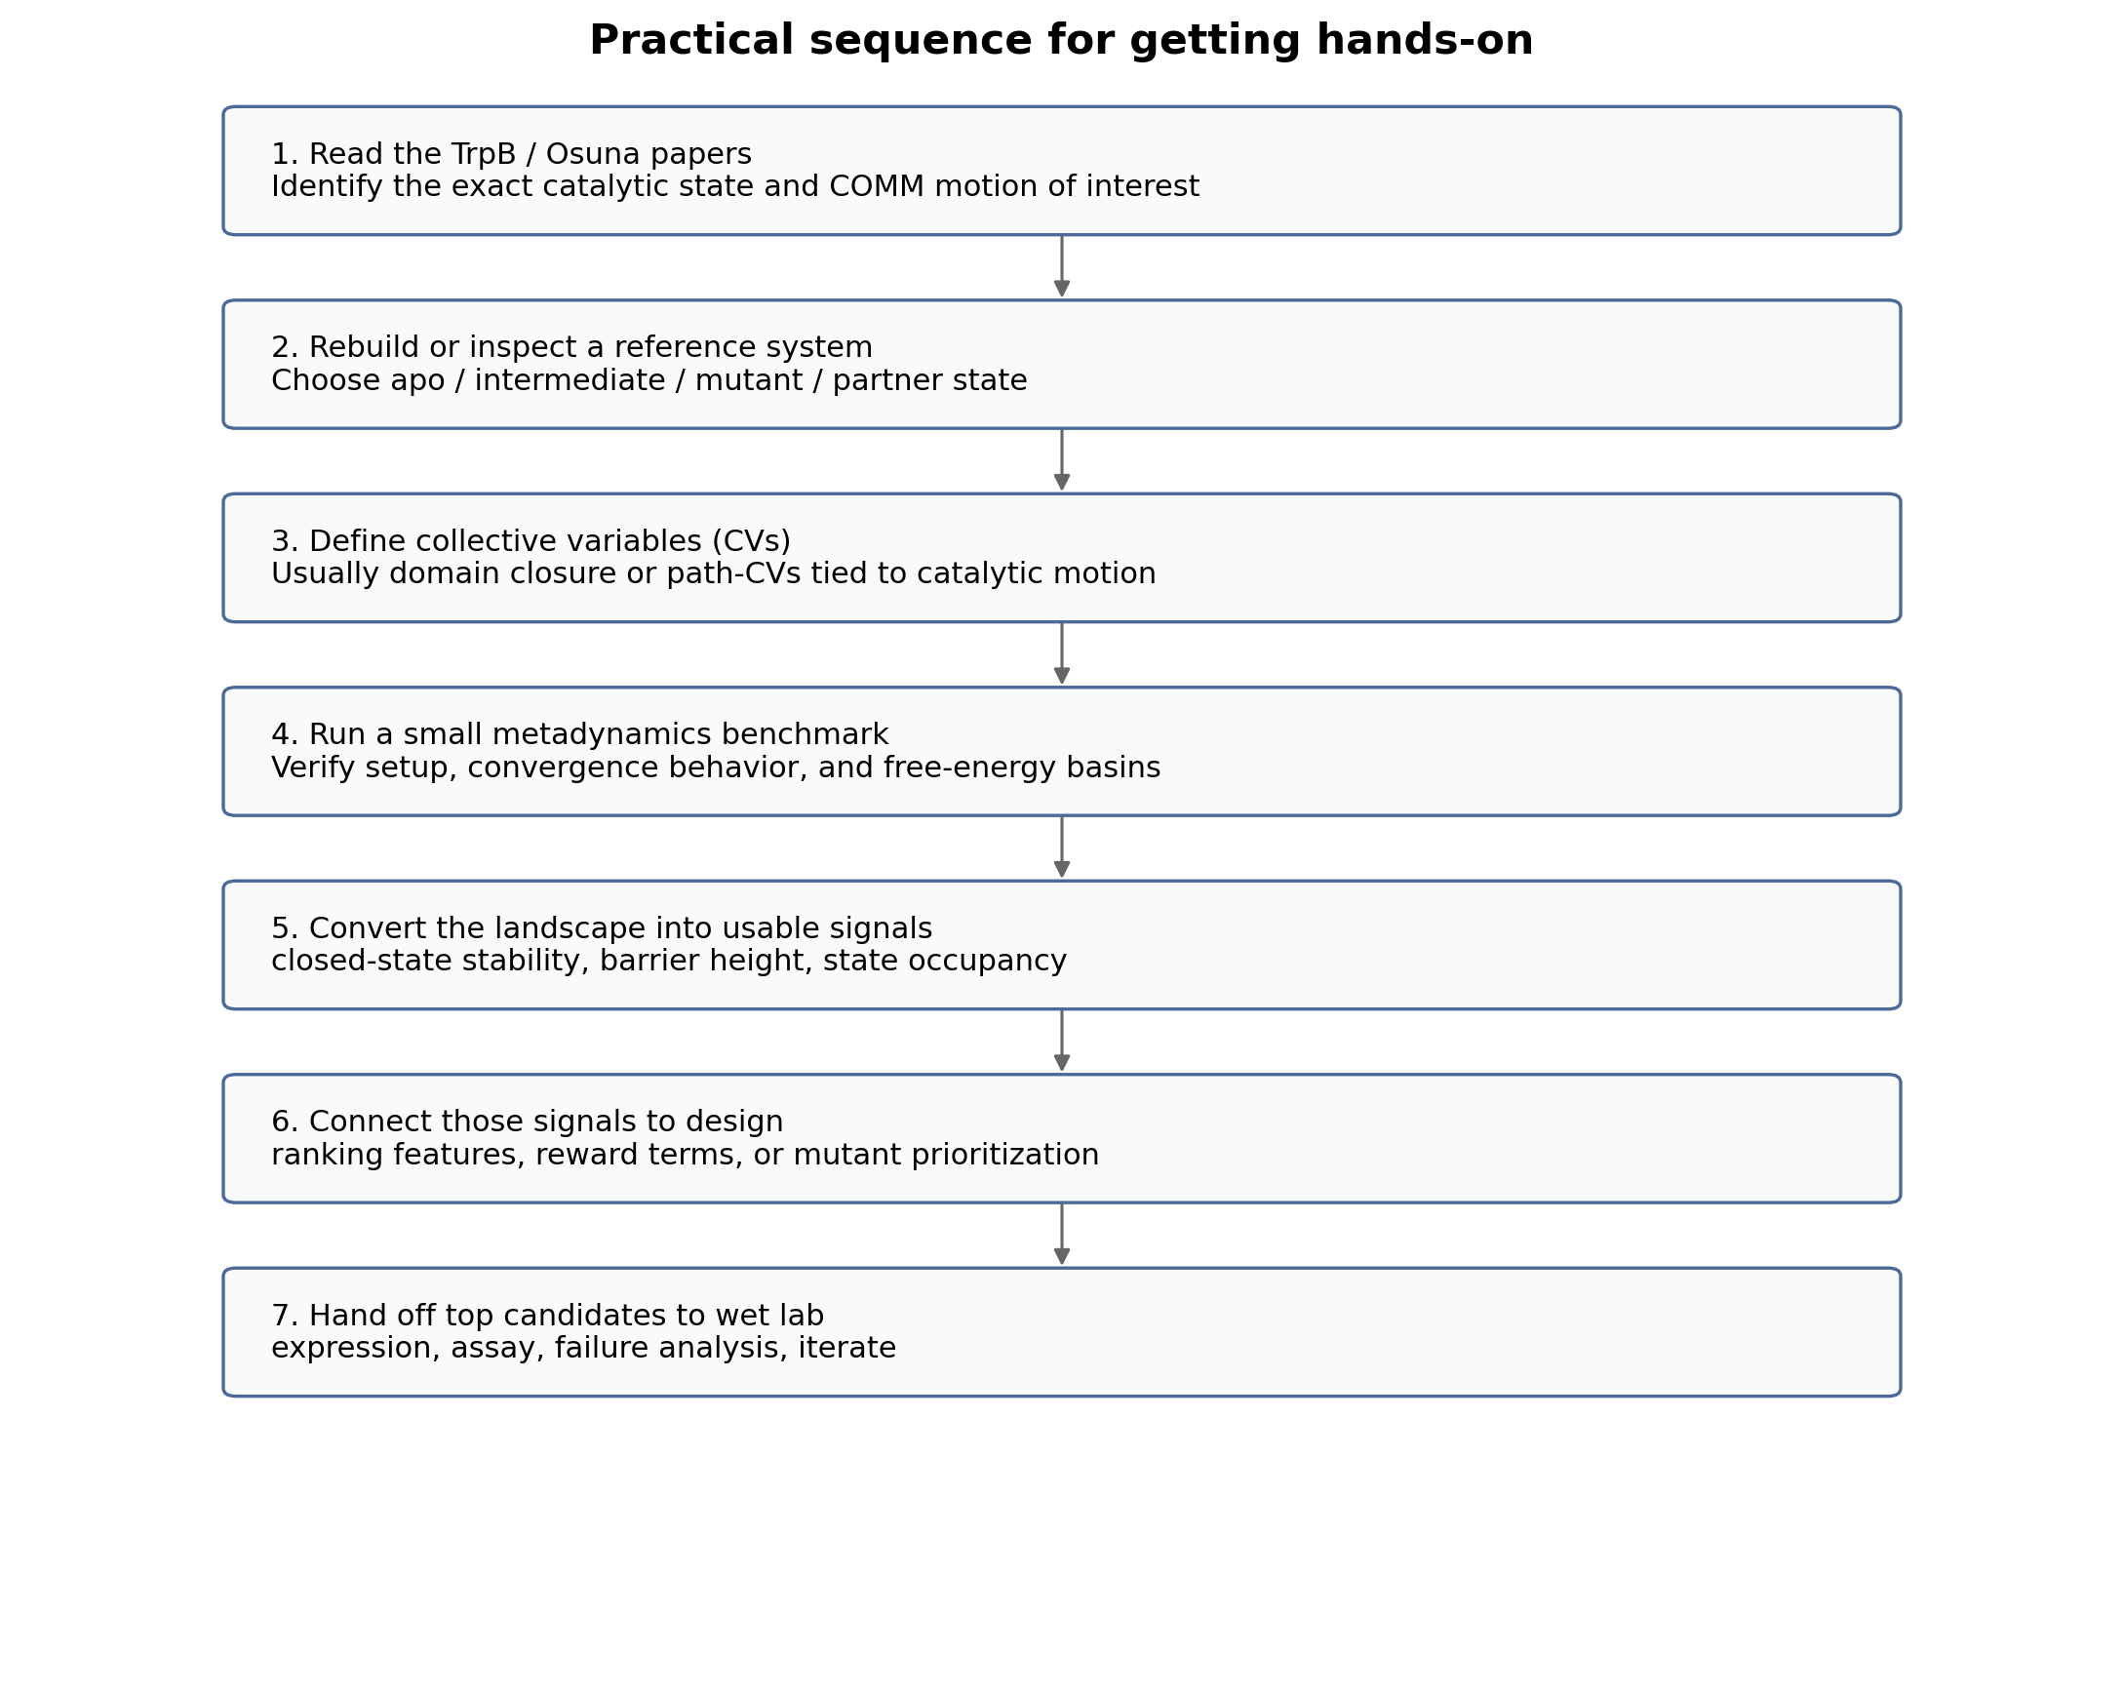
Figure 2. Derived stepwise roadmap for onboarding. This is an explanatory schematic synthesized from the literature and your project context.

Stage A. Literature reconstruction
Read TrpB mechanism, conformational-state papers, and the Osuna papers in chronological order. The goal is to understand what the relevant states are, which motion matters, and how those states were measured or estimated.

Stage B. Reference-system definition
Choose a concrete molecular system. That means specifying which TrpB variant, which catalytic intermediate or binding state, whether the partner subunit is present, and which structure or model is the starting point.

Stage C. CV design
Define the collective variables. This is one of the hardest and most important steps. In TrpB, a good CV should distinguish open, partially closed, and closed behavior in a mechanistically meaningful way.

Stage D. Metadynamics setup
Prepare the topology, restraints if any, MD engine, biasing plugin, deposition schedule, hill height/width, bias factor, number of walkers, and convergence checks. The first successful outcome is not a paper-ready result but a controlled pilot run.

Stage E. Landscape interpretation
Extract free-energy basins, state occupancies, representative structures, and transition barriers. Ask which state looks catalytically productive and whether the model reproduces known literature behavior.

Stage F. Translation into design metrics
Convert the FEL into quantities that a design workflow can consume. Examples: closed-state stabilization score, barrier-to-productive-state score, occupancy of a pre-reactive geometry, or a binary flag for productive closure.

Stage G. Cheaper screening layer
Use tAF2, short MD, or other lower-cost methods to prescreen larger design sets. Reserve full metadynamics for a smaller number of high-value candidates.

Stage H. Wet-lab interface
Hand top candidates to the experimental team for expression, purification, and activity or selectivity assays. Compare experimental outcomes with the simulation-derived metrics and refine the workflow.

9. What your final deliverable is supposed to be
At the beginning, your deliverable is understanding and reproducibility: a clean summary of the literature, a defensible statement of what motion matters in TrpB, and a working metadynamics pilot setup that you can explain line by line.
After that, your deliverable becomes a method bridge. You should aim to produce one or more of the following: (i) a reproducible reference pipeline for a TrpB system, (ii) a set of interpretable landscape-derived metrics, (iii) a cheap-to-expensive screening strategy that reserves metadynamics for top candidates, and (iv) a short memo explaining how those metrics can plug into generation, ranking, or wet-lab triage.
The strongest version of your contribution is therefore not “I ran metadynamics.” It is “I built a physics-informed layer that helps the lab decide which generated candidates are worth testing and why.”

10. What you should do first if you want to get hands-on fast
• Read the 2019 JACS paper first for the biological question and the ensemble logic.
• Read the 2022 Protein Science paper second for the reduced-cost tAF2 idea and its relation to conformational heterogeneity.
• Read the 2024 Faraday Discussions paper third for the integrated tAF2-MD-SPM workflow and its comparison to metadynamics-derived conclusions.
• Write one page in your own words answering four questions: what system, what motion, what CV, what design-useful output.
• Build a reference note that maps every abbreviation you encounter: TrpS, TrpB, COMM, FEL, CV, WTMetaD, SPM, tAF2.
• Only after the above, start rebuilding an actual metadynamics setup.

11. Annotated paper set
[1] Maria-Solano MA, Iglesias-Fernandez J, Osuna S. Deciphering the Allosterically Driven Conformational Ensemble in Tryptophan Synthase Evolution. J Am Chem Soc. 2019;141(33):13049-13056. DOI: 10.1021/jacs.9b03646. Read this first. It establishes the ensemble view of TrpB and why restoring open / partially closed / closed balance matters for stand-alone activity.
[2] Casadevall G, Duran C, Estevez-Gay M, Osuna S. Estimating conformational heterogeneity of tryptophan synthase with a template-based AlphaFold2 approach. Protein Sci. 2022;31(10):e4426. DOI: 10.1002/pro.4426. Read this second. It introduces tAF2 as a cheaper way to estimate the effect of mutation on the conformational landscape.
[3] Duran C, Casadevall G, Osuna S. Harnessing conformational dynamics in enzyme catalysis to achieve nature-like catalytic efficiencies: the shortest path map tool for computational enzyme redesign. Faraday Discuss. 2024;252:306-322. DOI: 10.1039/D3FD00156C. Read this third. It shows how SPM and tAF2-MD are used together, and how those faster methods compare against metadynamics-based conclusions.
[4] Laio A, Parrinello M. Escaping free-energy minima. Proc Natl Acad Sci USA. 2002;99(20):12562-12566. DOI: 10.1073/pnas.202427399. Classical conceptual paper for the method.
[5] Barducci A, Bussi G, Parrinello M. Well-tempered metadynamics: a smoothly converging and tunable free-energy method. Phys Rev Lett. 2008;100:020603. DOI: 10.1103/PhysRevLett.100.020603. The standard reference for the better-behaved version of metadynamics.
[6] Watson JL, Juergens D, Bennett NR, et al. De novo design of protein structure and function with RFdiffusion. Nature. 2023;620:1089-1100. DOI: 10.1038/s41586-023-06415-8. Useful for understanding the generative-design side of the pipeline.
[7] Buller AR, Brinkmann-Chen S, Romney DK, et al. Directed evolution of the tryptophan synthase beta-subunit for stand-alone function recapitulates allosteric activation. Proc Natl Acad Sci USA. 2015;112(47):14599-14604. DOI: 10.1073/pnas.1516401112. Important experimental background for stand-alone TrpB and allosteric rescue.

12. References
[1] Maria-Solano MA, Iglesias-Fernandez J, Osuna S. Deciphering the Allosterically Driven Conformational Ensemble in Tryptophan Synthase Evolution. J Am Chem Soc. 2019;141(33):13049-13056. DOI: 10.1021/jacs.9b03646.
[2] Casadevall G, Duran C, Estevez-Gay M, Osuna S. Estimating conformational heterogeneity of tryptophan synthase with a template-based AlphaFold2 approach. Protein Sci. 2022;31(10):e4426. DOI: 10.1002/pro.4426.
[3] Duran C, Casadevall G, Osuna S. Harnessing conformational dynamics in enzyme catalysis to achieve nature-like catalytic efficiencies: the shortest path map tool for computational enzyme redesign. Faraday Discuss. 2024;252:306-322. DOI: 10.1039/D3FD00156C.
[4] Laio A, Parrinello M. Escaping free-energy minima. Proc Natl Acad Sci USA. 2002;99(20):12562-12566. DOI: 10.1073/pnas.202427399.
[5] Barducci A, Bussi G, Parrinello M. Well-tempered metadynamics: a smoothly converging and tunable free-energy method. Phys Rev Lett. 2008;100:020603. DOI: 10.1103/PhysRevLett.100.020603.
[6] Watson JL, Juergens D, Bennett NR, et al. De novo design of protein structure and function with RFdiffusion. Nature. 2023;620:1089-1100. DOI: 10.1038/s41586-023-06415-8.
[7] Buller AR, Brinkmann-Chen S, Romney DK, et al. Directed evolution of the tryptophan synthase beta-subunit for stand-alone function recapitulates allosteric activation. Proc Natl Acad Sci USA. 2015;112(47):14599-14604. DOI: 10.1073/pnas.1516401112.

