Field | Value
To | Prof. Anima Anandkumar and Anima Lab members
From | Zhenpeng Liu (UNC Chapel Hill)
Date | 2026-03-28
Week | #2: Simulation environment setup and MetaDynamics toolchain validation

Project Context
I am replicating a MetaDynamics-based conformational analysis of TrpB enzymes, following the protocol published by the Osuna group (JACS 2019). TrpB is an enzyme that synthesizes tryptophan. Its catalytic activity depends on whether a structural region called the COMM domain (a ~88-residue "lid" that opens and closes) can reach the correct closed conformation. The Osuna group showed that MetaDynamics (an enhanced sampling method that accelerates rare conformational transitions) can predict TrpB activity by mapping the free energy landscape of this open-to-closed transition.
My goal is to first validate this method on known systems, then apply it to screen AI-generated enzyme variants from the Anima Lab GenSLM pipeline. This week I focused on setting up the simulation environment on UNC Longleaf HPC and running a validation test to confirm the software toolchain works.

Pipeline Overview
Phase 1: Replicate Osuna JACS 2019 results
[1] Environment setup (AMBER, GROMACS, PLUMED) DONE (this week)
[2] Toolchain validation (alanine dipeptide toy test) DONE (this week)
[3] PLP cofactor parameterization NEXT
[4] O-to-C reference path generation (15 frames)
[5] PfTrpS system preparation
[6] 500 ns conventional MD
[7] Well-tempered MetaDynamics (10 walkers)
[8] Compare FES with published Figure 2a
Phase 2: Apply to GenSLM-designed enzymes (after Phase 1 benchmark passes)
Phase 3: Build reward function for generative design loop

Summary
This week I moved from paper reading into hands-on setup. I installed three simulation packages on UNC Longleaf: AMBER 24p3 (for conventional molecular dynamics), GROMACS 2026.0 (the dynamics engine used in the original paper), and PLUMED 2.9 (the MetaDynamics plugin). I then ran an alanine dipeptide MetaDynamics test to validate the toolchain. The test produced a free energy surface (FES: a map showing which conformations are energetically preferred) with physically reasonable energy basins. The main unresolved item is PLP cofactor parameterization: the original paper's Supporting Information does not include the actual force field files, so I will need to regenerate them using antechamber (a tool for deriving force field parameters from quantum chemistry calculations) and Gaussian (quantum chemistry software).

Section 1: Work Done
# | Task | Category | Context | Status
1 | Read WIREs 2020 (Osuna review) | Paper | DOI: 10.1002/wcms.1500 | Done
2 | Read Protein Science 2025 (standalone TrpB) | Paper | DOI: 10.1002/pro.70103 | Done
3 | Install PLUMED 2.9 on Longleaf | Setup | conda-forge, trpb-md env | Done
4 | Install GROMACS 2026.0 with PLUMED patch | Setup | conda-forge | Done
5 | Verify AMBER 24p3 (GPU) | Setup | module load amber/24p3 | Done
6 | Extract MetaDynamics params from SI (Supporting Information) | Analysis | JACS 2019 SI PDF | Done
7 | Download PDB structures | Setup | 1WDW, 3CEP, 4HPX, 5IXJ | Done
8 | Alanine dipeptide WT-MetaD test | Simulation | 6.1 ns, 6088 hills | Done
9 | Generate and analyze FES | Analysis | plumed sum_hills | Done
10 | Verify Gaussian16 / ORCA availability | Setup | For PLP RESP charges | Done
11 | Fact-check project documentation | Analysis | 7 errors corrected | Done

Section 2: What I Learned

A natural standalone TrpB provides a conformational benchmark
To understand what a "naturally evolved" solution to the standalone TrpB problem looks like, I read Kinateder et al. (Protein Science 2025). They found a TrpB from Pelodictyon luteolum (plTrpB) that works without its usual partner protein TrpA. Its catalytic rate is 0.35 s^-1 on its own, compared to 0.009 s^-1 for a variant where six key residues are replaced (Table 1 in the paper).
The COMM domain open-to-closed energy barrier in plTrpB is about 5 to 6 kcal/mol. For comparison, the engineered variant PfTrpB-0B2 has a barrier of only ~2 kcal/mol (Maria-Solano et al., JACS 2019, Figure 3). This gives me a quantitative scale: if GenSLM-230 truly outperforms 0B2, I should see its barrier fall below 2 kcal/mol in my MetaDynamics simulations.

Validating the GROMACS + PLUMED2 toolchain on alanine dipeptide
Before running the actual TrpB simulations, I needed to confirm that GROMACS (the molecular dynamics engine) and PLUMED (a plugin that adds MetaDynamics capabilities) work together correctly on Longleaf. I ran a well-tempered MetaDynamics simulation (a variant where the bias gradually decreases for better convergence) on alanine dipeptide, a standard test system.
The simulation deposited 6,088 Gaussian hills over 6.1 ns at 300 K. The hill height decayed from ~0.6 kJ/mol at the start to 0.19 kJ/mol at the end, confirming that the well-tempered scheme works. The resulting FES (Figure 1) shows the expected energy basins on the Ramachandran map (a plot of backbone dihedral angles phi and psi). The right-handed alpha-helix basin sits at phi = -53, psi = -32 degrees (6.1 kJ/mol above the global minimum). The positive-phi region is more populated than at 300 K. This is a standard result for alanine dipeptide at 300 K.

What the original paper provides and what it does not
I extracted all MetaDynamics parameters from the JACS 2019 Supporting Information. The key ones are listed in the Parameters section below. One critical gap: the SI states that PLP cofactor charges were computed using GAFF (a general-purpose small-molecule force field) with RESP charges (electrostatic charges fit to quantum calculations at the HF/6-31G(d) level), but the actual parameter files are not included. I confirmed that Gaussian 16c02 is available on Longleaf, so I can regenerate these parameters from scratch next week.

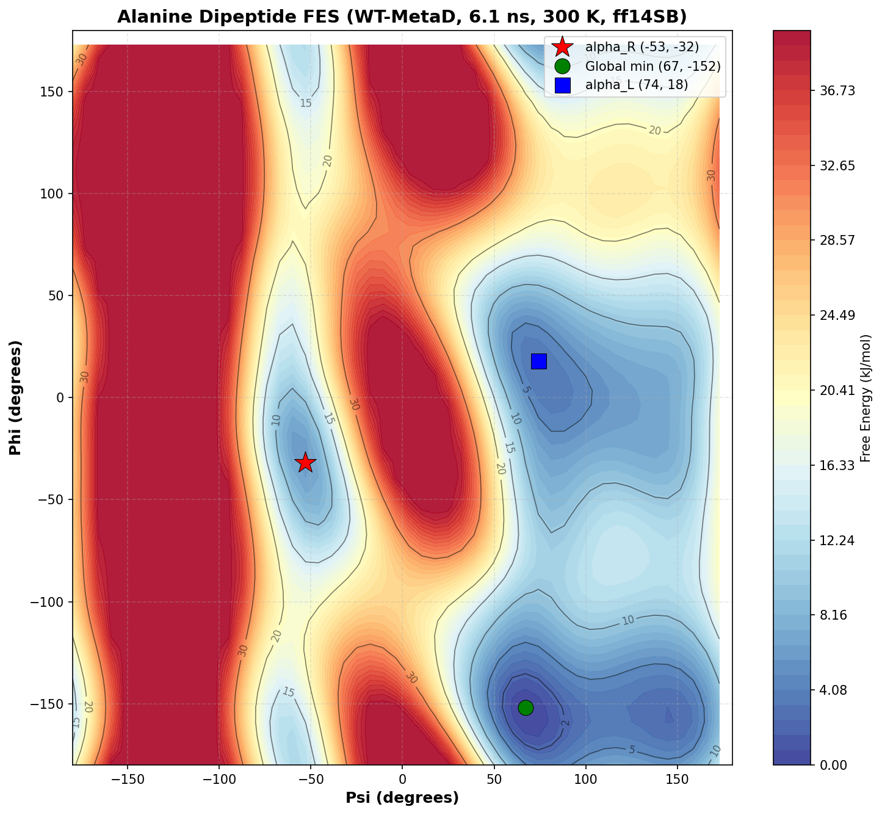
Figure 1. Free energy surface of alanine dipeptide from well-tempered MetaDynamics (6.1 ns, 300 K, ff14SB, GROMACS 2026.0 + PLUMED 2.9). Energy capped at 40 kJ/mol for visualization. Stars/circles mark key energy basins.

Section 3: Problems Encountered and How I Solved Them

Force field atom name mismatch in PDB input
What happened: the GROMACS topology builder (pdb2gmx) rejected the alanine dipeptide PDB with the error "Atom N in residue ACE not found in rtp entry."
Root cause: the ACE capping group in the AMBER ff14SB force field only contains CH3, C, and O atoms. The initial PDB file incorrectly included an N atom.
How I fixed it: I rewrote the PDB with the correct atom set, matching the aminoacids.rtp definitions in the force field directory.
Lesson: PDB atom names must be verified against the force field definition files before running any topology builder. A quick pdb2gmx dry run catches these errors early.

PLUMED atom indices shifted after topology generation
What happened: the PLUMED input file defined phi/psi torsion angles using atom indices from the original PDB. The simulation ran without errors, but the collective variable (CV: a reduced coordinate describing the molecular conformation) values were wrong.
Root cause: pdb2gmx reorders atoms when adding hydrogens and renaming residues. The correct indices (5, 7, 9, 15 for phi; 7, 9, 15, 17 for psi) had to be read from the output .gro file, not the input PDB.
Lesson: PLUMED atom indices must always come from the post-topology .gro file. I will build this check into all future PLUMED input generation scripts.

Slurm thread settings conflicting with GROMACS
What happened: the first two Slurm job submissions failed within seconds. GROMACS reported a fatal error about inconsistent OpenMP thread counts.
Root cause: Longleaf sets OMP_NUM_THREADS=1 by default. The GROMACS command used -ntomp 4. The mismatch caused an immediate crash.
How I fixed it: I added "export OMP_NUM_THREADS=4" to the Slurm script, placed after environment activation and before the GROMACS command. The third submission ran successfully for the full walltime.
Lesson: all Slurm submission scripts must explicitly set OMP_NUM_THREADS to match the requested thread count. This is now in my script template.

Section 4: Open Questions
1. PLP parameter files: the JACS 2019 SI does not provide the actual mol2/frcmod files for the PLP cofactor. I plan to regenerate them with antechamber + Gaussian16. If this proves difficult, should I contact the Osuna lab directly?
2. D-Trp facial selectivity: I have no literature precedent for defining a collective variable that captures the indole attack direction on aminoacrylate. This blocks the D-Trp screening direction. Is there someone in the lab who has worked on stereoselectivity-related collective variables?
3. GenSLM-230 and NdTrpB structures: I need the sequences and/or homology models to begin Phase 2 comparisons. Are these available, or should I build models myself?

Section 5: Key Simulation Parameters (from JACS 2019 SI)
All parameters below were extracted from the Supporting Information of Maria-Solano et al., JACS 2019 (DOI: 10.1021/jacs.9b03646). I verified each value against the SI PDF on 2026-03-28.
Parameter | Value | Source
Force field | AMBER ff14SB (protein-specific parameter set) | SI Methods
Water model | TIP3P | SI Methods
Box type / buffer | Cubic, 10 A buffer | SI Methods
Temperature | 350 K | SI Methods (P. furiosus thermophile)
Conventional MD length | 500 ns (NVT production) | SI Methods
Conventional MD engine | AMBER16 (original); AMBER 24p3 (replication) | SI Methods / our setup
MetaDynamics engine | GROMACS 5.1.2 + PLUMED 2 (original); GROMACS 2026.0 + PLUMED 2.9 (replication) | SI Methods / our setup
MetaDynamics scheme | Well-tempered | SI Methods
Gaussian height | 0.15 kcal/mol (0.628 kJ/mol) | SI Methods
Gaussian width | Adaptive (local FES properties) | SI Methods
Deposition pace | Every 2 ps (1000 steps at 2 fs timestep) | SI Methods
Bias factor (controls how fast bias decays) | 10 | SI Methods
Number of walkers | 10 | SI Table S2
Time per walker | 50 to 100 ns | SI Table S2
Path CV atoms (CV = collective variable) | C-alpha of residues 97-184 + 282-305 | SI Methods
Path CV frames | 15 (linear interpolation from open to closed PDB) | SI Methods
Electrostatics | PME (Particle Mesh Ewald), 8 A cutoff | SI Methods
Bond constraints | SHAKE (constrains bonds to H); SETTLE (constrains water geometry) | SI Methods
PLP parameterization | GAFF + RESP at HF/6-31G(d) via antechamber | SI Methods

Section 6: Next Week Plan

Papers to read
1. Maria-Solano et al., JACS 2019: full close read with annotation. I need to understand Figure 2 (FEL comparison across three TrpB systems) and the productive vs. unproductive closure distinction before evaluating my own results.
2. Lambert et al., Nature Communications 2026: full read. Focus on how GenSLM-230 was selected and what experimental assays were used to validate it.

Tasks
1. PLP cofactor parameterization for the Ain intermediate (the internal aldimine form of the PLP-enzyme complex). Extract PLP coordinates from PDB 1WDW and compute RESP charges using Gaussian16. Then generate force field parameter files via antechamber.
2. Generate 15-frame open-to-closed reference path: linear interpolation of C-alpha atoms (residues 97-184 + 282-305) between PDB 1WDW (open) and PDB 3CEP (closed).
3. Test GROMACS GPU acceleration: verify that the conda-forge build supports GPU offloading (important for the 10-walker production runs).
4. Begin PfTrpS(Ain) system preparation if PLP parameters are ready: solvation, energy minimization, 7-step heating to 350 K, and NPT equilibration (constant pressure and temperature).

Section 7: References
1. Maria-Solano, M. A.; Iglesias-Fernandez, J.; Osuna, S. "Deciphering the Allosterically Driven Conformational Ensemble in Tryptophan Synthase Evolution." J. Am. Chem. Soc. 2019, 141, 13049-13056. DOI: 10.1021/jacs.9b03646.
Role in this project: Primary source for MetaDynamics protocol, path CV design, and all simulation parameters. Benchmark target for Phase 1 replication.
2. Maria-Solano, M. A.; Kinateder, T.; Iglesias-Fernandez, J.; Sterner, R.; Osuna, S. "In Silico Identification and Experimental Validation of Distal Activity-Enhancing Mutations in TrpB." ACS Catal. 2021, 11, 13733-13743. DOI: 10.1021/acscatal.1c03950.
Role in this project: Extended the JACS 2019 method with experimental validation of SPM-predicted mutations. Confirms that the MetaDynamics + SPM pipeline has predictive power.
3. Lambert, T.; Tavakoli, A.; Dharuman, G. et al. "Sequence-based generative AI design of versatile tryptophan synthases." Nat. Commun. 2026, 17, 1680. DOI: 10.1038/s41467-026-68384-6.
Role in this project: Source of GenSLM-designed TrpB variants. GenSLM-230 is the primary target for Phase 2 comparison.
4. Kinateder, T.; Sterner, R.; Osuna, S. et al. "Identification and Characterization of a Naturally Occurring Standalone Beta Subunit of Tryptophan Synthase." Protein Sci. 2025, 34(4), e70103. DOI: 10.1002/pro.70103.
Role in this project: Provides a natural standalone TrpB benchmark (plTrpB). COMM domain barrier of 5-6 kcal/mol sets a comparative scale for my results.

