Field | Value
To | Prof. Anima Anandkumar (aNima Lab, Caltech)
From | Zhenpeng Liu
Date | 2026-03-28
Week | #3: HPC environment setup and MetaDynamics toolchain validation

Summary
This week I shifted from paper reading to hands-on work. I set up the full simulation stack on UNC Longleaf (AMBER 24p3, GROMACS 2026.0, PLUMED 2.9) and ran an alanine dipeptide well-tempered MetaDynamics test to validate the toolchain. The test produced a physically reasonable free energy surface with expected Ramachandran basins. The main unresolved item is PLP cofactor parameterization: the JACS 2019 SI does not include the actual force field files, so I will need to generate them from scratch using antechamber and Gaussian.

Section 1: Work Done
# | Task | Category | Context | Status
1 | Read WIREs 2020 (Osuna review) | Paper | DOI: 10.1002/wcms.1500 | Done
2 | Read Protein Science 2025 (standalone TrpB) | Paper | DOI: 10.1002/pro.70103 | Done
3 | Install PLUMED 2.9 on Longleaf | Setup | conda-forge, trpb-md env | Done
4 | Install GROMACS 2026.0 with PLUMED patch | Setup | conda-forge, PLUMED support confirmed | Done
5 | Verify AMBER 24p3 (pmemd.cuda) | Setup | module load amber/24p3 | Done
6 | Extract MetaDynamics params from JACS 2019 SI | Analysis | ja9b03646_si_001.pdf | Done
7 | Fact-check all project documentation | Analysis | 5 parallel checks, 7 errors corrected | Done
8 | Download PDB structures (1WDW, 3CEP, 4HPX, 5IXJ) | Setup | Path CV endpoints + references | Done
9 | Run alanine dipeptide WT-MetaD toy test | Simulation | 6.1 ns, 6088 hills, Job 39960327 | Done
10 | Generate and analyze FES from toy test | Analysis | plumed sum_hills, matplotlib | Done
11 | Verify Gaussian16/ORCA availability | Setup | PLP RESP parameterization feasible | Done
12 | Set up 6-stage replication pipeline | Documentation | Profiler to Journalist | Done

Section 2: What I Learned

Protein Science 2025: a natural standalone TrpB exists
Kinateder et al. found a naturally occurring standalone TrpB from Pelodictyon luteolum (plTrpB) that contains the same six key residues (LBCA-Res6) identified through ancestral sequence reconstruction. Its kcat is 0.35 s^-1 without TrpA, compared to 0.009 s^-1 for a variant where those six residues are replaced by consensus residues (Kinateder et al., Protein Science 2025, Table 1).
The COMM domain O-to-C barrier in plTrpB is 5 to 6 kcal/mol. This is higher than the 2 kcal/mol barrier in PfTrpB-0B2 (Maria-Solano et al., JACS 2019, Figure 3) but still low enough for standalone activity. This gives me a natural benchmark: if GenSLM-230 truly has higher activity than 0B2, its barrier should be below 2 kcal/mol.

GROMACS + PLUMED2 toolchain: validated on alanine dipeptide
I ran a well-tempered MetaDynamics simulation of alanine dipeptide at 350 K using GROMACS 2026.0 + PLUMED 2.9 on Longleaf. The simulation deposited 6088 Gaussian hills over 6.1 ns. The Gaussian height decayed from ~0.6 kJ/mol at the start to 0.19 kJ/mol at the end, confirming that the well-tempered scheme is working correctly.
The resulting FES (Figure 1) shows the expected Ramachandran basins. The alpha_R basin appears at phi = -53, psi = -32 with a free energy of 6.1 kJ/mol. The alpha_L basin is at phi = 74, psi = 18 at 3.3 kJ/mol. The global minimum is in the positive-phi region (phi = 67, psi = -152), which is expected at 350 K because thermal fluctuations populate higher-energy basins more than they would at 300 K.

Parameter extraction from SI: what the paper gives and what it does not
I extracted all MetaDynamics parameters from the JACS 2019 Supporting Information: Gaussian height = 0.15 kcal/mol (SI Methods), deposition pace = 2 ps, bias factor = 10, adaptive Gaussian width, 10 walkers per system, 50 to 100 ns per walker (SI Table S2). The force field is ff14SB with TIP3P water and 8 A PME cutoff.
One critical gap: the SI does not include the actual PLP cofactor parameter files (mol2/frcmod). It only states that GAFF + RESP charges at HF/6-31G(d) were used via antechamber. I confirmed that Gaussian 16c02 and ORCA 6.0/6.1 are available on Longleaf, so I can regenerate these parameters from scratch.

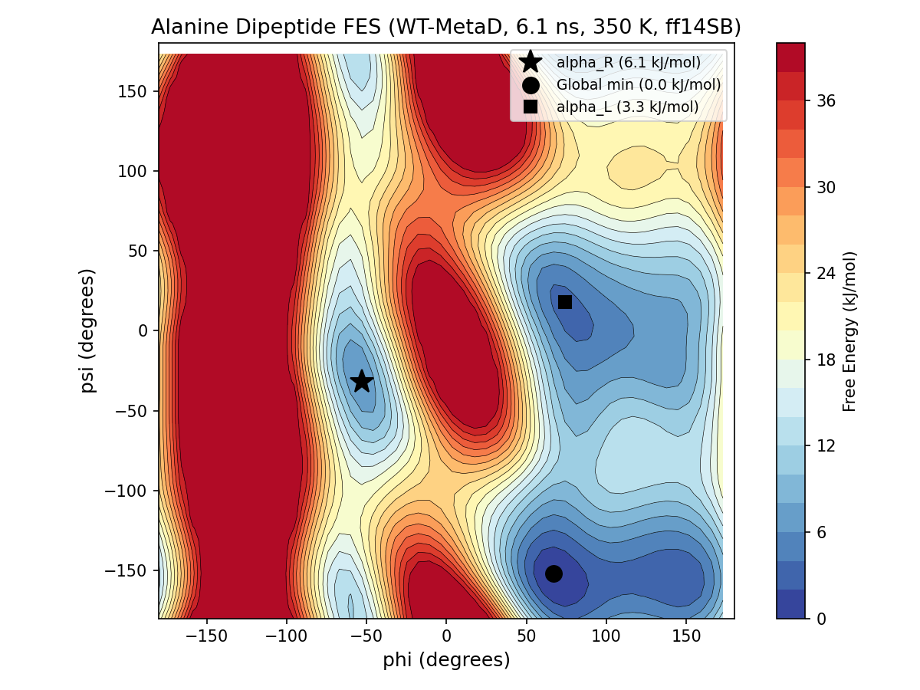
Figure 1. Free energy surface of alanine dipeptide from well-tempered MetaDynamics (6.1 ns, 350 K, ff14SB, GROMACS 2026.0 + PLUMED 2.9). Energy capped at 40 kJ/mol for visualization.

Section 3: Problems Encountered and How I Solved Them

PDB atom names not matching force field definitions
What happened: pdb2gmx rejected the alanine dipeptide PDB with "Atom N in residue ACE not found in rtp entry."
Root cause: the ACE capping group in AMBER ff14SB only contains CH3, C, and O atoms. The initial PDB incorrectly included an N atom in ACE.
How I fixed it: I rewrote the PDB with the correct atom set for ACE (CH3, C, O) and NME (N, H, CH3), matching the aminoacids.rtp definitions.
Lesson: never write PDB atom names from memory. Always check the force field rtp file or run a pdb2gmx dry run first.

PLUMED atom indices wrong after pdb2gmx reordering
What happened: the PLUMED input file defined phi/psi torsions using atom indices 4, 5, 6, 7. PLUMED ran without errors, but the CV values were nonsensical.
Root cause: pdb2gmx reorders atoms (adds hydrogens, renames). The correct indices for phi/psi after reordering were 5, 7, 9, 15 and 7, 9, 15, 17, confirmed by inspecting the .gro output file.
Lesson: PLUMED atom indices must always be determined from the post-pdb2gmx .gro file, never from the input PDB.

Slurm OMP_NUM_THREADS conflict
What happened: the first two Slurm submissions (Jobs 39960167, 39960248) failed within seconds. GROMACS reported a fatal error about inconsistent thread settings.
Root cause: Longleaf sets OMP_NUM_THREADS=1 by default, but the GROMACS command used -ntomp 4. The mismatch caused an immediate crash.
How I fixed it: I added 'export OMP_NUM_THREADS=4' to the Slurm script, placed after conda activation and before gmx mdrun. Job 39960327 ran successfully.
Lesson: all future Slurm scripts must explicitly set OMP_NUM_THREADS to match the -ntomp flag.

Section 4: Open Questions
1. PLP parameter files: the JACS 2019 SI does not provide mol2/frcmod files for the PLP cofactor intermediates. I plan to regenerate them using antechamber + Gaussian16. If this proves difficult, should I contact the Osuna lab to request their files?
2. D-Trp facial selectivity CV: I still have no literature precedent for defining a collective variable that captures the indole attack direction on aminoacrylate. This blocks Direction B (D-Trp screening). Is there someone in the lab who has worked on stereoselectivity CVs?
3. GenSLM-230 and NdTrpB structures: I need the actual sequences and/or homology models to begin Phase 2. Are these available in the lab, or should I build homology models myself?
4. GROMACS GPU support in conda: the conda-forge GROMACS build supports PLUMED, but I have not verified GPU acceleration ('gmx mdrun -nb gpu'). For the 10-walker MetaD runs this will matter.

Section 5: Next Week Plan

Papers to read
JACS 2019 (Maria-Solano et al.): full read with annotation. I need to understand Figure 2 (FEL comparison) and Figure 3 (productive vs unproductive closure) in detail before I can evaluate my own FES results.
Nature Communications 2026 (Lambert et al.): full read. Focus on how GenSLM-230 was selected and what experimental assays were used.

Tasks
1. PLP parameterization (Ain intermediate): extract PLP coordinates from 1WDW, run antechamber with GAFF + RESP at HF/6-31G(d) using Gaussian16. Depends on: Gaussian availability (confirmed).
2. Generate 15-frame O-to-C reference path: linear interpolation of C-alpha atoms (residues 97-184 + 282-305) between 1WDW (open) and 3CEP (closed). Depends on: PDB files (downloaded).
3. Test GROMACS GPU acceleration: run 'gmx mdrun -nb gpu' with a small system to confirm the conda build supports GPU offloading.
4. Begin PfTrpS(Ain) system preparation: solvation, minimization, and heating protocol. Depends on: PLP parameters (task 1).

