# Exercise 1

Everytime the function run calls the function table_driven_agent it will append the parameter value percept to the list percepts. This is so it keeps a history of if it’s clean or dirty where it is. Then it checks the dictionary with the history where the last scan/information decides what to do next. The picture below shows that. If A and clean then right, if dirty then suck and lastly if B and clean then left.

## 1.3

You could take it down to 4:  
(‘A’, ‘Dirty’), (‘B’, ‘Dirty’), (‘A’, ‘Clean’), (‘B’, ‘Clean’).

## 1.4

I think you will need TT+1.

# Exercise 2

## 2.3

It does not allow it in a way where it functions probably since it will always stay on the same tile.

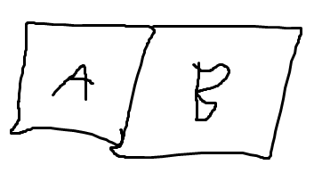

It stands on A and wants to go to B, so it must go right. But everytime it tries to go to B it will go left instead and still be on A.

# Exercise 3

## 3.3

See the same explanation from exercise 2.3