# Task 5/ Website testing and validation

CSS validation :

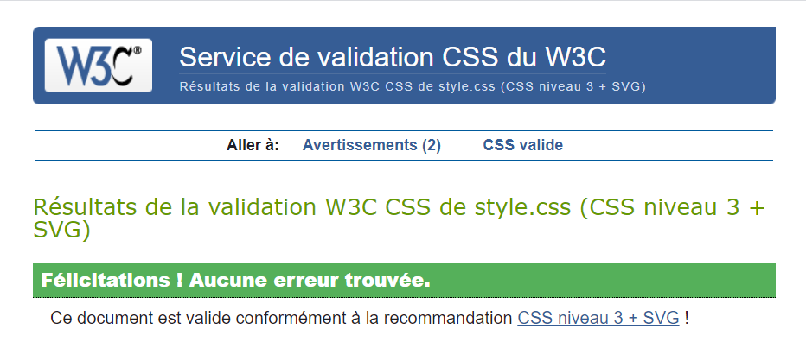

It seems like everything is clear!

HTML validation :

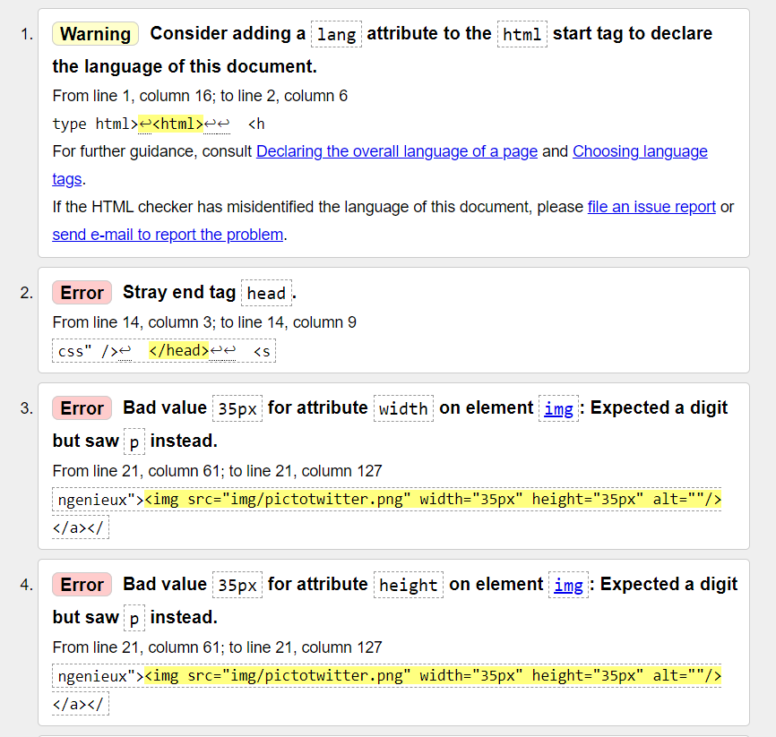

Her ewe can see a lot of “Error”, but all the errors I think I could have solved have been solved.

Most of these errors come from the “bad value …”. It is like that that on all my 4 HTML pages.