**I. Practical utility**

**I.1 What makes the Automatic Irrigation System essential?**

Visiting the local botanical garden, we observed an acute water resource management issue: over-watering, under-watering and resource waste. The manual watering of plants, dependent on human staff, was most of the times inefficient, not only because of the hundreds of liters wasted monthly during the process, but also because this method lacked a suitable control of the optimal humidity a plant species needs. Talking to garden experts, we learned that a plant needs, in general, three elements to grow properly: light, warmth and water - one of the most important resources of life.



**I.2 Research**

Throughout our research activity, we found out that 2022 was one of the driest recorded years, with corn yields down 40% and sunflower seed yields down 30%. From data submitted by the Ministry of Agriculture and Rural Development, we learned that 1.3 million hectares were affected by drought in 37 counties and Bucharest municipality.

Specifically, according to the National Meteorological Administration, 2022 was the third warmest year in the history of meteorological measurements in Romania, with an average annual temperature of 11.77°C and a temperature deviation of 1.55°C from the 1981-2010 average. The data were taken from 129 full-string meteorological stations from 1961 to 2022 (Fig. 1).

The 5 warmest years from 1900 to 2022 are 2019, 2020, 2022, 2015 and 2007, and 2012 to 2022 is the 11 consecutive years of the warmest period, which clearly confirms the trend of rising air temperatures in our country.

Positive deviations were recorded in nine out of the 12 months of the year, with the mean monthly temperature over the country being higher than the median of the standard reference range (1991 - 2020) with values ranging from 0.7 ºC (May) to 2.6 ºC (December). In the remaining months the deviation was negative and ranged from 0.1 ºC in September to 1.8 ºC in March (Fig. 2).

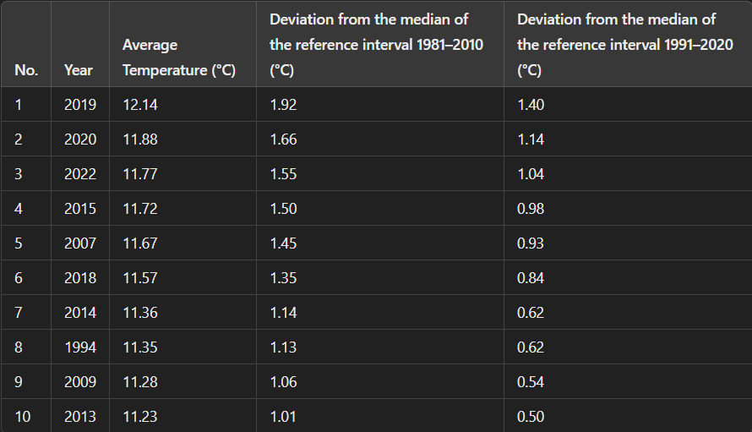

*Fig. 1.* *Top ten warmest years from 1900 to 2022*

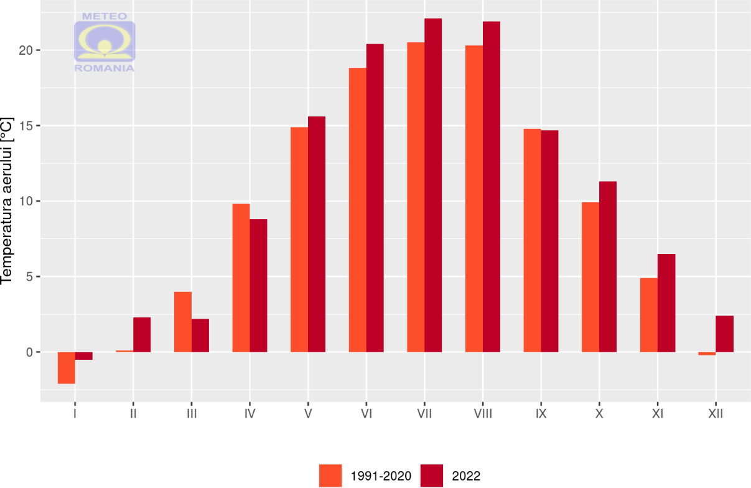

*Fig. 2. Evolution of the average monthly mean temperature, averaged over the country, in Romania, in 2022, compared to the median of the standard climatological interval (1991 - 2020)*

**I.3 Market analysis**

Analyzing the market place and existing offers, we came to the conclusion that ordering one of the existing systems that would fit the requirements imposed by the botanical garden’s experts, it would cost at least EUR 500, without being equipped with real-time sensors transmitting the necessary parameters for the growth of plants. Not satisfied with this solution, we decided to design our own.

Thus, The Automatic Irrigation System implemented into Smart Garden was created.

One important factor we considered when designing it was its sustainability, in the sense of conserving water resources. Another factor was the potential of this system to offer crucial data to garden experts, through its sensor-based automatic design, thus facilitating efficient plant growth analysis. By creating this system, we primarily wanted to eliminate the huge amount of wasted water caused by the inefficient method adopted by the Botanical Garden, while substantially reducing the human resource needed to water them by hand.

***The automatic irrigation system is completely autonomous, it does not require human intervention, and it transmits real-time parameters that influence plant growth.***

Following discussions with specialists from the Botanical Garden, the plants in the greenhouse have been divided into 3 zones: ZONE 1 - water-loving plants (high water quantity), ZONE 2 - common plants (medium water quantity), ZONE 3 - arid zone (low water quantity).

By deploying capacitive soil moisture sensors to transmit information from each watering zone to the intelligent system, plants receive the water they need to grow according to their characteristics, eliminating the risk of overwatering or delayed watering, which leads to their death.

We also implemented a nozzle system for spraying water that mimics rain.

**II. Mechanics behind the system**

**II.1 Complexity**

The prototype we created could be compared to a robot, as it is developed with an **Arduino UNO board** as its core. Beside the Arduino board, we added:

- **solenoid valves**, instead of motors, three for the watering zones and one for the spray nozzles. The solenoid valves are actuated by an intermediate relay plate, as the outputs from the UNO plate could not handle the power supply from the solenoid valve coils.

- **sensors** chosen taking into consideration the three main elements a plant needs :

1. humidity sensors

2. soil temperature and air humidity sensors

3. soil temperature sensors

**- LCD local display** on which there are shown:

- temperature and humidity of the greenhouse

- soil temperature

- humidity for each of the three zones

- system status

- **Wi-Fi ESP8266 board,** which sends data to the Blynk server

**II. 2 Building efficiency**

The system can be operated using a 230VAC/12VDC power supply or an Arduino solar tracking system charging a 9V battery.

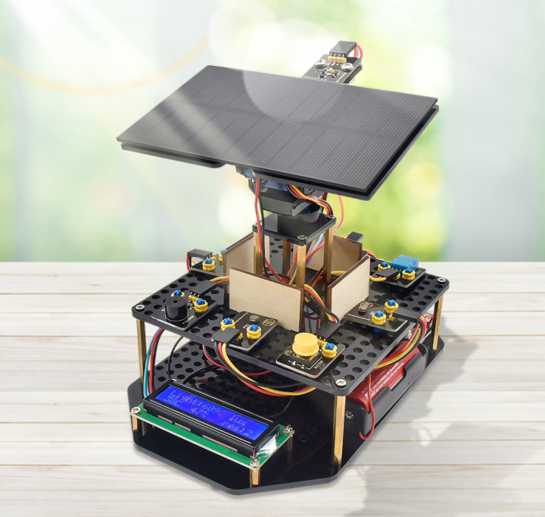

*Fig. 3 - Solar tracking system*

**II.3 Solar tracking system**

The solar tracking system is developed on an Arduino UNO board to which we connected:

* Two servos to orient the solar panel to get as much light as possible
* Solar-powered lithium power supply and USB cable
* Phone charging module
* Display LCD I2C
* Sensors:

- light intensity sensor

- photorezistors

- air temperature and humidity sensor

- buzzer

- button

**Capitolul III. Electronics**

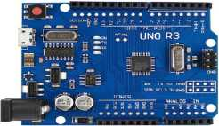**III.1 Smart Garden Components**

**Arduino UNO board**

The UNO R3 development board with ATmega328p microcontroller required to control the process.

**Technical specifications** Fig. 4 - Arduino UNO board

* Microcontroller: ATmega328p
* USB Chip: CH340G
* USB power supply voltage: 5V
* DC connector supply voltage: 8-12V
* Digital I/O pins: 14 (6 support PWM output)
* Analog pins: 6
* Maximum current per I/O pin: 40 mA
* Flash memory: 32 KB (ATmega328)
* SRAM: 2 KB (ATmega328)
* EEPROM: 1 KB (ATmega328)
* Frequency: 16 MHz

**Esp8266 Wi-Fi Board**

The ESP8266 module transmits data from the Arduino board to the Blynk server.

**Technical Specifications:**

* 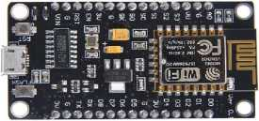Voltage: 3.3V.
* Wi-Fi Direct (P2P), soft-AP.
* Current consumption: 10uA ~ 170mA.
* Attachable flash memory: maximum 16MB (normal 512K).
* Integrated TCP/IP protocol.
* Processor: 32-bit Tensilica L106. Fig. 5 - Wi-Fi board Esp 8266
* Processor speed: 80 ~ 160MHz.
* RAM: 32K + 80K.
* GPIO: 17 (multiplexed with other functions).
* Analog to digital: 1 input with 1024 step resolution.
* Output power + 19.5 dBm in 802.11b mode
* 802.11 support: b/g/n.
* Maximum concurrent TCP connections: 5

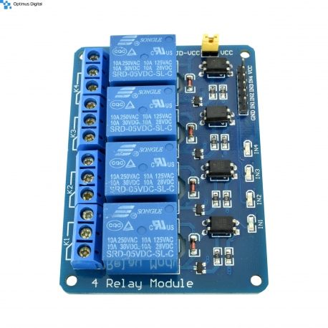**Intermediate relay board**

An intermediate relay board is used to control the valves.

**Technical Specifications:**

* Supply voltage: 24VDC
* Channels: 4
* Relay voltage: 24VDC
* Interface: Integrated USB
* Control IC: ATMega 8A
* Relay control IC: ULN2803
* USB Type: Type-B
* Relay Tip: Songle 24V
* Relay rating: 250V, 10A AC and 30V, 10A DC Fig. 6 - Relay board
* Control terminal connection mode: NC (Normally closed), COM (Common), NO (Normally open)
* LED indicators: Green for relay on, Red for relay off
* Compatibility: Supports Windows 7, XP, 32-bit and 64-bit without the need for additional drivers
* USB Type: HID (Human Interface Design)
* Dimensions mm: 72 x 66mm

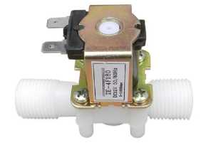

**Electromagnetic valves**

Solenoid valve that allows the circuit to open when an electric voltage is applied. The model is Normally Closed (opens when voltage is applied).

**Technical specifications:** Fig. 7 - Solenoid valve

* Supply voltage: 12 VDC
* Recommended current: 0.6-1.5A
* Connection size: 1/2"
* Material: Metal + plastic
* Pressure: 0.02- 0.8Mpa
* Maximum liquid temperature: 100°C
* Operating mode: Normally Closed
* Valve type: Diaphragm
* Usage: water and low viscosity liquids
* Dimensions mm: 78 x 60mm
* Inside diameter: 13.5mm
* 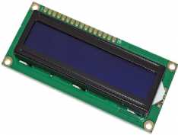Outside diameter: 20mm

**2x16 I2C LCD Display**

The 2004 LCD module displays sensor data and the status of each zone.

**Technical specifications:**

* Supply voltage: 5V; Fig. 8 - LCD display
* Current: 2 mA;
* Backlight supply voltage: 4.2V;
* Backlight current: 250mA (MAX).

**III.2 Types of sensors used**

The sensors were chosen according to the needs of the plants as follows:

**1. Sensors for soil moisture control**

Initially we used classical sensors, which we noticed that after a while of use, the corrosion phenomenon appears and they no longer transmit real data.

We replaced them with capacitive plastic sensors which have a long life and are no longer affected by corrosion, and the information transmitted is correct.

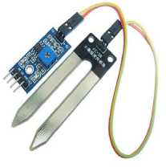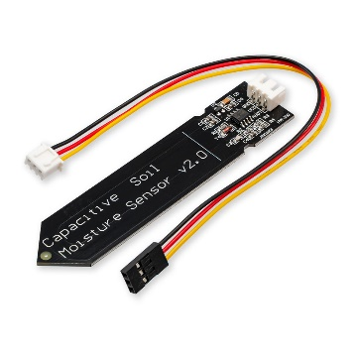

Fig. 9 - Capacitive sensor Fig.10 - Classic sensor

Soil moisture sensor calibration:

We took the values displayed by the sensors in an environment with 0% humidity and in an environment with 100% humidity represented by a glass of water.

After that, we overlaid the ranges determined by these values with the 0-100 range to display the humidity of each zone in percent.

**Zone 1** - high humidity zone

If the value drops below 70%, the solenoid valve is switched on and the system consisting of hoses and nozzles with water flow preset at 10l/hour becomes active and the water reaches the roots of the plants.

When the sensor value is above 70%, the solenoid valve is switched off.

**Zone 2** - medium humidity zone

If the value falls below 50%, the solenoid valve is switched on and the system consisting of hoses and nozzles with a preset water flow rate of 5l/hour becomes active and the water reaches the roots of the plants.

When the sensor value is above 50%, the solenoid valve is switched off.

**Zone 3** - arid zone

If the value falls below 30%, the solenoid valve is switched on and the system consisting of hoses and nozzles with a preset water flow rate of 2l/hour becomes active and the water reaches the roots of the plants. When the sensor value is above 30%, the solenoid valve is switched off.

**2. Air temperature and humidity sensors**

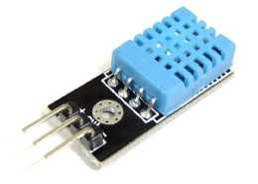The DHT22 is a digital temperature and humidity sensor. It uses a capacitive humidity sensor and a thermistor to measure the air temperature.

**Technical specifications:**

* Size: 28mm X 12mm X 10mm
* Humidity measuring range: 0 - 100 RH
* Humidity measurement accuracy: ± 2% RH
* Temperature measurement accuracy: ± 0.5° Fig. 11 - Temperature sensor
* Working voltage: DC 3-5V temperature si
* Power consumption: 2.5mA max (when processing data) air humidity
* Operating temperature: -40 +80 degrees Celsius

With this sensor, we display the temperature and humidity of the air inside the greenhouse, parameters that are necessary for specialists to analyze the development of plants and to be able to make studies on them.

**3. Soil temperature sensor**

The DS18B20 chip-based temperature sensor, consisting of a waterproof probe and a 1m long wire, used to measure soil temperature.

Depending on the values displayed by this sensor, specialists can carry out easier studies on plants.

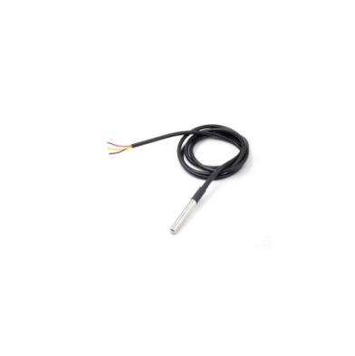 **Technical specifications:**

* Power supply: 3.0V to 5.5V
* Temperature range: -55 °C to + 125 °C
* High accuracy: ± 0.5 °C (-10 °C to + 85 °C)
* Sensor type: DS18B20
* Conversion accuracy 9~12 bits A/D
* Short temperature conversion delay, maximum 750 ms
* Supports multi-point networks
* Waterproof

Fig. 12 - Soil temperature sensor

*The smart garden is a completely autonomous system, it does not require human intervention, moreover it transmits in real time information about the parameters necessary for the development of plants.*

**III.3 Components kit solar tracking**

**Servo**

A servo is an electronic actuating device that uses position, velocity and torque measurements to control an automated process.

**Technical specifications:**

* Technical specifications:
* Operating voltage: 4.8 ~ 6.0V
* Current: 0.19A@5V, 0.24A@6V
* Operating speed: 0.12sec/60 degrees (4.8V) ~ 0.1 sec/60 degrees (6.0V)
* Torque: 1.6 kg / cm (4.8V)
* Temperature range: -30 ~ + 60℃
* Cable length: 25cm
* Servo type: analog servo
* Dimension: 23X12.2X29MM

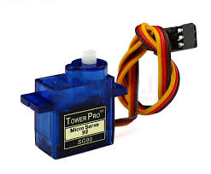

Fig. 13 - Servo

**Buzzer**

This module consists of an active piezoelectric buzzer that generates a sound when a preset value is exceeded. It produces a sound of approximately 2.5KHz.

**Technical specifications:**

* Supply voltage: 1.5~15V DC
* Tone generation range: 1.5 ~ 2.5kHz
* Dimensions: 18.5mm x 15mm

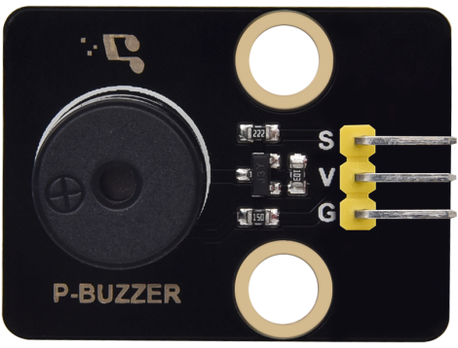

Fig. 14 - Buzzer

**Photoresistor**

The photoresistor is a passive circuit element whose resistance varies according to the intensity of the light reaching it.

**Technical specifications:**

* Power consumption 100 mW
* Temperature - 30°C - +70°C
* Spectral value 540 nm
* Light resistance 10 - 20 KΩ

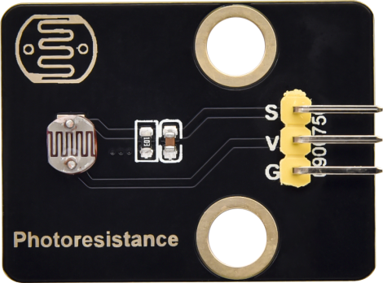

Fig. 15 - Photorezistor

**Chapter IV. Software**

The Arduino board takes data from the sensors, analyzes it, and based on that, decides whether to give the plants water or not. At the same time, the data is sent to the Wi-Fi board, which connects to the local network and forwards it to the Blynk server where it is displayed.

So the app displays on your phone and computer, in real time, wherever you are, both the sensor data and whether the valve is open or closed and you can control it remotely.

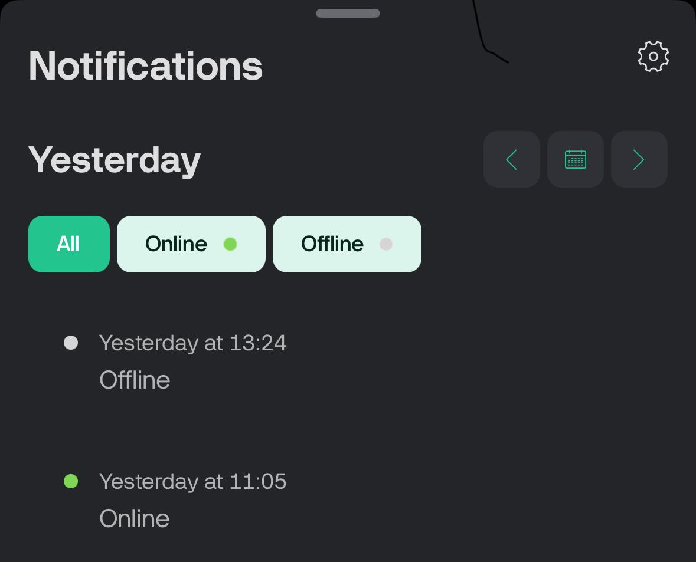

Fig. 16 - History of system activity

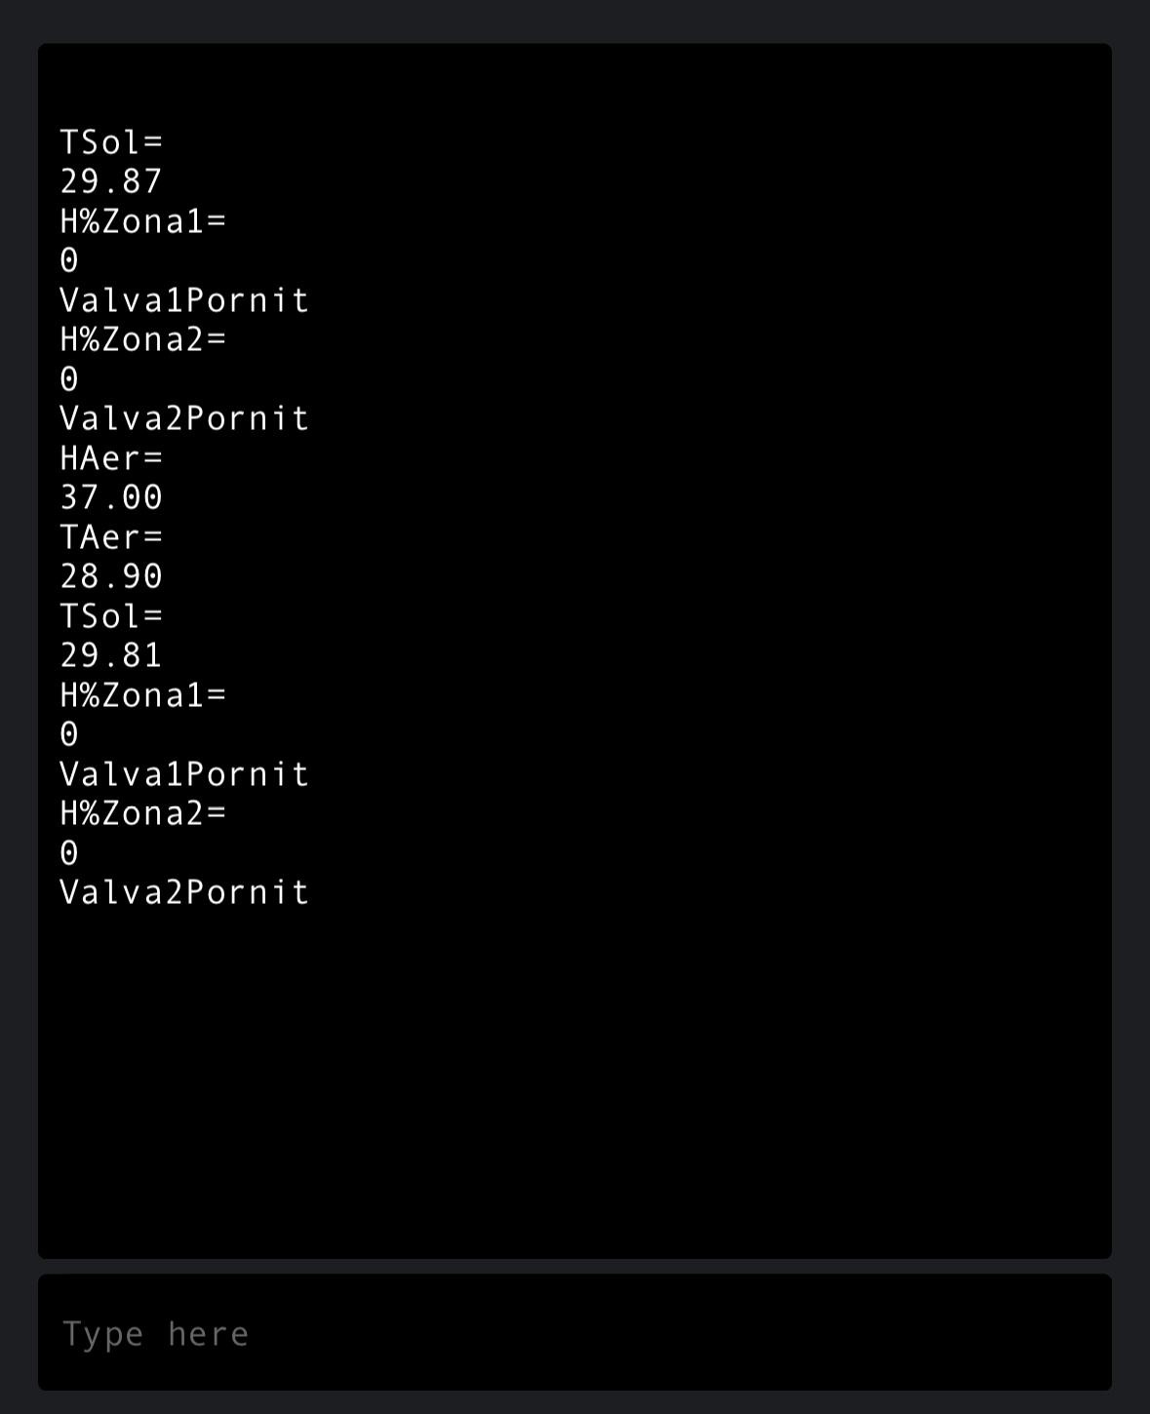

Fig. 17 – Data displayed on phone

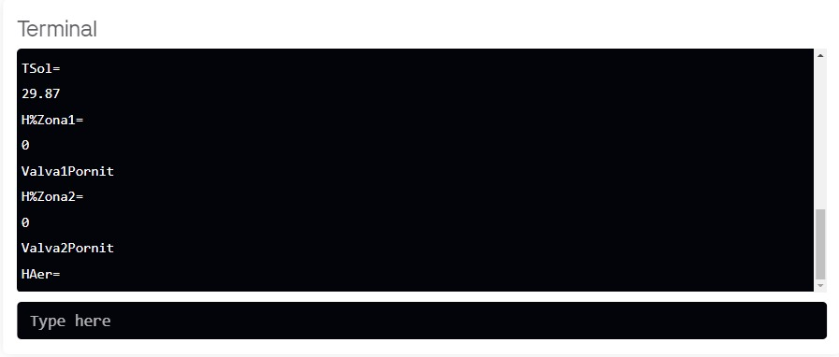

Fig. 18 – Data displayed on computer

**Link to GitHub**



Fig. 19 - Link to GitHub

**Chapter VI. Conclusions**

Considering that water is a vital element of life and must be used rationally, the system I have designed and implemented, called "Smart Garden", is intended to save water and human resources.

This system can be applied in any field related to the growth and development of plants (agriculture, greenhouses, gardens and house plants).

**Chapter VII. Improvement possibilities**

- Turning the garden into a smart home by adding more sensors such as gas sensors, motion detection or a live streaming camera

- Possibility to add as many sensors as possible for possible plant redistribution

- Possibility to add control systems for water pumping equipment (level sensors for water tanks, relays to control water pumps)

**Chapter VIII. Media appearances:**

<https://tvrinfo.ro/echipa-de-robotica-a-colegiului-na-ional-mihai-viteazul-din-ploie-ti-a-realizat-un-sistem-inteligent-de-iriga-ii-folosit-la-gradina-botanica-din-bascov_926211/>

<https://fb.watch/pqLYnkCqqx/>

<https://www.observatorulph.ro/social/2678234-elevii-cnvm-ploiesti-au-introdus-un-sistem-inteligent-de-irigatii-la-gradina-botanica-bucov>

<https://republikanews.ro/sistem-inteligent-de-irigatii-pentru-gradina-botanica-video>

<https://youtu.be/NUcoy_RShCg?feature=shared>

<https://stirileprotv.ro/video/cum-a-fost-transformata-gradina-botanica-bucov-intr-o-sera-inteligenta-inovatia-lansata-de-elevii-unei-echipe-de-robotica/62328319/>

**Chapter IX. Screenshots**

