CW Report TitleSTUDENT NAME: Bordei AlexandruID:23026303CS4051 Fundamentals of Computing2024 second semester

Index
Introduction 3
Literature review 4
Mode 4
Median 4
Mean 4
Skewness 4
Methodology 5
The scope of the project 5
Problem solving method 5
Structure of application 5
Requirements 5
Implementation 7
Testing 9
Conclusion 13
Appendix 14

Introduction
This module helped me to develop programming skills in order to reach my potential . It developed skills such as logigs and the ability of creating a few algorithms in order to resolve a certain problem . Through my ming this skills will help me in my future job. The coursework helped me to learn how to work by myself and only ask a few things that I don’t understand to my tutor. The point of the coursework was to make me push new limits and develop my skills on creating algorithms to resolve a certain problem. It is easy to apply a certain formula by yourself but when you try make the computer do that for you and make it work for as many possibilities s possble ,thing are getting harder ,that is why this coursework only helped us in a good way.

Literature review

Mode
The Mode is the value that appears most frequently in a data set. A data set may have one mode, more than one mode, or no mode at all (in cases where no number repeats). Mode is especially useful for categorical data where we want to know which is the most common category.

Median
The Median is the middle value of a dataset when arranged in ascending order. If the dataset has an even number of observations, the median is typically defined as the average of the two middle numbers. The median is a useful measure of central tendency, especially in datasets with outliers or skewed data because it is not affected by extreme values as much as the mean.

Mean
The Mean, or average, is calculated by adding all data points together and then dividing by the number of data points. The mean is the most basic measure of central tendency. While it provides a useful overall estimate, it is sensitive to outliers and skewed data, which can mislead by pulling the mean too far in the direction of the outliers.

Skewness
Skewness measures the asymmetry of the probability distribution of a real-valued random variable about its mean. Positive skewness indicates a distribution with an asymmetric tail extending toward more positive values, whereas negative skewness indicates a distribution with a tail extending toward more negative values. Skewness can affect various data analyses, including the mean and median, by indicating how much a distribution deviates from the normal distribution.

- Black, K. (2019). Business Statistics: For Contemporary Decision Making, 9th ed. Wiley.
- Bock, D.E., Velleman, P.F., and De Veaux, R.D. (2014). Stats Modeling the World, 4th ed. Pearson.
- Healey, J.F. (2015). The Essentials of Statistics: A Tool for Social Research, 3rd ed. Cengage Learning.

Methodology

The scope of the project
Developing functionalities to calculate statistical measures like mode, median, mean, and skewness. And also implementing the property of importing data from an external file from the computer.

Problem solving method
I used the agile mothod solving method because it is a dynamic method that allows me to modify and to change as the project continues. As for example I creted the main methods then I gad to add more functionalities in order to make the program validate the reading method (to allow only the numbers)

Structure of application
I used a hierarchical structure the menu is the main method ,in the menu I call every method and every method is based on the reading method . That’s how the dependancy appear

Requirements

Functional Requirements:

Users must be able to input or import data.
The application must calculate statistical measures like mode, median, mean, and skewness.
Users should be able to visualize data through graphs and charts.
The application should support exporting reports in various formats.

Non-Functional Requirements:

The application should ensure data accuracy and reliability.
It should perform calculations within a predefined time limit to ensure efficiency.
User data should be securely handled to protect privacy.

Implementation
The read_vector() function is designed to read a vector of integers from user input, performing validation checks to ensure that the input is correctly formatted and meets specific criteria. The function handles multiple common input issues, such as non-numeric values and insufficient data entries, by prompting the user until valid input is provided. Let's break down each line and component of this function in detail:

Detailed Breakdown
def read_vector():
Purpose: Define a function named read_vector which doesn't take any parameters.
Action: Begins the definition of the function which is intended to read and validate a list of integers from user input.
vector = []
Purpose: Initialize an empty list named vector.
Action: This list will be used to store integers that are read from the user's input once validated.
while True:
Purpose: Start an infinite loop.
Action: This loop will continue indefinitely until it is explicitly broken out of, which allows repeated prompting for user input until valid data is received.
input_str = input("Enter numbers separated by spaces or commas (at least two numbers required): ")
Purpose: Prompt the user to enter a string of numbers, informing them that both spaces and commas can be used as delimiters and that at least two numbers are required.
Action: The input function captures the string entered by the user and stores it in the variable input_str.
inputs = input_str.replace(',', ' ').split()
Purpose: Prepare the input string for processing by replacing commas with spaces and then splitting the string into a list.
Action: The replace() function changes all commas in the string to spaces to standardize the delimiters. The split() function then divides the string into a list of substrings based on these spaces.
if all(item.lstrip('-').isdigit() for item in inputs) and len(inputs) >= 2:
Purpose: Check if all elements in the list are numeric and if the list contains at least two elements.
Action: The all() function evaluates whether all items in the list satisfy two conditions: each item, stripped of any leading negative sign (lstrip('-')), must be a digit (isdigit() checks this), and the list must have at least two items (len(inputs) >= 2).
vector.extend(map(int, inputs))
Purpose: Convert all string inputs to integers and add them to the vector list.
Action: The map() function applies the int function to each element in inputs, converting them from strings to integers. The extend() method then adds these integers to the vector list.
return vector # Return the filled vector.
Purpose: Return the populated list of integers.
Action: Once valid input is successfully processed and stored in vector, it is returned to the caller, effectively ending the function.

elif not all(item.lstrip('-').isdigit() for item in inputs):
Purpose: Check if any of the split inputs are not numeric.
Action: This condition checks the same as part of the first condition but specifically identifies if any items are non-numeric, triggering the corresponding error message.
print("Error: Please enter only numbers. Try again.")
Purpose: Inform the user that their input contained invalid (non-numeric) characters.
Action: Outputs an error message to prompt the user to enter only numeric values.
else:
Purpose: Handle the case where fewer than two numbers are provided.
Action: This block is executed if the input contains numeric values but not enough entries (fewer than two).
print("Error: Please enter at least two numbers.")
Purpose: Notify the user that they need to provide at least two numbers.
Action: Outputs an error message prompting the user to input at least two numbers for valid processing.

Testing
Reading the elements of the vector
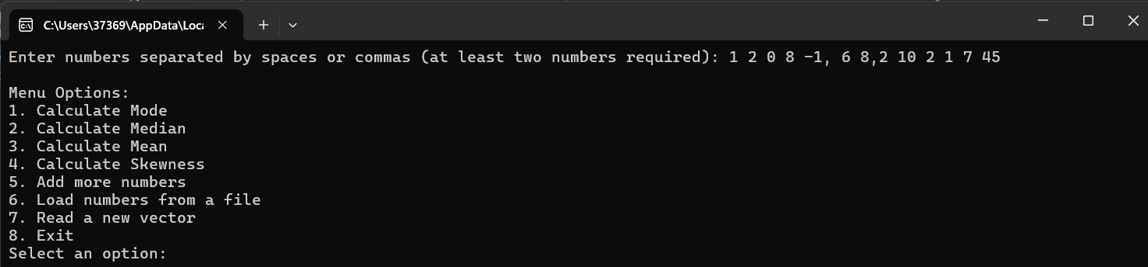
Option 2 to find the mode:
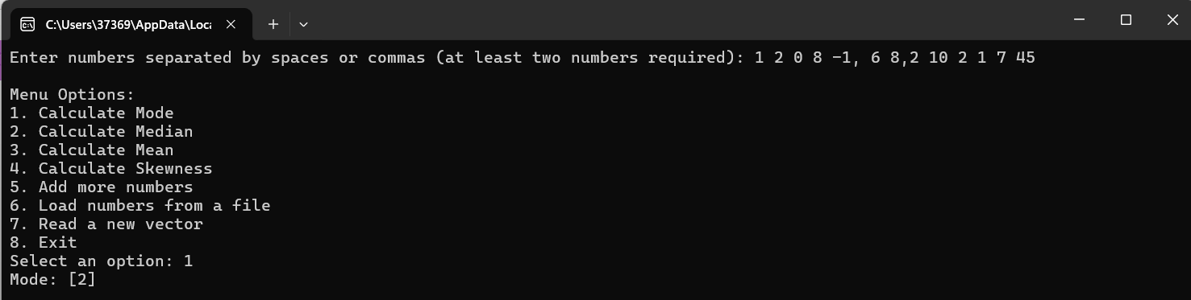
Option 2 to find the median
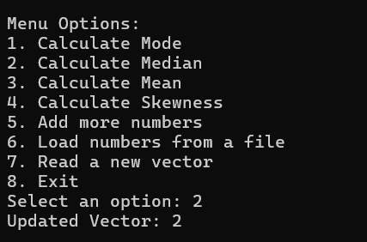
Option 3 to find the mean
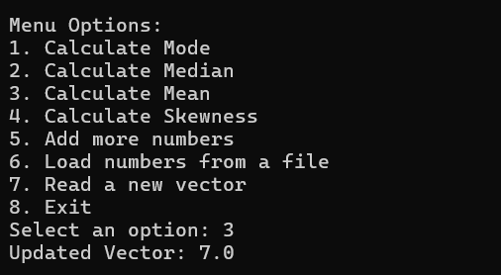

Option 4 to find the skewness and option 7 to write another vector to work with
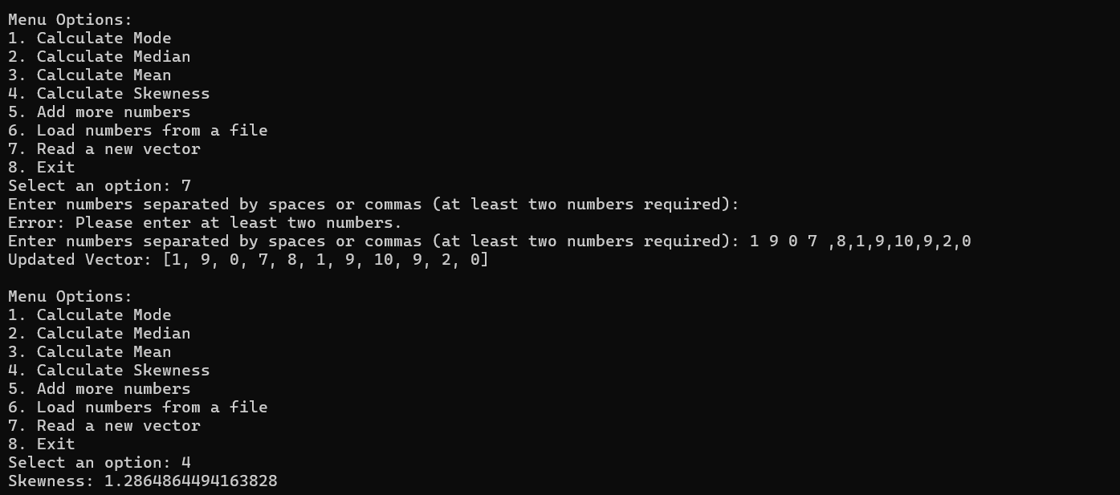

I created a new file TextFile1.txt and wrote a few numbers in it
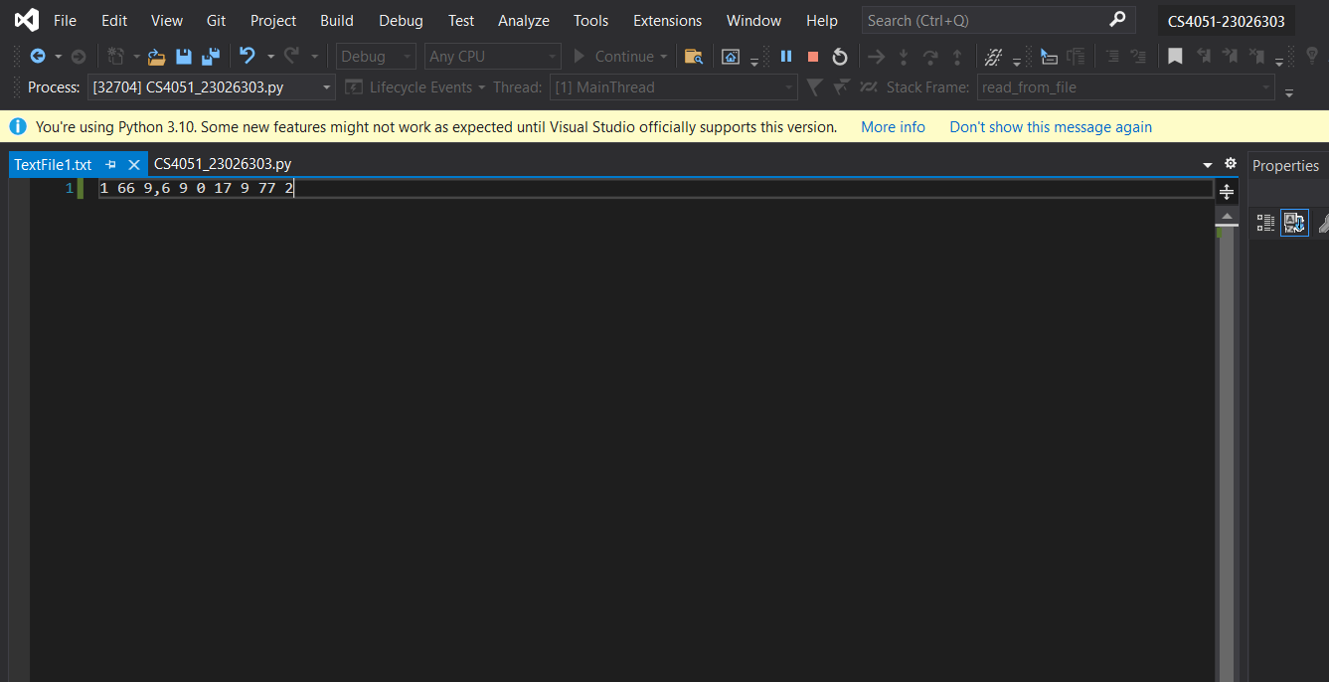
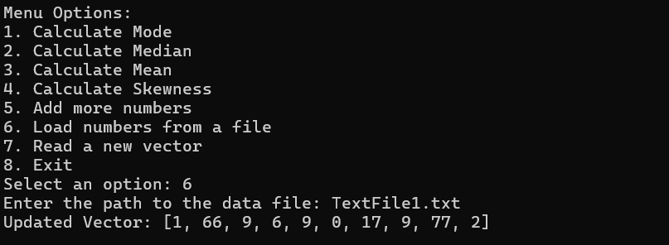

Here I tried to execute the first opption for the new numbers
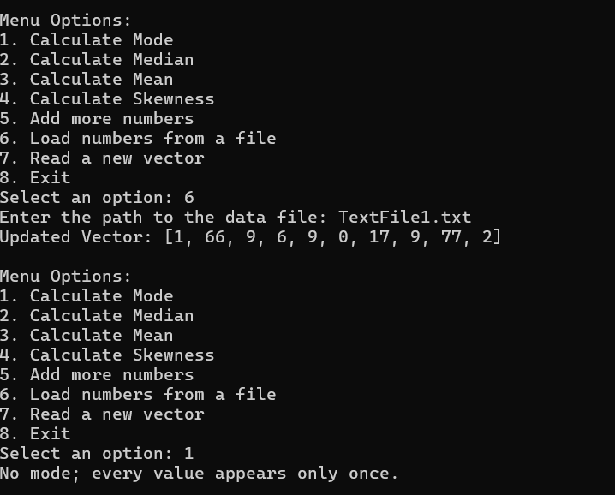
I tried opption 5 and it worked
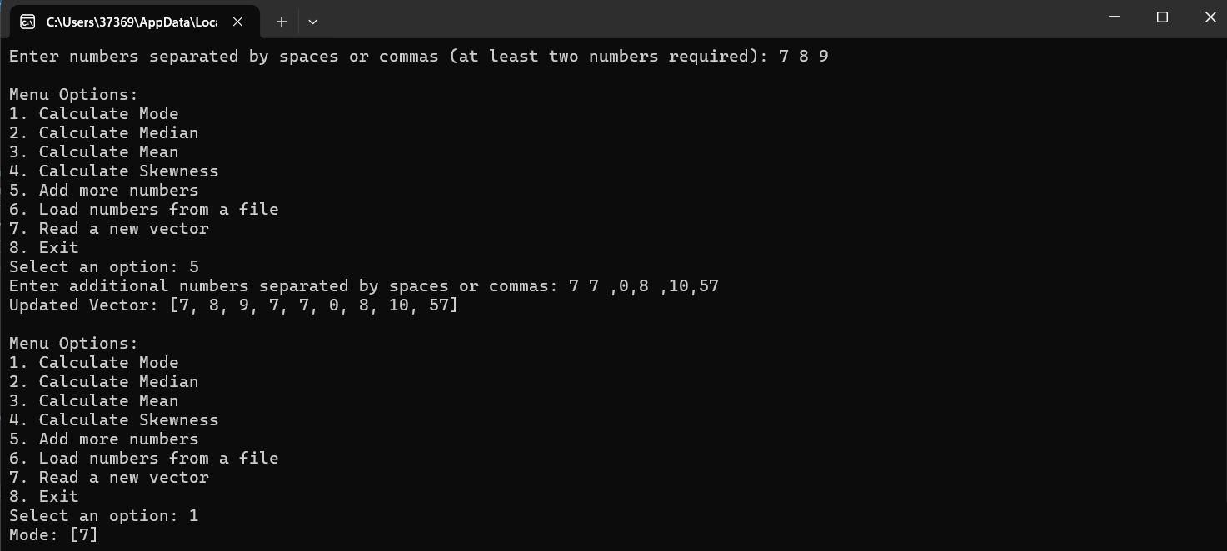

Conclusion
Testing and Validation:
Reflection: While the project successfully meets its basic functional requirements, I could have implemented a more rigorous testing strategy. Continuous and automated testing, particularly with real user data scenarios, would enhance reliability and robustness.
Future Approach: Implement unit tests for each statistical function and integration tests to ensure that modules interact correctly. Use test-driven development (TDD) to guide future coding, ensuring each function behaves as expected before it is integrated.
User Experience and Accessibility:
Reflection: The initial design focused heavily on functionality with less emphasis on user experience. The interface could be more intuitive and accessible, particularly for users with disabilities.
Future Approach: Consult UX/UI designers and conduct user testing to refine the interface. Ensure compliance with accessibility standards like WCAG to make the application usable for a broader audience.
Performance Optimization:
Reflection: In the development process, I may not have fully optimized the code for performance, especially when handling large datasets which could slow down computations.
Future Approach: Profile the application to identify bottlenecks and optimize algorithms, possibly by implementing more efficient data handling and computation methods like vectorization or using parallel processing.

Appendix
#CS4051_23026303
#The purpose of the program is to calculate the MODE, MEDIAN, MEAN and SKEWNESS of a vector
#The author of the proggram is Bordei Alexandru StudentID:23026303
#08.05.2024

import math #Import the math library to access mathematical functions.

#Read integers from user input and return them as a list.
def read_vector():
vector = [] #Initialize an empty list to store integers.
while True: #Begin an infinite loop to continuously prompt for input until valid input is received.
#Prompt user for a string of numbers, allowing both commas and spaces as separators.
input_str = input("Enter numbers separated by spaces or commas (at least two numbers required): ")
#Remove commas and split the string into a list based on spaces.
inputs = input_str.replace(',', ' ').split()
#Check if all split inputs are numeric and if there are at least two numbers.
if all(item.lstrip('-').isdigit() for item in inputs) and len(inputs) >= 2:
#Convert all string inputs to integers and add them to the vector list.
vector.extend(map(int, inputs))
return vector # Return the filled vector.
elif not all(item.lstrip('-').isdigit() for item in inputs):
#If any input is non-numeric, inform the user and prompt again.
print("Error: Please enter only numbers. Try again.")
else:
#If fewer than two numbers are entered, prompt for more input.
print("Error: Please enter at least two numbers.")

#Function to add more numbers to the existing vector.
def add_more_numbers(vector):
while True: #Similar to read_vector, loop until valid input is received.
input_str = input("Enter additional numbers separated by spaces or commas: ")
inputs = input_str.replace(',', ' ').split() #Remove commas and split the string into a list based on spaces.
if all(item.lstrip('-').isdigit() for item in inputs): #Check if all split inputs are numeric and if there are at least two numbers.
vector.extend(map(int, inputs))
return vector #Return the updated vector.
else:
print("Error: Please enter only numbers. Try again.")

# Function to read numbers from a specified file.
def read_from_file():
filepath = input("Enter the path to the data file: ") # Ask the user for the file path.
vector = []
try:
with open(filepath, 'r') as file: #Attempt to open the specified file in read mode.
data = file.read() #Read the entire file content.
inputs = data.replace(',', ' ').split() #Process the data like input strings.
if all(item.lstrip('-').isdigit() for item in inputs):
vector.extend(map(int, inputs)) #Convert all string inputs to integers and add them to the vector list.
else:
print("Error: File contains non-numeric values.")
return None
return vector
except FileNotFoundError: #If the file cannot be found, notify the user.
print("Error: File not found.")
return None

#Calculate the mode of the vector.
def calculate_mode(vector):
from collections import Counter #Import Counter to count occurrences of each element.
vector_sorted = sorted(vector) #Sort the vector to prepare for counting.
count = Counter(vector_sorted) #Count the frequency of each element in the vector.
max_occurrences = max(count.values()) #Find the maximum occurrence frequency.
mode = [num for num, freq in count.items() if freq == max_occurrences] # Identify all numbers that occur most frequently.
if len(mode) == len(vector): #If each number appears only once, indicate no mode.
print("No mode; every value appears only once.")
elif len(count) == 1: #If all numbers are the same, that number is the mode.
print(f"Mode: {mode[0]} (all numbers are the same)")
else:
print(f"Mode: {mode}") #Display the mode(s).

#Calculate the median of the vector.
def calculate_median(vector):
vector_sorted = sorted(vector) #Sort the vector.
n = len(vector_sorted) #Find the number of elements in the vector.
mid = n // 2 #Find the middle index.
if n % 2 == 0: #If there's an even number of elements, calculate median as the average of the two middle numbers.
median = (vector_sorted[mid - 1] + vector_sorted[mid]) / 2
else: #If there's an odd number of elements, the median is the middle element.
median = vector_sorted[mid]
return median #Return the median.

#Calculate the mean of the vector.
def calculate_mean(vector):
mean = sum(vector) / len(vector) #Sum the vector and divide by the number of elements.
return mean #Return the mean.

#Calculate the standard deviation of the vector.
def calculate_std_deviation(vector):
mean = calculate_mean(vector) #First calculate the mean.
variance = sum((x - mean) ** 2 for x in vector) / (len(vector) - 1) #Then calculate variance.
return math.sqrt(variance) #Take the square root of variance to get standard deviation.
def calculate_skewness(vector):
# Calculate the mean (average) of the vector
mean = calculate_mean(vector)

# Calculate the median of the vector
median = calculate_median(vector)

# Calculate the standard deviation of the vector. This involves:
# 1. Subtracting the mean from each element x in the vector,
# 2. Squaring the result of each subtraction,
# 3. Summing all the squared results,
# 4. Dividing the total by the number of elements minus one (for sample standard deviation),
# 5. Taking the square root of the result to get the standard deviation
std_dev = math.sqrt(sum((x - mean) ** 2 for x in vector) / (len(vector) - 1))

# Calculate the skewness using the formula: (3 * (mean - median)) / standard deviation
# This formula assesses the asymmetry of the data distribution around the mean.
skewness = (3 * (mean - median)) / std_dev

# Print the calculated skewness value
print("Skewness:", skewness)
#Define the menu function for user interaction.
def menu():
vector = read_vector() #Initialize the vector by reading from user input.
#Define available actions with corresponding functions.
actions = {
'1': ("Calculate Mode", lambda: calculate_mode(vector)), #Option to calculate the mode.
'2': ("Calculate Median", lambda: calculate_median(vector)), #Option to calculate the median.
'3': ("Calculate Mean", lambda: calculate_mean(vector)), #Option to calculate the mead.
'4': ("Calculate Skewness", lambda: calculate_skewness(vector)), #Option to calculate the skewness.
'5': ("Add more numbers", lambda: add_more_numbers(vector)), #Option to calculate add more numbers in the vector.
'6': ("Load numbers from a file", lambda: read_from_file()), #Option to read a vector from file.
'7': ("Read a new vector", lambda: read_vector()), #Option to read a new vector.
'8': ("Exit", None)
}

#Loop to display the menu and process user choices.
while True:
print("\nMenu Options:")
for key in actions:
print(f"{key}. {actions[key][0]}") #Print each menu option.
choice = input("Select an option: ") #Ask for user input.
if choice == '8': # Exit option.
print("Exiting the program.")
break #Exit loop and end program.
elif choice in actions and actions[choice][1]:
result = actions[choice][1]() #Execute the function associated with the chosen option.
if result is not None:
print("Updated Vector:", result) #Show updated vector or result.
else:
print("Invalid option, please try again.") #Handle invalid input.

menu() #Calling the menu function.

