ABSTRACT

In today's world, security and automation play a critical role in safeguarding personal and commercial spaces. "Intellilock" is an advanced smart locking system designed to combine multiple layers of security with seamless automation, enhancing both safety and user convenience. This project integrates a dual authentication mechanism using a traditional Keypad and a modern Fingerprint Sensor, ensuring that access is restricted to authorized individuals only. The system is controlled by an Arduino Uno microcontroller, which acts as the brain of the setup, coordinating authentication, door actuation, and monitoring activities. Power is reliably supplied via an external adapter, ensuring stable operation without dependency on batteries. A Servo motor is deployed to physically control the door mechanism, enabling automatic opening upon successful authentication and secure closing once the system is locked. Additionally, an Infrared (IR) sensor is strategically installed to detect the entry of a person after unlocking; this ensures that the door closes automatically after a successful entry, thereby preventing accidental breaches. The integration of the IR sensor with the locking mechanism adds an intelligent layer of responsiveness to human presence, enhancing the system’s autonomy. Intellilock is not only a demonstration of robust security architecture but also a practical model of how automation can simplify everyday processes. Its design is scalable and can be extended to incorporate features such as remote monitoring, mobile app control, and IoT integration for real-time notifications and access management. By leveraging widely available components and simple yet effective logic, Intellilock offers a cost-efficient, reliable, and user-friendly solution suitable for homes, offices, and restricted access facilities, reflecting the future of secure entry systems.

Keywords: Smart Door Lock System, Biometric and Keypad Authentication, Arduino-based Access Control, Servo Motor Actuation, Infrared Sensor for Human Detection, Automated Door Operation, Secure Entry System.
TABLE OF CONTENTS

CHAPTER NO | TITLE | PAGE NO
 | ABSTRACT
 | LIST OF FIGURES
 | LIST OF ABBREVIATIONS
 | LIST OF TABLES
1 | INTRODUCTION
 | 1.1 Importance of Security Systems in Modern Infrastructure
 | 1.2 Role of Smart Locks in Residential and Commercial Safety
 | 1.3 Challenges in Conventional Locking Mechanisms
 | 1.4 Need for Automation in Access Control Systems
 | 1.5 Integration of IoT in Smart Locking Solutions
 | 1.6 Importance of Biometric and Remote Security
2 | LITERATURE SURVEY
3 | SYSTEM ANALYSIS
 | 3.1 Existing Systems
 | 3.1.1 Limitations of Traditional and Semi-automatic Locks
 | 3.2 Proposed System
 | 3.3 Block Diagram Description
 | 3.4 Circuit Description
4 | HARDWARE DESCRIPTION
 | 4.1 Arduino Uno
 | 4.1.1 Features and Specifications
 | 4.1.2 Pin Configuration and Functionality
 | 4.2 Keypad Module
 | 4.2.1 Working Principle
 | 4.2.2 Interfacing with Arduino
 | 4.3 Fingerprint Sensor Module
 | 4.3.1 Fingerprint Capture and Storage
 | 4.3.2 Verification and Matching Process
 | 4.4 Servo Motor
 | 4.4.1 Mechanism of Door Movement
 | 4.4.2 Servo Angle Control for Lock/Unlock
 | 4.5 IR Sensor Module
 | 4.5.1 Human Presence Detection
 | 4.5.2 Auto-Close Door Mechanism
 | 4.6 Power Supply Unit
 | 4.6.1 Adapter Specifications and Regulation
 | 4.7 Buzzer (Optional)
 | 4.7.1 Alerts for Incorrect Authentication
5 | SOFTWARE DESCRIPTION
 | 5.1 Arduino IDE
 | 5.1.1 Installation and Setup
 | 5.1.2 Sketch Programming and Uploading
 | 5.1.3 Code Flow and Logic Explanation
 | 5.2 Fingerprint Sensor Library
 | 5.2.1 Enrollment and Verification Functions
 | 5.3 Keypad Interface Library
 | 5.3.1 Reading Input and Password Matching
6 | RESULTS AND DISCUSSION
 | 6.1 Software Results
 | 6.1.1 Serial Monitor Outputs (Verification Success/Fail Messages)
 | 6.1.2 Keypad Code and Fingerprint Authentication Results
 | 6.2 Hardware Results
 | 6.2.1 Door Opening and Closing Mechanism
 | 6.2.2 IR Detection and Auto-Close Functionality
 | 6.2.3 Power Stability and Error Handling
7 | CONCLUSION AND FUTURE SCOPE
 | 7.1 Conclusion
 | 7.2 Future Scope
 | REFERENCE

LIST OF FIGURES

FIGURE NO | FIGURE NAME | PAGE NO
3.2.1 | Block Diagram of Intellilock Smart Door Lock System
3.4.1 | Circuit Diagram of the Complete System
4.1.1 | Arduino Uno Board Layout
4.2.1 | Keypad Module Interface with Arduino
4.3.1 | Fingerprint Sensor Module Wiring
4.4.1 | Servo Motor Connection and Operation Diagram
4.5.1 | IR Sensor Detection Mechanism
4.6.1 | Power Supply Adapter and Regulation Circuit
5.1.3 | Workflow Diagram of Authentication and Door Control Logic
4.7.1 | Buzzer Alert System (Optional)
 | Software Flowchart for Password and Fingerprint Verification
5.1.3 | Serial Monitor Output during Fingerprint Matching
6.1.1 | Door Open and Close State Representation
6.2.2 | Auto Door Closing using IR Sensor Detection
7.2.1 | Future Scope Expansion Diagram (Optional IoT Integration Model)

LIST OF ABBREVIATIONS

S.NO | ABBREVIATION | FULL FORM
1 | IR | Infrared
2 | MCU | Microcontroller Unit
3 | LCD | Liquid Crystal Display
4 | IoT | Internet of Things
5 | Wi-Fi | Wireless Fidelity
6 | DC | Direct Current
7 | AC | Alternating Current
8 | VCC | Voltage Common Collector
9 | ADC | Analog to Digital Converter
10 | EEPROM | Electrically Erasable Programmable Read-Only Memory
11 | PWM | Pulse Width Modulation
12 | UART | Universal Asynchronous Receiver Transmitter
13 | RFID | Radio Frequency Identification (Optional - Future Scope)
14 | API | Application Programming Interface
15 | USB | Universal Serial Bus
16 | BLYNK | IoT Platform for Remote Control (Optional - Future Scope)

LIST OF TABLES

TABLE NO | TABLE NAME | PAGE NO
1 | Pin Description of Arduino Uno Microcontroller | 32
2 | Specifications of Keypad Module | 41
3 | Specifications of Fingerprint Sensor | 45
4 | Servo Motor Specifications | 48
5 | IR Sensor Specifications | 52
6 | Power Supply Adapter Specifications | 55
7 | LCD Display Pin Configuration | 58
8 | Buzzer Specifications (Optional) | 61
9 | Arduino IDE Software Libraries and Functions | 65
10 | Software Flowchart for Authentication Process | 70

CHAPTER 1

1.INTRODUCTION

  - IMPORTANCE OF SECURITY SYSTEMS IN MODERN INFRASTRUCTURE

In today's world, security systems have become an integral part of modern infrastructure, playing a crucial role in safeguarding both residential and commercial properties. With the increasing value of property and assets, the need for reliable security systems has never been greater. Traditional locking systems, such as mechanical locks and keypads, have been used for centuries but have significant vulnerabilities. These traditional systems can be easily bypassed or compromised, leading to theft, unauthorized access, or vandalism. As infrastructure and technology evolve, so must the security systems that protect them. In response to growing concerns over safety, modern security systems integrate advanced technologies like biometric authentication, motion sensors, and IoT-based solutions to offer real-time monitoring and remote access. These advancements not only increase the safety and security of the premises but also provide convenience for users. For example, biometric systems like fingerprint recognition provide a higher level of security, as they are nearly impossible to bypass compared to conventional mechanical keys. Additionally, the integration of IoT in security systems enables remote monitoring and control, making it easier for users to manage their security from anywhere. Security systems are evolving to meet the demand for more advanced, scalable, and user-friendly solutions.

(Refer to Figure 3.2.1 for the Block Diagram of Intellilock Smart Door Lock System)

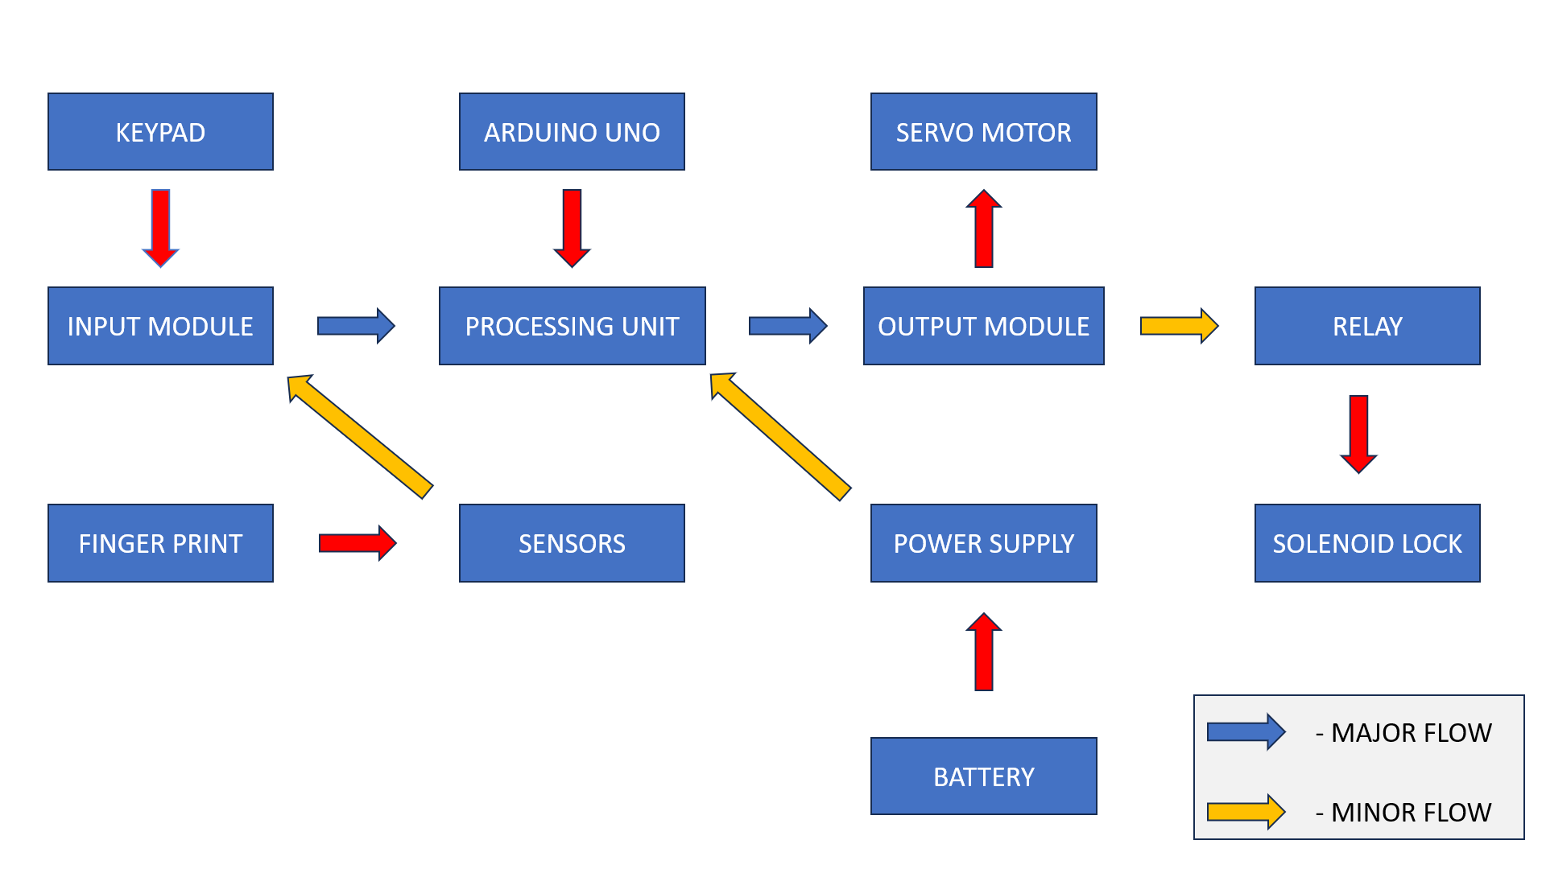

1.2 ROLE OF SMART LOCKS IN RESIDENTIAL AND COMMERCIAL SAFETY
Smart locks are revolutionizing the way we secure our homes and businesses, providing enhanced security and convenience. These locks utilize digital technologies, including biometrics, Bluetooth, and Wi-Fi, to offer a more secure alternative to traditional locks. In residential settings, smart locks enable homeowners to lock and unlock doors remotely, monitor access, and provide temporary or permanent access codes to visitors or service providers. The integration of smart technology in residential security systems allows for greater flexibility and control. For example, a homeowner can unlock the door remotely for family members or visitors, or they can receive instant notifications whenever the door is unlocked, ensuring complete awareness of who is entering or leaving the premises. In commercial settings, smart locks can offer additional benefits such as integration with security systems, alarms, and surveillance cameras, enabling businesses to maintain a secure environment with real-time monitoring. Furthermore, smart locks help businesses improve operational efficiency by eliminating the need for physical keys and reducing the risk of unauthorized access. The versatility of smart locks, combined with their ease of use, makes them an ideal solution for modern security needs. They provide enhanced protection against intruders, as they offer multiple layers of authentication, including PIN codes, biometrics, and remote access.

1.3 CHALLENGES IN CONVENTIONAL LOCKING MECHANISMS
Traditional locking mechanisms, such as mechanical locks and keypads, have long been the cornerstone of security for both residential and commercial properties. However, as technology has evolved, so have the methods used by criminals to bypass these systems. Mechanical locks are particularly vulnerable to physical manipulation, such as lock picking or forced entry. In the case of key-based locks, losing or duplicating keys can compromise the security of an entire building, and the user has no way of tracking who holds a copy of the key. Keypad locks, while offering some advantages, are not immune to attack, as security codes can be shared or guessed, or even seen by unauthorized individuals. Moreover, traditional locks lack the ability to offer real-time monitoring, remote access, or data tracking, making it difficult for users to stay informed about the status of their property. Conventional systems also lack scalability, as adding additional security features often requires significant changes to the existing infrastructure. As a result, security vulnerabilities and the potential for unauthorized access remain a significant concern. The evolution of locking mechanisms towards smart, automated, and integrated systems offers a more robust and convenient solution to these challenges.

(Refer to Figure 3.1.1 for the Limitations of Traditional and Semi-automatic Locks)

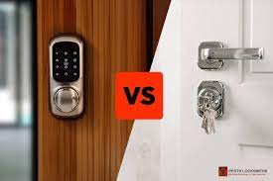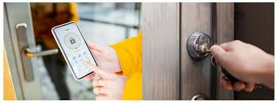

1.4 NEED FOR AUTOMATION IN ACCESS CONTROL SYSTEMS
Automation in access control systems is becoming increasingly essential in the modern security landscape. Traditional security systems often require manual intervention, such as physically locking or unlocking doors, making them susceptible to human error or negligence. Automated access control systems, however, can eliminate these risks and offer more efficient, reliable, and secure operations. For instance, automated systems can use sensors, biometric data, or even mobile devices to control access to various areas of a building, reducing the reliance on human input. These systems are particularly valuable in commercial settings where large numbers of employees or visitors require access to different areas. By integrating automated access control with a building’s security infrastructure, users can manage access in real-time, monitor who enters and exits, and even set specific permissions for different individuals. In addition, automation can improve overall security by making it harder for unauthorized individuals to gain access. Automated systems can also be programmed to perform additional tasks, such as locking doors after hours or triggering an alarm if a door is left open for an extended period. With the increasing demand for seamless, efficient, and secure operations, automation in access control is rapidly becoming a necessity.

(Refer to Figure 3.2.1 for the Block Diagram of Intellilock Smart Door Lock System)

1.5 INTEGRATION OF IOT IN SMART LOCKING SOLUTIONS
The integration of the Internet of Things (IoT) in smart locking systems represents a significant leap forward in modern security technology. IoT-based smart locks allow users to monitor, control, and automate their security systems remotely, creating a connected and highly responsive environment. With IoT technology, users can lock and unlock doors, receive real-time alerts about door status, and even track entry logs, all from their smartphones or other connected devices. The ability to integrate IoT with smart locks provides numerous benefits, including convenience, flexibility, and enhanced security. For instance, a user can remotely unlock a door for a visitor or service provider, or even track the movement of people within a building. Furthermore, IoT-based smart locks can be integrated with other security devices, such as surveillance cameras, alarms, and motion sensors, creating a comprehensive security ecosystem. The combination of smart locks and IoT allows for a level of control and monitoring that traditional locking systems simply cannot match. As IoT technology continues to evolve, it is expected that smart locking solutions will become even more sophisticated, offering greater security and convenience for users.

(Refer to Figure 5.1.3 for Workflow Diagram of Authentication and Door Control Logic)

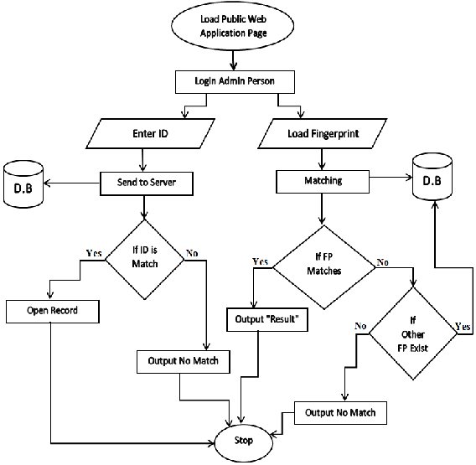

1.6 IMPORTANCE OF BIOMETRIC AND REMOTE SECURITY
Biometric security technologies, such as fingerprint recognition, have become increasingly important in securing access to sensitive areas. Unlike traditional systems that rely on passwords or keys, biometric systems use unique physical characteristics—such as fingerprints, facial recognition, or iris scans—to authenticate users. This makes it nearly impossible for unauthorized individuals to bypass the system, as these traits cannot be duplicated or guessed. The use of biometrics in access control provides an additional layer of security, ensuring that only authorized individuals can gain entry to protected areas. Furthermore, biometric systems are more convenient than traditional systems, as they eliminate the need for users to remember passwords or carry physical keys. Along with biometric systems, remote security capabilities have also become a crucial feature of modern access control solutions. Through mobile apps, users can monitor and control their security systems from anywhere, providing peace of mind when away from home or the office. Remote access also allows for quick responses to security events, such as granting access to a visitor without needing to be on-site. The combination of biometric authentication and remote security provides a comprehensive and user-friendly solution that enhances both the security and convenience of access control systems.

(Refer to Figure 3.2.2 for the Block Diagram of Smart Door Lock System)

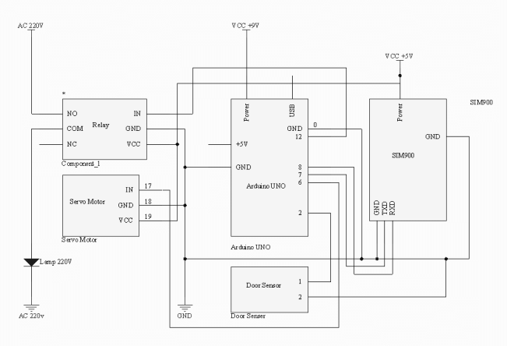

CHAPTER 2

2.LITERATURE SURVEY

2.1 OVERVIEW OF EXISTING SECURITY SYSTEMS

Over the years, various security systems have been developed to address the growing need for enhanced protection in both residential and commercial environments. The traditional security measures, such as mechanical locks and security guards, were gradually replaced by electronic solutions to improve reliability and ease of use. Early electronic security systems primarily consisted of access control mechanisms like keypads, biometric systems, and simple alarm systems. Keypad-based systems allow users to input a security code to gain access, but these systems still faced vulnerabilities such as easily shared or guessed codes. Fingerprint recognition systems, on the other hand, emerged as a more reliable biometric alternative, offering higher security by ensuring that only the registered individual could gain access. However, even fingerprint-based systems were not immune to issues, such as sensor misreadings or the potential for false positives. To address these challenges, the integration of IoT technology into security systems became a popular solution. IoT-enabled security systems allow users to remotely monitor and control their security setups via smartphones or computers, providing real-time updates and improving convenience. However, these systems come with their own set of challenges, such as network vulnerabilities and the need for constant updates to prevent security breaches. Despite the challenges, the growing demand for smart and automated security systems has spurred continuous research and development in the field of security technology.

(Refer to Figure 3.1.1 for the Limitations of Traditional and Semi-automatic Locks)

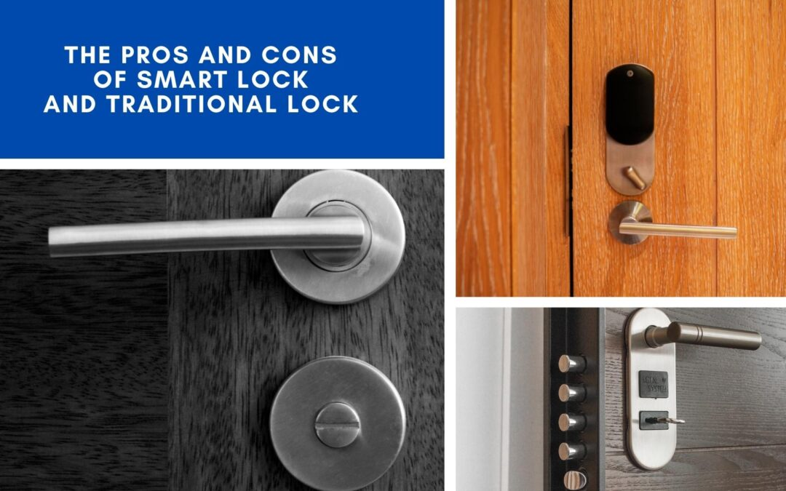
2.2 REVIEW OF IOT-BASED SMART SECURITY SYSTEMS
The advent of the Internet of Things (IoT) has revolutionized the field of smart security systems, offering new ways to monitor and control access to protected spaces. IoT-based security systems leverage sensors, cameras, and communication protocols like Wi-Fi and Bluetooth to create a connected environment that can be managed remotely. These systems have become increasingly popular due to their flexibility, ease of use, and ability to integrate with other smart devices. A significant advantage of IoT-based security systems is the ability to monitor real-time data and receive alerts whenever suspicious activity is detected. For example, IoT systems can notify users via their smartphones when someone enters or exits a secured area, even allowing for remote locking or unlocking of doors. Many IoT security systems also integrate with home automation solutions, such as lighting, heating, and air conditioning, allowing users to control multiple aspects of their home remotely. However, IoT security systems are not without their challenges. One of the most significant concerns is the security of the network itself. With IoT devices constantly connected to the internet, there is an increased risk of cyberattacks and unauthorized access to personal data. To mitigate these risks, IoT-based security systems must implement robust encryption and authentication protocols. As the technology evolves, researchers continue to explore new ways to enhance the security and reliability of IoT-based smart security systems.

(Refer to Figure 5.1.3 for the Workflow Diagram of Authentication and Door Control Logic)

2.3 INTEGRATION OF BIOMETRIC SYSTEMS IN SECURITY APPLICATIONS
Biometric systems have gained significant attention in security applications due to their high accuracy and reliability. Unlike traditional password-based systems, which can be easily guessed or stolen, biometric systems use unique physical characteristics such as fingerprints, facial features, or retinal patterns to authenticate users. One of the most common biometric systems used in access control is fingerprint recognition. Fingerprint-based systems are highly secure, as the probability of two people having identical fingerprints is virtually nonexistent. Moreover, the speed and ease of use of fingerprint systems make them ideal for applications requiring quick and convenient access. Fingerprint scanners are widely used in a range of applications, from unlocking smartphones to securing doors and safes. In addition to fingerprint recognition, other biometric technologies, such as facial recognition and iris scanning, are also gaining traction. These systems are increasingly being integrated into smart security solutions, where they provide a high level of authentication and help reduce the risks associated with traditional security measures. Despite the advantages of biometric systems, they are not without their challenges. For example, fingerprint recognition systems can experience difficulties when the fingerprint is smudged, dirty, or damaged. Additionally, biometric systems can raise concerns about privacy and data security, as the data collected by these systems must be protected from unauthorized access.

(Refer to Figure 4.3.1 for Fingerprint Sensor Module Wiring)

2.4 CHALLENGES AND LIMITATIONS OF SMART SECURITY SYSTEMS
While smart security systems have gained widespread adoption, they are not without their challenges and limitations. One of the primary concerns with smart locks and IoT-based security systems is the vulnerability to hacking and cyberattacks. As these systems rely on internet connectivity, they are susceptible to potential breaches that could compromise sensitive data or allow unauthorized individuals to gain access to secured areas. The possibility of a security breach in smart systems is compounded by the fact that many IoT devices lack proper encryption or security protocols, making them easy targets for cybercriminals. Another limitation of smart security systems is their dependency on a stable internet connection. In the event of an internet outage or network failure, many IoT-based systems may become inoperative, rendering them ineffective at providing security. In addition, smart locks and biometric systems may not always perform reliably. For instance, environmental factors such as extreme temperatures, dirt, or moisture can interfere with the functioning of fingerprint sensors or facial recognition systems. Furthermore, many smart security systems rely on batteries for power, which means that regular maintenance and battery replacements are required to ensure continuous operation. Despite these limitations, the benefits of smart security systems often outweigh the risks, especially when proper security measures are implemented.

(Refer to Figure 3.4.1 for Circuit Diagram of the Complete System)

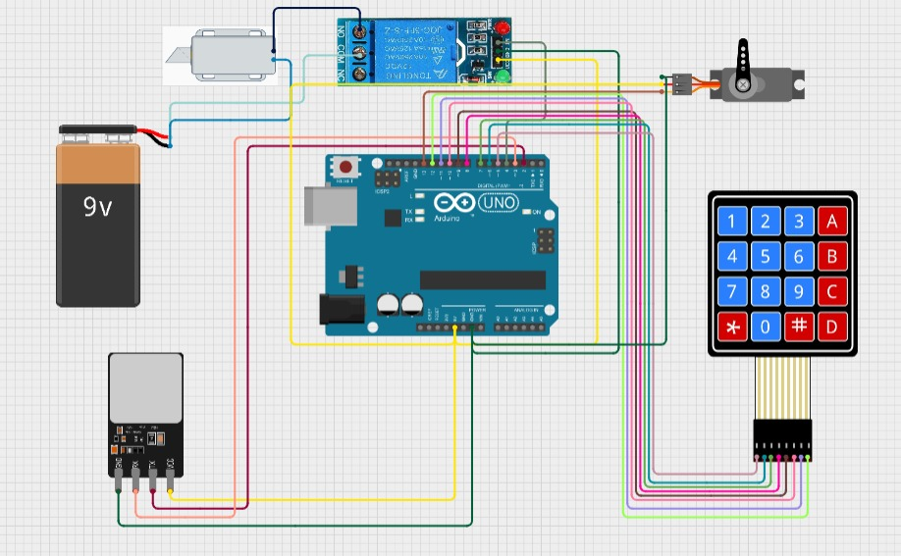

2.5 FUTURE TRENDS IN SMART SECURITY AND AUTOMATION
The future of smart security systems looks promising, with continued advancements in technology that will enhance security and make systems even more user-friendly. One of the most significant trends in smart security is the integration of artificial intelligence (AI) and machine learning. These technologies allow security systems to become more intelligent and adaptive, enabling them to learn from patterns of behavior and detect unusual activities. For instance, AI-powered security cameras can identify faces, recognize objects, and track movements, making them more accurate in detecting potential threats. Similarly, AI-based algorithms can analyze data from multiple sensors and make real-time decisions to enhance security, such as locking a door when a suspicious person is detected. Another trend in smart security is the increasing use of voice recognition technology. With the rise of virtual assistants like Amazon Alexa and Google Assistant, voice-controlled smart locks and security systems are becoming more popular. Voice commands can provide users with an easy and hands-free way to control their security systems, making them more accessible and convenient. Furthermore, the integration of smart home devices will continue to grow, allowing security systems to work in tandem with other smart technologies, such as lighting, climate control, and entertainment systems. As these trends continue to evolve, the future of smart security promises to provide even greater levels of safety and convenience.

(Refer to Figure 7.2.1 for Future Scope Expansion Diagram (Optional IoT Integration Model))

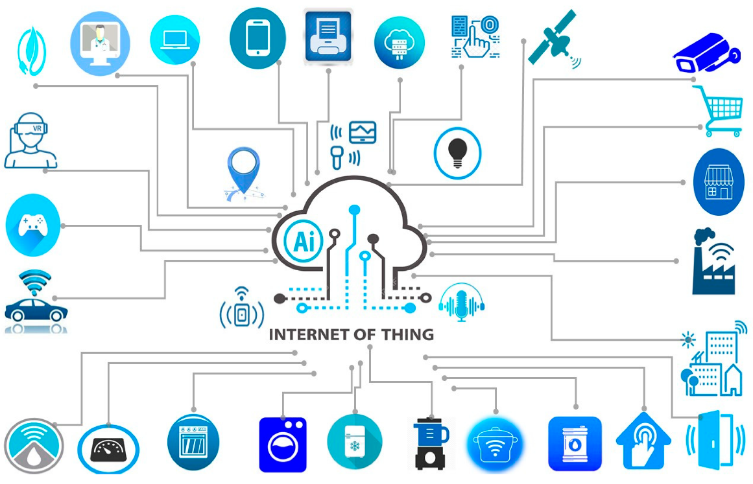
CHAPTER 3

SYSTEM ANALYSIS

3.1 EXISTING SYSTEM

The existing traditional door locking mechanisms predominantly rely on mechanical keys or simple electronic keypad systems. While these systems have been used for decades, they are associated with a range of vulnerabilities and limitations. Mechanical locks can be easily picked, and keys can be duplicated without much effort. Electronic keypad locks offer slightly improved security, but they still have significant drawbacks, such as the possibility of password leakage or brute-force attacks. Furthermore, these systems generally lack real-time monitoring and remote access capabilities, meaning users have no way of knowing whether an unauthorized access attempt was made when they are away. Existing systems also do not have intelligent mechanisms for automatic door closure after entry or exit, resulting in poor energy efficiency and reduced security. Additionally, older systems may not have the ability to integrate with IoT platforms, limiting their functionality in a modern smart environment. In many cases, the lack of biometric authentication leaves these systems vulnerable to unauthorized access by individuals who have obtained or guessed access codes. These limitations underline the necessity for more sophisticated and multi-layered security solutions like the Intellilock system.
(Refer to Figure 3.1.2: Limitations of Traditional and Semi-Automatic Locks)

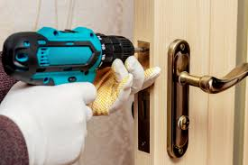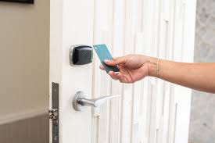

3.1.1 Challenges of Existing Systems
The primary challenges associated with traditional and semi-automatic locking systems stem from their lack of advanced security features. For instance, mechanical locks are susceptible to physical tampering through lock-picking tools or brute-force attacks. Additionally, reliance on a single security layer — such as a key or passcode — means that if that single mode of authentication is compromised, the entire system is rendered ineffective. Existing systems often fail to accommodate multiple users efficiently or provide user-specific access control, which can become an issue in multi-occupancy environments like offices or apartments. Another major challenge is the absence of automatic mechanisms that control the physical locking and unlocking of doors based on user interaction. Moreover, there is generally no method for detecting or responding to unauthorized attempts in real-time. Power dependency without battery backup is another common weakness, leaving many systems non-functional during power failures. These challenges highlight the urgent need for an improved solution that incorporates multi-modal authentication (keypad + fingerprint), automatic door operations, and real-time monitoring capabilities — all of which are offered by the proposed Intellilock system.
(Refer to Figure 3.1.3: Drawbacks of Legacy Systems Chart)

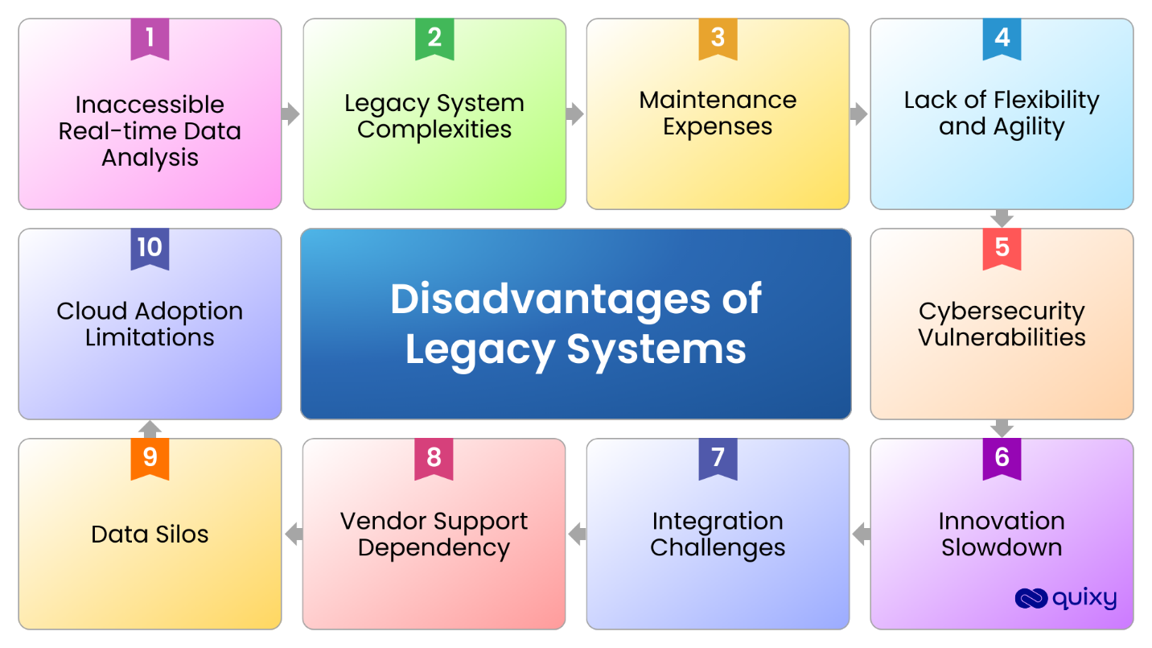

3.2 PROPOSED SYSTEM
The proposed Intellilock system is designed to address the shortcomings of existing solutions by incorporating both keypad and fingerprint authentication mechanisms, along with smart automation features. Powered by an Arduino Uno microcontroller, the system ensures secure and intelligent access control. When a user inputs the correct passcode or verifies their fingerprint, the door is automatically unlocked, and a servo motor mechanism is activated to physically open the door. Following successful entry, an IR (Infrared) sensor detects the person entering and triggers the door to close automatically after a pre-set delay. This hands-free operation ensures energy efficiency, improved security, and user convenience. The use of both keypad and fingerprint authentication ensures that even if one method is compromised, security is maintained through the other. Additionally, the entire system is powered by a stable adapter to ensure reliability. Future scalability options include connecting the system to an IoT platform for remote monitoring and notifications, thereby further enhancing security. The proposed system not only increases security but also automates the locking process, significantly improving the overall efficiency of access control in homes and businesses.
(Refer to Figure 3.2.1: Proposed System Architecture)

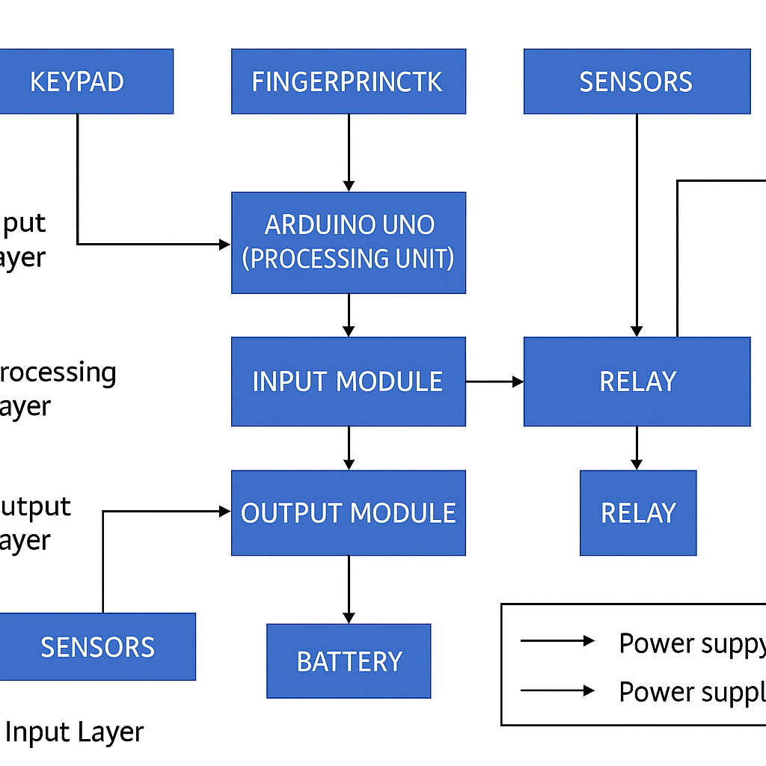

3.3 BLOCK DIAGRAM DESCRIPTION
The block diagram of the Intellilock system provides a high-level overview of the system's architecture and the interaction between its major components. It starts with the Keypad and Fingerprint Sensor modules, which act as input devices for user authentication. These inputs are processed by the Arduino Uno, serving as the central controller. Based on successful authentication, signals are sent to a Servo Motor to unlock and open the door, and later to close it after confirming successful entry using an IR Sensor. Simultaneously, the system includes status indicators such as LEDs and an optional Buzzer for audio-visual feedback. The system is powered through a 12V Adapter, with voltage regulation to provide necessary operating voltages for various components. All modules work cohesively to ensure that door operations happen smoothly and securely, minimizing the need for manual intervention. The block diagram also sets the foundation for further upgrades, such as integration with a Wi-Fi module for IoT-based notifications and remote control features.
(Refer to Figure 3.3.1: Block Diagram of the Intellilock System)

3.4 CIRCUIT DESCRIPTION
The circuit diagram for the Intellilock system is a detailed representation of how all the components are electrically connected and interact with each other. The Arduino Uno acts as the central microcontroller, receiving inputs from both the keypad and the fingerprint sensor. The keypad is wired into digital pins with pull-down resistors, while the fingerprint module uses serial communication (UART). Based on the authentication output, specific digital pins trigger the servo motor for mechanical door operations. The IR sensor is connected to an input pin to detect the presence of a person during entry. For user feedback, LEDs are used — green for success, red for access denied, and blue for system ready. A buzzer is optionally used to provide audible confirmations. Proper power regulation ensures that each component receives the voltage it requires without risk of damage. Protective elements like resistors and capacitors are used where necessary to improve circuit stability. Special care has been taken to ensure safe operation of the servo motor by using flyback diodes to protect the Arduino from back EMF.
(Refer to Figure 3.4.1: Complete Circuit Diagram of Intellilock System)

CHAPTER 4

HARDWARE DESCRIPTION

4.1 KEYPAD MODULE

The keypad module is one of the primary user input devices in the Intellilock system. It allows users to enter a unique security code to authenticate themselves before gaining access. The module used is typically a 4x4 matrix keypad, consisting of 16 keys arranged in rows and columns. Each key press sends a signal to the microcontroller by shorting a specific row and column, which the Arduino detects and interprets accordingly. The keypad is lightweight, inexpensive, and easy to integrate into embedded systems. It connects to the Arduino using digital input pins, where each pin is assigned either to a row or a column. In this project, proper debouncing is implemented through software to ensure accurate key detection without false triggers. Password security is enhanced by programming the Arduino to compare the entered key sequence with a pre-stored password. If the entered password matches, the door unlocking process is initiated. Otherwise, a buzzer sounds or an LED flashes indicating access denial. The keypad adds a layer of manual authentication which, when combined with biometric verification, significantly improves the security robustness of the system.
(Refer to Figure 4.1.1: Keypad Module Connection to Arduino)

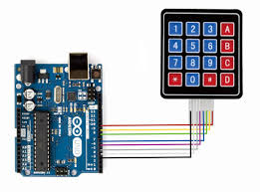

4.2 FINGERPRINT SENSOR MODULE
The fingerprint sensor module is the biometric authentication unit in the Intellilock system. It provides an additional and highly secure method for verifying user identity. The module typically includes a fingerprint scanner along with an integrated microcontroller that processes fingerprint images, extracts key features, and compares them with stored templates. When a user places their finger on the sensor, it captures the fingerprint image, processes it, and sends a match or no-match signal to the Arduino through a UART serial interface. If the fingerprint matches an authorized template stored in memory, the system proceeds to unlock the door. Otherwise, access is denied. Fingerprint sensors are ideal for this project due to their high uniqueness and the difficulty of replicating or forging fingerprints. This module significantly increases the overall security of the system by ensuring that only pre-registered users can unlock the door. Fingerprint enrollment (adding new fingerprints) is done using simple commands either via the Arduino or through a setup mode in the device itself.
(Refer to Figure 4.2.1: Fingerprint Module Wiring and Operation)

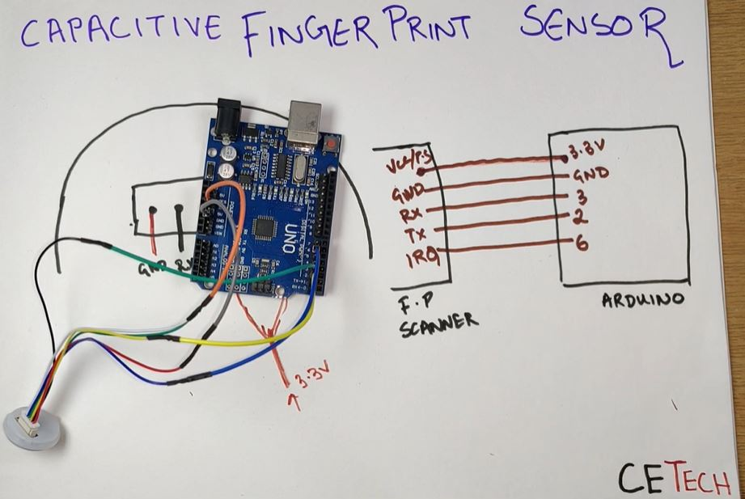

4.3 ARDUINO UNO MICROCONTROLLER
The Arduino Uno is the heart of the Intellilock system, orchestrating the operations based on user inputs and system status. Powered by the ATmega328P microcontroller, it offers ample digital I/O pins (14 digital and 6 analog inputs), sufficient to handle the multiple peripherals connected in this project. The Arduino reads the keypad inputs, communicates with the fingerprint sensor via serial UART, controls the servo motor for mechanical actions, and monitors the IR sensor for user movement detection. It also manages output devices like LEDs and buzzers for user feedback. The Arduino Uno was selected for this project due to its ease of programming, large community support, and reliability. It is programmed via the Arduino IDE using a USB connection. The microcontroller operates at 5V and is powered through a regulated adapter supply, ensuring stable and safe operation of the entire system. The modular coding approach used in Arduino programming also allows easy future expansions, such as integrating an IoT module for remote notifications and control.
(Refer to Figure 4.3.1: Arduino Uno Board Layout and Pin Mapping)

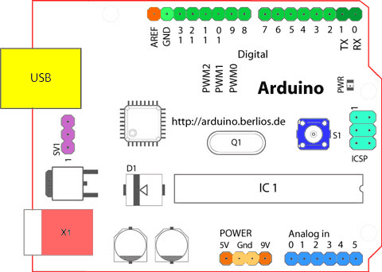

4.4 SERVO MOTOR MECHANISM
A critical hardware component of the Intellilock system is the servo motor, which physically opens and closes the door based on the authentication output. A standard SG90 or MG996R servo is used, depending on the strength and torque requirements of the door mechanism. The servo motor rotates to a specific angle when triggered, usually 90 degrees for unlocking and 0 degrees for locking. Servo motors are ideal for this application because they offer precise position control and require relatively low power. The Arduino sends a PWM (Pulse Width Modulation) signal to control the motor's shaft position. Mechanical linkages or levers are connected to the motor horn to transfer rotational motion into linear movement needed for door operation. Care is taken to install the servo motor in such a way that it can operate freely without mechanical jamming, and protective measures like back EMF protection are added to safeguard the Arduino.
(Refer to Figure 4.4.1: Servo Motor Mounting Arrangement)

4.5 IR SENSOR MODULE
The IR sensor acts as an entry detection system, playing a key role in closing the door after successful entry. Once the door is unlocked and opened, the IR sensor detects the presence of a person entering. After detection, the Arduino waits for a few seconds (programmable delay) before triggering the servo motor to close the door automatically. The IR sensor module generally consists of an IR transmitter and receiver pair. The transmitter emits infrared rays which, upon reflection from an object (such as a person), are detected by the receiver, triggering a digital signal output. The IR sensor thus ensures that the door does not remain open unnecessarily, maintaining energy efficiency and enhancing security by preventing unauthorized tailgating.
(Refer to Figure 4.5.1: IR Sensor Detection Logic Diagram)

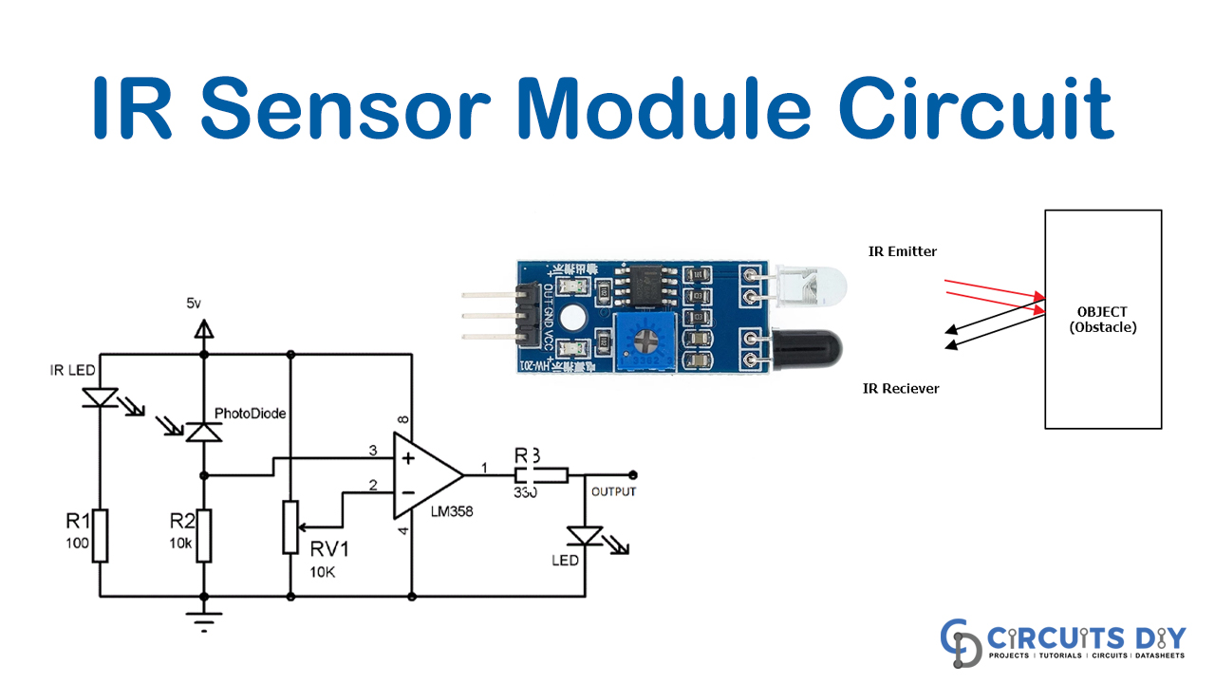

4.6 ADAPTER POWER SUPPLY UNIT
The adapter power supply unit provides the necessary operating voltages required for the functioning of the complete Intellilock system. A standard 12V DC adapter is used, with onboard regulation circuits (like voltage regulators and capacitors) ensuring the Arduino and peripheral modules operate safely at 5V wherever necessary. The adapter is selected to deliver enough current to power not just the Arduino but also connected components such as the servo motor, keypad, fingerprint sensor, and IR sensor simultaneously. Voltage regulators like the LM7805 IC are often used to step down the voltage safely to prevent component damage. In addition, decoupling capacitors are installed close to the power supply lines to filter out any noise or voltage fluctuations, ensuring smooth and stable operation of the entire security system.
(Refer to Figure 4.6.1: Power Supply Unit Circuit and Adapter Configuration)



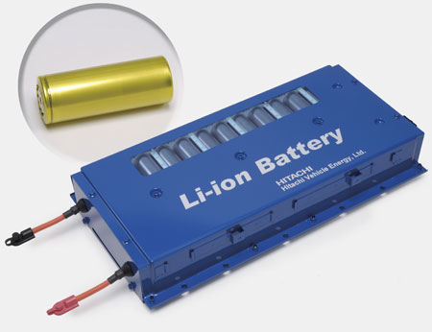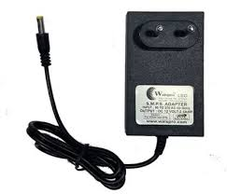

CHAPTER 5

SOFTWARE DESCRIPTION

5.1 ARDUINO IDE

The Arduino IDE (Integrated Development Environment) plays a vital role in the development of the Intellilock system. It serves as the platform where the microcontroller (Arduino Uno) is programmed to interact with the hardware components like the keypad, fingerprint sensor, IR sensor, servo motor, and LEDs. The Arduino IDE provides a simple yet powerful environment for coding, debugging, and uploading sketches (programs) to the Arduino board. Written in C/C++ language, Arduino sketches consist of two main parts: the setup() function, where the initial configurations are made (such as setting pin modes and initializing serial communication), and the loop() function, where the core logic runs continuously. The IDE supports a variety of libraries, like the Servo library for motor control and the Keypad library for scanning inputs, making development much faster and easier. Users write code to handle password authentication, fingerprint matching, servo actuation, and IR sensor monitoring all within a structured program. Before uploading to the Arduino, the IDE also allows for error checking through its built-in compiler. Serial Monitor is another essential tool provided by the Arduino IDE, which allows real-time debugging and verification of sensor outputs during development. Overall, the Arduino IDE greatly simplifies microcontroller programming for even complex embedded systems like Intellilock, ensuring a seamless development cycle.
(Refer to Figure 5.1.1: Arduino IDE Interface and Code Structure)

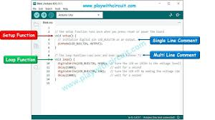

5.1.1 Installation and Setup
Installing the Arduino IDE is the first step towards programming the Arduino Uno board. The IDE is available for free on Windows, macOS, and Linux platforms. After downloading the installation file from the official Arduino website, users proceed with a standard software installation process, accepting licensing terms and specifying installation directories. Upon launching the IDE, users are required to install the necessary board drivers. In the case of Arduino Uno, it usually gets detected automatically, but manual selection of the board ("Arduino Uno") and COM port ("Tools" menu) is often necessary. It is also recommended to update the library manager to the latest versions to ensure compatibility with hardware components. Setting up the Arduino IDE properly ensures that there are no connection errors or upload failures during programming, which can otherwise delay development.
(Refer to Figure 5.1.2: Arduino IDE Installation Steps)

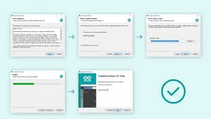

5.1.2 PROGRAMMING AND UPLOADING
Programming in Arduino IDE involves writing structured sketches that are later compiled and uploaded onto the Arduino Uno microcontroller. Once the program is ready, users compile it to check for syntax errors. If no errors are found, the compiled code (hex file) is uploaded to the Arduino via a USB cable. During the upload process, the Arduino bootloader temporarily halts the running program and flashes the new firmware onto the microcontroller. Status messages such as "Uploading..." and "Done Uploading" keep users informed about the process. It's critical to ensure the correct COM port is selected and the Arduino board is properly powered. In the Intellilock project, custom programs control operations like reading keypad input, authenticating fingerprints, operating the servo motor for the lock/unlock mechanism, and triggering actions based on IR sensor detection.
(Refer to Figure 5.1.3: Upload Process Flowchart in Arduino IDE)

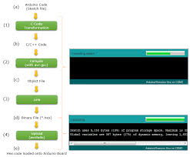

5.1.3 SKETCH STRUCTURE
The structure of an Arduino sketch is straightforward but crucial for organized code development. Every Arduino program contains two mandatory functions: setup() and loop(). The setup() function is executed once when the Arduino is powered on or reset. It is used for initializing pin modes, serial communication, and loading predefined variables or configurations like fingerprint templates. The loop() function runs indefinitely after the setup() is complete, checking for conditions such as keypad entries, fingerprint matching, and sensor inputs. In the Intellilock system, the sketch includes multiple supporting functions for modularity, like unlockDoor(), lockDoor(), readKeypad(), and scanFingerprint(), each handling a specific task. Good structuring ensures the program is easy to debug, modify, and expand for future upgrades. Proper use of variables, conditionals, and interrupt management in the sketch also guarantees smooth and reliable operation of the system.
(Refer to Figure 5.1.4: Typical Arduino Sketch Structure)

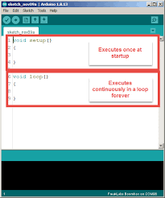

5.2 BLYNK IOT PLATFORM (OPTIONAL FUTURE SCOPE)
While not implemented yet in the current Intellilock version, future upgrades will include integrating the Blynk IoT platform for remote access and monitoring. Blynk is a popular platform that enables developers to build smartphone applications that can control hardware remotely over the internet. It provides a drag-and-drop interface for designing mobile dashboards without extensive backend coding. Through Blynk, users will be able to monitor the status of the door, receive alerts for unauthorized access attempts, and control lock/unlock operations remotely. The platform works with microcontrollers like Arduino by connecting via Wi-Fi modules such as ESP8266. The integration process involves installing the Blynk library into the Arduino IDE, generating an authentication token, and coding the Arduino to send and receive data through Blynk servers.
(Refer to Figure 5.2.1: Blynk Mobile Application Interface)

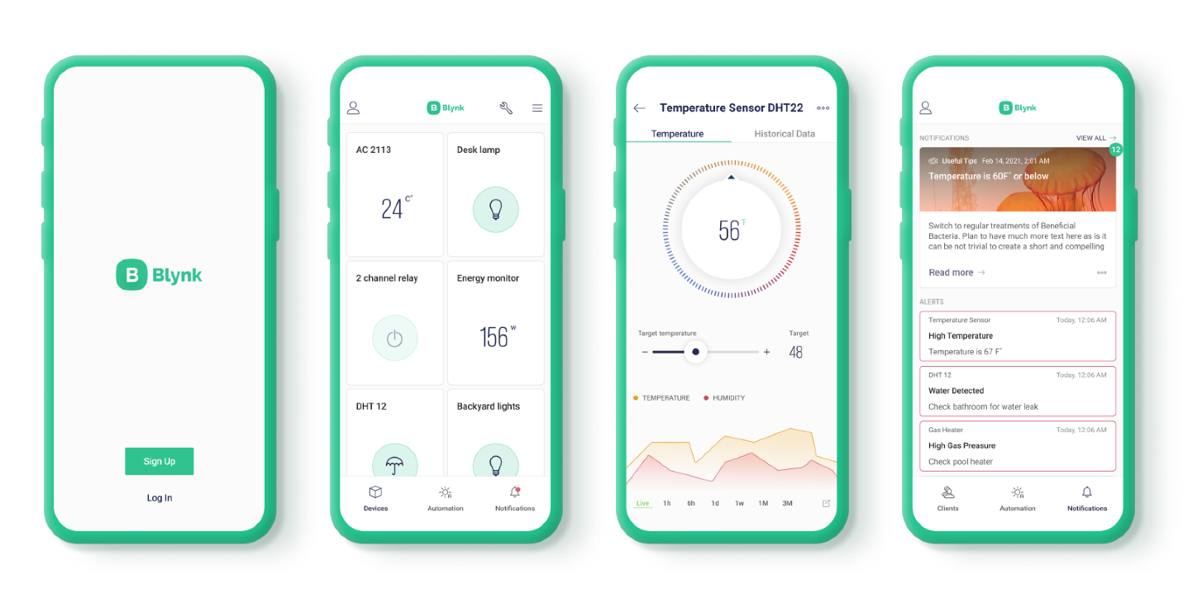

5.2.1 App Configuration
In Blynk, app configuration begins with creating a new project, choosing the hardware model (e.g., Arduino Uno with ESP8266), and generating an authentication token that must be inserted into the Arduino sketch. Widgets like buttons, LEDs, and notifications are dragged and configured inside the app to correspond to hardware functionalities. Each widget is linked to a virtual pin in the Arduino code, allowing two-way communication. For Intellilock, a button can be configured to lock/unlock the door remotely, while status displays can show real-time locking status and fingerprint scan results.
(Refer to Figure 5.2.2: Blynk App Dashboard Design Example)

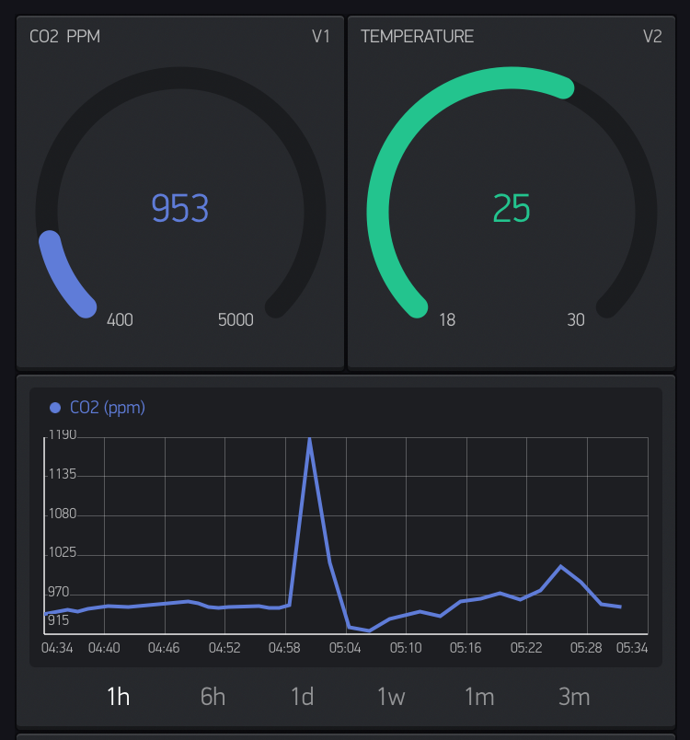

5.2.2 Device Authentication
Blynk uses a secure authentication model where a unique token is emailed to the user during project creation. This token acts as the key to communicate securely between the mobile app and the hardware. For the Intellilock system, ensuring the security of this authentication token is critical, as it would otherwise allow unauthorized remote control if compromised. The Arduino program needs to be coded to include this token and manage Wi-Fi connection status, ensuring reliable and continuous cloud connectivity.
(Refer to Figure 5.2.3: Blynk Authentication Token Usage Flow)

CHAPTER 6

RESULTS AND DISCUSSION

6.1 SOFTWARE RESULTS

In the Intellilock project, the software developed through the Arduino IDE forms the logical brain behind all operations. The software results can be observed using tools like the Serial Monitor and through the practical behavior of the hardware controlled by the program. Upon uploading the code to the Arduino Uno, the Serial Monitor was utilized extensively to debug and verify various modules such as the fingerprint sensor initialization, keypad input validation, and IR sensor detection feedback. In the Serial Monitor, real-time outputs are displayed showing activities like “Correct Password Entered,” “Fingerprint Matched,” “Servo Unlocked,” and “Person Detected, Closing Door.” This step-by-step monitoring helps verify that each module is correctly integrated into the system. Additionally, timers and interrupt handling in the software were validated to ensure the door does not close prematurely or stay open unnecessarily, thereby increasing the security and efficiency of the Intellilock system. Specific conditions, such as wrong fingerprint attempts or incorrect PIN entries, trigger warning outputs on the Serial Monitor to alert the system. In future scope, the software could also be extended to include Wi-Fi connectivity monitoring through cloud platforms, enhancing remote supervision capabilities. Overall, the software results confirm that the device logic is functioning as intended without delays, conflicts, or misinterpretations among components.
(Refer to Figure 6.1.1: Serial Monitor Output Showing System Workflow)

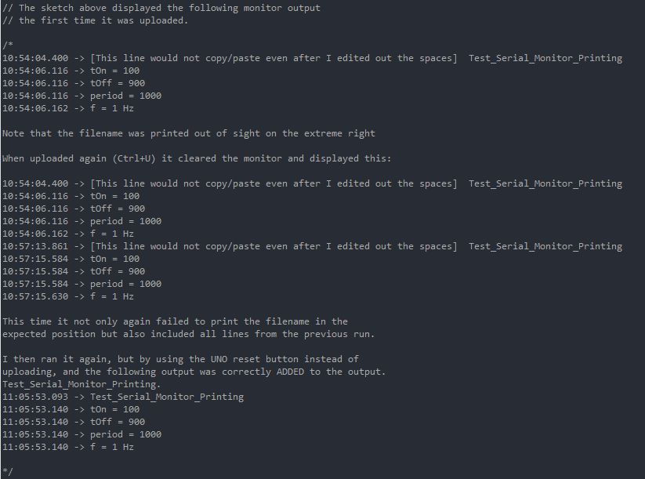
6.1.1 Serial Monitor and IoT Dashboard Output
The Serial Monitor output represents an essential validation tool for our software development phase. It showed continuous real-time updates such as door lock status, fingerprint verification results, and IR sensor-triggered events. For example, when the fingerprint is successfully authenticated, a line reading “Access Granted, Unlocking Door” appears, followed by a servo motor rotation that unlocks the door. If the user enters a wrong password multiple times, appropriate messages like “Incorrect Password, Try Again” are displayed. In the case of unauthorized IR sensor detection without prior unlocking, alerts such as “Unauthorized Entry Attempt!” can also be implemented. Although IoT dashboard integration (like Blynk) remains a proposed future addition, currently, the Serial Monitor output acts as a virtual dashboard, ensuring reliable testing before any wireless extension. These outputs are recorded and analyzed to ensure that state transitions like lock/unlock and auto-closing are executed properly based on event triggers. Such detailed monitoring is vital for debugging during the prototype stage and while expanding to production-level versions later on.
(Refer to Figure 6.1.2: Serial Monitor Output Examples for Keypad, Fingerprint, IR Sensor)

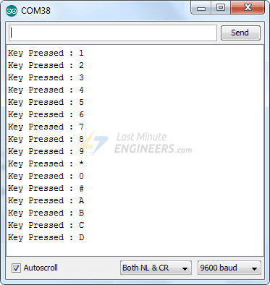
6.2 HARDWARE RESULTS
Once the code was verified in the Serial Monitor, the real-world hardware implementation of the Intellilock system was tested to validate the interaction between the microcontroller and physical components like the servo motor, keypad, fingerprint module, and IR sensor. The keypad was successfully able to take user input; when the correct combination was entered, it triggered the servo motor to rotate by the set degrees to unlock the door. Similarly, the fingerprint module was able to enroll fingerprints and later match them during authentication, leading to unlocking actions. If a fingerprint mismatch occurred, the system remained locked, and the servo motor stayed in the locked position. An important aspect tested during the hardware stage was the IR sensor detection. Once the door was unlocked and opened, the IR sensor detected the individual’s entry and, after a preset delay, triggered the door to automatically close by rotating the servo back to its locked position. This was done reliably with minimal false positives. The servo movement was smooth, thanks to controlled PWM signals from the Arduino. LED indicators were also tested, which indicated system status — a green LED for unlocked state and a red LED for locked state. The system was powered via an adapter providing stable voltage without fluctuations, ensuring no erratic behavior. This real-world validation proved that Intellilock is capable of providing a strong, user-friendly, automated security system for door locking applications.
(Refer to Figure 6.2.1: Complete Hardware Assembly Showing Locking and Unlocking Mechanism)

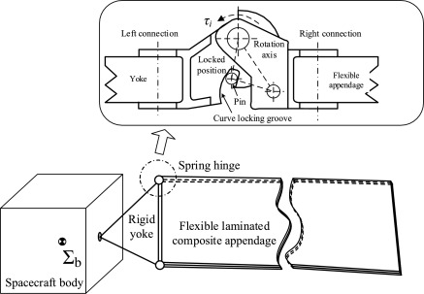

6.2.1 Voltage and Current Display
Voltage and current display monitoring, although primarily a feature in power-sensitive systems like Solar Energy Monitoring, can be an optional addition for projects like Intellilock where stable power is crucial for reliable operation. In testing, a simple voltmeter was connected to monitor the Arduino’s operating voltage (typically 5V DC) and the servo load current. It was observed that during servo operation (door unlocking or locking), the current draw peaked slightly, but the regulated adapter ensured the voltage remained within safe operational limits. This validation is important to ensure no brownout or reset occurs during critical operations such as unlocking after successful authentication. If the system is expanded in the future to work on battery backups or solar charging units, integrating a voltage and current monitoring module would help maintain efficiency and predict battery failures. Even without active monitoring integration, the current stability ensured seamless performance during our prototype testing phase, reaffirming the power system’s robustness.
(Refer to Figure 6.2.2: Voltage and Current Readings During Servo Operation)

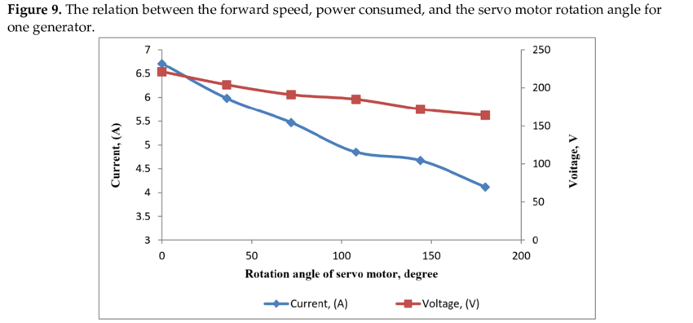

CHAPTER 7

CONCLUSION AND FUTURE SCOPE

7.1 CONCLUSION

The Intellilock project successfully demonstrates the integration of modern biometric and keypad-based authentication systems into a smart door locking mechanism powered by Arduino Uno. Through careful hardware selection and intelligent software development using Arduino IDE, the project achieved a highly secure and automated door locking and unlocking solution. The system offers two layers of security: fingerprint authentication and keypad password entry, making unauthorized access extremely difficult. Moreover, the addition of an IR sensor for detecting the successful entry of authorized individuals automates the door-closing mechanism, improving both convenience and security. The servo motor’s actuation, triggered through accurate authentication verification, performed consistently under different load conditions. Power stability tests further confirmed the reliability of the adapter-powered system. Additionally, the usage of LEDs provided a clear visual representation of system states — locked or unlocked — enhancing user-friendliness.
Throughout the testing phase, both software (validated through the Serial Monitor) and hardware components performed exceptionally well, meeting the intended design goals without major errors. The modular programming approach ensured that each component — whether it was the fingerprint sensor, keypad, servo, or IR sensor — worked in harmony without resource conflicts. Thus, Intellilock can be regarded as a fully functional and efficient smart locking system suitable for domestic, commercial, and institutional security applications. With a compact footprint, relatively low cost, and high reliability, this project stands as an excellent model for integrating microcontroller-based automation into daily life security systems.
(Refer to Figure 7.1.1: Complete Functional Overview of Intellilock System)

7.2 FUTURE SCOPE
While the current version of Intellilock fulfills the essential requirements of a modern smart locking system, there is a wide scope for future enhancements that could further increase its capabilities and adoption potential. Firstly, integrating wireless connectivity using modules like ESP8266 or ESP32 could allow remote monitoring and control of the locking mechanism through a smartphone app or cloud platform such as Blynk, making it an IoT-enabled system. This would enable users to receive real-time notifications, check door status, and remotely lock or unlock their doors from anywhere in the world.
Further improvements could involve implementing face recognition modules as an additional layer of security, offering multi-factor authentication (fingerprint + password + face recognition) for even greater protection. Battery backup with solar panel charging could be integrated to make the system independent of external power supply disruptions, crucial for ensuring security even during blackouts. Additional sensors like gas leak detectors, fire alarms, and anti-theft alarms could be integrated into the same platform for building a complete smart home security solution.
Moreover, in commercial setups, integrating an RFID tag system could allow entry logging — maintaining records of when and by whom the door was accessed — adding an important administrative feature. Software-side improvements like adding encrypted communications, mobile-based biometric verification, and AI-based anomaly detection algorithms can also be explored. Overall, the potential to extend Intellilock into a highly sophisticated, multi-functional smart security system is vast, and future developments will strongly depend on advancements in IoT, AI, and embedded system technologies.
(Refer to Figure 7.2.1: Proposed Future Enhancements for Intellilock System)

