# Technical Design Document: Luis_ProgrammingExercise_6

# Name: Luis Calel De Leon
# Date: November 1, 2026
# Program Description: This program will allow you to create csv file and read the file.

## Function: creating_csv
Creates a CSV file and stores student names and exam grades.

Parameters:
None

Variables:
num_students(int): The number of students the instructor wants to enter.
csvfile(file): The CSV file being created.
writer(object): Writes records into the CSV file.
i(int): Keeps track of the number of students being entered.

Logic:
1. Prompts the instructor to enter the number of students.
2. Opens grades.csv in write mode and creates the file if it doesn't exist.
3. Writes the column headers into the CSV file.
4. Uses a for loop to collect each student's information.
5. Writes each student's name and exam grades as a separate record.

Return:
None

## Function: reading_csv
Reads the grades.csv file and displays student information in tabular format.

Parameters:
None

Variables:
csvfile(file): The CSV file being opened for reading.
reader(object): Reads the records stored in the CSV file.
row(list): Stores each record read from the CSV file.

Logic:
1. Opens grades.csv in read mode.
2. Creates a CSV reader to retrieve the records.
3. Uses a for loop to go through each row in the file.
4. Uses f-string formatting to align the information into columns.
5. Displays each student's information in tabular format.

Return:
None

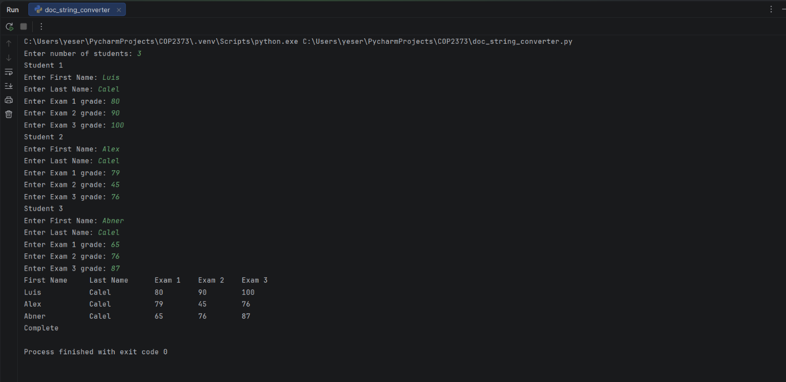

#Link to your repository: https://github.com/alex23442/COP2373.git

