PERSONAL DATA

|  |  |
| --- | --- |
| **Name:** | Alex (Alexey) Haurylchyk |
| **Date of Birth:** | 30/07/1985 |
| **Location:** | Belarus, Minsk |
| **Mobile:** | +375 (33) 332-56-03 |
| **E-mail:** | [ahaur307@gmail.com](mailto:ahaur307@gmail.com) |
| **Skype:** | alexg3007 |
| **LinkedIn:** | [**www.linkedin.com/in/ahaurylchyk**](http://www.linkedin.com/in/ahaurylchyk) |

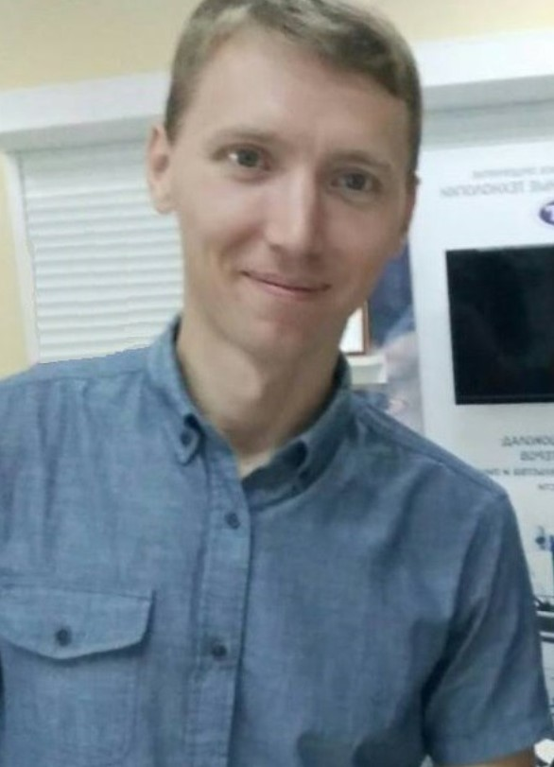

OBJECTIVE

|  |  |
| --- | --- |
| **Desired Position:** | Junior Frontend developer (React) |

SUMMARY OF QUALIFICATION

|  |
| --- |
| I practise Web development starting from 2018 and study all technologies by myself. |

TECHNICAL SKILLS

* Javascript ES6
* CSS 3
* Html 5
* Bootstrap
* React and Redux
* Git

RELEVANT EXPERIENCE

* Web development (Front-End)

Portfolio: [http://alex300785.ws2.cloudpark.tech/#](http://alex300785.ws2.cloudpark.tech/)

* LANGUAGES
* English – Pre-Intermediate
* Russian – Native Speaker
* Belarussian – Native Speaker

EDUCATION

* 2003 – 2008 /Belarusian National Technical University, Information Technologies Faculty / Automation of technological processes (Automation engineer) / Minsk, Belarus
* OTHER INFORMATION ABOUT ME

|  |
| --- |
| I prefer a healthy lifestyle like traveling, biking, jogging and physical exercises. I like self-development activities and the natural sciences. I am free of the bad habits. I can find the way from difficult situation by myself. |

COURSES AND CERTIFICATES

|  |  |  |  |  |  |  |  |  |
| --- | --- | --- | --- | --- | --- | --- | --- | --- |
| |  |  | | --- | --- | | **Course name:** | English | | **Issued:** | Streamline school | | **Year of study:** | 2017 | | **Certificate license number:** | 1-1617-20616 | |

|  |  |
| --- | --- |
| **Course name:** | React |
| **Issued:** | It - incubator |
| **Year of study:** | 2019 |

PROFESSIOANL EXPERIENCE

|  |  |
| --- | --- |
|  | |
| **Company:** | “New optical electronic technologies” |
| **Company Location:** | Belarus, Minsk |
| **Project Industry:** | Automation, Controllers, 3d-printers |
| **Project Web Site:** | <https://by3d.by> |
| **Project Location:** | Belarus, Minsk |
| **Duration:** | 08/2008 – present time |
| **Description:** | Production and integration of automatic devices |
| **Position:** | Chief of department |
| **Overall Team Size:** | 1 developers, 2 QA engineers, 1 manager |
| **Responsibilities:** | * Organization of staff work (4 employees) * Design of structural units in CAD * Contract support * Administration of local network * Corporate website development * 3D printing on 3D printers * Participation in exhibitions |

|  |  |
| --- | --- |
|  | |
| **Company:** | Dzerzhinsk Gymnasium No.1 |
| **Company Location:** | Belarus, Minsk |
| **Project Industry:** | Education |
| **Project Location:** | Belarus, Minsk |
| **Duration:** | 09/2017 – 05/2018 |
| **Position:** | Teacher of additional education |