Modifying STM NUCLEO432KC

The pin in use :

The static pin configuration is defined in file RootDir/local/NUCLEO432/board.cfg
Important pins, are :
PA03 CASTEL_ICU2 ICU AF:TIM15_CH2 #ARD_A2
PA05 CASTEL_ICU1 ICU AF:TIM2_CH1 #ARD_A4
PA08 CASTEL_PWM1 PWM AF:TIM1_CH1 #ARD_D9
PA11 CASTEL_PWM2 PWM AF:TIM1_CH4 #ARD_D10

principle :
For each ESC channel, there is two pins : PWM generation, and ICU input capture.
The two pins has to be linked, and the resulting wire has to be connected to a resistor pullup (2.2kΩ 1/4W resistor conencted to 3.3V)

Wiring :

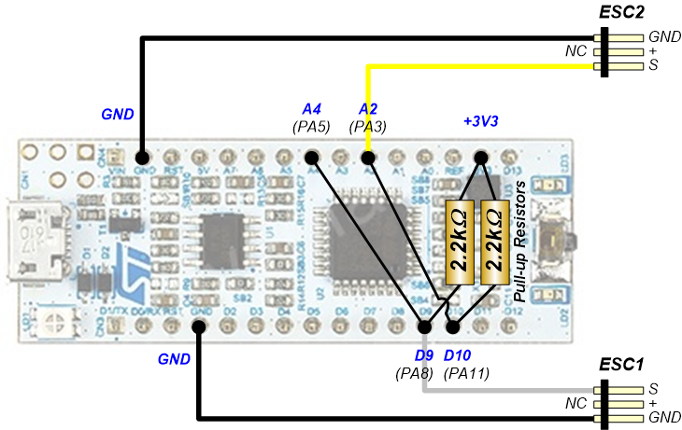

Soldering :

