1. 



(b)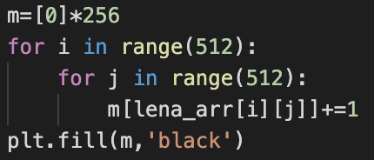

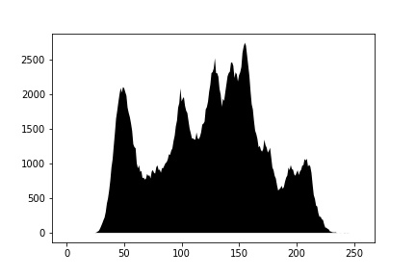

1. using dfs to find all connected component >500

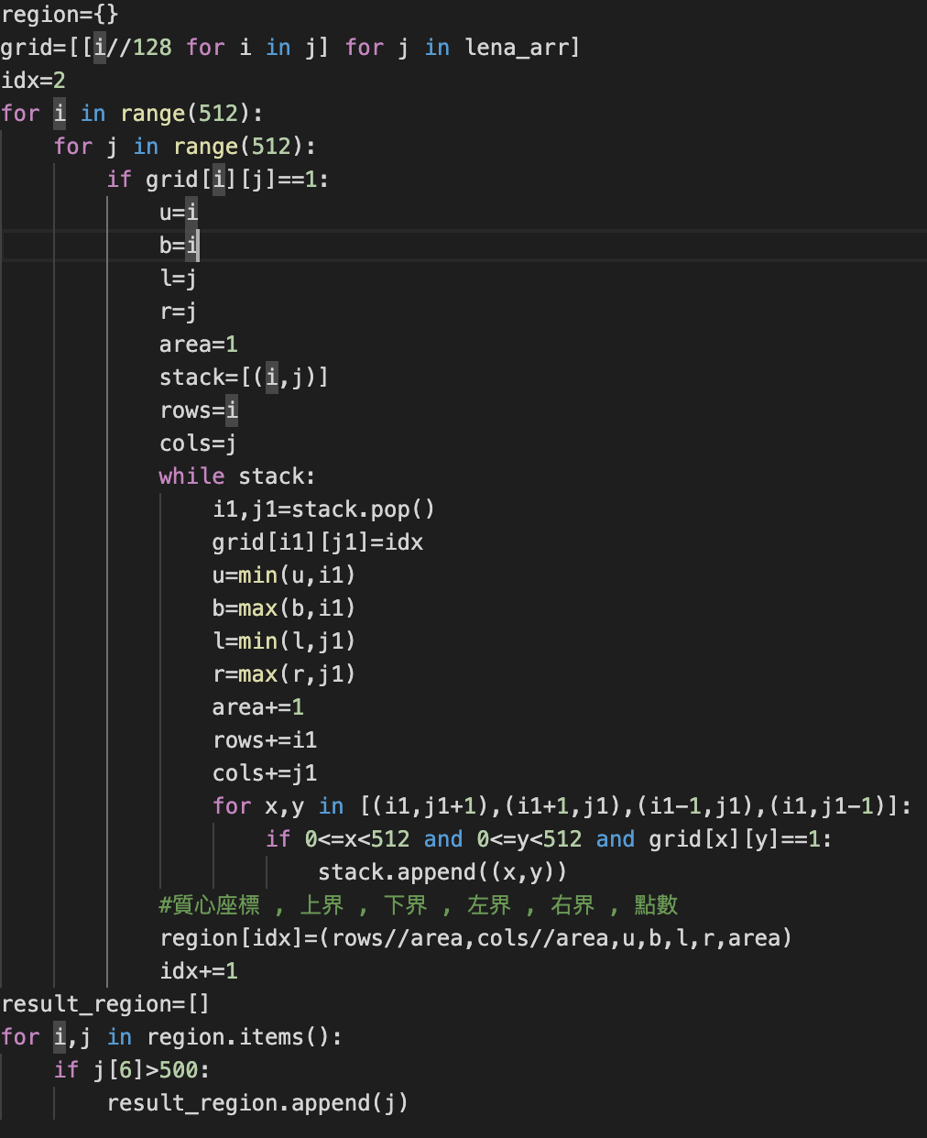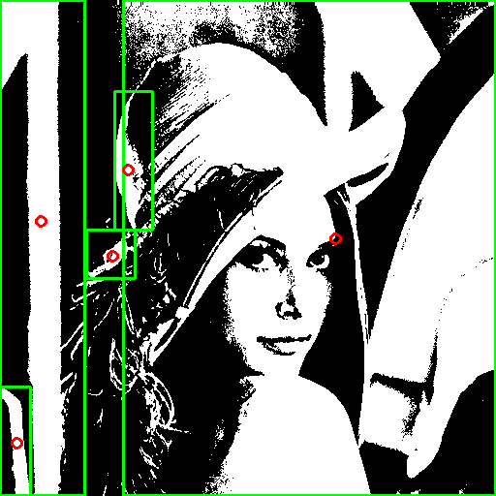4-connectivity

>>result_region

[(228, 42, 0, 511, 0, 87, 35849),

(246, 346, 0, 511, 127, 511, 205524),

(175, 132, 94, 237, 118, 157, 3798),

(264, 116, 237, 287, 89, 139, 1134),

(457, 17, 399, 511, 0, 31, 2827)]