Georgian College 404 page

Users:
Primary user: A future student looking for information. Probably proficient with technologies, but not a geek. Statistically not many health issues, which this website should recognize. Possible color blindness.
Secondary user: A teacher looking to book a tour. Probably proficient with technologies, but not a geek. Possible eyesight issues.

Information Architecture:
Header → Logo and navigation, like on a normal page.
Body → Information about the 404 page. Example: “404 – Looks like you’re looking for a pare that doesn’t exist.”
Footer → Logo, navigation and other information found on a normal page.

Wireframe:

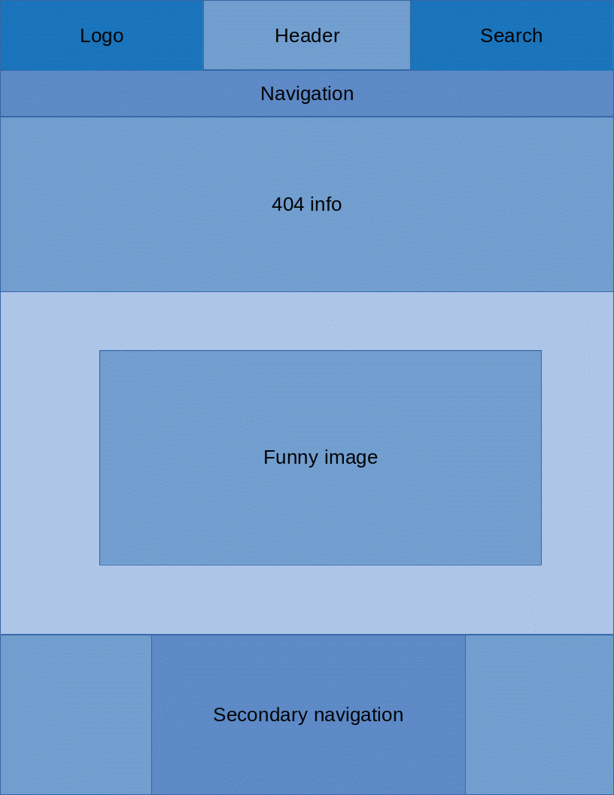

I decided to plan out the website this way, because this makes everything easily readable. The logo and search bar in the header make the website symmetrical. The image will be centered. As well as the secondary navigation in the footer.
When user lands on this page, he will first see the 404 info, then he’ll see a funny image, and see that it’s not something horrible. Then more relaxed, he’ll just look around the page, and either use one of the menus to go back, or use a link provided with the 404 info.

