Made by Alex Zaslavskis 11/02/2021

How make 8BytesCamera.

1) Order / Make by yourself the Pcb or build it on BreadBoard.
2) Connect Arduino to PC and install Arduino IDE
3) Open Calibrate Firmware (calibrate.ino) and upload it by selecting port and pressing Ctrl + U
4) Onen serial port monitor. And take some paper.
4) Take torch in your hand and all some light to leds . As result in you should had two values . When is no light on led`s copy the value. After it add led and copy value for monitor.
5) Open 8BytesCam.ino and type the value then is no light to MAX_0 value
6) type the value then is light on led to MAX_1 value
7) Upload the firmware to Arduino and open software.

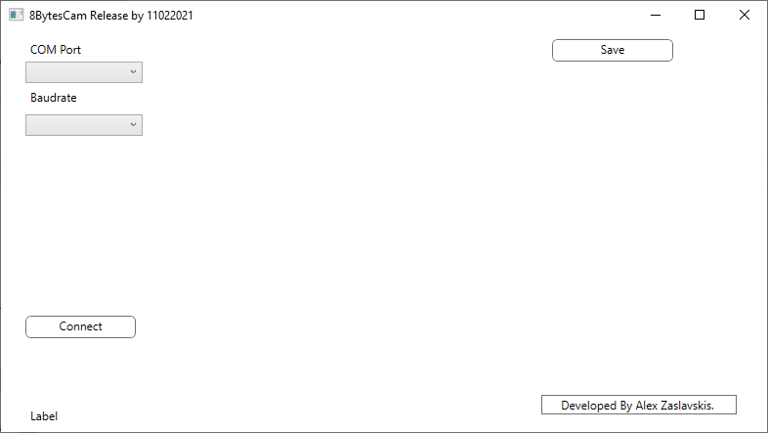
8) Select port in software and Baudrate. The port should be same that you selected to programm arduino. (Do not forget to turn off Arduino software) an press connect .
9) Congraturations you got the 8 Bytes image.
10) By pressing Save button you can save file as .bmp format
11) :)))) IS nice isn`t ?

If reading text instruction for you is complicated , you can watch our video on YouTube.....

