**SoftUni OOP Game Contest**

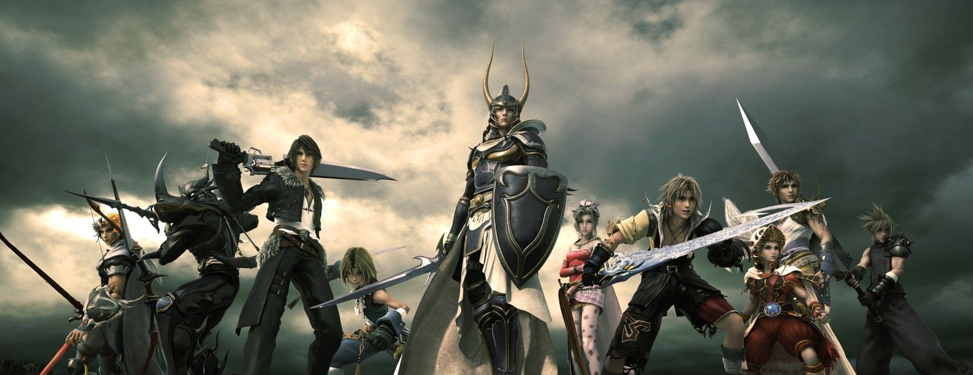

Softuni is organizing a contest for the best **role playing game** from the OOP teamwork projects The winning teams will receive a **grand prize**

The game should be:

* Properly structured OOP
* Awesome
* ... Very Awesome

|  |  |  |
| --- | --- | --- |
| Team | Game | Pints |
| - | - | - |
| - | - | - |
| - | - | - |

The top 3 teams will receive a SPECTACULAR prize:

**A HANDSHAKE FROM NAKOV**