laravel快速配置
一键下载安装
http://www.golaravel.com/download/

服务器配置
- Apache
配置httpd.conf: `php5_module` `rewrite_module`
listen

配置extra/httpd-vhost: `端口` `站点` `域名` `默认首页`
系统host：将`域名`指向本地
重启Apache
Linux系统下，修改文件权限：`storage` `vendor`，Windows系统不分文件权限，不用修改

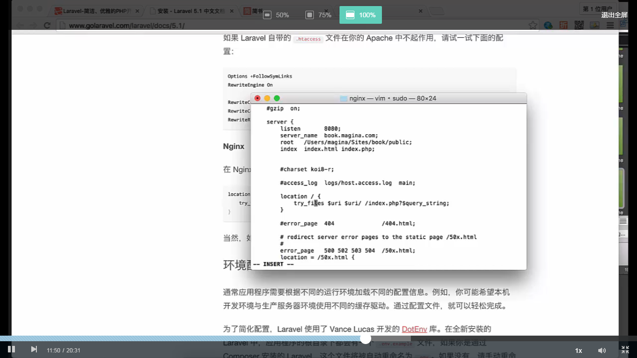

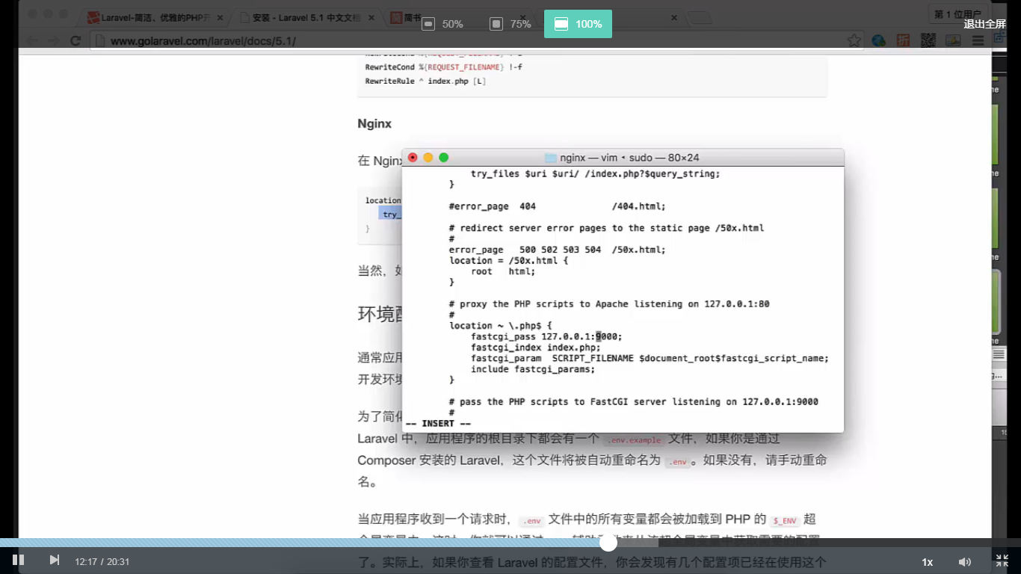

- nginx
配置nginx.conf `端口` `站点` `域名` `默认首页`
FastCgi

location ~ \.php$ {
fastcgi_split_path_info ^(.+\.php)(/.+)$;
# 如果用到 sock 则值参考 unix:/var/run/php/php7.0-fpm.sock
fastcgi_pass 127.0.0.1:9000;
fastcgi_index index.php;
fastcgi_param SCRIPT_FILENAME $document_root$fastcgi_script_name;
include fastcgi_params;
}

配置重写规则

location {
try_files $uri $uri/ /index.php?$query_string;

}

系统host：将`域名`指向本地

重启服务器器
Linux系统下，修改文件权限：`storage` `vendor`，Windows系统不分文件权限，不用修改

- IIS建立站点

新建站点，配置 `站点名称` `域名` `端口` `站点目录`
Hander Mapping -> Add Module Mapping , 将`*..php`用`fastcgi`来解析
配置重写规则，URL rewrite，引入public目录下`.htaccess`,导入即可
配置首页，default document，添加 `index.php`
系统host：将域名指向`本地`
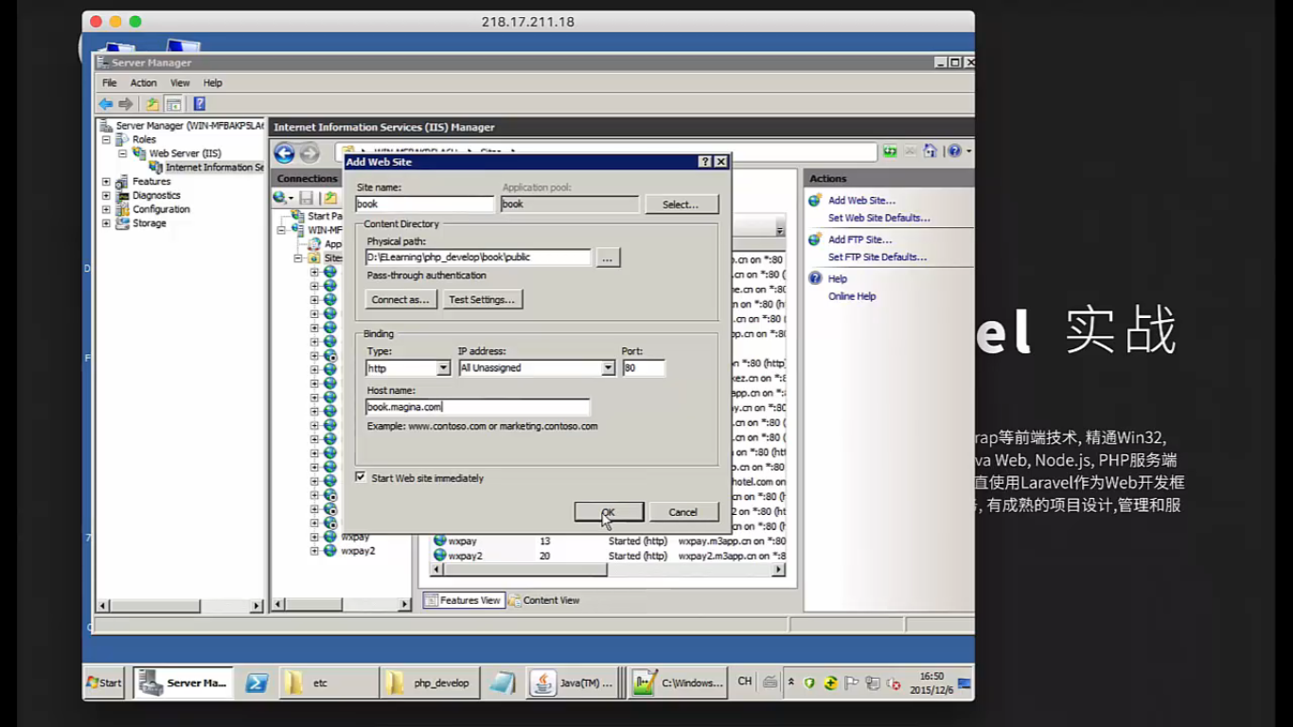

引入fastcgi模块
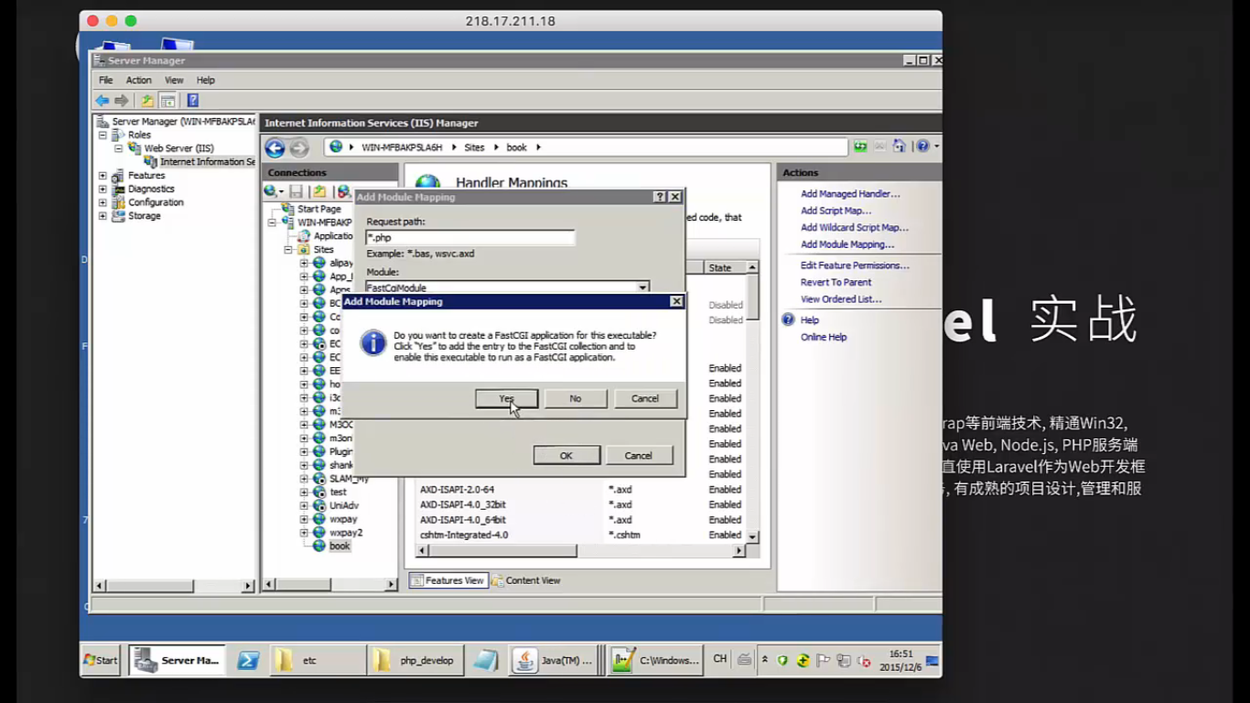

IIS将域名指向本地
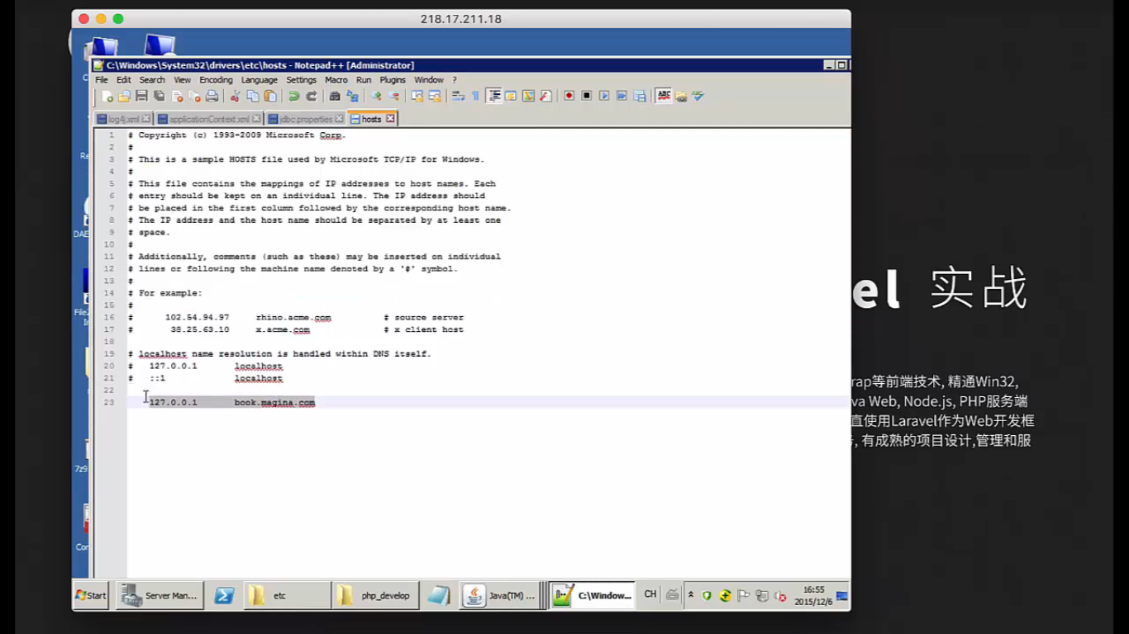

给文件写权限

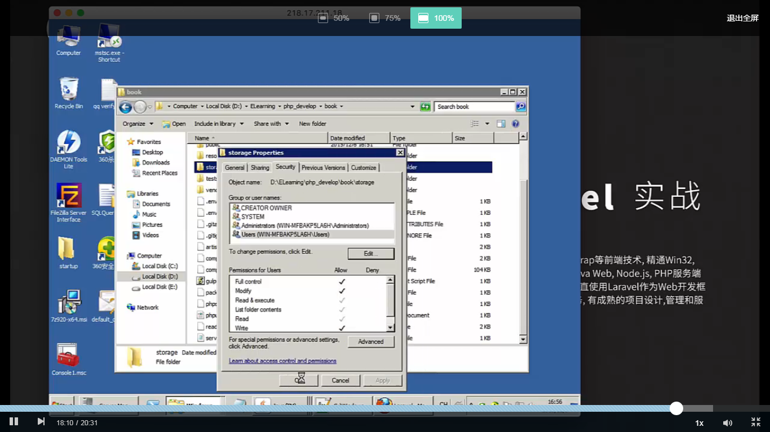

- laravel快速配置
.env
APP_ENV=local
APP_DEBUG=true
APP_KEY=base64:QX3Q4cAdjNP2byizqIJ2IxEx7xMx4PuRi0C5QDqxorc=
APP_URL=http://localhost

DB_CONNECTION=mysql
DB_HOST=127.0.0.1
DB_PORT=3306
DB_DATABASE=laravel5
DB_USERNAME=root
DB_PASSWORD=null

CACHE_DRIVER=file
SESSION_DRIVER=file
QUEUE_DRIVER=sync

REDIS_HOST=127.0.0.1
REDIS_PASSWORD=null
REDIS_PORT=6379

MAIL_DRIVER=smtp
MAIL_HOST=mailtrap.io
MAIL_PORT=2525
MAIL_USERNAME=null
MAIL_PASSWORD=null
MAIL_ENCRYPTION=null

config/app.php
'timezone' => 'Asia/Shanghai',
'locale' => 'zh',
'key' => env('APP_KEY', 'base64:QX3Q4cAdjNP2byizqIJ2IxEx7xMx4PuRi0C5QDqxorc='),

config/database.php

'default' => env('DB_CONNECTION', 'mysql'), //默认数据库连接，可以在.env里面指定

'mysql' => [
'driver' => 'mysql',
'host' => env('DB_HOST', 'localhost'),
'port' => env('DB_PORT', '3306'),
'database' => env('DB_DATABASE', 'forge'),
'username' => env('DB_USERNAME', 'forge'),
'password' => env('DB_PASSWORD', ''),
'charset' => 'utf8',
'collation' => 'utf8_unicode_ci',
'prefix' => '',
'strict' => false,
'engine' => null,
],

//避免出错，可以重复指定

