影像處理HW3

Question 1.

1. matlab code:

RGB = imread('HW4_einstein.tif');

fft_RGB = fft2(RGB);

% get magnitude of DFT Image

fft_Mag = abs(fft_RGB);

fft_Mag= log(fft_Mag+1);

fft_Mag = mat2gray(fft_Mag);

% get phase of DFT Image

fft_phase = angle(fft_RGB);

fft_phase = mat2gray(fft_phase);

% display magnitude and phase

imshow(fft_Mag,[]);

title('magnitude')

figure, imshow(fft_phase,[]);

title('phase')

2. 作法:

(1) 讀檔後將RGB值轉入頻域

(2) 計算magnitude時，使用絕對值以及取log計算(+1是為了避免log 0 的出現)，最後限制magnitude值在0~1

(3) 計算phase時，直接使用function取得角度值，一樣限制在0~1

(4) output成圖片

3. 結果

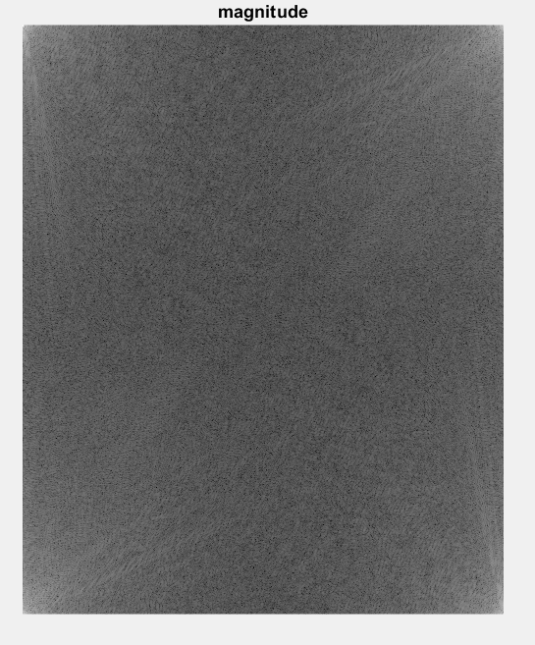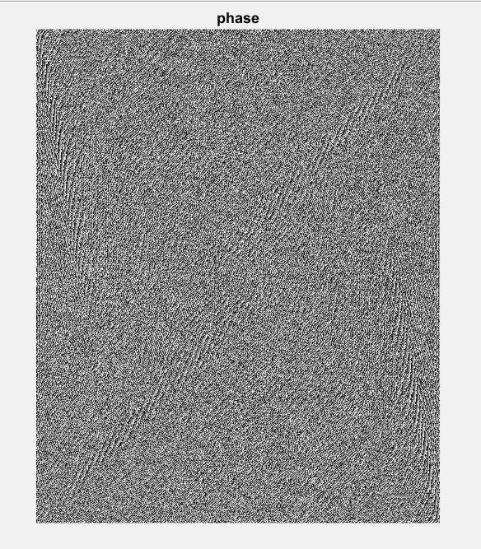

Question 2:

1. matlab code:

RGB = imread('HW4_einstein.tif');

fft_RGB = fft2(RGB);

%place the DC value into middle

fft_RGB = fftshift(fft_RGB);

% get magnitude of DFT Image

fft_Mag = abs(fft_RGB);

fft_Mag= log(fft_Mag+1);

fft_Mag = mat2gray(fft_Mag);

% get phase of DFT Image

fft_phase = angle(fft_RGB);

fft_phase = mat2gray(fft_phase);

% display magnitude and phase

imshow(fft_Mag,[]);

title('magnitude')

figure, imshow(fft_phase,[]);

title('phase')

2. 作法:

(1) 在將RGB值轉入頻域後，以fftshift這個function將數值置中，其他同Q1

3. 結果:

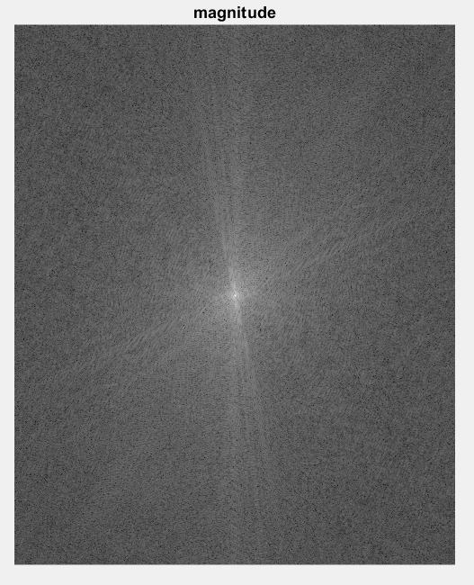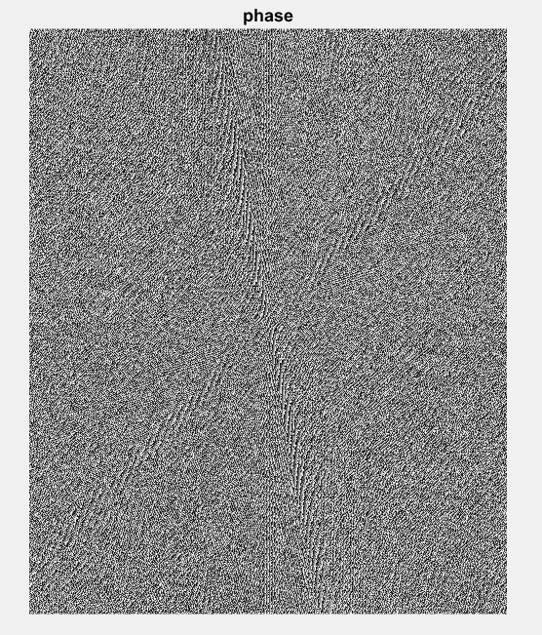

Question 3

1. matlab code:

RGB = imread('HW4_einstein.tif'); %ÅªÀÉ

fft_RGB = fft2(RGB);

fft_RGB = fftshift(fft_RGB);

[M N]=size(fft_RGB);

P_1=10;

P_2=20;

P_3=30;

newX=0:N-1;

newY=0:M-1;

[newX newY]=meshgrid(newX,newY);

fix_X=0.5*N;

fix_Y=0.5*M;

filter1=exp(-((newX - fix_X).^2 + (newY - fix_Y).^2)./(2 * P_1).^2);

filter2=exp(-((newX - fix_X).^2 + (newY - fix_Y).^2)./(2 * P_2).^2);

filter3=exp(-((newX - fix_X).^2 + (newY - fix_Y).^2)./(2 * P_3).^2);

output1 = fft_RGB.*filter1;

output1 = ifftshift(output1);

output1 = ifft2(output1);

output2 = fft_RGB.*filter2;

output2 = ifft2(ifftshift(output2));

output3 = fft_RGB.*filter3;

output3 = ifft2(ifftshift(output3));

imshow(output1,[])

title('Filter Parameter=10')

figure, imshow(output2,[])

title('Filter Parameter=20')

figure, imshow(output3,[])

title('Filter Parameter=30')

[M, N] = size(RGB);

zero_padding = padarray(RGB, [M, N], 0, 'post');

fft_RGB=fftshift(fft2(zero_padding));

[M,N]=size(fft_RGB);

newX=0:N-1;

newY=0:M-1;

[newX,newY]=meshgrid(newX,newY);

Cx=0.5*N;

Cy=0.5*M;

filter4=exp(-((newX-Cx).^2+(newY-Cy).^2)./(2*P_3).^2);

output4=fft_RGB.*filter4;

output4=ifft2(ifftshift(output4));

[M, N] = size(RGB);

figure, imshow(output4(1:M,1:N),[])

title('with padding, filter parameter=15')

2. 作法:

(1) 將RGB轉入頻域後，依照圖片的大小以及設定的參數製作filter

(2) 將圖片套入filter

(3) 將圖片轉回時域

(4) output出圖片

(5)加入zero padding再一次

3. 結果

