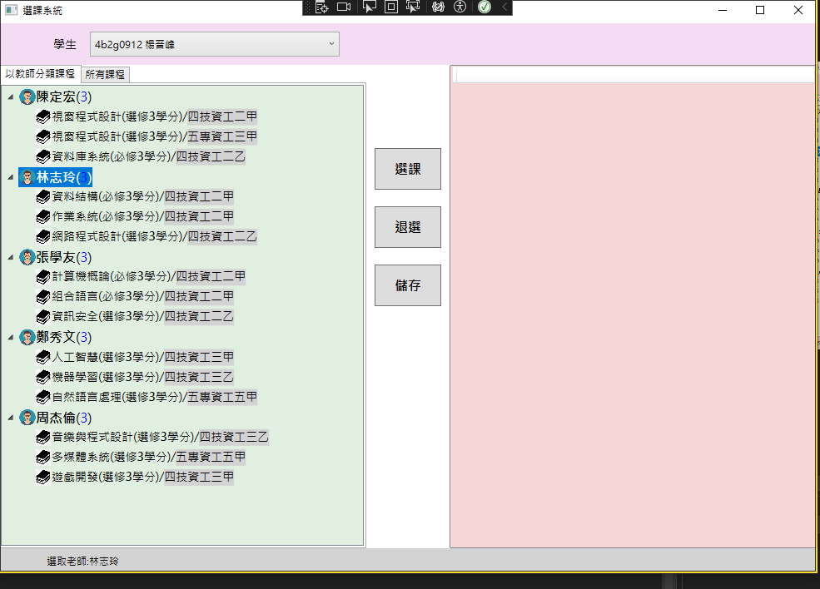

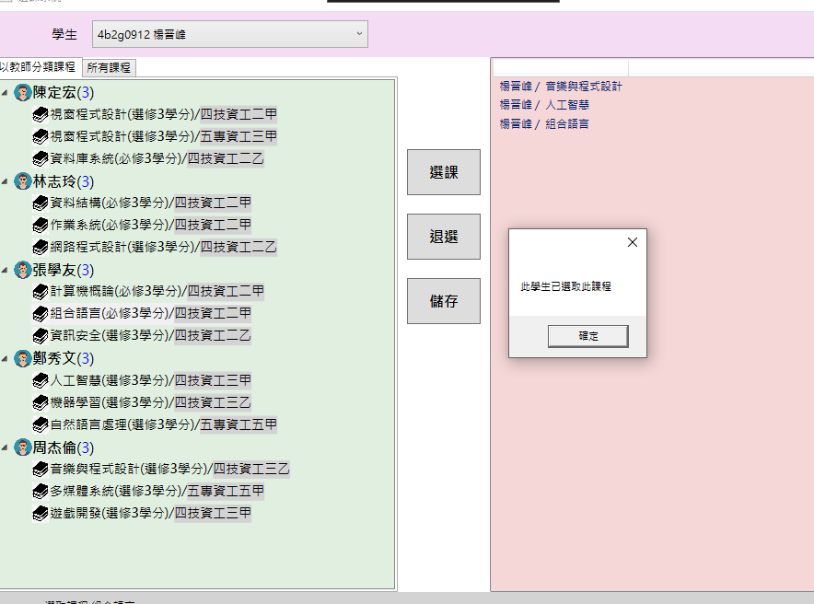

using System.Text;

using System.Windows;

using System.Windows.Controls;

using System.Windows.Data;

using System.Windows.Documents;

using System.Windows.Input;

using System.Windows.Media;

using System.Windows.Media.Imaging;

using System.Windows.Media.Media3D;

using System.Windows.Navigation;

using System.Windows.Shapes;

namespace _20241210Wpf

{

/// <summary>

/// Interaction logic for MainWindow.xaml

/// </summary>

public partial class MainWindow : Window

{

// 建立學生、教師、課程和紀錄的列表

List<Student> students = new List<Student>();

List<Teacher> teachers = new List<Teacher>();

List<Course> courses = new List<Course>();

List<Record> records = new List<Record>();

// 建立所選擇的學生、教師、課程和紀錄的變數

Student selectedStudent = null;

Teacher selectedTeacher = null;

Course selectedCourse = null;

Record selectedRecord = null;

public MainWindow()

{

InitializeComponent();

InitailizeData(); // 初始化數據

}

private void InitailizeData()

{

// 新增學生資料，連結至cmbStudent

students.Add(new Student { StudentId = "4b2g0912", StudentName = "楊晋峰" }); // 新增學生"楊晋峰"

students.Add(new Student { StudentId = "4b2g0002", StudentName = "華" }); // 新增學生"華"

students.Add(new Student { StudentId = "4b2g0012", StudentName = "英" }); // 新增學生"英"

cmbStudent.ItemsSource = students; // 設定cmbStudent的項目來源為students列表

cmbStudent.SelectedIndex = 0; // 預設選擇第一個學生

// 新增教師資料以及所授課程

Teacher teacher1 = new Teacher("陳定宏"); // 新增教師"陳定宏"

teacher1.TeachingCourses.Add(new Course { CourseName = "視窗程式設計", OpeningClass = "四技資工二甲", Point = 3, Tutor = teacher1, Type = "選修" }); // 新增課程"視窗程式設計"

teacher1.TeachingCourses.Add(new Course { CourseName = "視窗程式設計", OpeningClass = "五專資工三甲", Point = 3, Tutor = teacher1, Type = "選修" }); // 新增課程"視窗程式設計"

teacher1.TeachingCourses.Add(new Course { CourseName = "資料庫系統", OpeningClass = "四技資工二乙", Point = 3, Tutor = teacher1, Type = "必修" }); // 新增課程"資料庫系統"

teachers.Add(teacher1); // 將teacher1加入teachers列表

Teacher teacher2 = new Teacher("林志玲"); // 新增教師"林志玲"

teacher2.TeachingCourses.Add(new Course { CourseName = "資料結構", OpeningClass = "四技資工二甲", Point = 3, Tutor = teacher2, Type = "必修" }); // 新增課程"資料結構"

teacher2.TeachingCourses.Add(new Course { CourseName = "作業系統", OpeningClass = "四技資工二甲", Point = 3, Tutor = teacher2, Type = "必修" }); // 新增課程"作業系統"

teacher2.TeachingCourses.Add(new Course { CourseName = "網路程式設計", OpeningClass = "四技資工二乙", Point = 3, Tutor = teacher2, Type = "選修" }); // 新增課程"網路程式設計"

teachers.Add(teacher2); // 將teacher2加入teachers列表

Teacher teacher3 = new Teacher("張學友"); // 新增教師"張學友"

teacher3.TeachingCourses.Add(new Course { CourseName = "計算機概論", OpeningClass = "四技資工二甲", Point = 3, Tutor = teacher3, Type = "必修" }); // 新增課程"計算機概論"

teacher3.TeachingCourses.Add(new Course { CourseName = "組合語言", OpeningClass = "四技資工二甲", Point = 3, Tutor = teacher3, Type = "必修" }); // 新增課程"組合語言"

teacher3.TeachingCourses.Add(new Course { CourseName = "資訊安全", OpeningClass = "四技資工二乙", Point = 3, Tutor = teacher3, Type = "選修" }); // 新增課程"資訊安全"

teachers.Add(teacher3); // 將teacher3加入teachers列表

// 新增更多教師和課程

Teacher teacher4 = new Teacher("鄭秀文"); // 新增教師"鄭秀文"

teacher4.TeachingCourses.Add(new Course { CourseName = "人工智慧", OpeningClass = "四技資工三甲", Point = 3, Tutor = teacher4, Type = "選修" }); // 新增課程"人工智慧"

teacher4.TeachingCourses.Add(new Course { CourseName = "機器學習", OpeningClass = "四技資工三乙", Point = 3, Tutor = teacher4, Type = "選修" }); // 新增課程"機器學習"

teacher4.TeachingCourses.Add(new Course { CourseName = "自然語言處理", OpeningClass = "五專資工五甲", Point = 3, Tutor = teacher4, Type = "選修" }); // 新增課程"自然語言處理"

teachers.Add(teacher4); // 將teacher4加入teachers列表

Teacher teacher5 = new Teacher("周杰倫"); // 新增教師"周杰倫"

teacher5.TeachingCourses.Add(new Course { CourseName = "音樂與程式設計", OpeningClass = "四技資工三乙", Point = 3, Tutor = teacher5, Type = "選修" }); // 新增課程"音樂與程式設計"

teacher5.TeachingCourses.Add(new Course { CourseName = "多媒體系統", OpeningClass = "五專資工五甲", Point = 3, Tutor = teacher5, Type = "選修" }); // 新增課程"多媒體系統"

teacher5.TeachingCourses.Add(new Course { CourseName = "遊戲開發", OpeningClass = "四技資工三甲", Point = 3, Tutor = teacher5, Type = "選修" }); // 新增課程"遊戲開發"

teachers.Add(teacher5); // 將teacher5加入teachers列表

tvTeacher.ItemsSource = teachers; // 設定tvTeacher的項目來源為teachers列表

foreach (Teacher teacher in teachers)

{

foreach (Course course in teacher.TeachingCourses)

{

courses.Add(course); // 將每個教師的課程加入courses列表

}

}

lbCourse.ItemsSource = courses; // 設定lbCourse的項目來源為courses列表

}

private void tvTeacher_SelectedItemChanged(object sender, RoutedPropertyChangedEventArgs<object> e)

{

if (tvTeacher.SelectedItem is Teacher)

{

selectedTeacher = tvTeacher.SelectedItem as Teacher; // 獲取所選的教師

statusLabel.Content = $"選取老師:{selectedTeacher.TeacherName}"; // 顯示所選教師的名字

}

if (tvTeacher.SelectedItem is Course)

{

selectedCourse = tvTeacher.SelectedItem as Course; // 獲取所選的課程

statusLabel.Content = $"選取課程:{selectedCourse.CourseName}"; // 顯示所選課程的名字

}

}

private void btnAdd_Click(object sender, RoutedEventArgs e)

{

if (selectedStudent == null || selectedCourse == null)

{

MessageBox.Show("選取學生或課程"); // 提示用戶選取學生或課程

return;

}

else

{

Record record = new Record()

{

SelectedStudent = selectedStudent, // 設定所選學生

SelectedCourse = selectedCourse // 設定所選課程

};

foreach (Record r in records)

{

if (r.Equals(record))

{

MessageBox.Show("已選取此課程"); // 提示用戶此學生已選取該課程

return;

}

}

records.Add(record); // 新增紀錄至records列表

lvRecord.ItemsSource = records; // 更新lvRecord的項目來源

lvRecord.Items.Refresh(); // 刷新lvRecord顯示

}

}

private void cmbStudent_SelectionChanged(object sender, System.Windows.Controls.SelectionChangedEventArgs e)

{

selectedStudent = cmbStudent.SelectedItem as Student; // 獲取所選的學生

statusLabel.Content = $"選取學生:{selectedStudent.StudentName}"; // 顯示所選學生的名字

}

private void lbCourse_SelectionChanged(object sender, System.Windows.Controls.SelectionChangedEventArgs e)

{

selectedCourse = lbCourse.SelectedItem as Course; // 獲取所選的課程

statusLabel.Content = $"選取課程:{selectedCourse.CourseName}"; // 顯示所選課程的名字

}

}

}