**Inventory Lab**

Name: Chi Ming Lai

student id: 158400200

Email: cmlai@myseneca.ca

Section: SYD366 ZAA

Date: 17-06-2022

Professor: Marc Gurwitz

Class Diagram

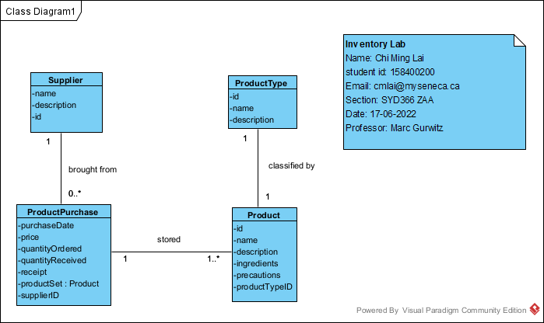

1. Add New product

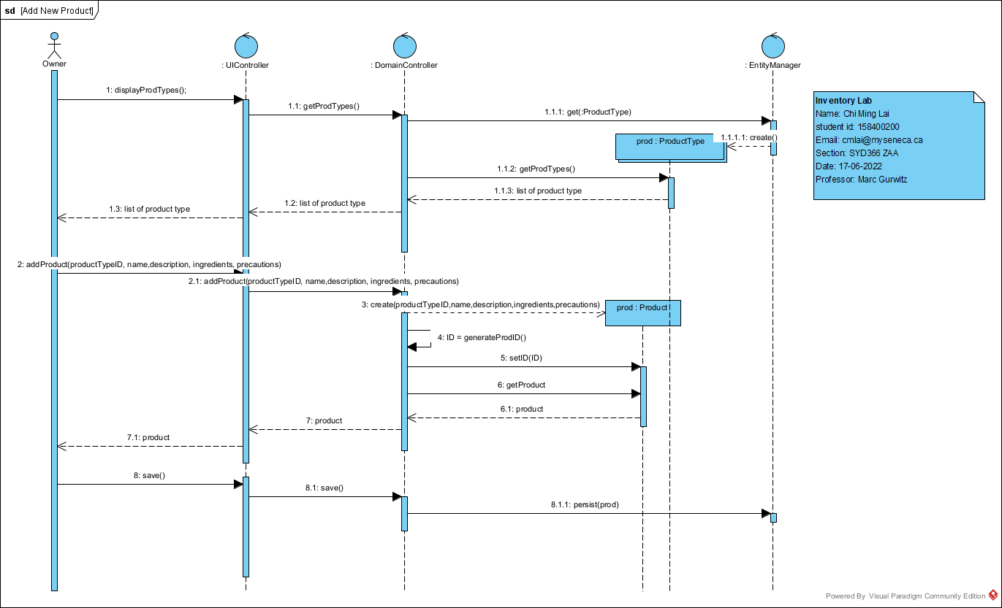

1. Add Items to Inventory

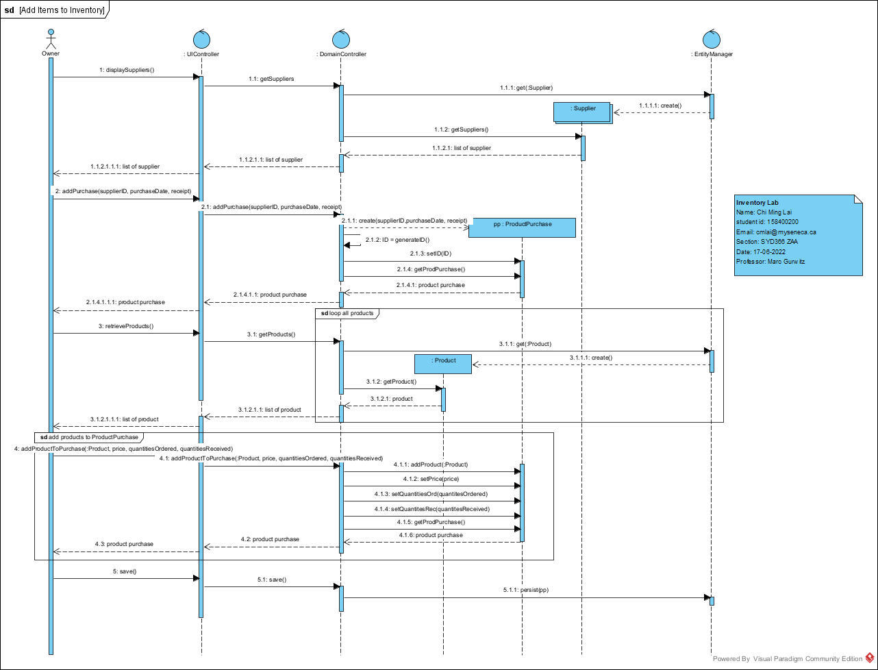

1. Query Purchases

