**Defining Classes Labs – Part 2**

**Group: 1**

**Name**: Chi Ming Lai, Chun Wing Mak, Kin Lok Chan, Wing Ho Cheung, Yatka Fung

**Student Number**: 158400200, 126998210, 119293215, 158387209, 151520202

**Section**: SYD366 ZAA

**Date**: 27-05-2022

**Professor**: Marc Gurwitz

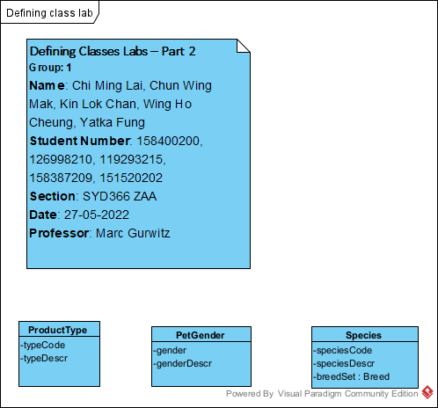

Change a product type description

