**MONEY LAB**

**Group: 1**

**Name**: Chi Ming Lai

**Student Number**: 158400200

**Section**: SYD366 ZAA

**Date**: 03-06-2022

**Professor**: Marc Gurwitz

Class Diagram:

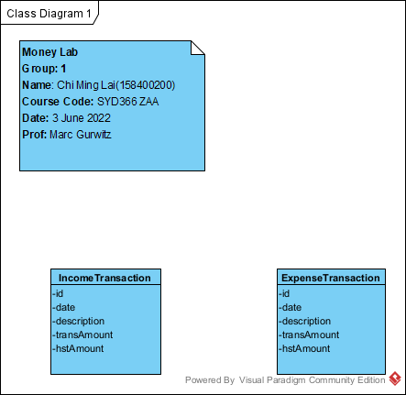

Create an income transaction

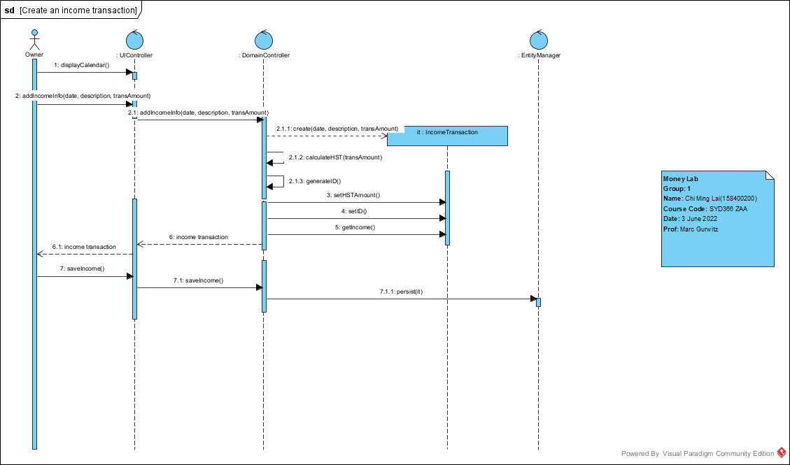

Create an expense transaction

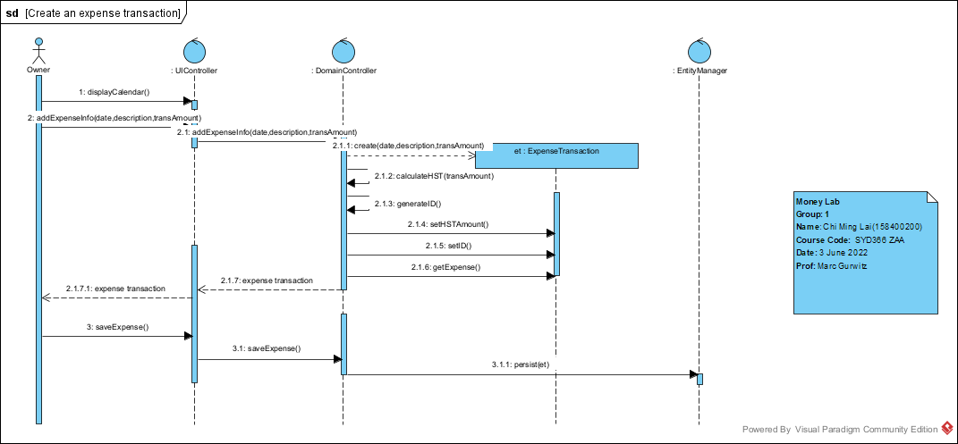

Query Financial Transaction

