MITRAHSOFT
ColdFusion Engineering — Proof of Concept
cf-token-manager
A JWT Access & Refresh Token Lifecycle Package for ColdFusion (CFML)
A reusable ColdFusion package that gives developers a complete JWT login system — issue, verify, decode and refresh access & refresh tokens — instead of the raw encode/decode primitives that every existing package stops at. It runs on all three CF engines (Adobe ColdFusion, Lucee, BoxLang), was proven with a live ColdBox app, and is deployed publicly on the internet.
Package | cf-token-manager
Version | 1.0.0 (initial release)
Type | ColdBox Module (service-only — no inbound routes)
Platform | CommandBox + ColdBox (MVC)
Engine support | Adobe ColdFusion >=2021 · Lucee >=5.3 · BoxLang >=1.0.0
Package repo | github.com/alexMs771/cf-token-manager
Install | box install github:alexMs771/cf-token-manager
Live demo | https://jwt-testing-app.onrender.com/
Test app repo | github.com/alexMs771/JWT_testing_APP
Distribution | Private / GitHub now → ForgeBox planned
License | MIT
Status | ✅ POC validated on a live, deployed ColdBox application

Prepared by the JWT Package Team, MitrahSoft
Tested with the TestingApp ColdBox application · Deployed live on Lucee 6 via CommandBox + Docker on Render

Table of Contents
1. Executive Summary
2. The Story — How This Task Started
3. Research — What We Learned About JWT in ColdFusion
4. The Gap We Found & Our Idea
5. What Is a JWT? (Plain-English Primer)
6. Package Structure
7. Architecture — The Two Layers
8. The Java Library — Why and What For
9. Public API Reference
10. Configuration — What the Developer Controls
11. Developer Workflow — How Easy It Is to Use
12. How We Tested It — The Live ColdBox App
13. Distribution — From Local Module to Installable Package
14. Deployment — Live on the Internet
15. Maintainability — Why This Is Easy to Keep Alive
16. ForgeBox Publishing Plan
17. Roadmap
18. Conclusion & Recommendation
19. Appendix — Glossary

1. Executive Summary
Our ColdFusion team lead asked us to build a reusable JWT token package for CommandBox / ColdBox and to contribute it to ForgeBox (the ColdFusion package registry).
We researched the existing landscape thoroughly (Adobe's native JWT functions, older package-based approaches, manual JWT construction, and Lucee/BoxLang options). We found that many JWT packages already exist, but they all stop at the low level — they can encode, decode, and verify a single token, and then leave the developer to hand-build everything a real login actually needs: payloads, expiry policy, and especially the access-token + refresh-token pattern.
So we built `cf-token-manager`: a thin, opinionated lifecycle layer that sits on top of a proven JWT engine and gives developers a batteries-included API:
issue() // mint an access + refresh token pair for a user
verify() // is this token authentic, unexpired, and the right type?
decode() // read the claims inside a token
refresh() // swap a valid refresh token for a fresh access token
We signed tokens using the JVM's `javax.crypto` classes so the behaviour is identical on Adobe ColdFusion, Lucee, and BoxLang. We proved it with a live ColdBox application (automated self-tests + a real login → dashboard → auto-refresh → auto-logout flow) and deployed it to the public internet. Version 2 will add role-based authentication.

2. The Story — How This Task Started
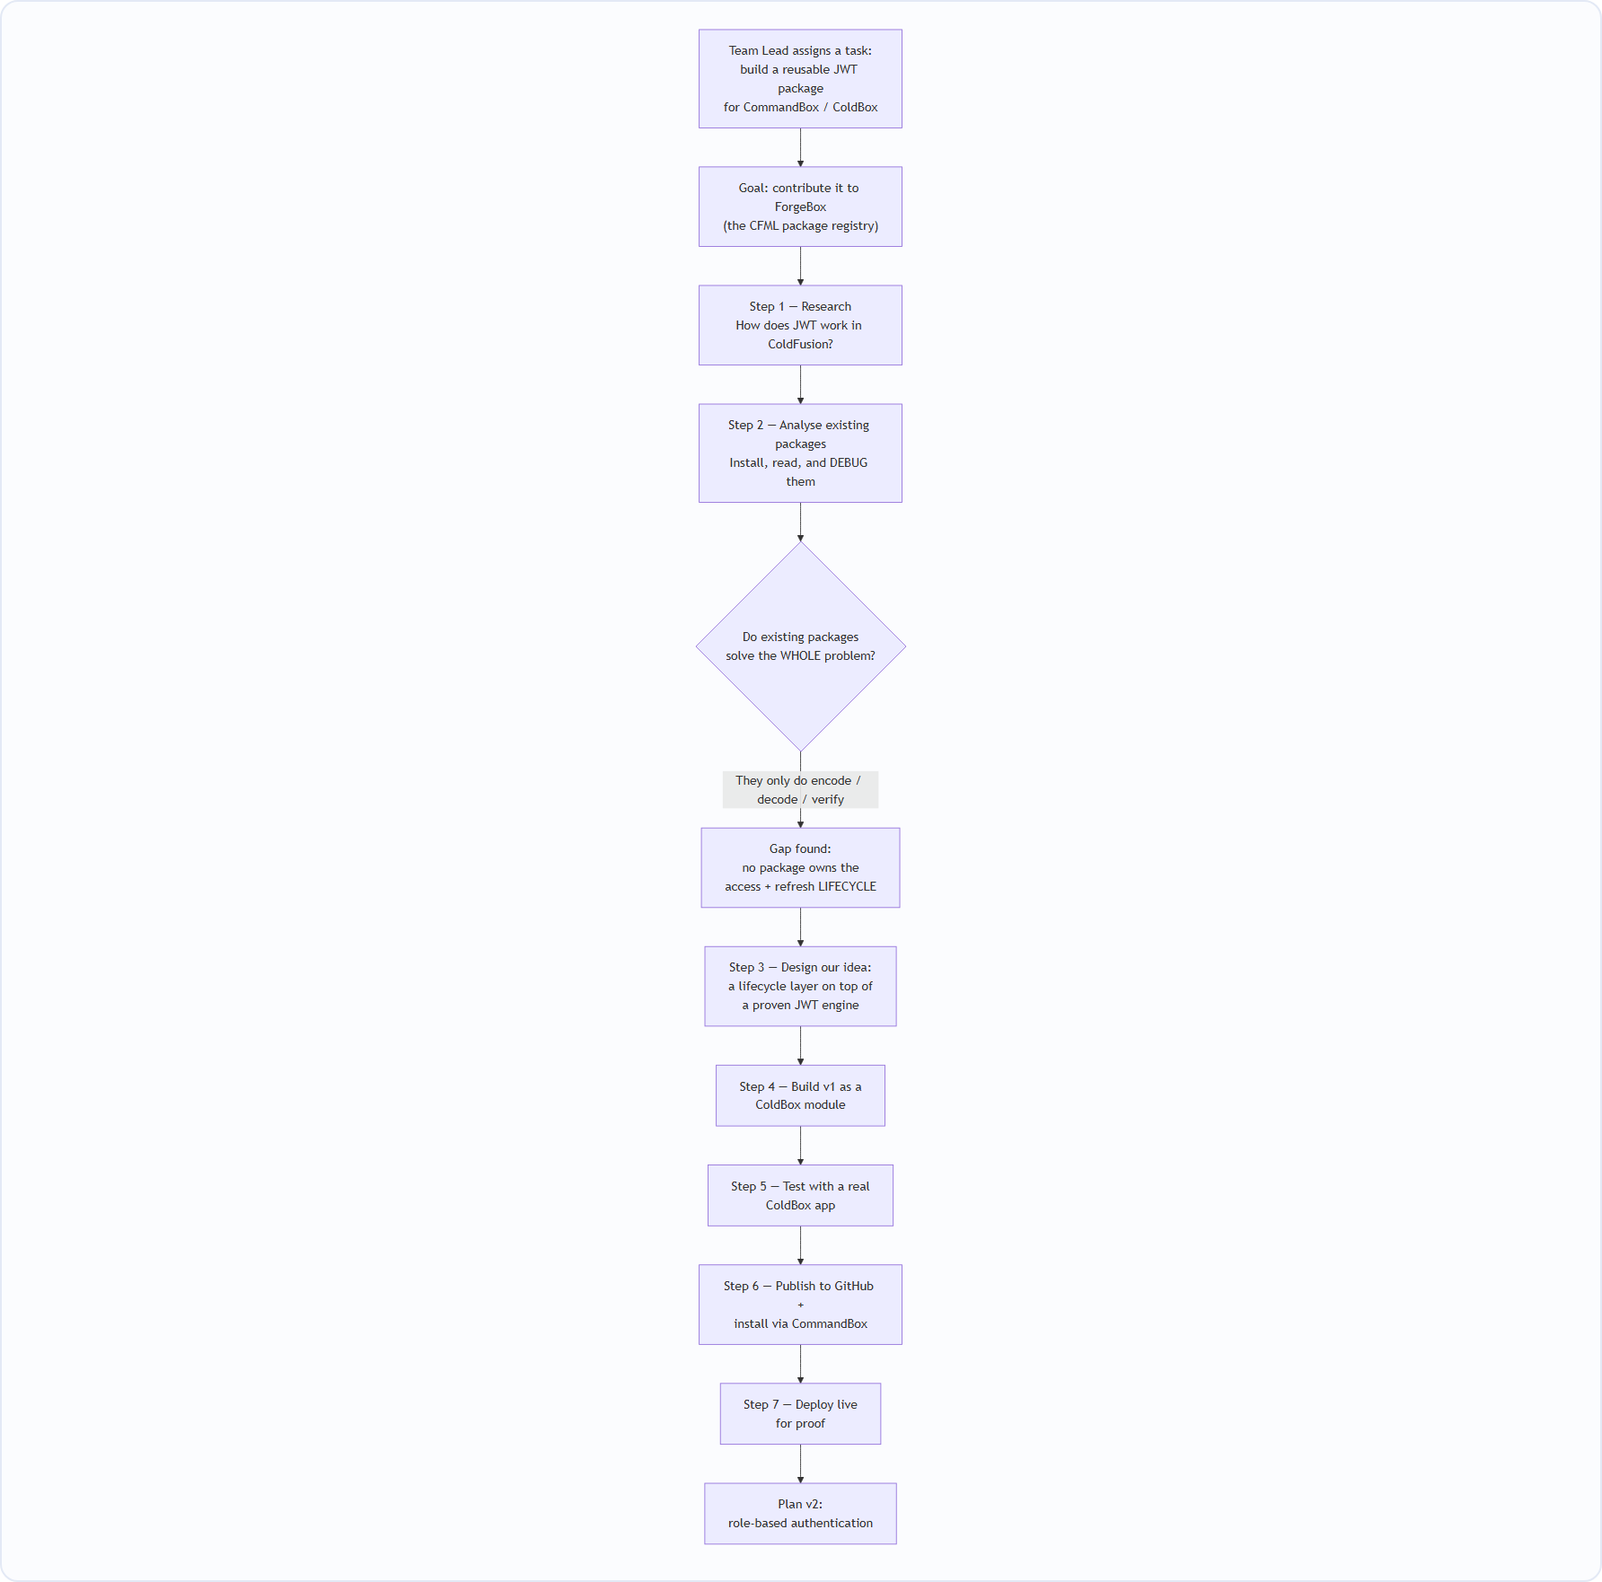
In plain words: our team lead (from the ColdFusion team) asked us to create a Proof of Concept for a JWT token package that works through CommandBox/ColdBox, with the intention of adding our contribution to ForgeBox. We started by researching how JWT works in ColdFusion, then we analysed and debugged the JWT packages that already exist to understand exactly what they do and where they stop. That research is what led us to the idea for this package.

3. Research — What We Learned About JWT in ColdFusion
(Summarised from our internal “Research Notes – JWT in ColdFusion (POC Preparation)”.)

3.1 The three ways to make a JWT in ColdFusion
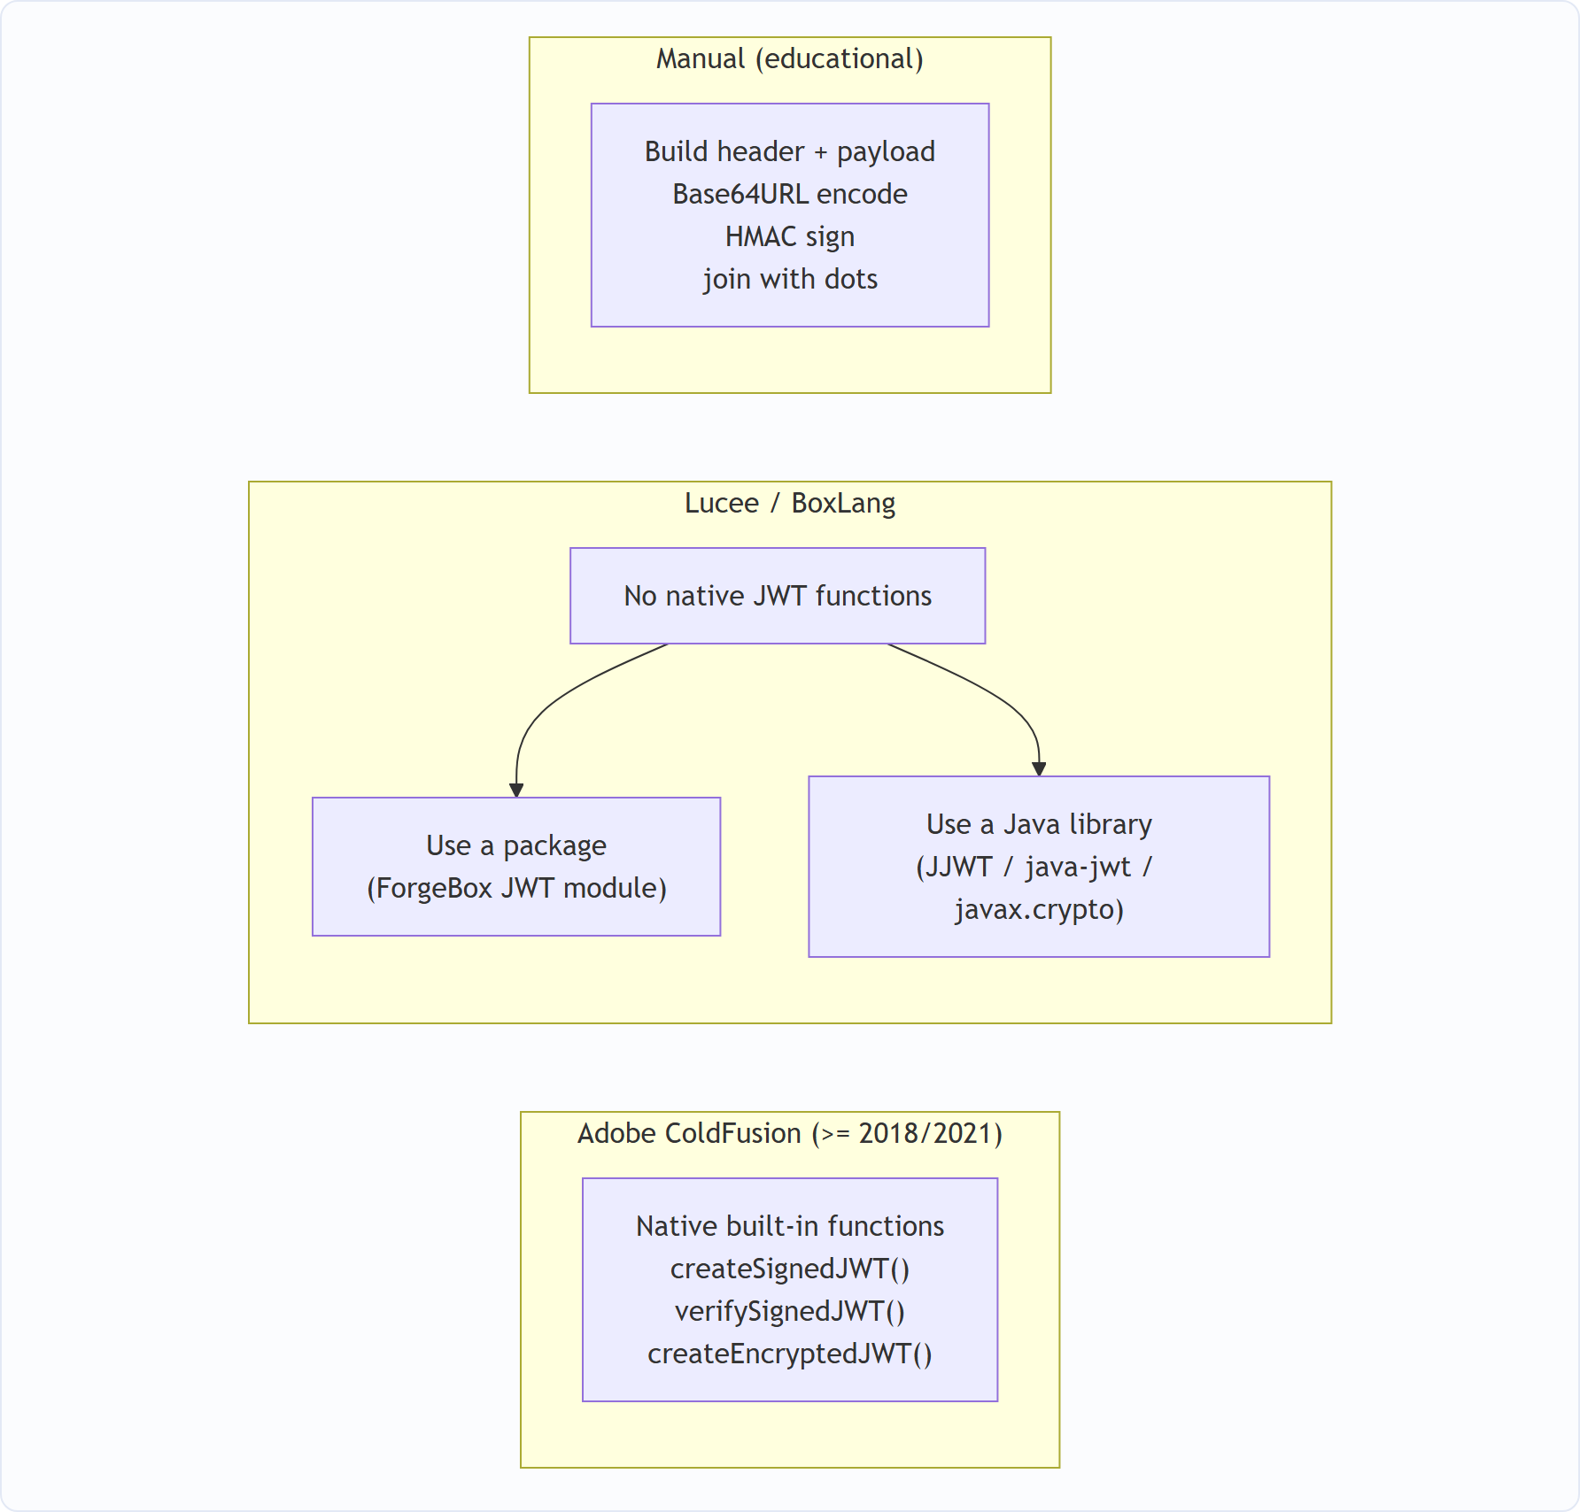
Key findings from the research:
Topic | What we found
Adobe native support | Adobe CF ships createSignedJWT(), verifySignedJWT(), createEncryptedJWT(). The developer supplies the payload + algorithm + secret; ColdFusion builds the header, JSON, Base64URL encoding, and signature automatically. No install needed — but Adobe-only.
Lucee / BoxLang | Have no native JWT functions. They must use a package or a Java library. Because a JAR runs on any JVM, a Java-library approach works on every engine.
Old package approach | Before native support, developers did box install jwt-cfml, then new JWTService().encode(payload, secret). Still low-level.
Manual approach | Understood JWT internals: base64UrlEncode(header) . base64UrlEncode(payload) . HMAC-signature. Good for learning; nobody should hand-roll this in production.
Signed vs Encrypted | Signed = payload is visible but tamper-proof. Encrypted = payload is hidden. For authentication tokens, signed is the standard (and what we implement).
Standard claims | iss, sub, aud, exp, iat, nbf, jti.

3.2 The decision that came out of research
Because we needed one package that behaves identically on Adobe CF, Lucee, and BoxLang, we chose the Java-library route for signing (javax.crypto) rather than Adobe's engine-specific native functions. A JAR is a JAR on every JVM — so the signature bytes are the same everywhere.

4. The Gap We Found & Our Idea

4.1 The gap
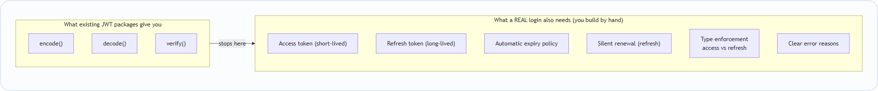
Plenty of JWT packages exist on ForgeBox, but they are low-level engines — they produce and verify a single token and stop. The access-token + refresh-token pattern that every real application needs (short-lived access token, long-lived refresh token, silent renewal, forced logout when the refresh token dies) has to be re-implemented by hand every single time. There was no package that made this lifecycle a standard, drop-in concept.

4.2 Our idea
- Don't reinvent the crypto. Reuse a proven JWT engine for the raw encode/decode/sign work.
- Add a second layer on top that owns the access & refresh lifecycle — issue, verify, decode, refresh, plus precise diagnostics.
- Be opinionated with safe defaults so a developer gets a correct login flow out of the box.
- Work on all CF engines by signing with Java.
- Ship v1 now; add role-based authentication in v2.

5. What Is a JWT? (Plain-English Primer)
A JWT (JSON Web Token) is a signed string with three parts joined by dots:
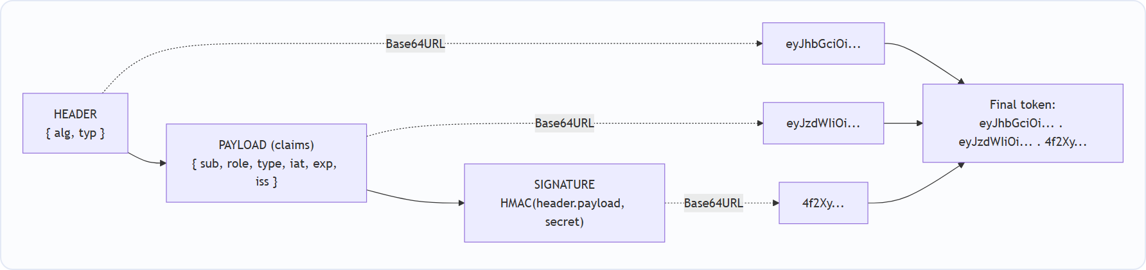
- The header says how it was signed (e.g. HS512).
- The payload holds the claims — who the user is (sub), their role, when it was issued (iat), when it expires (exp), who issued it (iss), and our custom type (access/refresh).
- The signature is an HMAC of header.payload using a secret. If anyone changes a single character, the signature no longer matches → the token is rejected.
Important: the payload is readable by anyone (it's just Base64), but it cannot be changed without invalidating the signature. So never put passwords in it — put an id and role.

6. Package Structure
The package is a small, focused ColdBox module:
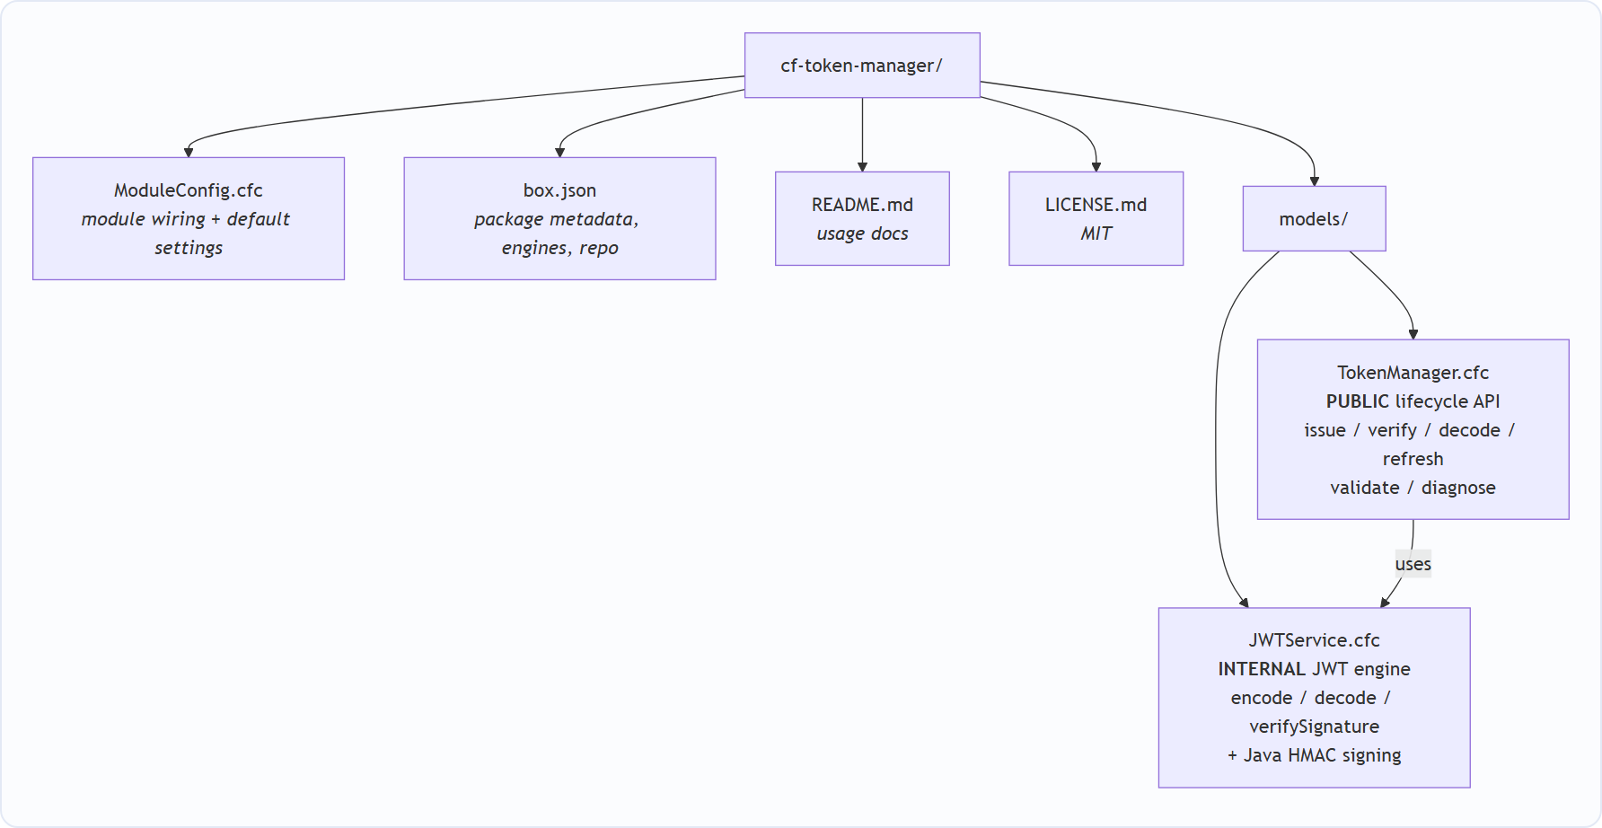
File | Public? | Responsibility
models/TokenManager.cfc | ✅ Public — the only thing host apps use | Access/refresh concept, expiry policy, type checking, claim stamping, precise error diagnostics
models/JWTService.cfc | 🔒 Internal — do not inject directly | Encode / decode / sign / verify a single JWT. No idea of access vs refresh
ModuleConfig.cfc | ⚙️ Config | Registers the models under the cf-token-manager namespace and exposes overridable settings
box.json | 📦 Metadata | Name, version, engines, keywords, GitHub repo, "private": true
README.md | 📖 Docs | Quick-start usage

“Initial / old module” note: we first built and tested cf-token-manager as a local ColdBox module living inside the host app at lib/modules/cf-token-manager/. Once it worked, we pushed it to GitHub so it could be installed as a real package (see §13 Distribution).

7. Architecture — The Two Layers
We deliberately split the package into two layers so the reusable engine and the opinionated policy stay cleanly separated.
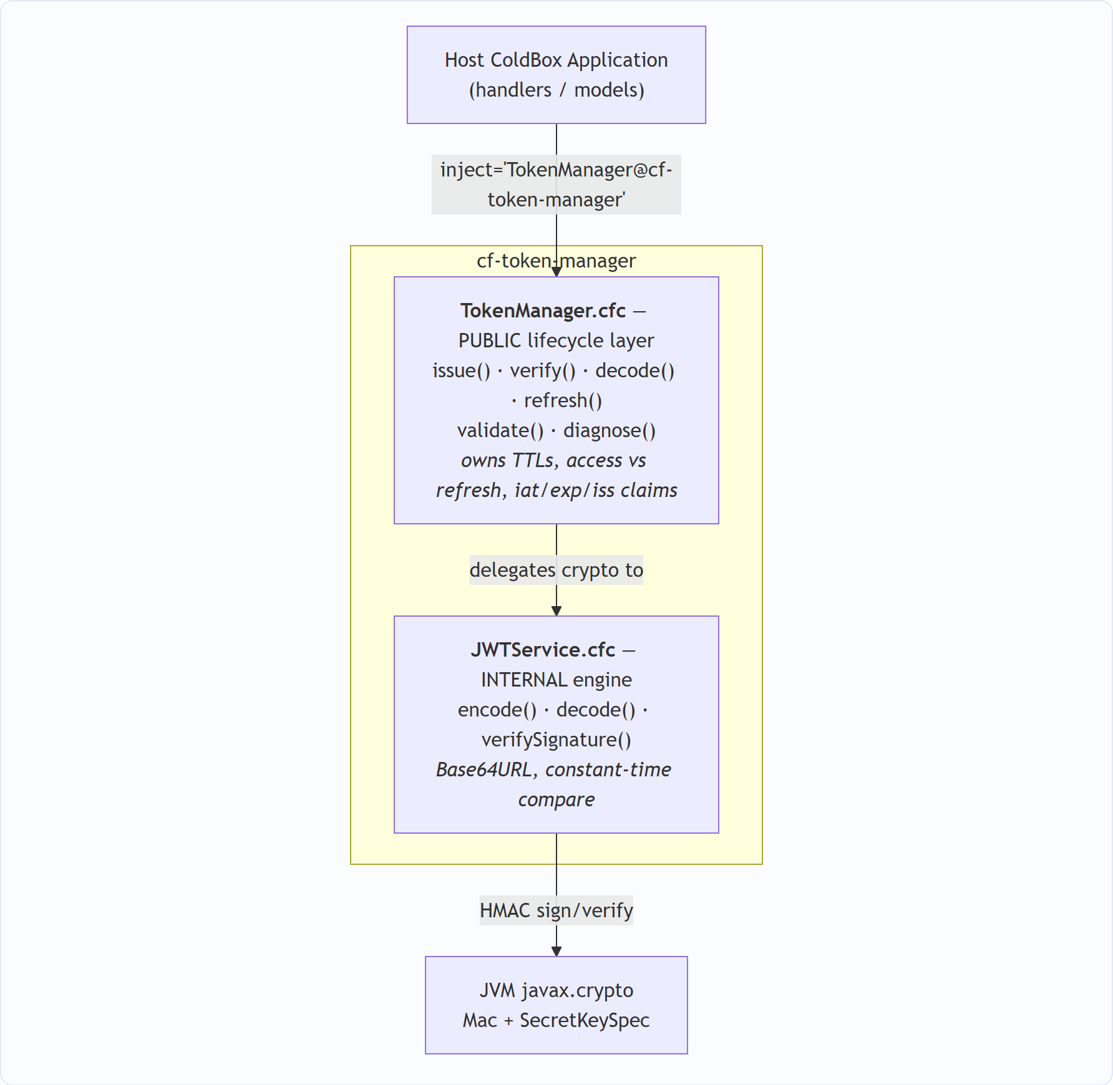

Why two layers?
- The engine (JWTService) can be upgraded or swapped without touching application code.
- The lifecycle layer (TokenManager) encodes all the "correct behaviour" (short access token, long refresh token, type enforcement) so developers never repeat it.
- Reserved control claims (type, iat, exp, iss) are owned by the package and stripped from any caller-supplied data — so a caller cannot forge a token's type or expiry.

8. The Java Library — Why and What For
What we use: the JVM's built-in cryptography classes — `javax.crypto.Mac` and `javax.crypto.spec.SecretKeySpec` — inside JWTService.cfc.
Its one job: compute the HMAC signature of header.payload using the secret, for the HS256 / HS384 / HS512 algorithms.
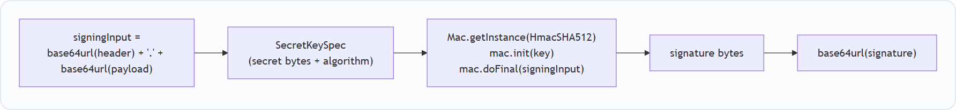
Why Java instead of Adobe's native functions?
Reason | Explanation
Runs on every engine | javax.crypto is part of the JVM. Adobe CF, Lucee, and BoxLang all run on the JVM, so the exact same signature bytes are produced everywhere. Adobe's createSignedJWT() would only work on Adobe.
No extra dependency | These classes ship with Java itself — nothing to download, no JAR to bundle.
Standard & battle-tested | HMAC via javax.crypto is the industry-standard, audited implementation.
Deterministic | Same input + same secret = same signature, every time, on every engine — which is exactly what a portable token package needs.

This single decision is why the package is truly cross-engine.

9. Public API Reference
Inject the manager anywhere in the host app:
property name="tokenManager" inject="TokenManager@cf-token-manager";
Function | Signature | What it does
issue | issue(struct subject) → { accessToken, refreshToken } | Mint a fresh access + refresh pair
verify | verify(string token, string type="access") → boolean | Authentic and unexpired and right type? (never throws)
decode | decode(string token) → struct | Read claims without verifying (use verify() first if you must trust it)
refresh | refresh(string refreshToken) → { accessToken } | Exchange a valid refresh token for a new access token
validate | validate(string token, string type) → struct (throws) | Strict check that throws a typed exception describing exactly why a token is bad
diagnose | diagnose(string token, string type) → { valid, code, message } | Non-throwing companion to validate() — perfect for clean JSON error responses

9.1 issue()
var tokens = tokenManager.issue( { id : 101, role : "admin", email : "a@b.io" } );
// {
// "accessToken" : "eyJ0eX...", // type=access, short-lived
// "refreshToken" : "eyJ0eX..." // type=refresh, long-lived
// }
- The id (or sub) key becomes the JWT sub claim.
- All other business keys (role, email, …) are carried into the token verbatim.
- Claim names are lower-cased for predictable behaviour across engines (Adobe CF otherwise upper-cases unquoted struct keys).
- Throws cftokenmanager.InvalidSubject if neither id nor sub is present.

9.2 Diagnostics — the error codes
When you need to tell the client why a token was rejected:
diagnose() code | Thrown exception type | Meaning
VALID | — | Authentic, unexpired, correct type
MISSING_TOKEN | cftokenmanager.MissingToken | Empty / no token supplied
MALFORMED_TOKEN | cftokenmanager.MalformedToken | Not a 3-segment JWT / unparseable body
INVALID_SIGNATURE | cftokenmanager.InvalidSignature | Signature doesn't match the secret (tampered / wrong secret)
TOKEN_EXPIRED | cftokenmanager.ExpiredToken | exp claim is in the past
INVALID_TOKEN_TYPE | cftokenmanager.InvalidTokenType | e.g. a refresh token used on an access endpoint

9.3 Security design notes
- Java HMAC signing (javax.crypto) → identical, portable behaviour across all engines.
- Constant-time signature comparison mitigates timing attacks.
- base64url encoding (URL-safe, no padding) per the JWT spec.
- Reserved claims (type, iat, exp, iss) are package-owned and stripped from caller input → the caller can't forge token type or expiry.
- Signature verified before claims are trusted — validate() checks the signature first, then reads exp/type.
- Epoch timestamps are cast to a Java long so they serialise as plain integers (never 1.78E9).

10. Configuration — What the Developer Controls
This is the part reviewers usually ask about: what does the user supply, what is default, what is changeable, and where do I change it?

10.1 The settings
Setting | Default | Changeable? | What it controls
secret | cf-token-manager-default-secret-change-me | ✅ Must change in production | The HMAC secret that signs every token
algorithm | HS512 | ✅ | Signing algorithm: HS256 / HS384 / HS512
accessTokenExpiry | 900 (15 min) | ✅ | How long the access token lives (seconds)
refreshTokenExpiry | 2592000 (30 days) | ✅ | How long the refresh token lives (seconds)
issuer | cf-token-manager | ✅ | The iss claim stamped on every token

10.2 Where the defaults live (the package)
cf-token-manager/ModuleConfig.cfc → configure():
settings = {
secret : "cf-token-manager-default-secret-change-me", // ALWAYS override
algorithm : "HS512", // HS256 | HS384 | HS512
accessTokenExpiry : 900, // 15 minutes
refreshTokenExpiry : 2592000, // 30 days
issuer : "cf-token-manager"
};

10.3 Where the developer OVERRIDES them (the host app)
In the host app's app/config/Coldbox.cfc → moduleSettings:
moduleSettings = {
"cf-token-manager" : {
secret : getSystemSetting( "JWT_SECRET", "change-me" ), // from .env
algorithm : "HS512",
accessTokenExpiry : 900,
refreshTokenExpiry : 2592000,
issuer : "my-app"
}
};
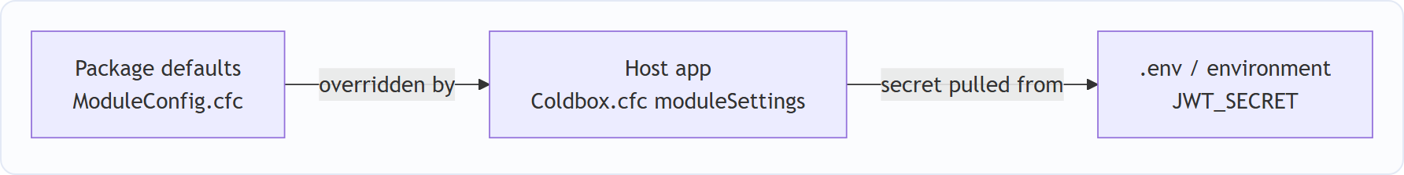

10.4 What is public vs private
Public (developer touches) | Private / internal (leave alone)
TokenManager.cfc methods: issue, verify, decode, refresh, validate, diagnose | JWTService.cfc (the whole engine)
The 5 settings above | sign(), base64UrlEncode(), constantTimeEquals(), normalizeSubject(), stripReservedClaims(), epochSeconds()
— | Reserved claims type, iat, exp, iss (managed automatically)

11. Developer Workflow — How Easy It Is to Use
From zero to a working login in five short steps:
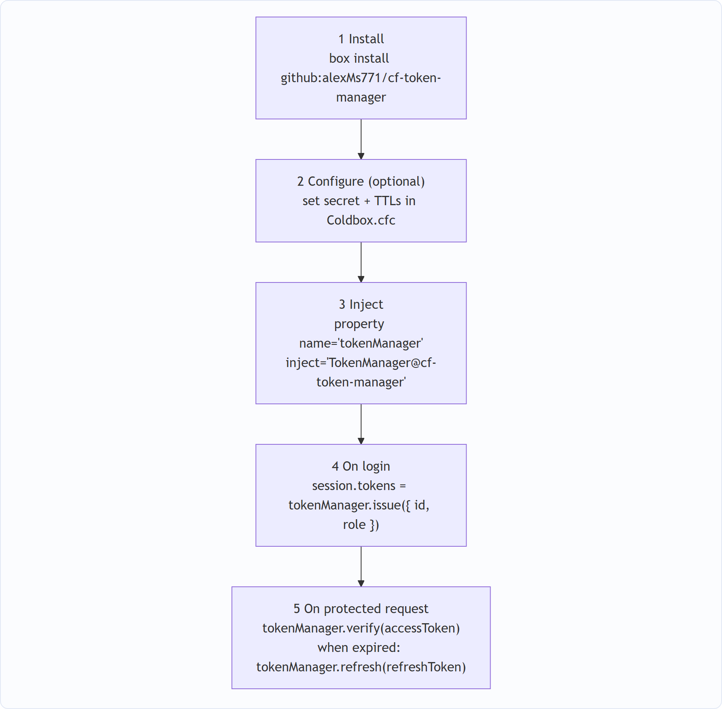
// 1. install (adds it to box.json and downloads from GitHub)
// box install github:alexMs771/cf-token-manager
// 2. inject the manager in any handler / model
property name="tokenManager" inject="TokenManager@cf-token-manager";
// 3. on login — mint the pair
session.tokens = tokenManager.issue( { id : username, role : "customer" } );
// 4. on a protected request — check the access token
if ( tokenManager.verify( session.tokens.accessToken ) ) {
var claims = tokenManager.decode( session.tokens.accessToken );
}
// 5. when the access token expires — silently renew
var fresh = tokenManager.refresh( session.tokens.refreshToken );
That's it — the developer never touches Base64, HMAC, header building, or expiry maths.

12. How We Tested It — The Live ColdBox App
We integrated the package into a real ColdBox application (`TestingApp`) and exercised it in two complementary ways.

12.1 The real authentication flow (Security handler + live dashboard)
This is the lifecycle exactly as a production app uses it:
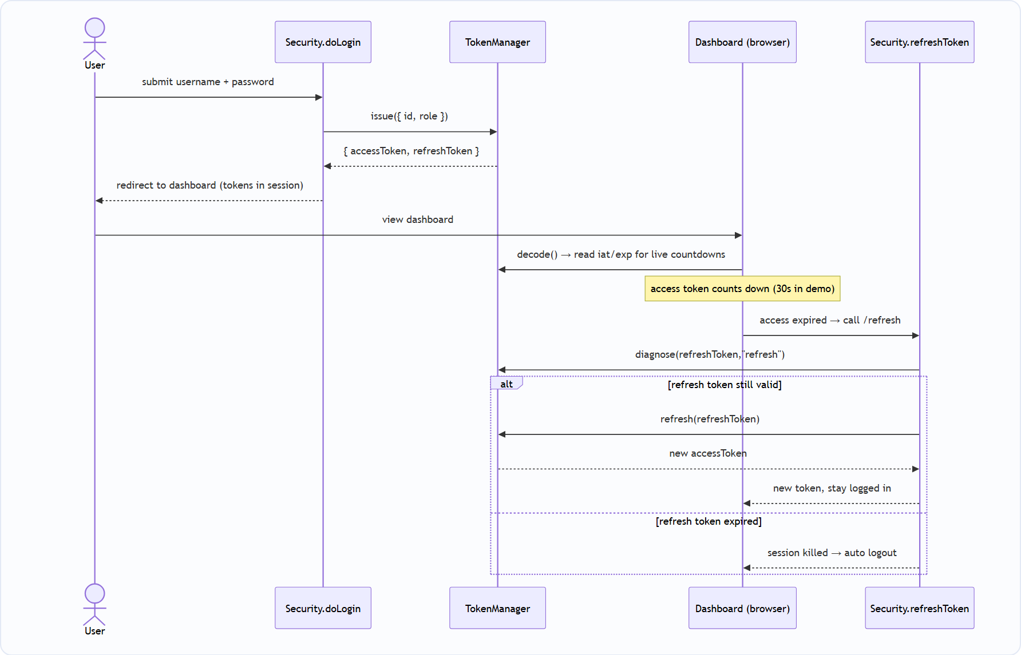
The app logic, step by step:
- Login → issue() mints the first access + refresh pair, stored in the session.
- Dashboard → decode() reads iat/exp to drive live countdown timers and progress bars.
- Access token expires → the browser calls the /refresh JSON endpoint, which uses diagnose() to confirm the refresh token is still good, then refresh() to **silently mint a new access token** — the user stays logged in.
- Refresh token expires → diagnose() reports it, the session is killed, and the user is logged out automatically.
Screenshot — the login screen (/login). A JWT access + refresh pair is issued on sign-in:
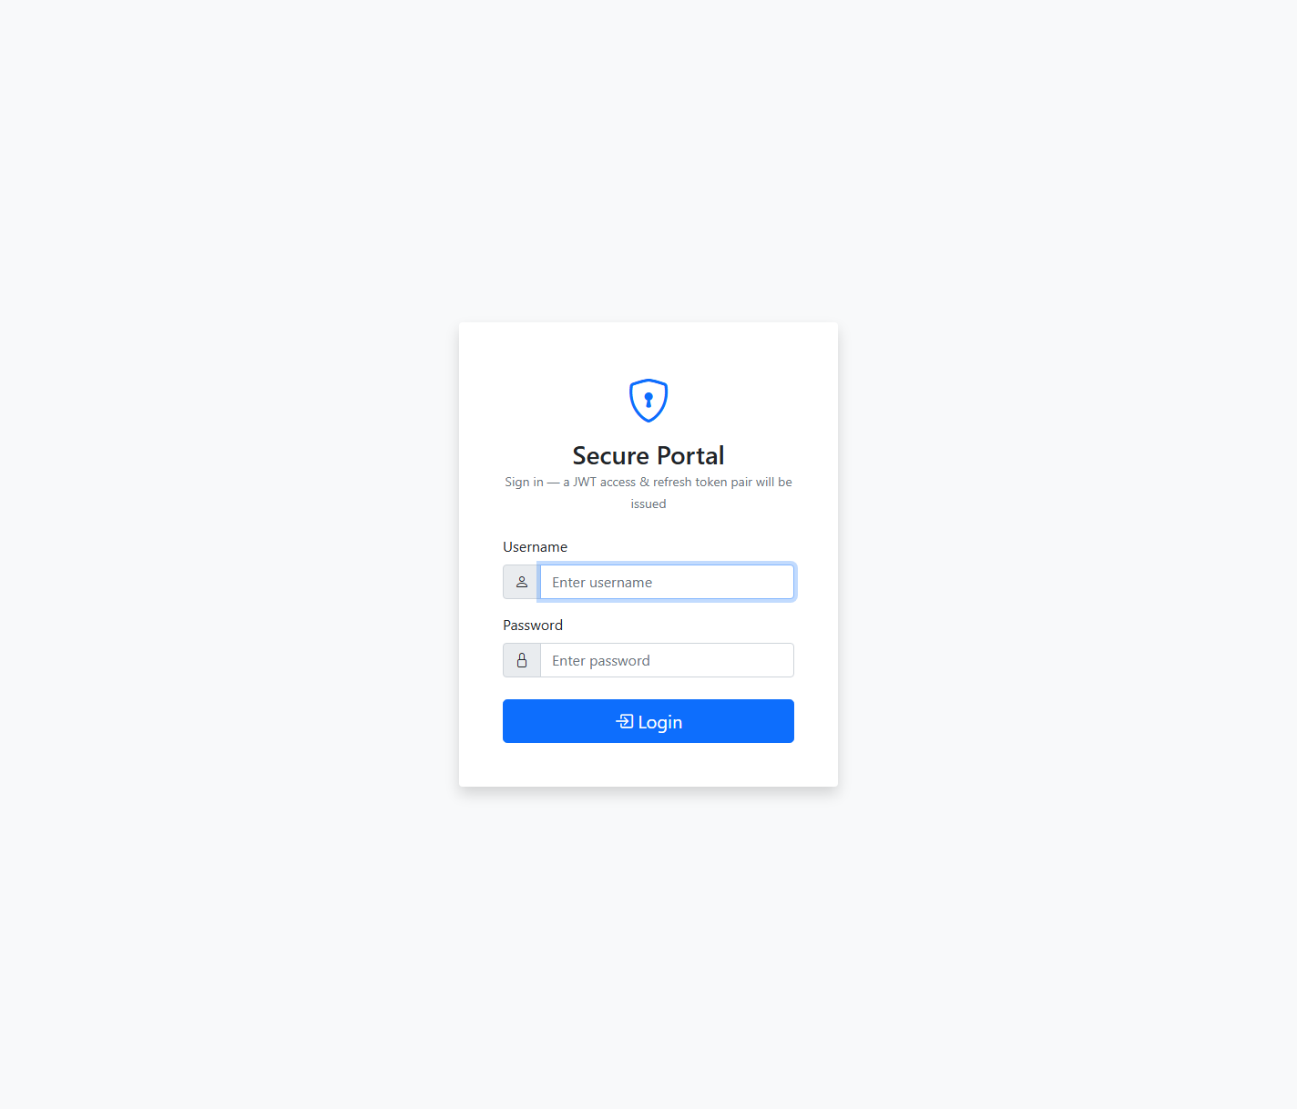
Login screen of the live app
Screenshot — the live dashboard after logging in as test. The access token counts down (here 0:27), the refresh token holds the session (1:57), and both real JWT strings are shown. When the access token hits zero the app silently calls refresh():
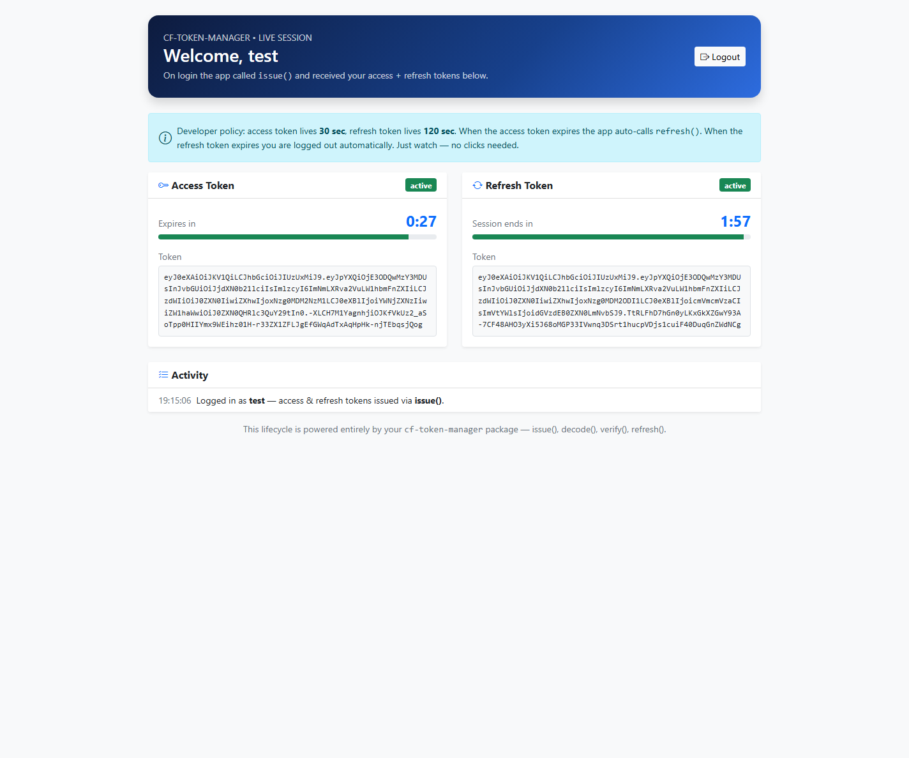
Live dashboard showing access and refresh token countdowns

12.2 Timeout settings used for the demo
So the whole lifecycle is visible in ~2 minutes during a live review, the host app uses short TTLs in app/config/Coldbox.cfc:
"cf-token-manager" : {
accessTokenExpiry : 30, // access token lives 30 seconds
refreshTokenExpiry : 120 // refresh token lives 2 minutes
}
(Production values would typically be `900` / `2592000`.) The ColdFusion session timeout itself is 30 minutes (public/Application.cfc).

12.3 The automated self-test console (/demo)
app/handlers/TokenDemo.cfc renders a self-test matrix that runs on every page load and reports expected-vs-actual for every public function across all success and failure modes.
Dimension | Function(s) | Expected | Result
Mint valid pair | issue() | Two 3-segment JWTs | ✅ PASS
Reject subject with no id/sub | issue() | InvalidSubject thrown | ✅ PASS
Read claims without verifying | decode() | Claims returned | ✅ PASS
Valid access token | verify() | true | ✅ PASS
Tampered token | verify() / diagnose() | false / INVALID_SIGNATURE | ✅ PASS
Wrong secret | diagnose() | INVALID_SIGNATURE | ✅ PASS
Expired token | diagnose() | TOKEN_EXPIRED | ✅ PASS
Malformed token | diagnose() | MALFORMED_TOKEN | ✅ PASS
Missing token | diagnose() | MISSING_TOKEN | ✅ PASS
Wrong type (access as refresh) | diagnose() | INVALID_TOKEN_TYPE | ✅ PASS
Valid refresh → new access | refresh() | New access token is VALID | ✅ PASS
Access token used as refresh | refresh() | InvalidTokenType thrown | ✅ PASS

All checks pass on page load and re-run live, so any regression is visible immediately.
Screenshot — the live self-test console (/demo) reporting 14 / 14 checks passed, with the full expected-vs-actual matrix and interactive issue() / refresh() / decode() / verify() panels below it:
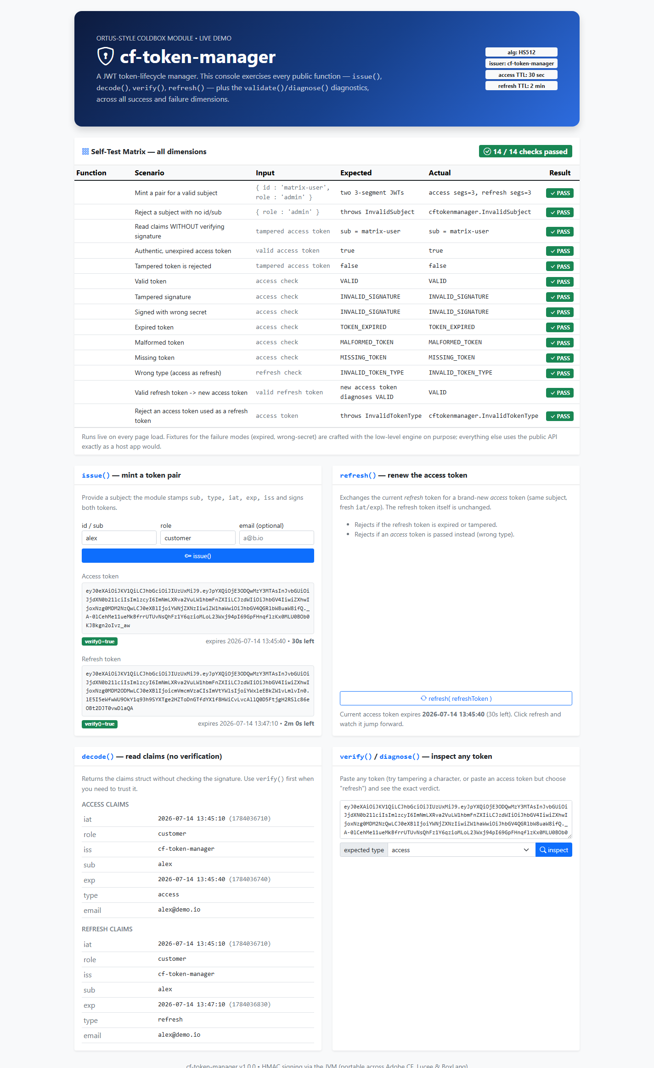
Live demo console showing 14 of 14 self-test checks passed

12.4 Test / demo routes
Route | Maps to | Purpose
/login, /dashboard, /refresh, /logout | security.* | End-to-end auth lifecycle
/demo | tokenDemo.index | Self-test matrix + interactive console
/demo/issue | tokenDemo.issue | Interactive issue()
/demo/refresh | tokenDemo.refresh | Interactive refresh()
/demo/inspect | tokenDemo.inspect | decode() + verify() + diagnose() on any pasted token

Demo credentials: test / test and user / pass.

13. Distribution — From Local Module to Installable Package
The package grew up in three stages — this is the "it acts as a real package" story:
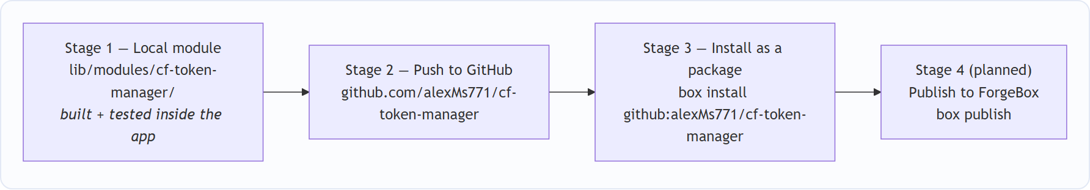
The host app's box.json now depends on it exactly like any real package:
"dependencies" : {
"coldbox" : "^8.0.0",
"cf-token-manager" : "github:alexMs771/cf-token-manager"
},
"installPaths" : {
"cf-token-manager" : "lib/modules/cf-token-manager/"
}
So a fresh developer just runs `box install` and CommandBox pulls the package straight from GitHub into lib/modules/, where ColdBox auto-discovers and loads it. The package's box.json declares "private": true today; flipping that to false and running box publish is all that's needed to list it on ForgeBox.

14. Deployment — Live on the Internet
The proof is public and running:
🔗 https://jwt-testing-app.onrender.com/
- Host: Render (free tier) with auto-deploy on every push to main.
- Container: a Dockerfile based on the official Ortus CommandBox image, running Lucee 6 as the CFML engine — proving the package's cross-engine claim in production (developed on BoxLang/Adobe locally, deployed on Lucee).
- Package: installed during the build with box install straight from GitHub.
ℹ️ On Render's free tier the instance sleeps after ~15 minutes of inactivity, so the first request after idle can take ~50 seconds to wake up. This is a hosting-plan characteristic, not a package behaviour.

15. Maintainability — Why This Is Easy to Keep Alive
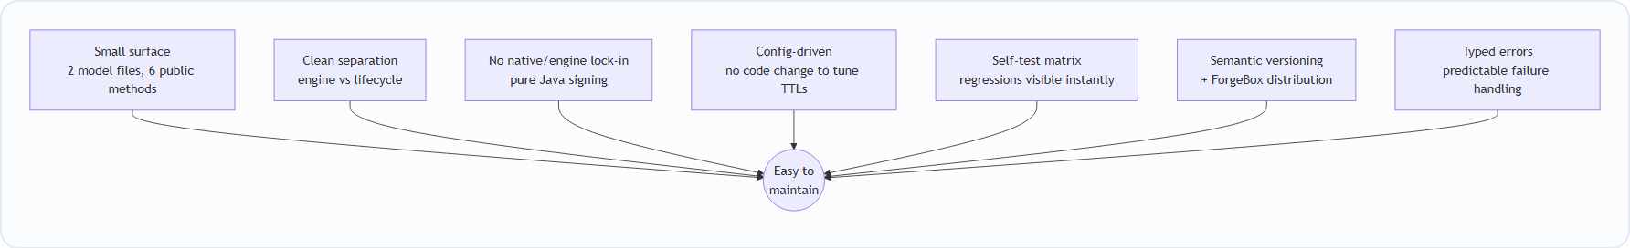
Property | Why it helps maintenance
Tiny, focused codebase | Two model files, six public methods — a new developer understands it in one sitting.
Two-layer separation | Upgrade the crypto engine without touching app-facing code, and vice-versa.
No engine lock-in | Java signing means an engine upgrade (Adobe → Lucee → BoxLang) doesn't break tokens.
Config over code | Changing secret, algorithm, or TTLs is a settings edit — never a code change.
Built-in self-tests | The /demo matrix re-validates every function on each load; regressions surface immediately.
Typed exceptions + diagnose codes | Callers handle failures predictably; behaviour is documented and stable.
Versioned & installable | Semantic versioning + box install / ForgeBox means clean, trackable upgrades.

16. ForgeBox Publishing Plan
ForgeBox is the CFML community's package registry (like npm for Node). A good ForgeBox listing needs the things we've already prepared:
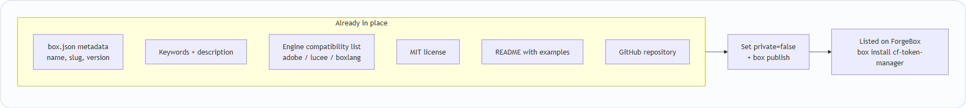
ForgeBox requirement | Our status
Unique slug | ✅ cf-token-manager
Semantic version | ✅ 1.0.0
shortDescription + description | ✅ Present
keywords (discoverability) | ✅ jwt, token, authentication, access-token, refresh-token, coldbox, security
license | ✅ MIT
Supported engines | ✅ Adobe >=2021, BoxLang >=1.0.0, Lucee >=5.3
Public repository | ✅ GitHub
Docs / README | ✅ Present

The only remaining action is to set "private": false and run box publish.

17. Roadmap
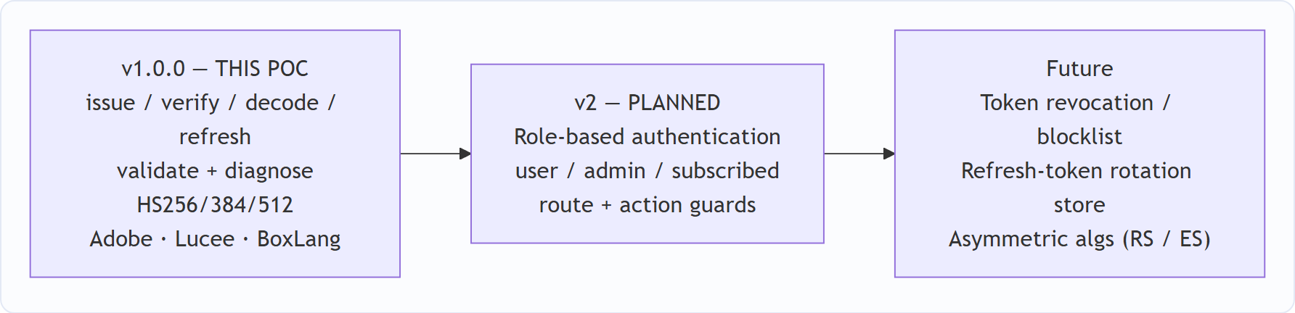
Version | Feature set
v1.0.0 (this POC) | Access + refresh token lifecycle: issue, verify, decode, refresh, plus validate/diagnose diagnostics; configurable policy; HS256/384/512; Adobe CF / Lucee / BoxLang support.
v2 (planned) | Role-based authentication — first-class roles such as user, admin, and subscribed, with helpers to guard routes/actions by role.
Future | Token revocation / blocklist, refresh-token rotation store, asymmetric algorithms (RS/ES).

18. Conclusion & Recommendation
This POC demonstrates that `cf-token-manager` closes a real, verifiable gap in the ColdFusion ecosystem: a standardised, developer-ready access & refresh token lifecycle for CFML/ColdBox, built on proven JWT primitives and portable across all three CF engines via Java crypto.
We proved it end-to-end:
- ✅ Every public function passes an automated self-test matrix across all success/failure modes.
- ✅ A real login → dashboard → silent-refresh → auto-logout flow works exactly as designed.
- ✅ It installs as a real package from GitHub (box install github:alexMs771/cf-token-manager).
- ✅ It is deployed and running live on Lucee in the cloud.
Recommendation: proceed to package polish and publish v1.0.0 to ForgeBox, then begin v2 (role-based authentication).

19. Appendix — Glossary
Term | Meaning
JWT | JSON Web Token — a signed, self-contained token carrying user claims
Access token | Short-lived token sent on every request to prove who you are
Refresh token | Long-lived token used only to get a new access token when it expires
Claim | A piece of data inside the token (e.g. sub, role, exp)
HMAC | Hash-based Message Authentication Code — the signing method (HS256/384/512)
Secret | The private key used to sign/verify tokens; must be kept safe
CommandBox | The CLI for CFML — package manager + server runner
ColdBox | The MVC framework for CFML applications
ForgeBox | The CFML package registry (like npm for ColdFusion)
Module | A self-contained, installable ColdBox component
CFML | ColdFusion Markup Language — runs on Adobe CF, Lucee, and BoxLang

POC prepared by the JWT package team. Package tested with the `TestingApp` ColdBox application and deployed live on Lucee 6 via CommandBox + Docker on Render.

