Alexander Palomba

Artificial Intelligence

20 September 2016

Homework 01

Problem 1.4

a.

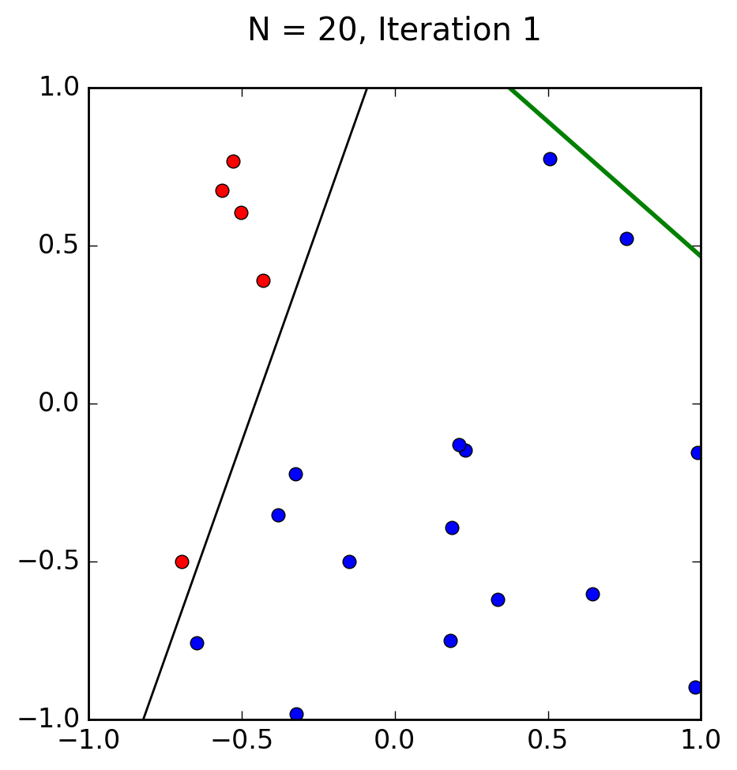

b.

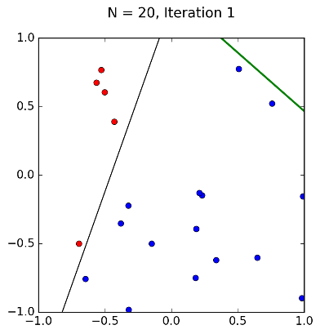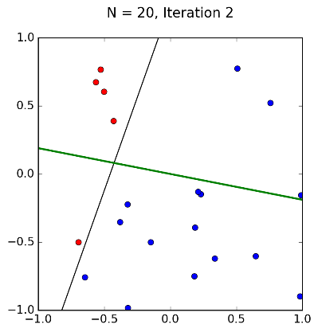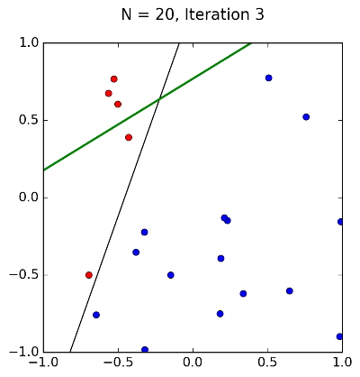

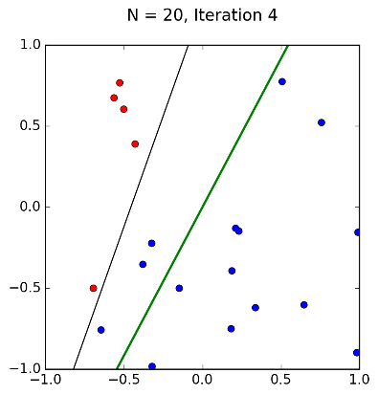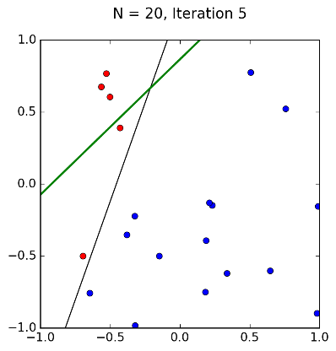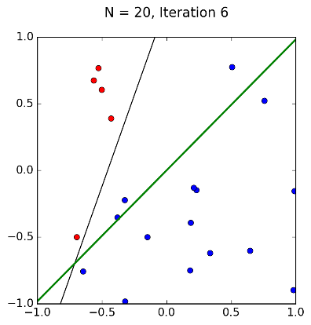

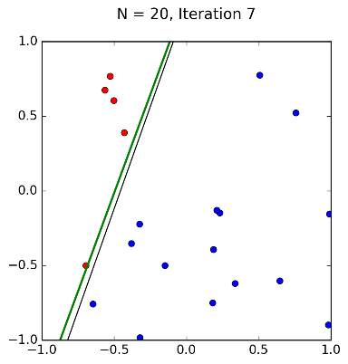

In this final iteration, *f* is reasonably close to *g.*

c.

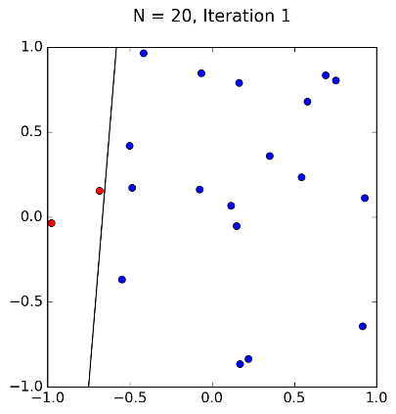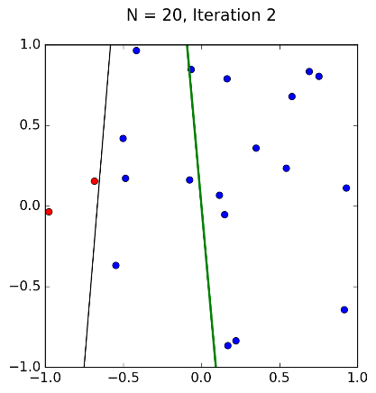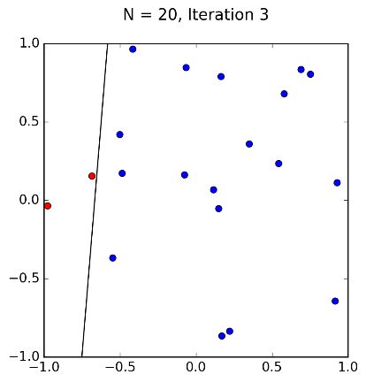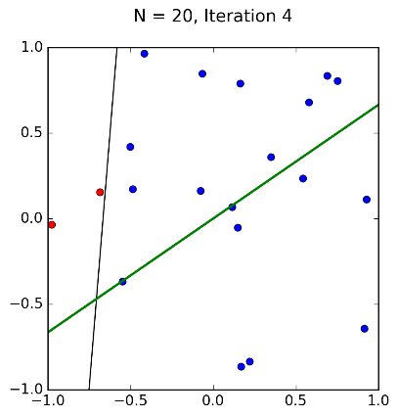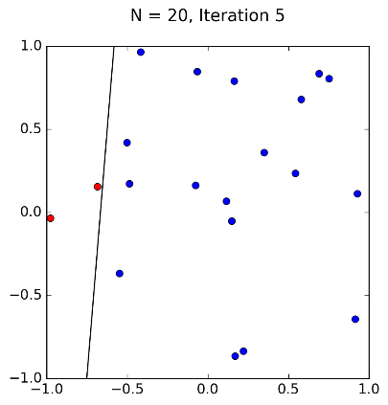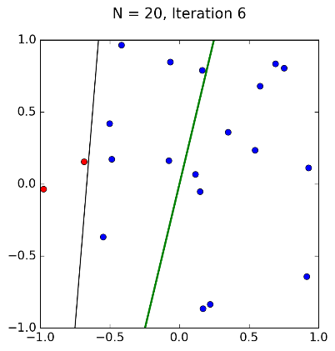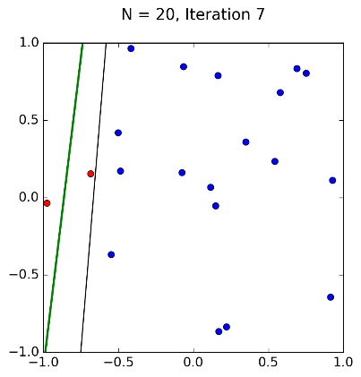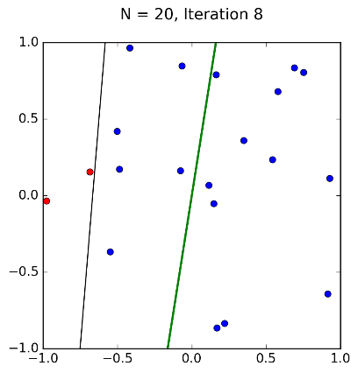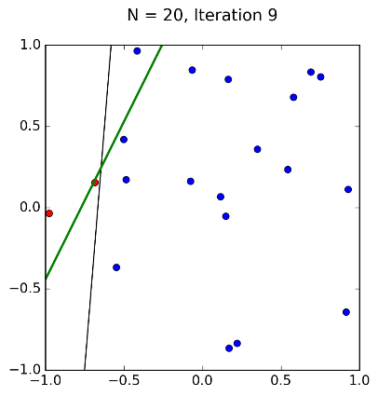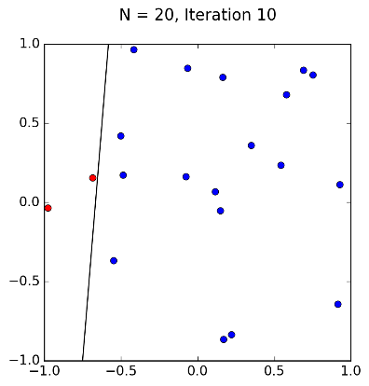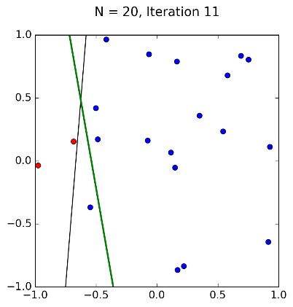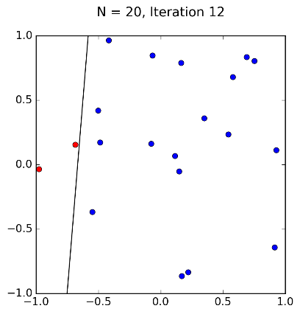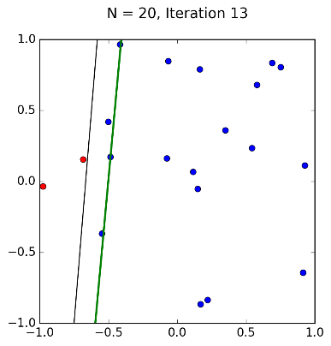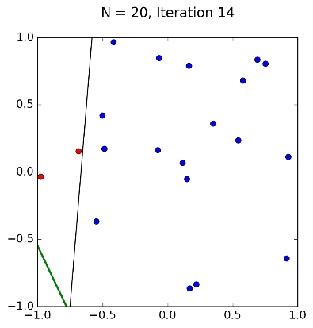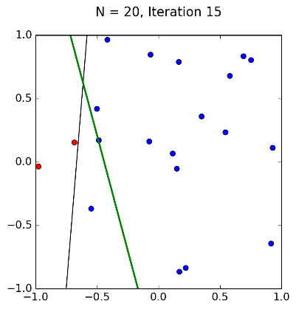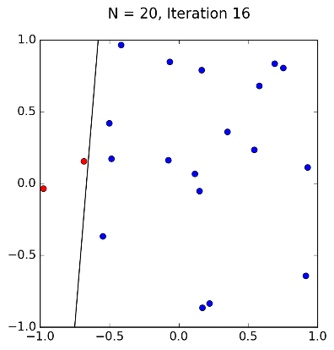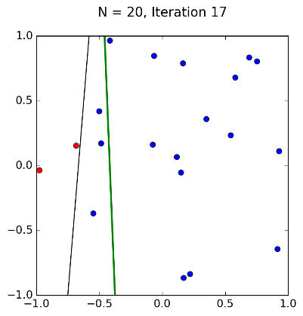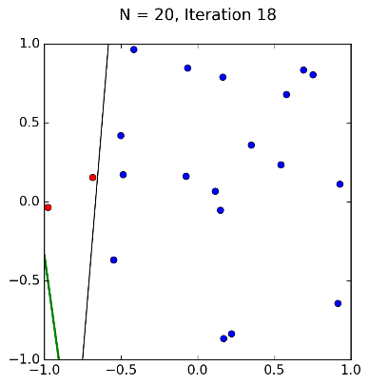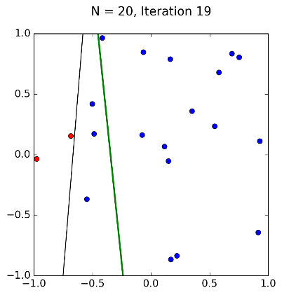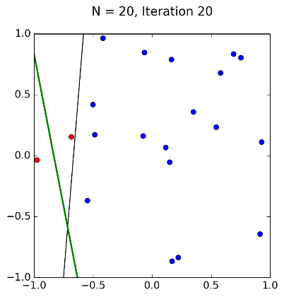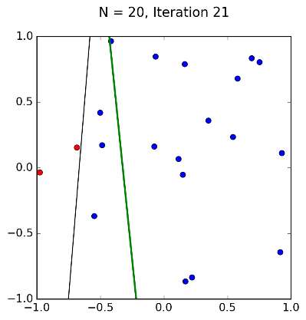

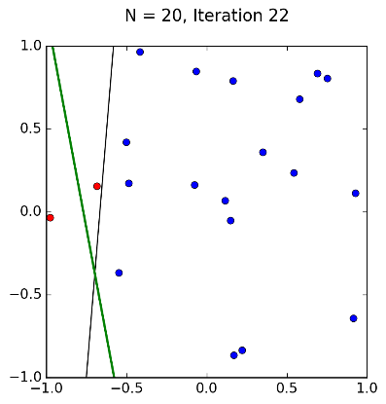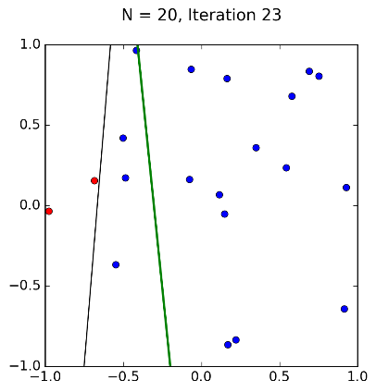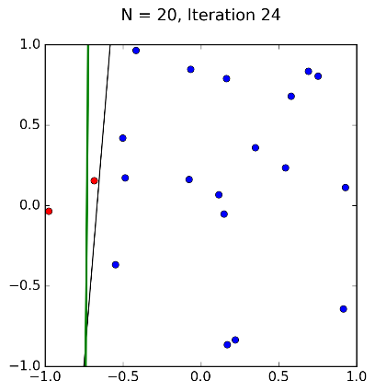

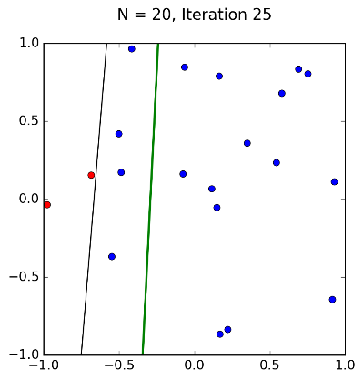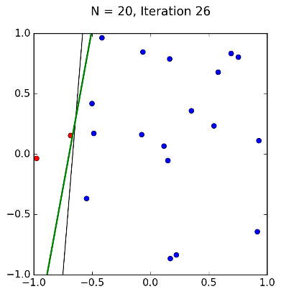

It took the perceptron algorithm significantly more iterations to reach a valid line separating the two classes, and *g* is not as close to *f* as it was in the first set.

d.

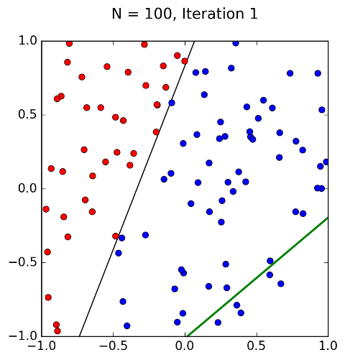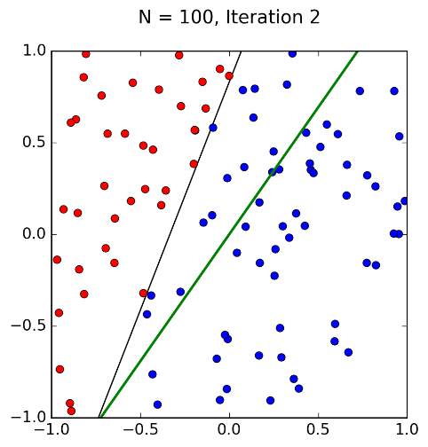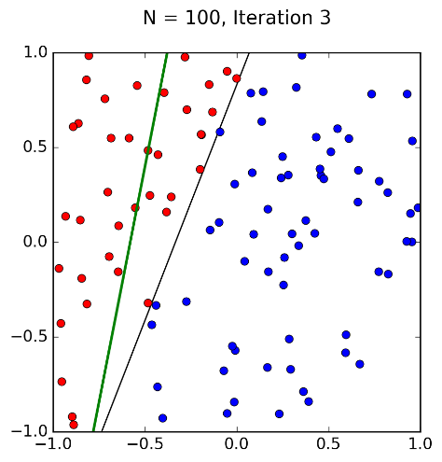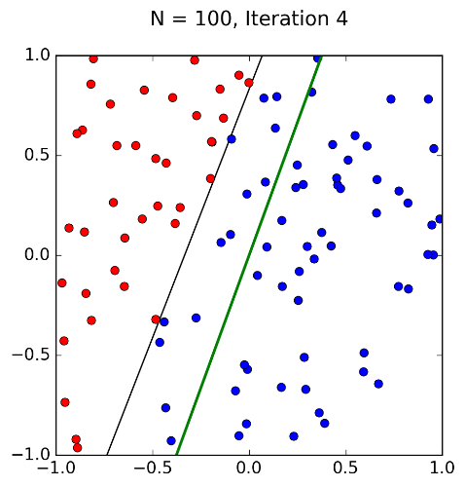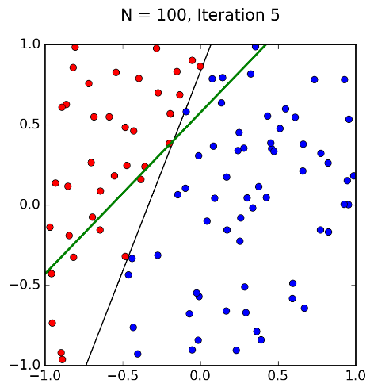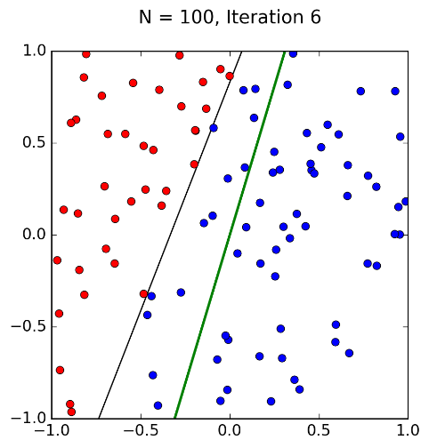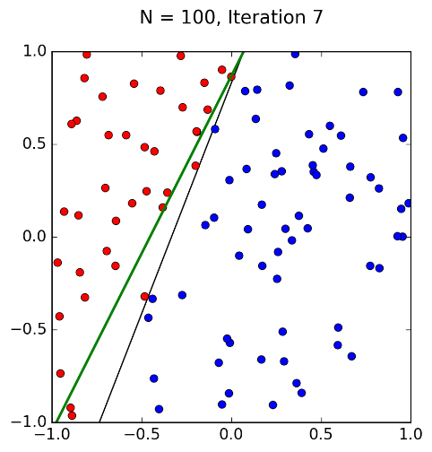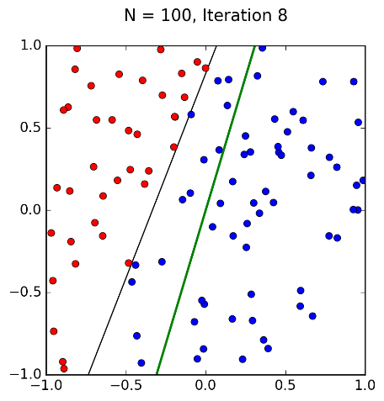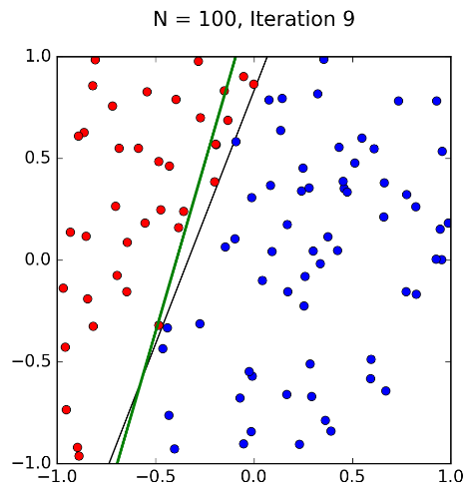

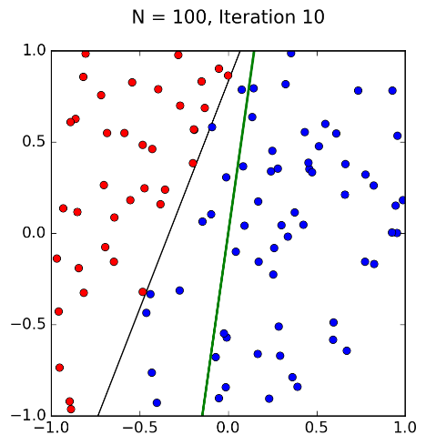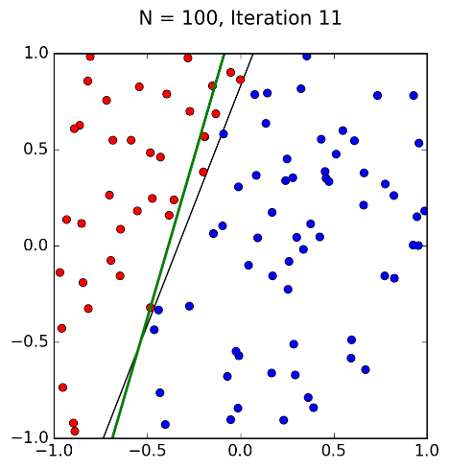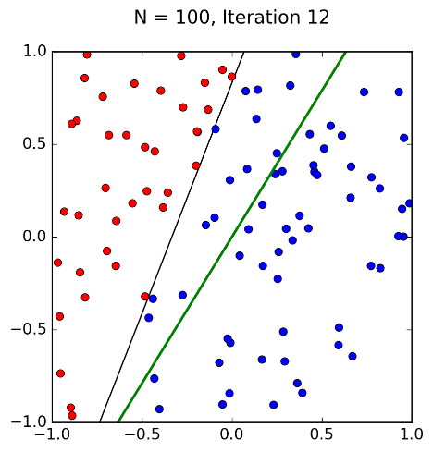

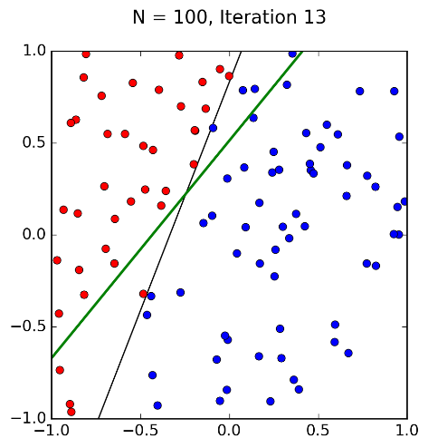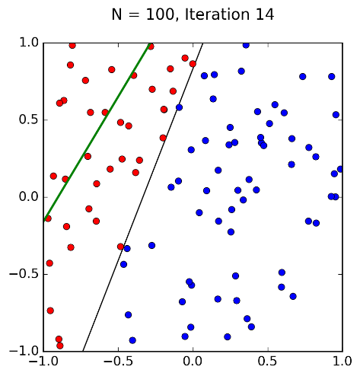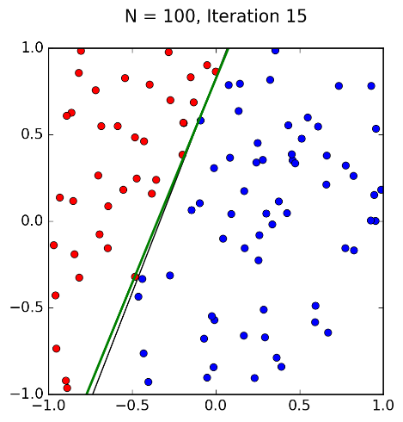

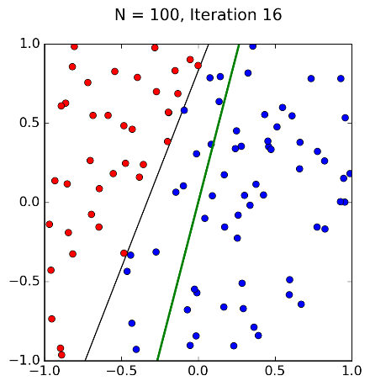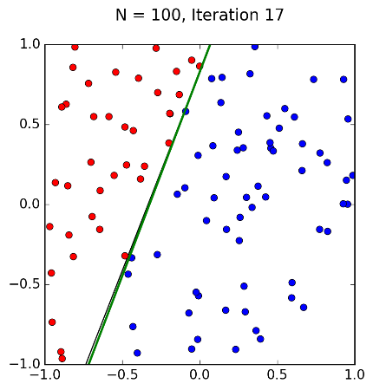

Surprisingly, the perceptron algorithm took only 17 iterations to compute a valid function for *g*, and it is very close to *f*.

e.

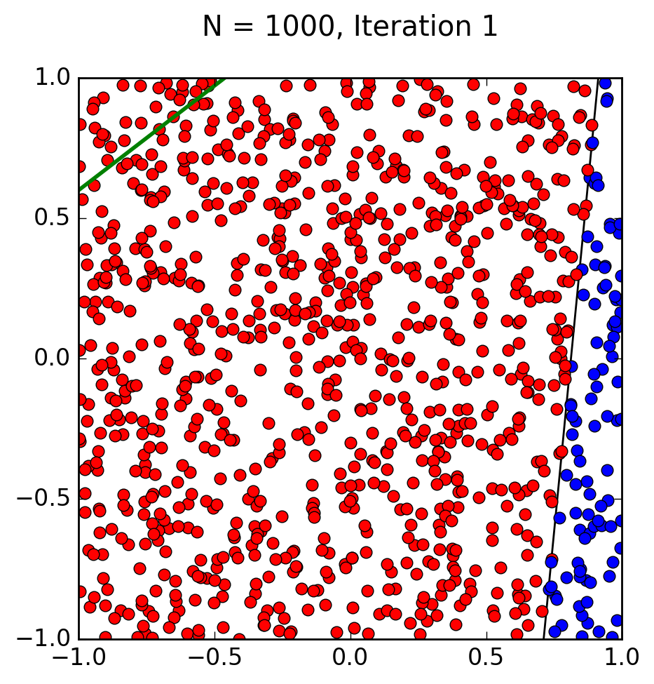

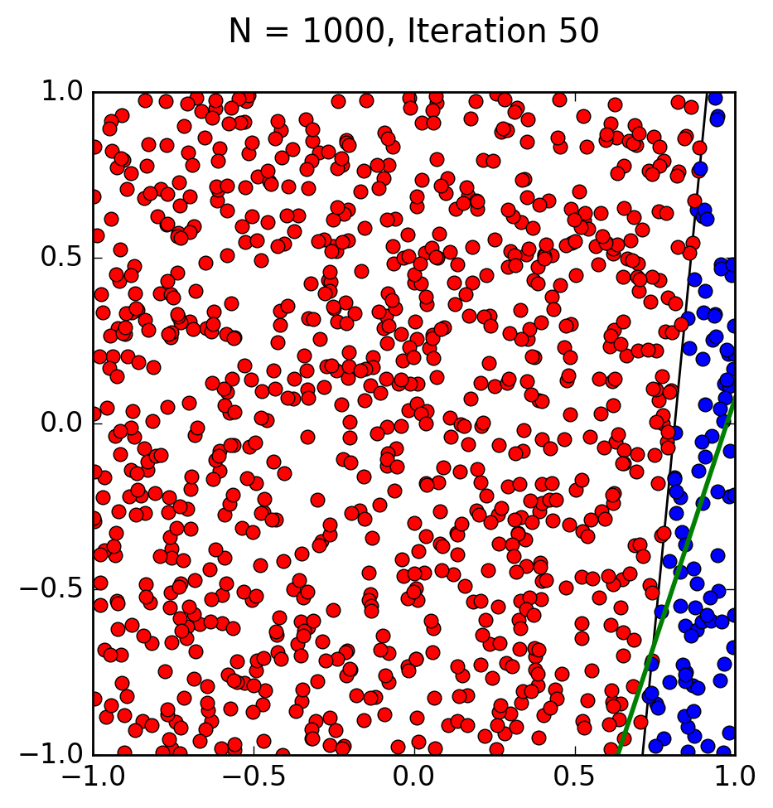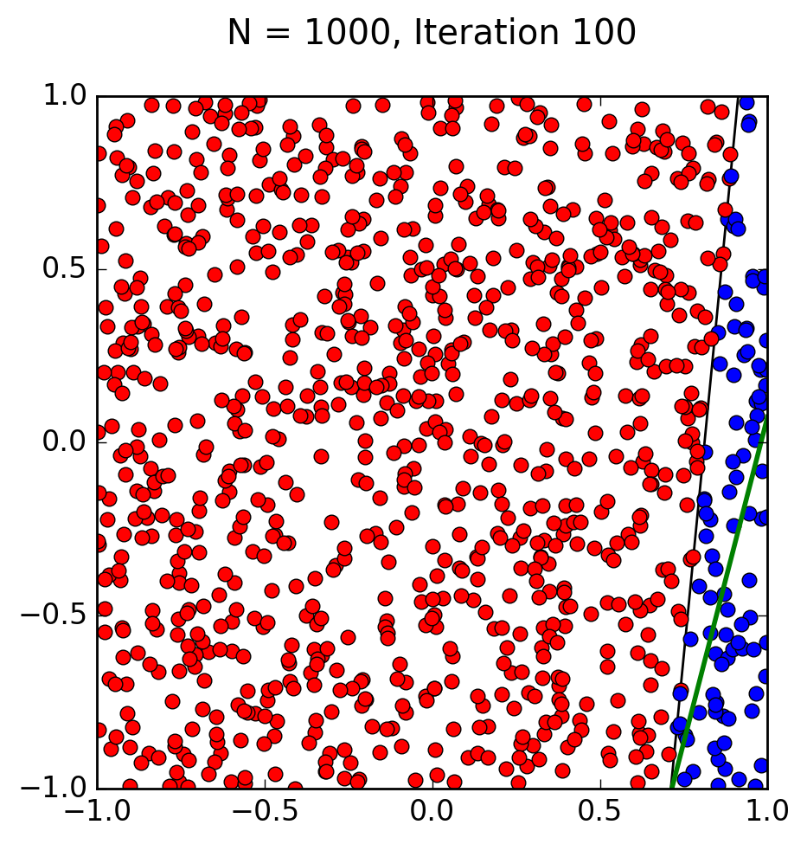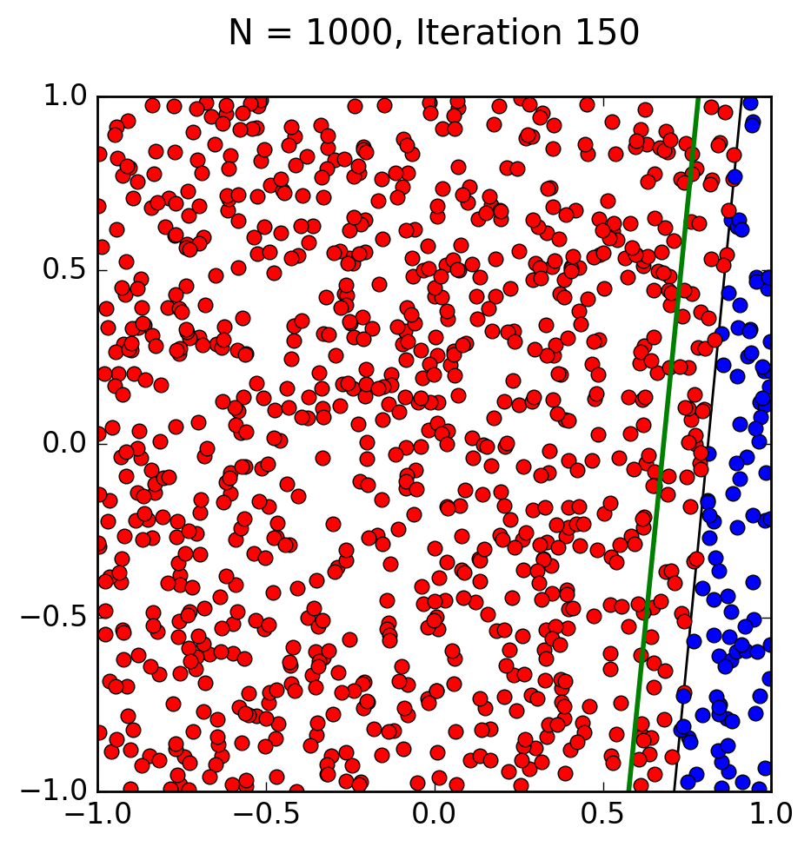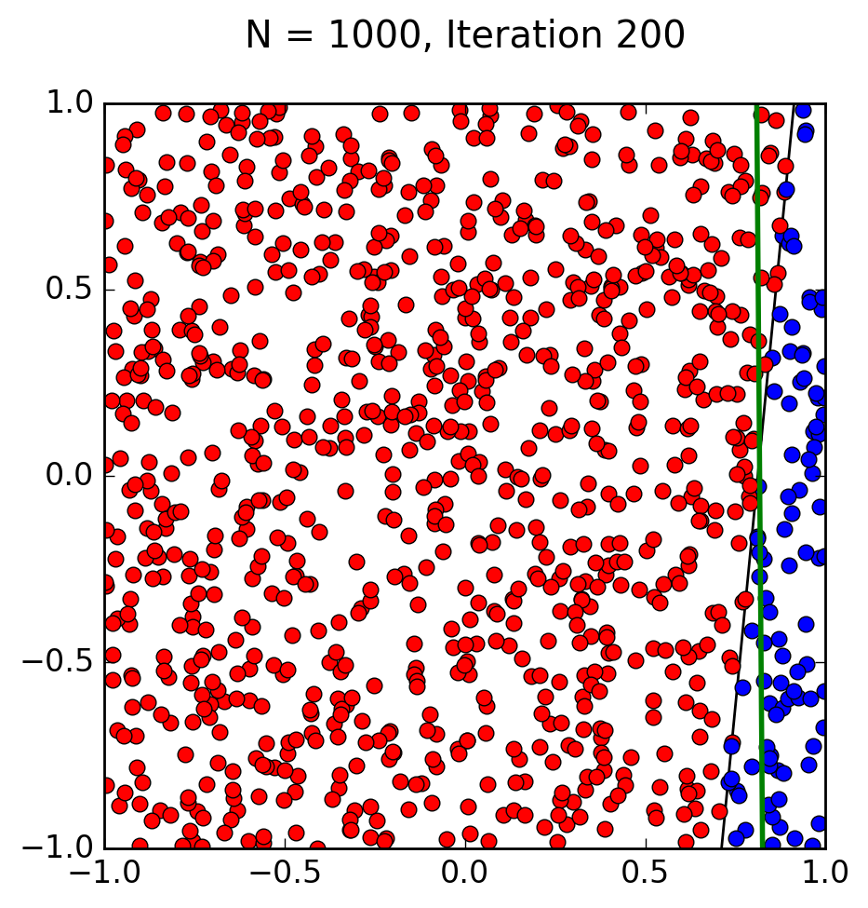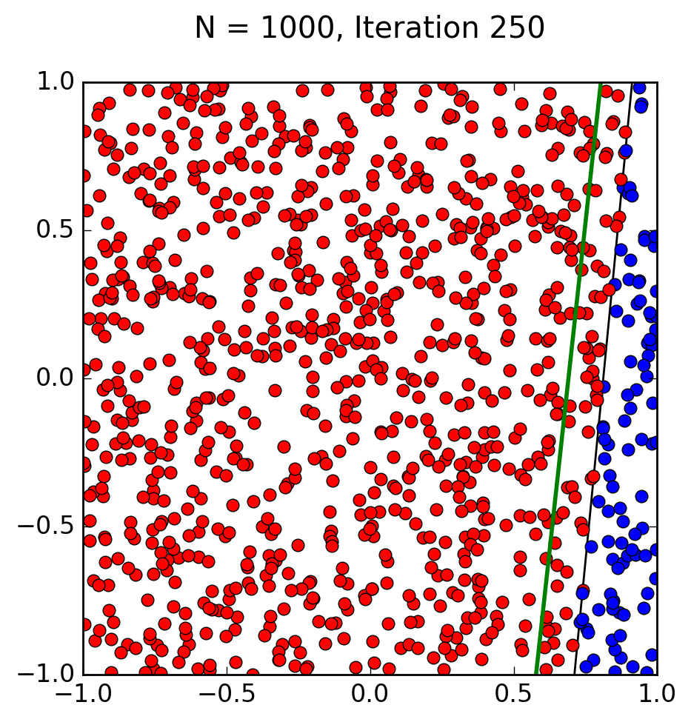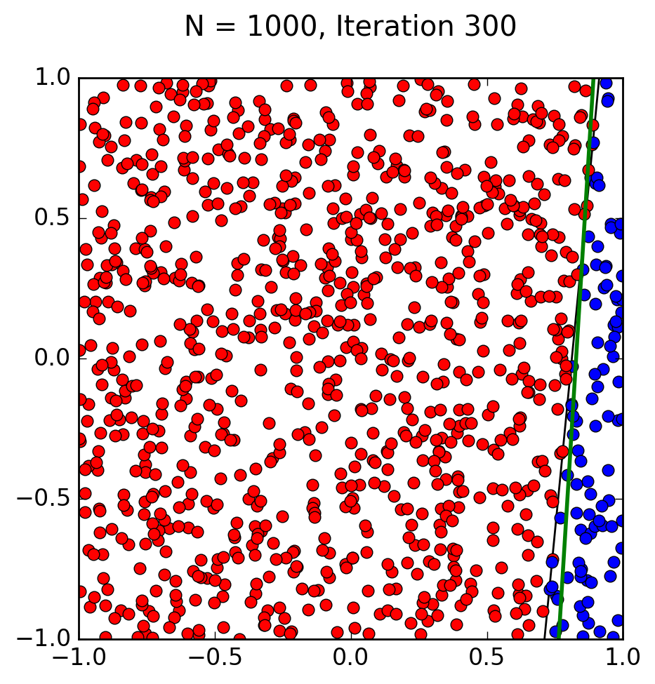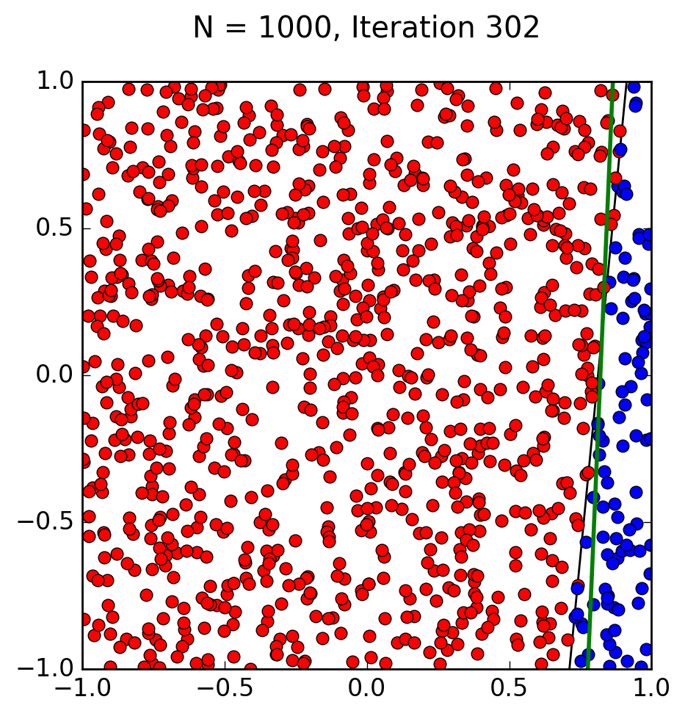

My computer just gave up after 302 iterations, but still got reasonably close to the target function.

f. & g.

I couldn’t get my python code to work. Here is what I tried to do:

import numpy as np

import random

import os, subprocess

import matplotlib.pyplot as plt

class Perceptron:

def __init__(self, N):

# Random linearly separated data

xA,yA,xB,yB = [random.uniform(-1, 1) for i in range(4)]

self.V = np.array([xB*yA-xA*yB, yB-yA, xA-xB])

self.X = self.generate_points(N)

def generate_points(self, N):

X = []

for i in range(N):

x1,x2,x3,x4,x5,x6,x7,x8,x9,x10 = [random.uniform(-1, 1) for i in range(2)]

x = np.array([1,x1,x2,x3,x4,x5,x6,x7,x8,x9,x10])

s = int(np.sign(self.V.T.dot(x)))

X.append((x, s))

return X

def plot(self, mispts=None, vec=None, save=False):

fig = plt.figure(figsize=(5,5))

plt.xlim(-1,1)

plt.ylim(-1,1)

V = self.V

a, b = -V[1]/V[2], -V[0]/V[2]

l = np.linspace(-1,1)

plt.plot(l, a*l+b, 'k-')

cols = {1: 'r', -1: 'b'}

for x,s in self.X:

plt.plot(x[1], x[2], cols[s]+'o')

if mispts:

for x,s in mispts:

plt.plot(x[1], x[2], cols[s]+'.')

if vec != None:

aa, bb = -vec[1]/vec[2], -vec[0]/vec[2]

plt.plot(l, aa*l+bb, 'g-', lw=2)

if save:

if not mispts:

plt.title('N = %s' % (str(len(self.X))))

else:

plt.title('N = %s with %s test points' \

% (str(len(self.X)),str(len(mispts))))

plt.savefig('p_N%s' % (str(len(self.X))), \

dpi=200, bbox_inches='tight')

def classification_error(self, vec, pts=None):

# Error defined as fraction of misclassified points

if not pts:

pts = self.X

M = len(pts)

n_mispts = 0

for x,s in pts:

if int(np.sign(vec.T.dot(x))) != s:

n_mispts += 1

error = n_mispts / float(M)

return error

def choose_miscl_point(self, vec):

# Choose a random point among the misclassified

pts = self.X

mispts = []

for x,s in pts:

if int(np.sign(vec.T.dot(x))) != s:

mispts.append((x, s))

return mispts[random.randrange(0,len(mispts))]

def pla(self, save=False):

# Initialize the weigths to zeros

w = np.zeros(3)

X, N = self.X, len(self.X)

it = 0

# Iterate until all points are correctly classified

while self.classification_error(w) != 0:

it += 1

# Pick random misclassified point

x, s = self.choose_miscl_point(w)

# Update weights

w += s*x

if save:

self.plot(vec=w)

plt.title('N = %s, Iteration %s\n' \

% (str(N),str(it)))

plt.savefig('p_N%s_it%s' % (str(N),str(it)), \

dpi=200, bbox_inches='tight')

self.w = w

def check_error(self, M, vec):

check_pts = self.generate_points(M)

return self.classification_error(vec, pts=check_pts)

p = Perceptron(20)

p.pla(save = True)

It’s a modified version of the code you told us to use in class.

h.

Based on the observations I was able to make, the accuracy (A) and running time (t) increase with the number of elements (N) and dimensions (d); meaning that accuracy and running time are directly correlated to number of elements and dimensions.

My educated guess for the formula would be:

A = Nd/ t