Alexander Palomba

Artificial Intelligence

27 September 2016

Homework 02

Problem 2.1

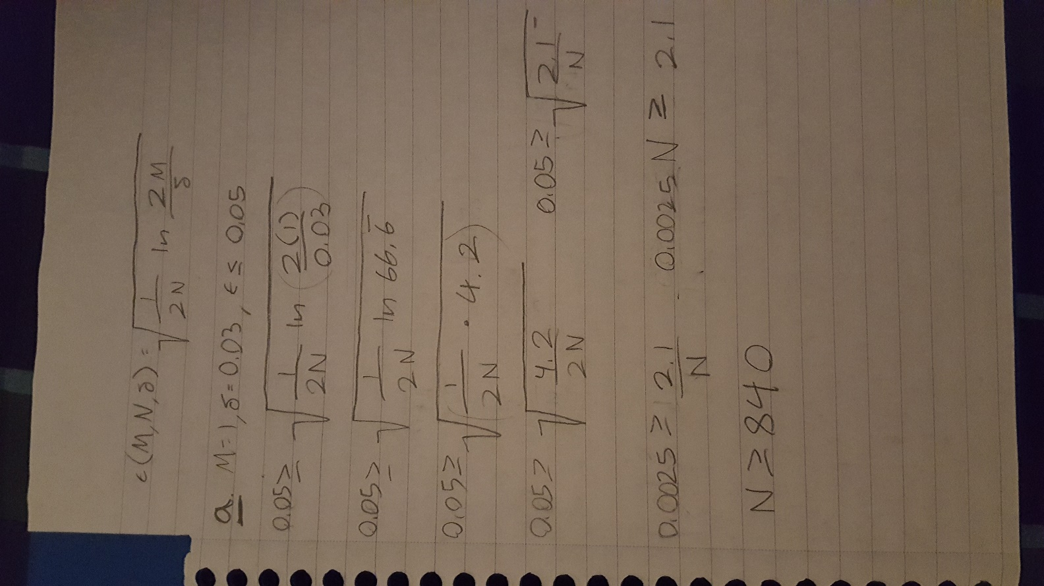

1. N ≥ 840

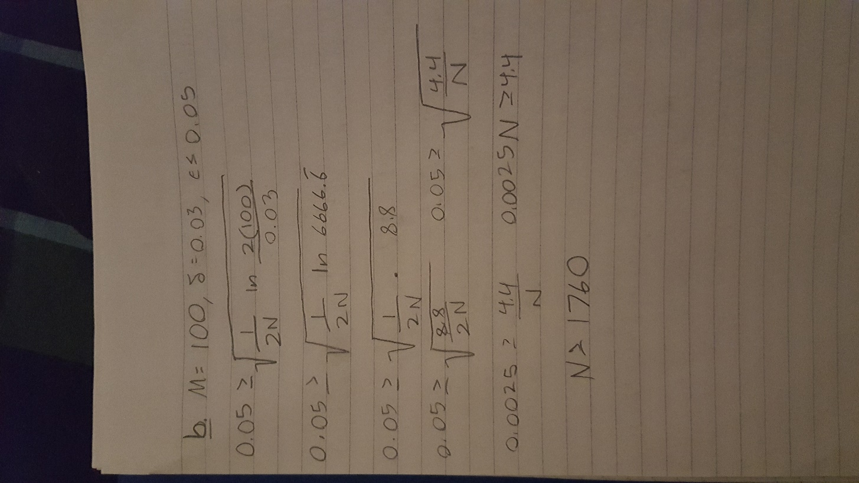

1. N ≥ 1760

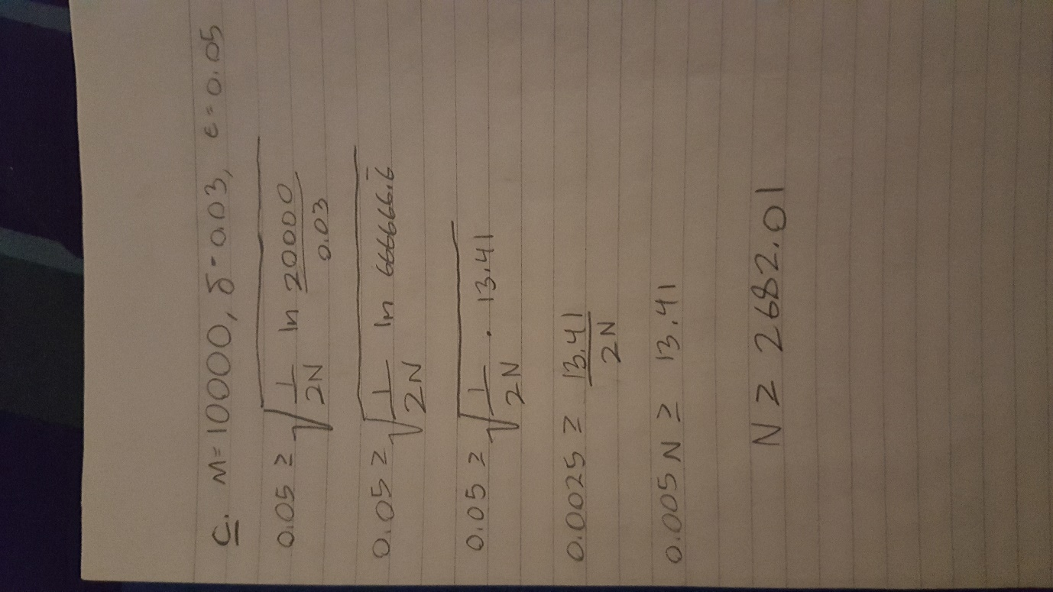

1. N ≥ 2682.01

Problem 2.11

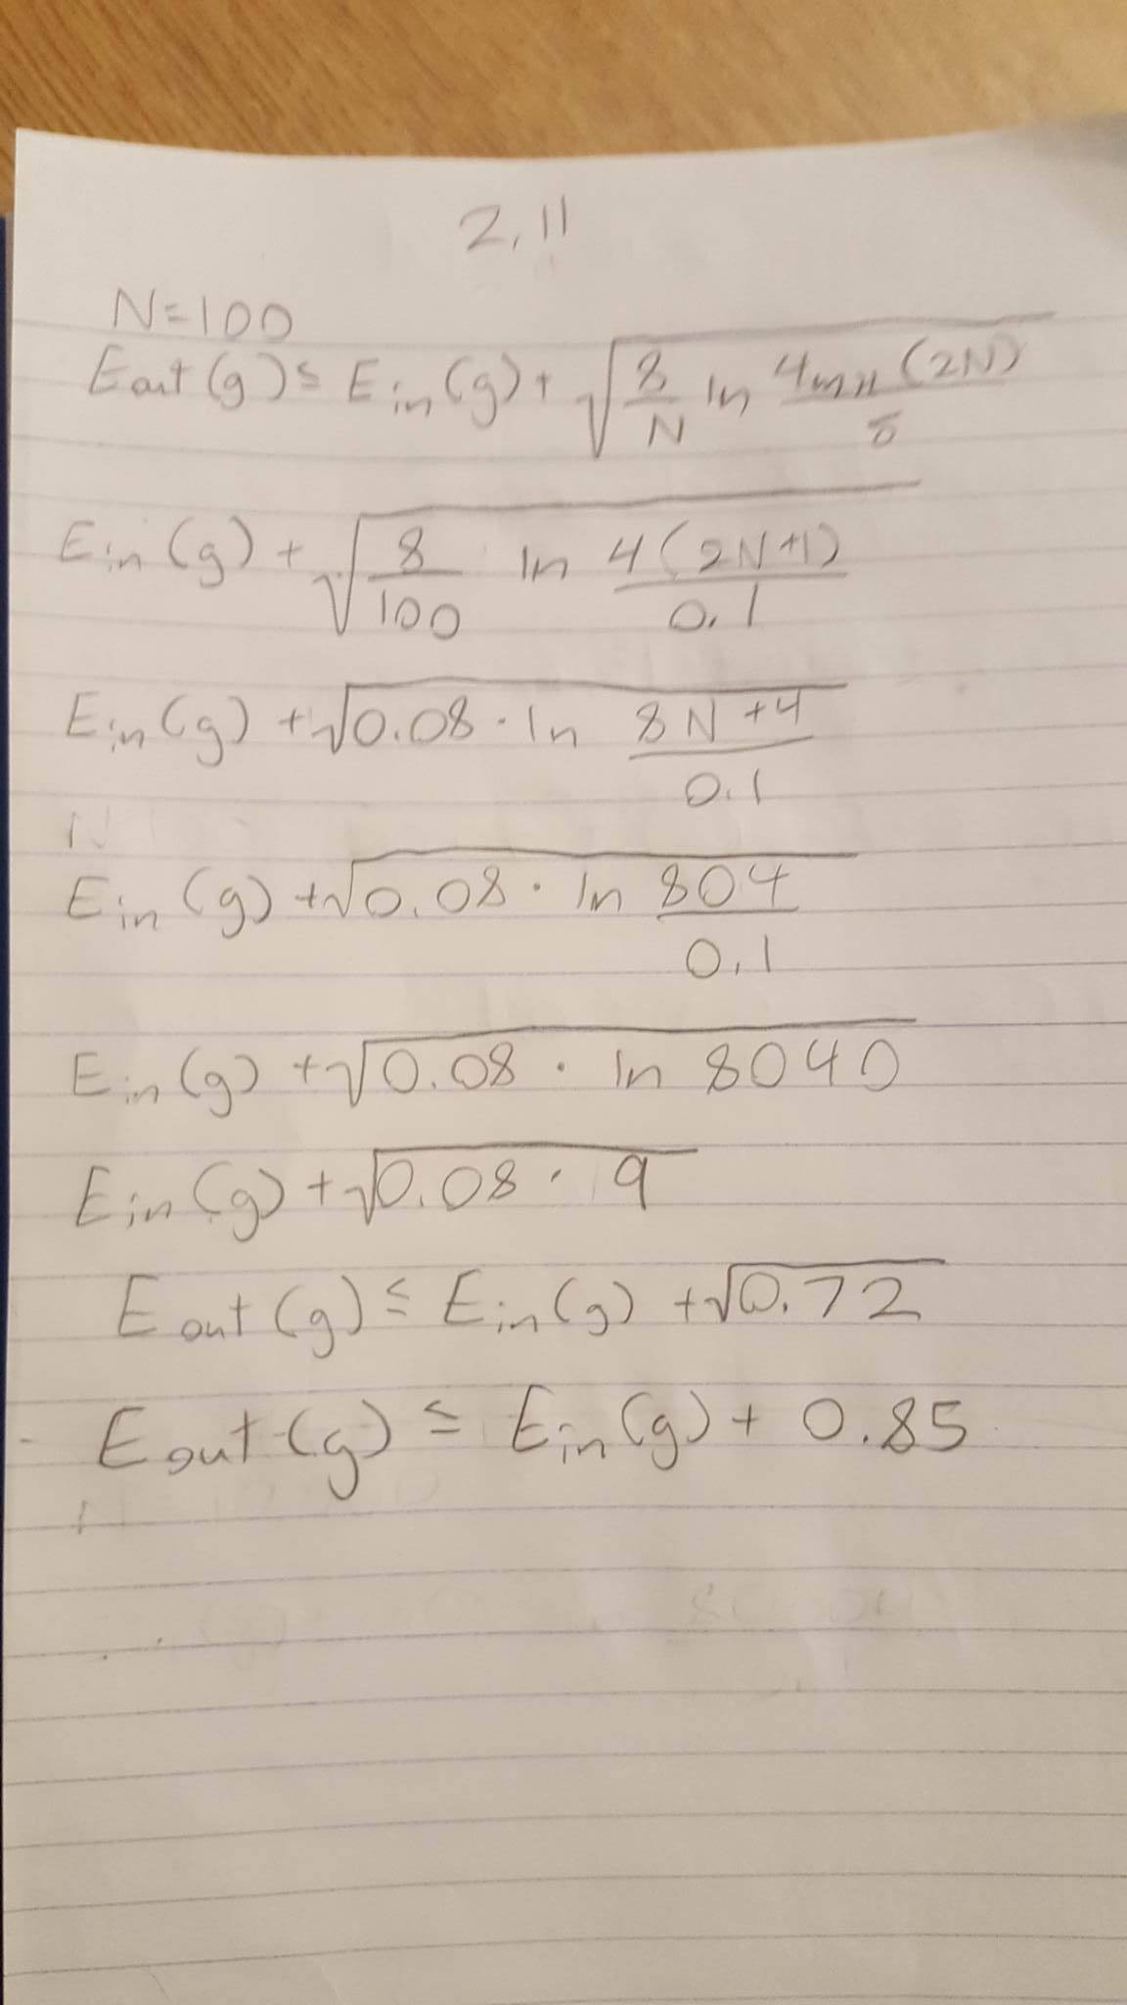

N = 100, Eout(g) ≤ Ein(g) + 0.85

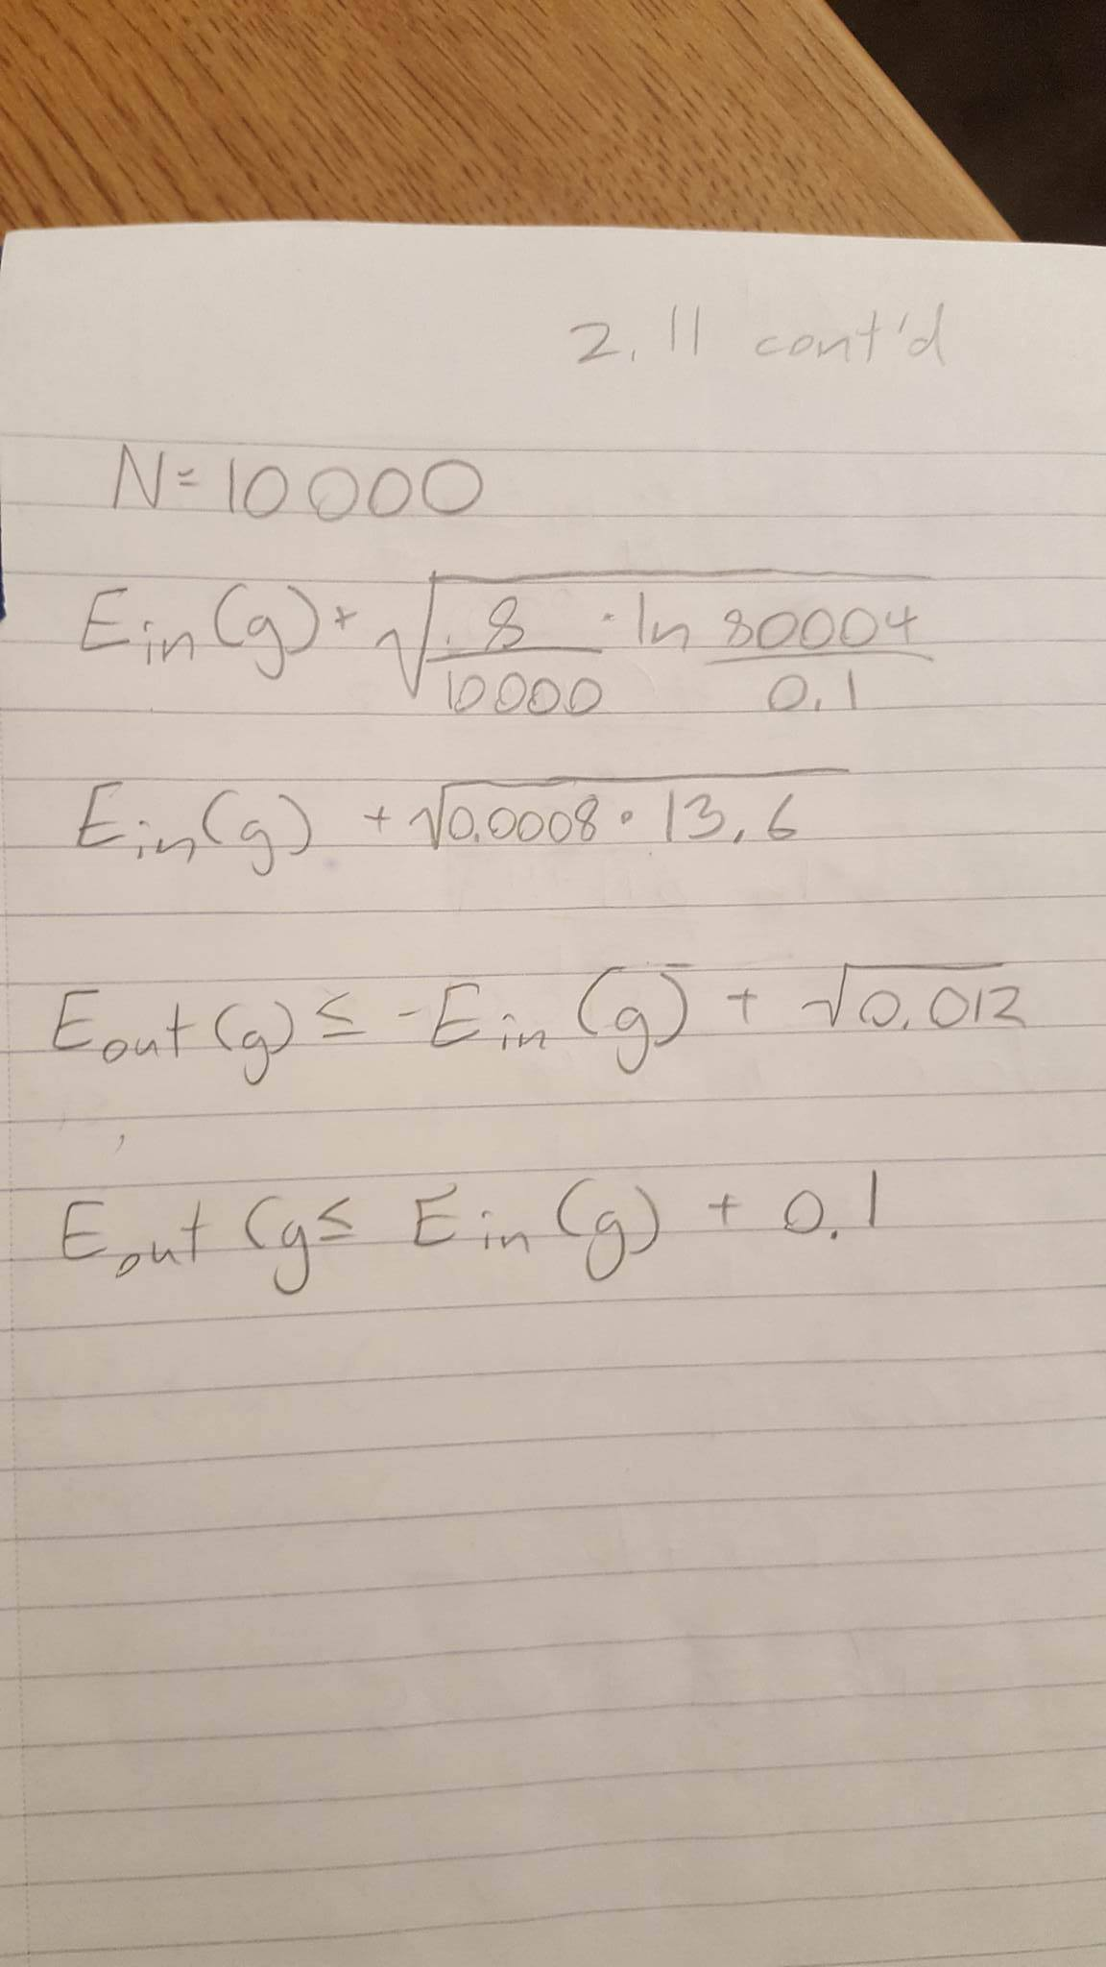

N = 10000, Eout(g) ≤ Ein(g) + 0.1

Problem 2.12

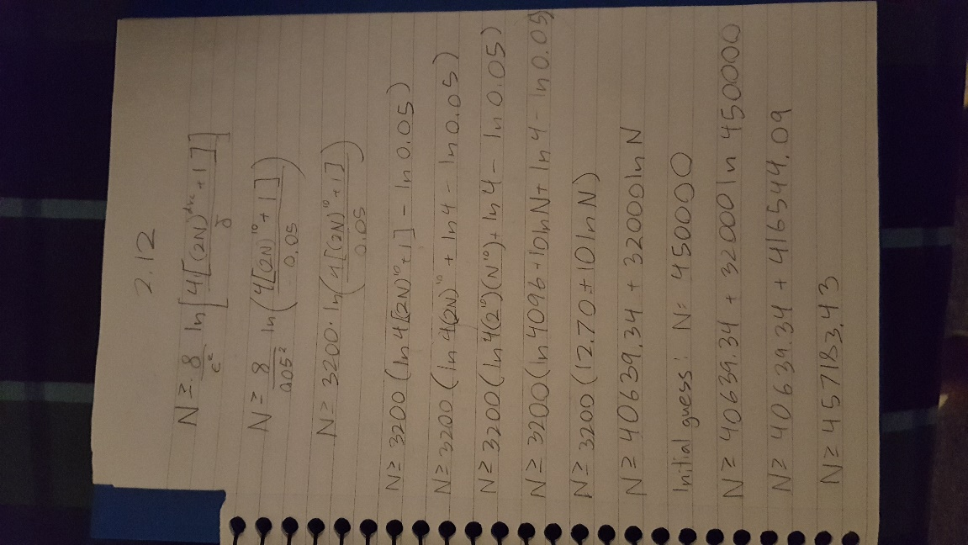

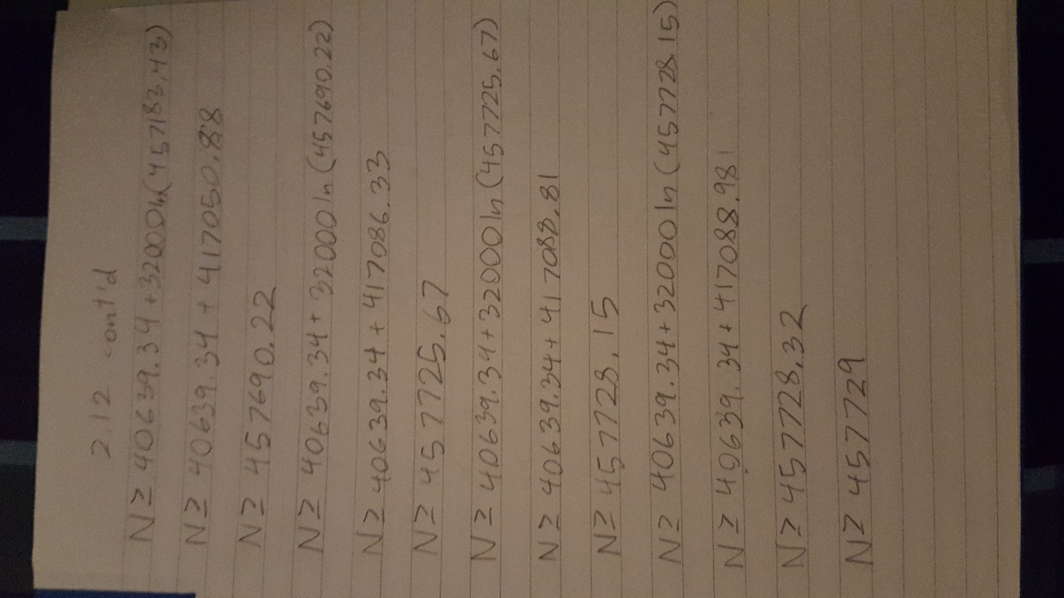

N ≥ 457729

Problem 3.1

a.

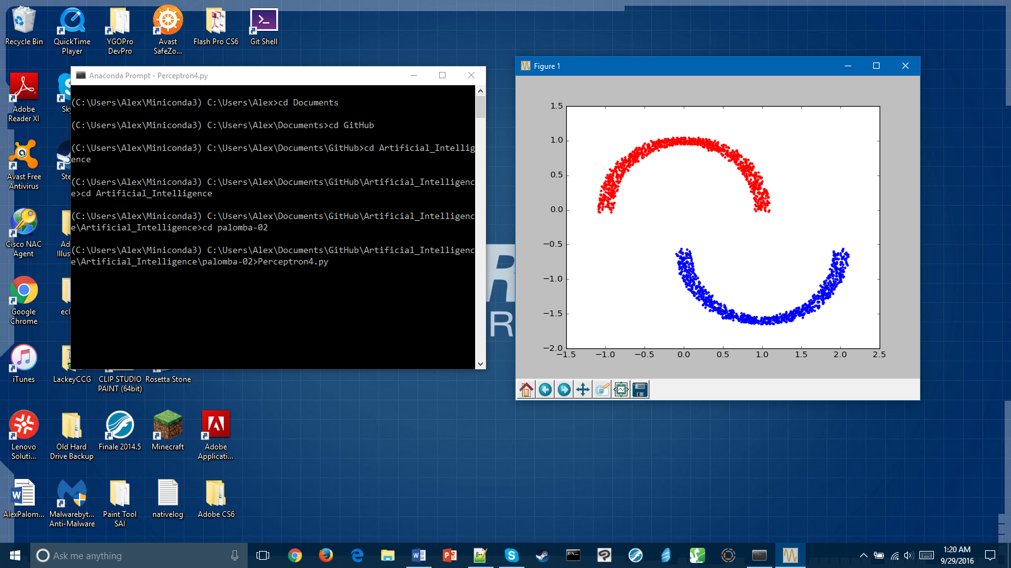

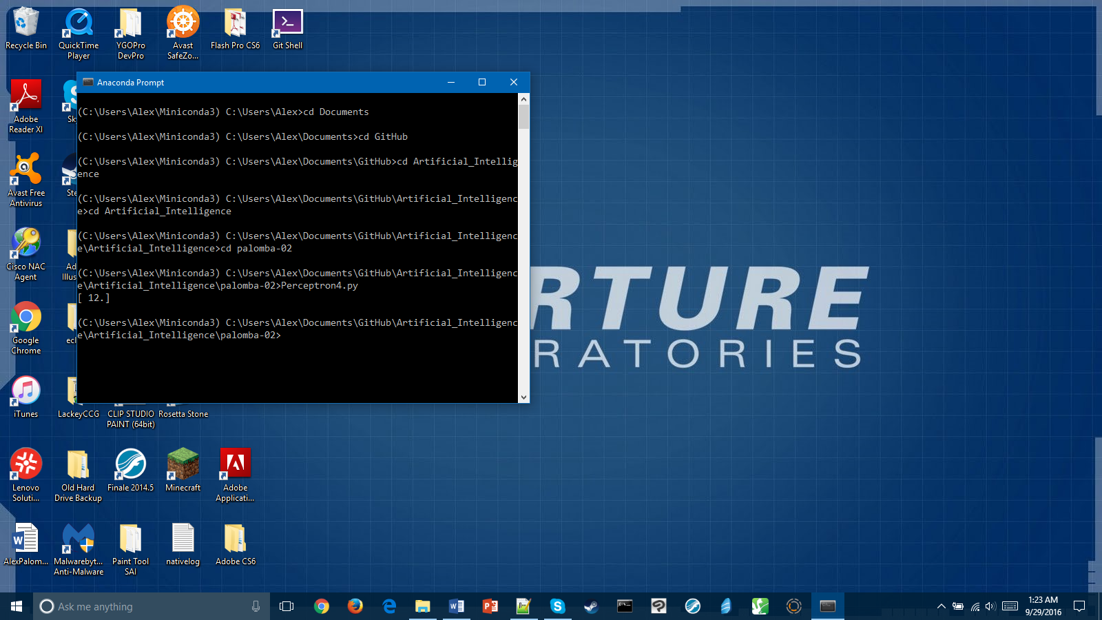

The PLA took 12 iterations to converge on *w*.

b.

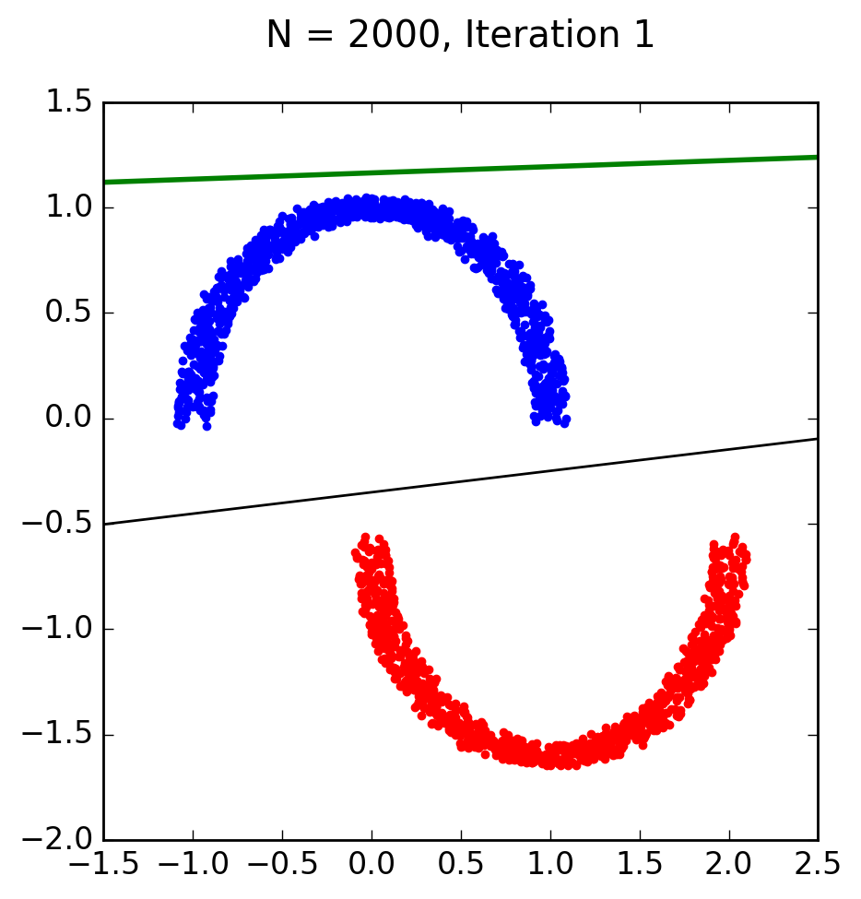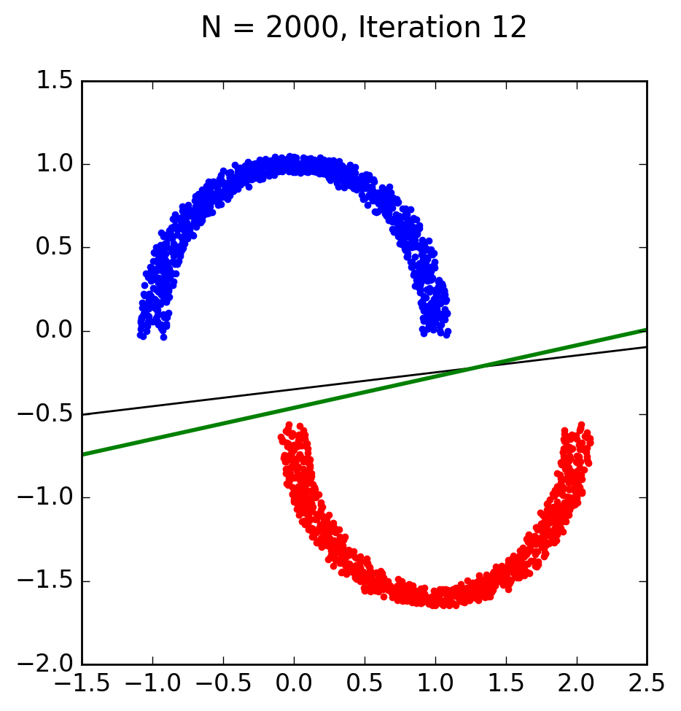

The green line represents the PLA from part a, and the black line represents the linear regression.