Alexander Palomba

13 October 2016

Artificial Intelligence

Homework 3

1.

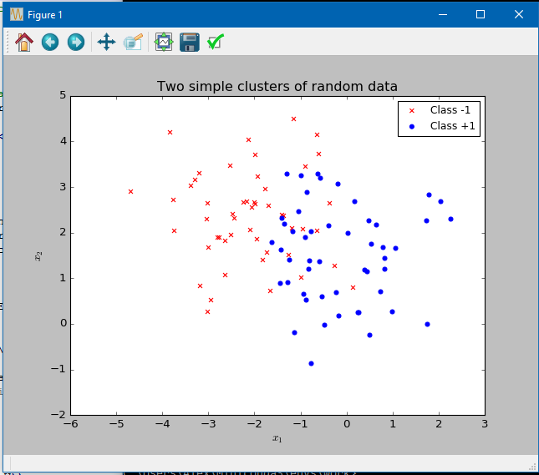

1. The *Eout* for the pocket algorithm starting from **w** = 0 is 0.13, which was reached after 3703 iterations.



1. The *Eout* for linear regression 0.17, and yielded a **w** of [0.86745859, 0.44992245, -0.18256571].





1. The *Eout* for the pocket algorithm using the **w** acquired from linear regression is 0.13, which was reached after 756 iterations.



Conclusions: Linear regression achieved a result the quickest, but with the least accuracy. The pocket algorithm had the same margin of error before and after linear regression was applied, but arrived at the result much quicker on the second attempt (**w** = [0.86745859, 0.44992245, -0.18256571]).