Alexander Palomba

Artificial Intelligence

1 November 2016

Homework 04

1.

a. Changed the range of the given function from 100 to 1000.

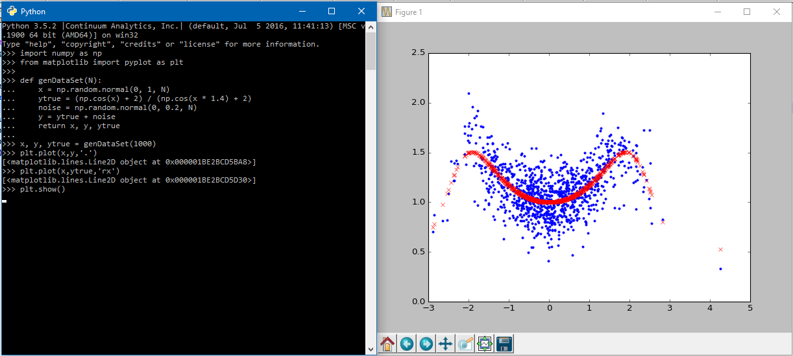

b. The best values for k were 0.37350275213775502, 0.25195631501903848, and 0.25192729352004434, which were at indices 1, 311, and 305, respectively. I attempted to get a graph to display the dataset, but it failed due to an unknown error.

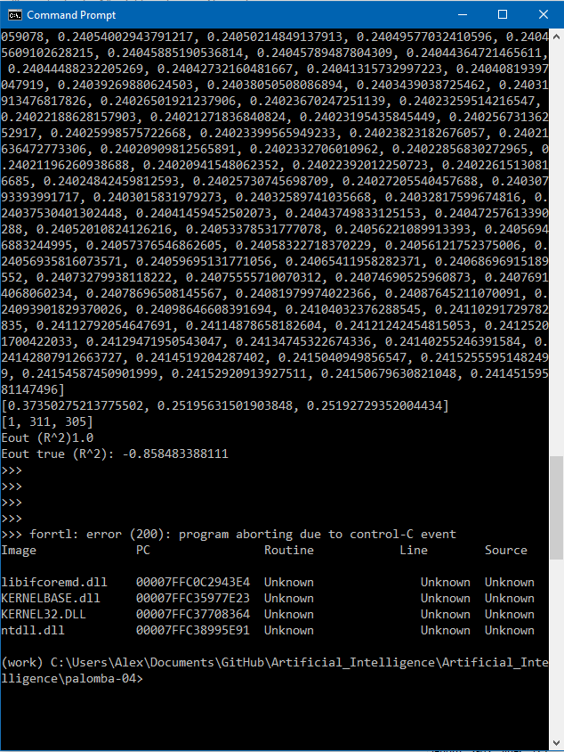

c. The best Eout was -0.858483388111, which was achieved using the third value of k acquired from part b, 0.25192729352004434.

