Alexander Palomba

Artificial Intelligence

Prof. Rivas

15 November 2016

Homework 5

1.

This is the original image I used:



These are the results when n_colors = 8:



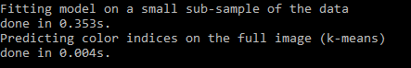

These are the results when n_colors = 20:



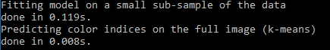

These are the results when n_colors = 50:



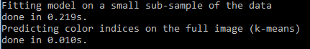

When you decrease the value of n_colors, the colors in the image with similar hue are are grouped together into a single hue. It’s reasonable to assume that this can also be applied to learning algorithms to predict the values of elements which are located close to elements whose values are already known. In this case, the picture looks distorted because the prediction algorithm lumps similar colors into the same hue, predicting what the other colors will be based on what they are close to.

2.

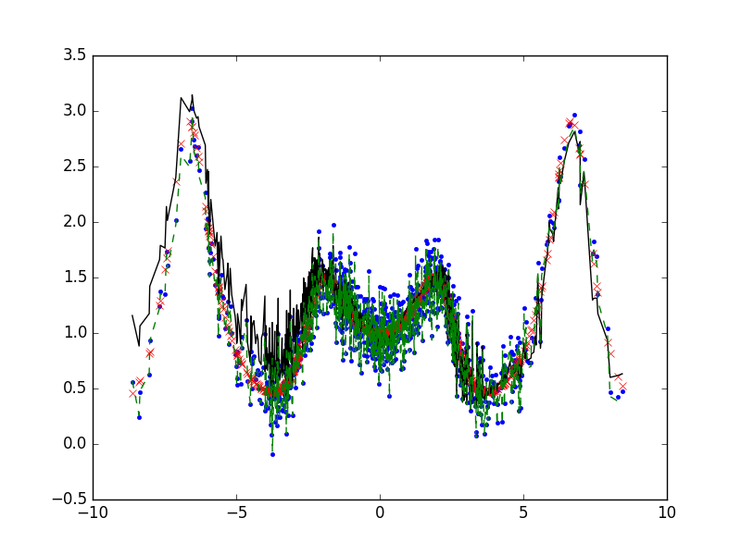

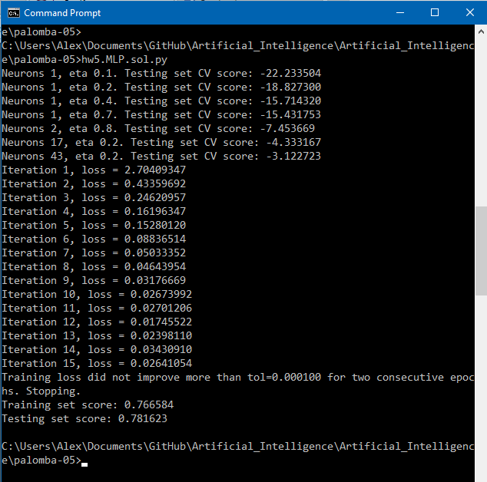

These are the results of the neural network with 1000 samples. The highest number of neurons was 43, and the highest ƞ was 0.8. As the number of neurons increased, the predictions became more accurate, but took longer to complete. With 43 neurons in the training samples, it took only 15 iterations to reach a loss of 0.02641054. If the program had run without training, it would likely have taken longer to converge on a result, and said result would not have been as accurate.

