Alexander Palomba

13 October 2016

Artificial Intelligence

Midterm Exam

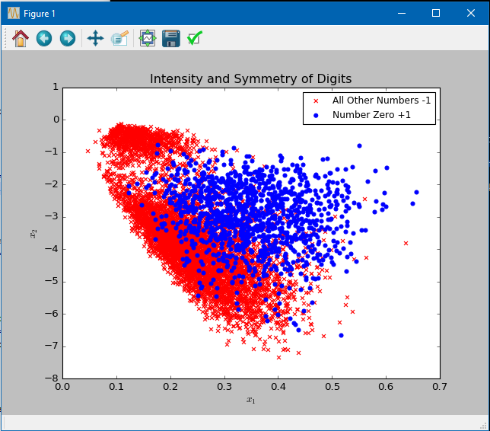

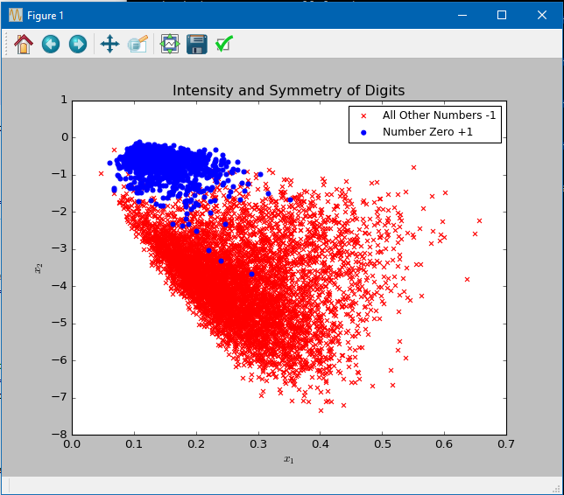

1. The Eout for the Pocket algorithm is 0.012069674941708956, which was reached after 701 iterations.



1. The Eout for linear regression is 0.01522424907420107, and yielded a w of [0.54592846, -0.9675805, 0.30085587]



1. The Eout for the Pocket algorithm with linear regression is 0.012069674941708956, and it took 1259 iterations to reach.



Conclusions: Linear regression reach a result much quicker, but with a higher Eout that the Pocket algorithm. Surprisingly, the Eout increased when the linear regression weight was applied. I ran the algorithm again to see if this was merely a freak accident – it wasn’t.

1. import numpy as np

def loop(N):

n = N + 1

iter = 0

while(n>N):

N = n

n = 32000\*np.log(N)

print(str(n))

iter = iter + 1

loop(1000)

