DUNNHUMBY

This dataset contains household level transactions over two years from a group of 2,500 households who are frequent shoppers at a retailer. It contains all of each household’s purchases, not just those from a limited number of categories. For certain households, demographic information as well as direct marketing contact history are included.

DATASET DETAILS

Campaing desc: This table give the length of the time for which a campaign runs. So, any coupons received as a part of a campaign are valid within the dates contained in this table.

- Type of campaign, the campaign ID, the start date, and the end date.

Campaing table: This table lists the campaigns received by each household in the study. Each hosehold received a different set of campaigns

- Type of campaign, the campaign ID, the start date, and the end date.

Causal data: This table signifies whether a given product was featured in the weekly mailer or was part of an in-store display (other than regular product placement).

- Product ID, store ID, week od the transaction, display location, mailer location

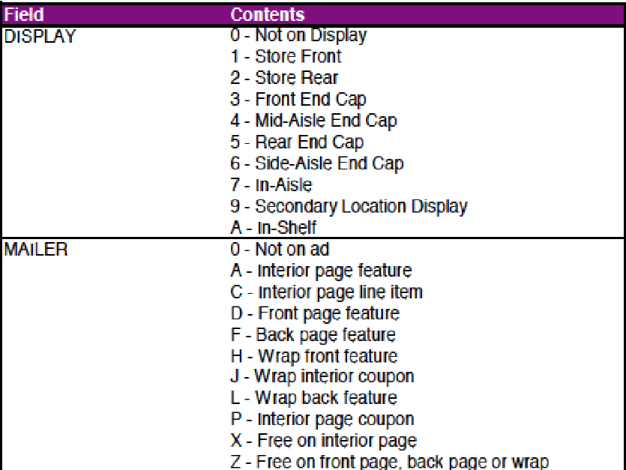

Coupon: This table lists all the coupons sent to customers as part of a campaign, as well as the
products for which each coupon is redeemable. Some coupons are redeemable for multiple
products. One example is a coupon for any private label frozen vegetable. There are a large
number of products where this coupon could be redeemed.

For campaign TypeA, this table provides the pool of possible coupons. Each customer
participating in a TypeA campaign received 16 coupons out of the pool. The 16 coupons
were selected based on the customer’s prior purchase behavior. Identifying the specific 16
coupons that each customer received is outside the scope of this database.

For campaign TypeB and TypeC, all customers participating in a campaign receives all
coupons pertaining to that campaign.

- UPC coupon, the product ID, and the campaign ID

Coupon redempt: This table identifies the coupons that each household redeemed.

- Household ID, Day (when transaction occurred), UPC coupon, campaign ID

Hh demographic: This table contains demographic information for a portion of households. Due to nature of the data, the demographic information is not available for all households.

- Household ID, age range, marital status (A-married, B-Single, U-Unknown), Income, Homeowner desc, household composition, size of household, number od children present

Product: This table contains information on each product sold such as type of product, national or
private label and a brand identifier

- Product ID, Deparment, Commodity desc, Sub commodity desc, manufacturer, brand, size of product

Transaction data: This table contains all products purchased by households within this study. Each line found in this table is essentially the same line that would be found on a store receipt.

- Hosusehold ID, basket ID, Day (transaction), product ID, quantity (number of products), sales value, store ID, coupon match discount (retailer math manufacturer), coupon discount (manufacturer coupon), retail discount, transaction time, week of transaction

Link: https://www.kaggle.com/datasets/frtgnn/dunnhumby-the-complete-journey

