Full after Kalman Procedure:
1: Copy files from Desktop to Passport
Sudo find home/alex/Documents/RF/KFRF/KalWRF/R3 –name “*filt*” –exec cp {} –t media/alex/’My Passport’/Kal52016 \;
2:CV Procedure (On Laptop C:Users/alex/Documents/RMSE/Sto2Full:
WindTSMad2.m
  - storm/20001234SC24.txt(r)
  - MadisCRno.csv
  - C24.txt(r)
  - R24.txt(r)
  - ST24.txt(r)
  - Madis/20001234_00staMA.txt(r)
  - Madis/20001234_00ffMA.txt(r)
  - WindMadOut2/F24.txt(w)

WindTSMet2.m
  - storm/20001234SC24.txt(r)
  - MetCRno.csv
  - WindMetOut2/C24.txt(r)
  - WindMetOut2/R24.txt(r)
  - WindMetOut2/ST24.txt(r)
  - Metar/20001234_00ST.txt(r)
  - Metar/20001234_00FF.txt(r)
  - WindMetOut2/F24.txt(w)

/Metar/pull.m
WindTCwSTm2.m
  - storm/20001234SC24.txt(r)
  - WindMadOut2/ST24.txt(r)
  - WindMetOut2/ST24.txt(r)
  - WindMadOut2/Fn024.txt(r)
  - WindMetOut2/Fn024.txt(r)
  - WindMadOut2/C24.txt(r)
  - WindMetOut2/R24.txt(r)
  - WindMadOut2/om.txt(r)
  - WindMetOut2/om.txt(r)
  - WindCombOut2/HtrC20001234_00.txt(w)
  - WindCombOut2/HtrR20001234_00.txt(w)
  - WindCombOut2/HtrFF20001234_00.txt(w)
  - WindCombOut2/HtrST20001234_00.txt(w)
  - WindBStat2/HElim20001234.csv(w)
  - WindBStat2/MaxReps20001234.csv(w)
  - storm/20001234SC24.txt(r)
  - WindMadOut2/F24ST.txt(r)
  - WindMetOut/F24ST.txt(r)
  - WindMadOut2/Fn024.txt(r)
  - WindMetOut2/Fn024.txt(r)
  - WindMadOut2/C24.txt(r)
  - WindMetOut2/R24.txt(r)
  - WindMadOut2/om.txt(r)
  - WindMetOut2/om.txt(r)
  - WindCombOut2/TtrC20001234_00.txt(w)
  - WindCombOut2/TtrR20001234_00.txt(w)
  - WindCombOut2/TtrFF20001234_00.txt(w)
  - WindCombOut2/TtrST20001234_00.txt(w)
  - WindBStat2/TElim20001234.csv(w)
  - WindBStat2/TMaxReps20001234.csv(w): There originally was no difference
  - storm/20001234SC24.txt(r)
  - WindMadOut2/F24ST.txt(r)
  - WindMetOut/F24ST.txt(r)
  - WindMadOut2/Fn024.txt(r)
  - WindMetOut2/Fn024.txt(r)
  - WindMadOut2/C24.txt(r)
  - WindMetOut2/R24.txt(r)
  - WindMadOut2/om.txt(r)
  - WindMetOut2/om.txt(r)
  - WindCombOut2/HtrC20001234_00.txt(r): I am missing the folder extension
  - WindCombOut2/HtrR20001234_00.txt(r)
  - WindCombOut2/HtrFF20001234_00.txt(r)
  - WindCombOut2/HtrST20001234_00.txt(r)
  - WindCombOut2/TTtrC20001234_00.txt(w)
  - WindCombOut2/TTtrR20001234_00.txt(w)
  - WindCombOut2/TTtrFF20001234_00.txt(w)
  - WindCombOut2/TTtrST20001234_00.txt(w)
  - WindBStat2/TTElim20001234.csv(w)
  - WindBStat2/TTMaxreps20001234.csv(w)

ByStatCV.m (Part 1)
  - storm/20001234SC24.txt(r)
  - MadisCRno.csv
  - C24.txt(r)
  - R24.txt(r)
  - ST24.txt(r)
  - Madis/20001234_00staMA.txt(r)
  - Madis/20001234_00ffMA.txt(r)
  - WindMadOut2/F24.txt(w)

BiasKrig.m (check iterator Line57)
  - Stormlist.csv(r):
  - CombOut385/trR20001234_00.txt (r)
  - CombOut385/trFF20001234_00.txt(r)
  - CombOut385/trST20001234_00.txt(r)
  - ZfKrig385/1yx.txt(w)
  - ZfKrig2/1mse.txt(w)
  - ZfKrig2/1CR.txt(w)
  - ZfKrig2/1ff.txt(w)
ByStatCV.m (Part 2)
  - alltime.txt
  - CombOut385/trC20001234_00.txt (r)
  - CombOut385/trR20001234_00.txt (r)
  - CombOut385/trFF20001234_00.txt(r)
  - CombOut385/trST20001234_00.txt(r)
  - ByStat385/Elim20001234.csv(r)
  - ByStat385/MaxReps20001234.csv (r)
  - ZfKrig385/1yx.txt(r)
  - ZfKrig385/1CR.txt(r)
  - ByStat385/RMSEK1234.png: Havn’t done bias yet
  - ByStat385/WindK1234.png

3: After Running on all computers recompile storms and create desired matrix
Repbu
  - Stormlist.csv(r):
  - Folder:ByStatOut(mkdir)
  - MetMad.csv(r):
  - ByStat20001234/Elim20001234.csv (r) (Does not change hourly because all CV Stats have to exist throughout)
  - ByStat20001234/MaxReps20001234.csv(r)
  - ByStat20001234/WindK1234.png(r)
  - ByStatOut/K1234/ WindK1234.png(w)

RepbuBias14
  - Stormlist.csv(r):
  - Folder:ByStatOut(mkdir)
  - MetMad.csv(r):
  - ByStat20001234/Elim20001234.csv (r) (Does not change hourly because all CV Stats have to exist throughout)
  - ByStat20001234/MaxReps20001234.csv(r)
  - ByStat20001234/BiasK1234.png(r)
  - ByStatOut/K1234/ BiasK1234.png(w)

RMSEuk.m
  - StormlistNO.csv(r)
  - Folder:ByStatOut(mkdir)
  - MetMad.csv(r)
  - ByStat20001234/Elim20001234.csv (r) (Does not change hourly because all CV Stats have to exist throughout)
  - ByStat20001234/MaxReps20001234.csv(r)
  - ukRMSENO.txt (w)
RMSEukEval.R
- C:\\Users\\alex\\Downloads\\ukRMSE.csv
- C:\\Users\\alex\\Downloads\\Stormlist.csv
- C:\\Users\\alex\\Downloads\\MetMad.csv
- C:\\Users\\alex\\Downloads\\MetMad8El.csv
- cluster.csv
- AvgRMSEbyStat.csv
C:\gisclass\Thesis\RMSEeval\AvgStatUKrmse.mxd
C:\gisclass\Thesis\RasterVidTest\OceanUK.mxd

KalmanComparison.m
  - alltime.txt
  - CombOut385/trC20001234_00.txt (r)
  - CombOut385/trR20001234_00.txt (r)
  - CombOut385/trFF20001234_00.txt(r)
  - CombOut385/trST20001234_00.txt(r)
  - ByStat385/Elim20001234.csv(r)
  - ByStat385/MaxReps20001234.csv (r)
  - ZfKrig385/1yx.txt(r)
  - ZfKrig385/1CR.txt(r)
  - WRFvidKal/modeltom_filt1.txt(r)
  - ByStat385/ KalEvalK1234.png(w)
  - ByStat385/ RMSEwrf.csv(w)
  - ByStat385/ RMSEkal.csv(w)
    - Some kind or RMSE creation code for all three types to make three RMSE matrices

C:\Users\alex\Desktop\Storm3Test\RMSEuk.m
G:\CV62015Cast\CEELab#\ByStatCV.m
In order the CV procedure is:
G:\CV62015Cast\CEELab#\WindTSMad2.m
G:\CV62015Cast\CEELab#\WindTSMet2.m
Metar/pull.m
G:\CV62015Cast\CEELab#\WindTCSTm2.m
G:\CV62015Cast\CEELab#\ByStatCV.m
G:\CV62015Cast\CEELab#\BiasKrig.m
G:\CV62015Cast\CEELab#\ByStatCV.m(pt2)

C:\Users\alex\Desktop\Storm3Test\RMSEBiasPWRF2.m
G:\CV62015Cast\CEELab#\ByStatCV.m
In order the CV procedure is:
G:\CV62015Cast\CEELab#\BiasTSMad2.m
G:\CV62015Cast\CEELab#\BiasTSMet2.m
Metar/pull.m
G:\CV62015Cast\CEELab#\BiasTCSTm2.m
G:\CV62015Cast\CEELab#\BiasByStatCV.m
G:\CV62015Cast\CEELab#\BiasKrig.m
G:\CV62015Cast\CEELab#\BiasByStatCV.m(pt2)

C:Users\alex\Desktop\Storm3Test\KalmanCompar2.m
C:Users\alex\Desktop\Storm3Test\KalmanScatter.m?????
C:Users\alex\Desktop\Storm3Test\KalScatter2.m
Azula\Documents\RF/KFRF/KalWRF/GCListComp (KFoutputs from KalmanCV.f90)
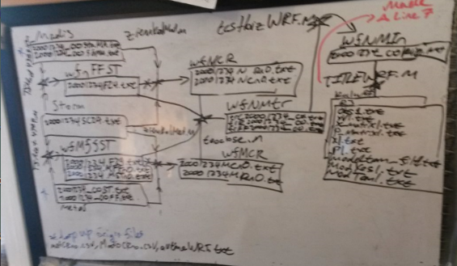

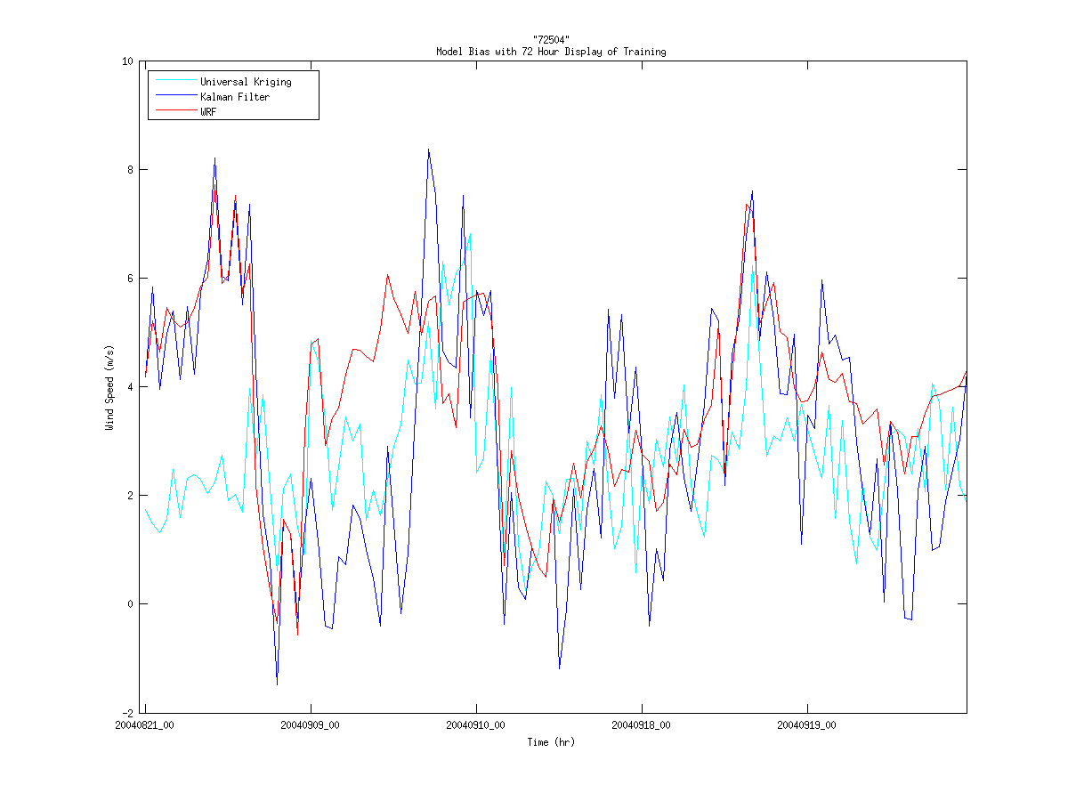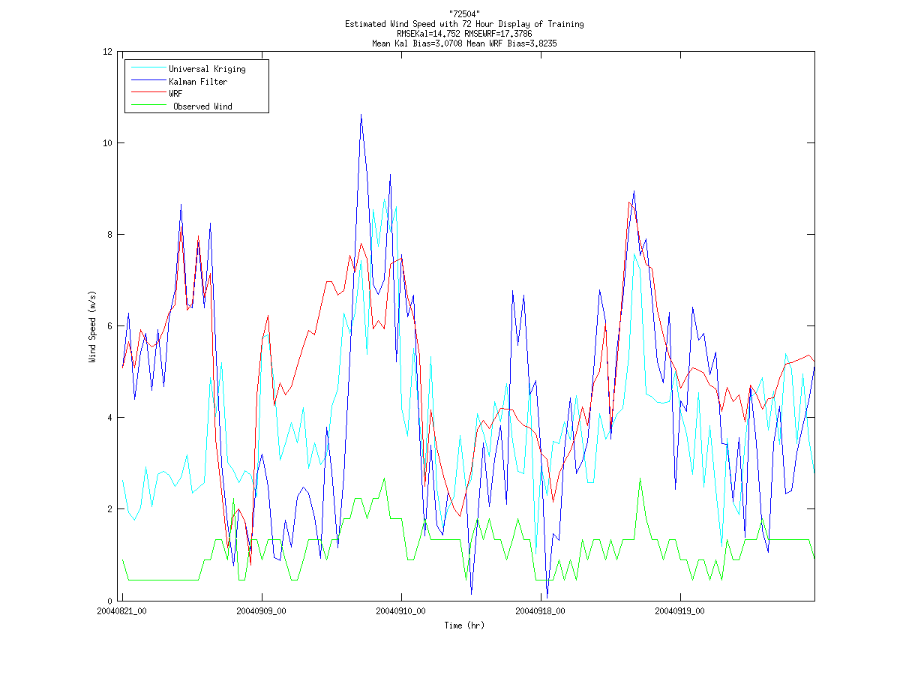
Azula/home/alex/Documents/RF/KFRF/KalmanAnalysisG.m
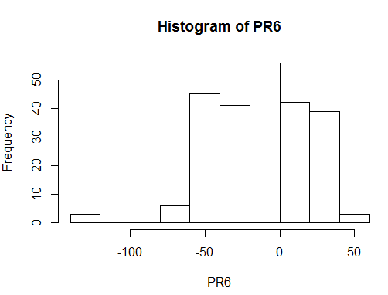
Laptop/Storm3Test/percentiles#.R

RMSE Maps
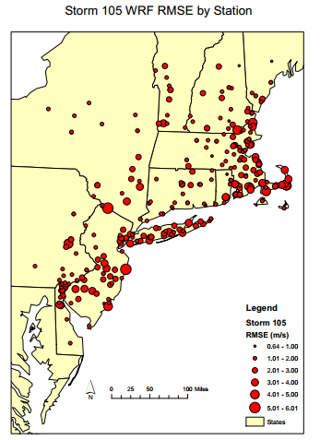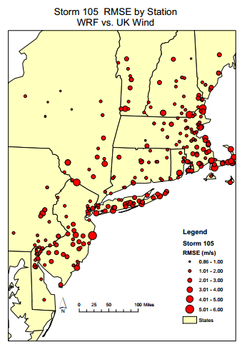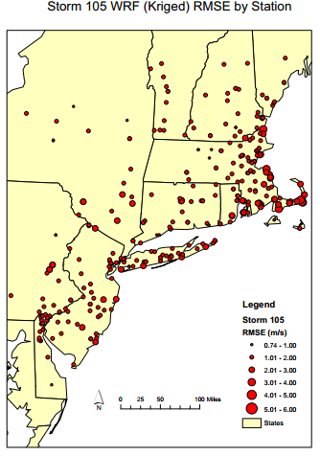

Map1: WRF vs. Kobs
G:\CV62015Cast\ByStatCV2wrf.m: RMSE eval\cross validation of WRF vs. Kobs
C:\Users\alex\Desktop\Storm3Test\RMSEwrfvuk.m makes the RMSE matrix used for plotting
C:\gisclass\Thesis\RMSEeval\11Storm\RMSEwvUKMap.m
Note: Output PDF’s C:\gisclass\Thesis\RMSEeval\

Map2 Obsk vs. Obs
G:Bias62015\SCVUKPWRF.m: RMSE eval\cross validation of WRF vs. WRFk
C:\gisclass\Thesis\RMSEeval\11Wind\RMSEBiasPWrf.m
C:\gisclass\Thesis\RMSEeval\11Storm\RMSEBiasPWrf.m

Map3 WRFk vs. WRF
G:Bias62015\SCVUKPWRF.m: RMSE eval\cross validation of WRF vs. WRFk
C:\gisclass\Thesis\RMSEeval\11Wind\RMSEBiasPWrf.m
C:\gisclass\Thesis\RMSEeval\11Storm\RMSEBiasPWrf.m
StormTime is in the desktop

How to make comparison maps
How do you makea-da-files in Matlab (somewhere in desktop)
C:\gisclass\Thesis\RasterVidTest\KalHist.mxd (doesn’t matter if a Hist file)
- Click the Catelog Icon
- Home-Thesis/RasterVidTest
- VidProd.tbx
  - RasterUSe
- What was my solution to matching the colormaps
  - I literally Manually changed using Min and Max
  - Problematic because the minimum and maximum may come from other file
All Scatters in: C:\Users\alex\Desktop\Storm3Test

Documentation on Creating the maps
1: Matlab Code used to Create files: C:\gisclass\Thesis\RMSEeval\11Wind
RMSEno0.m: Kind of misleading name, NOT THE FILE ENDED UP USING
ORIGINAL CONTAINED UK PULL
WRFRMSE.m: Last clean file I used a procedure of separate file creation. This reads the WRF RMSE matrix and creates a Time frozen all Station RMSE LAt Lon file
Original File locations: C:\Users\alex\Desktop\Storm3Test
2: ArcGIS Procedure: 11sto.mxd
Make the UK and WRF Layers. I made a model based off of the old raster builder but performance is limited. 11 txt->dbase->make xy conversions and plot as graduating symbols with manual classification=largest integer +1. Start backwards and end @ 0 to get minimum value
Note: There is a WRF Doc with a Screen Shot of all the ranges included in the base folder (only other word doc)
3:Missing Longitude due to string format (unkown cause 3 storms)
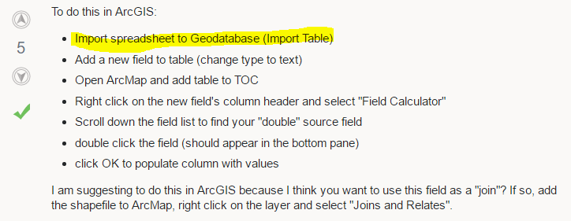

Just Bias analysis: Desktop Documents and Thumb drive (NU2d):BiasMats\RMSEBiasukNOWRF.m

Temporary RMSEforBias red dot Map C:gisclass\Thesis\RMSEeval\11Wind\RMSEBias10
Or is it RMSEBiasukNOWRF

Real WRF with and without Bias Comparison: C:Users\alex\Desktop\Storm3Test\RMSEBiasPWRF.m

C:Users/alex/Desktop/Statmatch.m : CR converter (LL) to
Conclusion was MetMad.csv read the first row as a number and deleted

Kriged Bias Rasters
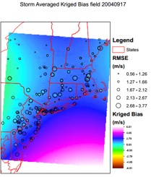
G:\Bias62015\CEELab05\BiasFieldInp.m
C:Users\alex\Desktop\BiasUKPre.m Averaging and map preparation, note the nonCV files did not exist
G:Bias62015\BiasKriFieldAll.m
G:BiasFieldInpAll.ma
Bias Raster Procedure: C:\Users\alex\Desktop\BiasUKPre.m dlmread(fullfile('G:','Bias62015','CEELab05','BiasZfKrig39', ...filename));Need to edit the storm iterator, right now makes one raster. Input raster info location listed above.
C:\gisclass\Thesis\RasterVidTest\BiasDiagUK output of edited yx files (Bias GC values)
C:\gisclass\Thesis\RMSEeval\11Wind\BiasUK.mxd ArgGIS Document template
NOTE: you still need to make averages… probs in matlab one per storm

Boxplots
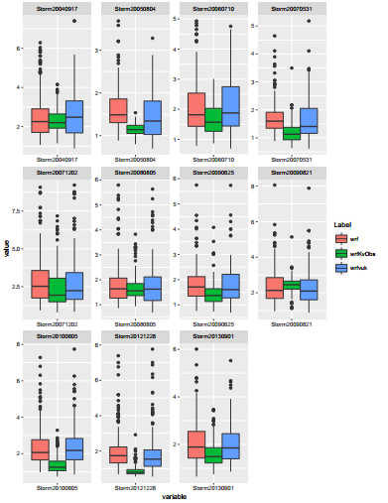
Requires the outputs from CV: 'wrfK.txt', 'wrfvuk.txt', 'RMSEWRFmat.txt'
C:Users\alex\Desktop\Storm3Test\Box.m
C:\Users\alex\Desktop\Storm3Test\BoxPlots.R
Two sets of graphing lines this is the second
Changing the words Label, Value and Variable (Some in code changes should give perfect output)

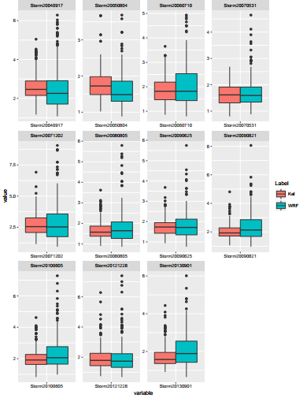
Line 19 of C:\Users\alex\Desktop\Storm3Test\BoxPlots.R
C:Users\alex\Desktop\Storm3Test\Box2.m
C:Users\alex\Desktop\Storm3Test\KalScatter2.m
C:Users\alex\Desktop\Storm3Test\KalmanCompar2.m

Inputs to Kalman Stuff on previous page
Firstarray2 and lastarray2 are made in G:/CV62015Cast/TS2.m
Kalman files were pulled out of Storm3Test/GCKalman Need to go back and find out what happened with Desktop
Gridcell list (used as input for Kalman) Created by: G:\CV62015\GCList.m … double check the input file used in Kalman and edit date

Kalman Graphing:
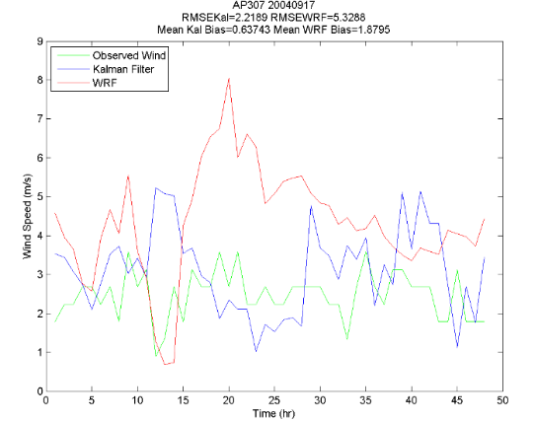

C:\Users\alex\Desktop\Storm3Test\KalmanComparison.m
C:Users\alex\Desktop\Storm3Test: Contains WindBstat folders with the Kalman input and code listed above. Need to edit the storm iterator, set to 2 but outputs line graphs assuming a 24 hour lag between modtom_filt and normal time
Time Serise edits Desktop/KalmanTS/FC24 Unique … go back and record findings
Kalman comparison
C:\gisclass\Thesis\KalmanSpace\Kalmantest.mxd
C:Users/alex/Desktop/StatmatchKal.m
G:CV62015Cast\TS2.m
G:CV62015Cast/GCList.m
GCKalman:
G:\CV62015Cast\GCList->GCList.txt
Documents/RF/KFRF/KalWRF/GC?/KalmanCV.f90

Original files are in Desktop/KalSpace
Dropbox Originals KalmanTF/Kalspace

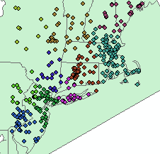

C:\gisclass\Thesis\RasterVidTest\OceanUK.mxd
C:\gisclass\Thesis\RasterVidTest\NewCluster
C:\Users\alex\Documents\KalmanInv.R
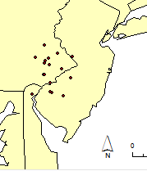
C:\gisclass\Thesis\KalmanSpace\11stoWRFvUK.mxd
C:\gisclass\Thesis\RMSEeval\11Wind\RMSEUKSC
C:\gisclass\Thesis\RMSEeval\11Wind\RMSEUKsc.m: makes the lat lon pairs
C:\Users\alex\Desktop\Storm3Test\RMSEukSC.m: makes the matrix
G:CV62015Cast\CEELAb20\ByStCVSC.m: input for kriging files and eval
G:CV62015Cast\CEELAb20\BiasKrig.m: forgot to change name, performes kriging
G:CV62015Cast\CEELAb20\zWindMadSC.m makes makes not unique station list that includes tails for small krigs, kept using CR so that CV would be straightforward, no combination and in theory smaller clustering

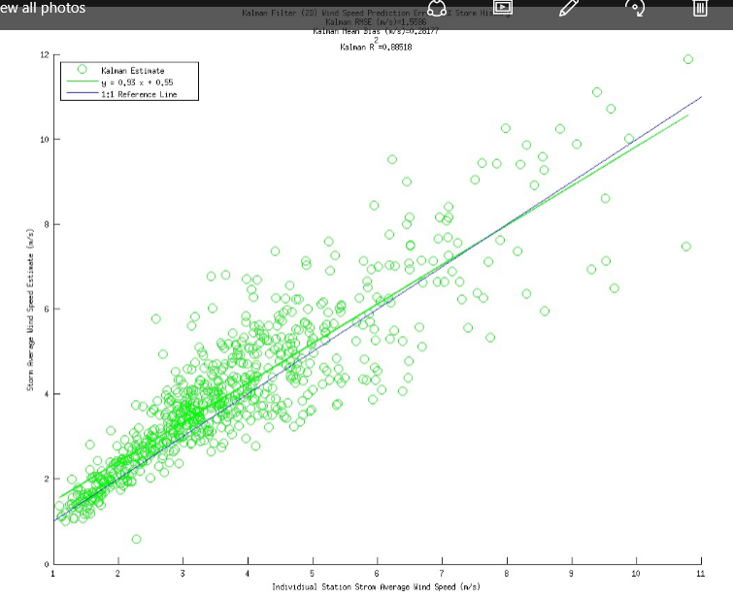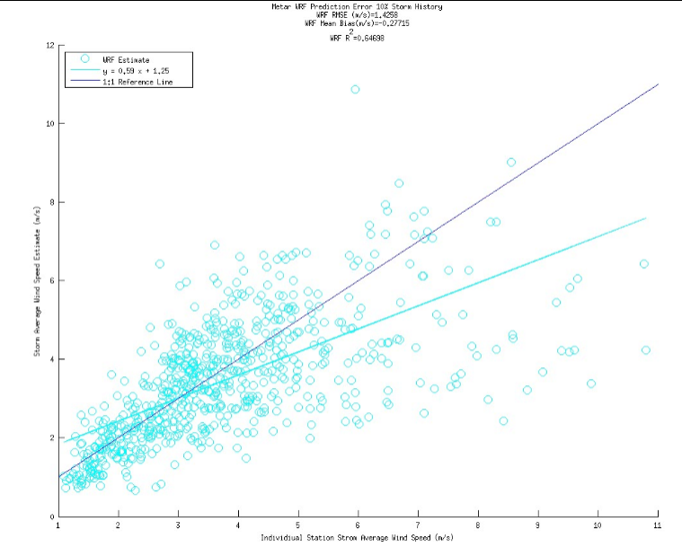
Metar Method 3
Azula/Documents/RF/KFRF/zWindMet2.m
Laptop/Desktop/Storm3Test/ HMetCreate.m
Laptop/ Desktop/Storm3Test/Meth3Met/Method34n.m
->Note this code creates Files with an Met extension… this creates difficulty in Kalman
->TitleM3Met.m copies the files to the appropriate name (but inefficient)
Azula/Documents/Meth34nBase/TitleM3Met.m
Azula/Documents/Meth34nBase/M03d2Met/KalmanCV.f90
Azula/Documents/Meth34nBase/Meth3KOMetFin.m
ADDED UNIQUE FUNCTION 2016/08/16 (G:drive version)
G:/Meth34nBase/Meth3KOMetFin.m
Azula/Documents/Meth34nBase/CVp1Met.m: Note Axis are not set according to Axis Min and Axis Max. Also,Check RMSE values in order to identify if it is a coding
Moved Everything (on Azula) to the G drive:
Only for Metar: G:/Meth34nBase/CVp1MetEVBSt.m compares past storm individually
G:/Meth34nBase/CVp1Meteval.m
G:Meth34nBase/CK2.m (final Graphing)
Edited Helim 16,39,44,57,64,69,105 Saved changes into Laptop/ Desktop/Storm3Test/REcHelimEdit.txt
Laptop/ Desktop/Storm3Test/KalCrev.m
Post MatMAnip was run on G? at some point I moved everything August 10th is the threshold date for when I reran all the KalinMetFin Data…. Reran in cape cod on desktop
Appears to have same origin… C:Users/alex/Desktop/Meth3Met/Method34n.m, copied and pasted data including TPSMet2.txt in between not perfect but Kalman run in Azula/Documents/Meth34nBase/M03d2Met old but remember that Discovered bad dates in library very long time ago, that was error 1. Error 2 was the 3rd row in the labels of old files dates match for both there was an extensive Metar investigation… however the change came in manual edits saved in REcHelimEdit.txt Much more modern madis because never fixed original problem due to the fact that I wanted to do Metar First

Madis Method 3
Azula/Documents/RF/KFRF/zWindMad2.m
Laptop/Desktop/Storm3Test/ HMadCreate.m
Laptop/ Desktop/Storm3Test/Meth3/Method34n.m
Azula/Documents/Meth34nBase/TitleM3v2.m
Azula/Documents/Meth34nBase/M03d2/KalmanCV.f90
Azula/Documents/Meth34nBase/Meth3KO.m
ADDED UNIQUE FUNCTION 2016/08/16 (G:drive version)
Azula/Documents/Meth34nBase/CVp1.m: Note Axis are not set according to Axis Min and Axis Max. Also,Check RMSE values in order to identify if it is a coding
Moved Everything (on Azula) to the G drive:
G:/Meth34nBase/CVp1Madeval.m
G:Meth34nBase/CK2.m
Edited Helim 16,39,44,57,64,69,105 Saved changes into Laptop/ Desktop/Storm3Test/REcHelimEdit.txt
Laptop/ Desktop/Storm3Test/KalCrev.m

EDITED TIMING ON KALFIN AND KALMET: Laptop/ Desktop/Storm3Test/MatMAnip.m
After KalinFin.txt was created different filepaths were used among the three locations. Because MatMAnip exists in the laptop, Method34n.m was run on the laptop M03d2 was copied and pasted to G drive and AGAIN copied into Azula as M03d2MadFin. Kalman was run (with Kriging inputs version)

G:Meth34nBase/CK2.m

What did I run after CK2 (still needs repeats to be taken out)

New Version:
F:\Meth34nBase\KrInMadHTM3 (pt1)
F:\Meth34nBase\KrInMetHTM3 (pt1)
C:\Users\alex\Desktop\Storm3Test\KalOutEv.R
Trim labels off Rem files
Sidenote: Documents\RMSE\StoSwCh.R counts
Station pool through time but not accurate for post trimming. Therefore a manual writing of what the f30 and f10 sizes were was used
Pt 2’s of KrIn Files
F:\Meth34nBase\BiasTCHTfin.m-> Appropirate GCElimMM: BiasTCHTM1M3
F:\Meth34nBase\BiasTCHTM3.m (for storm 2 with a consistent station pool throughout)
Note both do NOT send the tails to the right folder presently
Req. note… WILL NEED TO REMOVE 3rd Column problem Manually

F:\Meth34nBase\BiasBSCVM3.m (pt1)
~Kriging
F:\Meth34nBase\M3WCV.m was used for pt2 of the cross validation because it is FFmat friendly: where ffmat is the Expected bias THIS CODE ALSO COMPARES TO OBSERVATIONS
Due to the complexity WRF, Obs, Kal are all compared to the first cross validation in the remake: CVp1MadM3M3.m

Useful Excels?
Sidenote Do I need R code if I am taking the difference used in modeltom filt? … could just run and compare sizes to see if there is a difference
Diff suffix has zero issue

How did I make this?
F:\Meth34Diff\GCKM3Scatter.m
F:\Meth34Diff\ByStatCVGC.m?
F:Meth34Diff\BiasTC13Diff.m
F:\Meth34Diff\KrInMadHTDiff.m
F:\Meth34Diff\KrInMetHTDiff.m

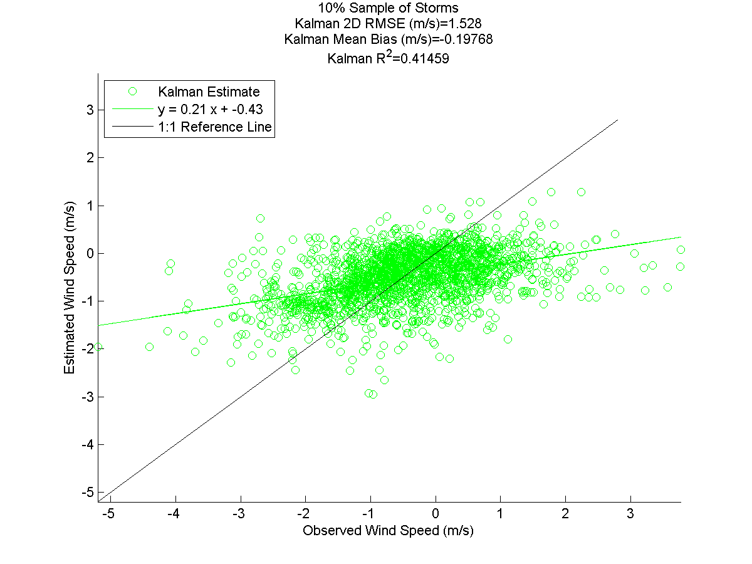
F:\Meth34Diff\KM3Scatter.m
F:\Meth34Diff\ByStatCVDiff.m
F:Meth34Diff\BiasTC13Diff.m
F:\Meth34Diff\KrInMadHTDiff.m
F:\Meth34Diff\KrInMetHTDiff.m

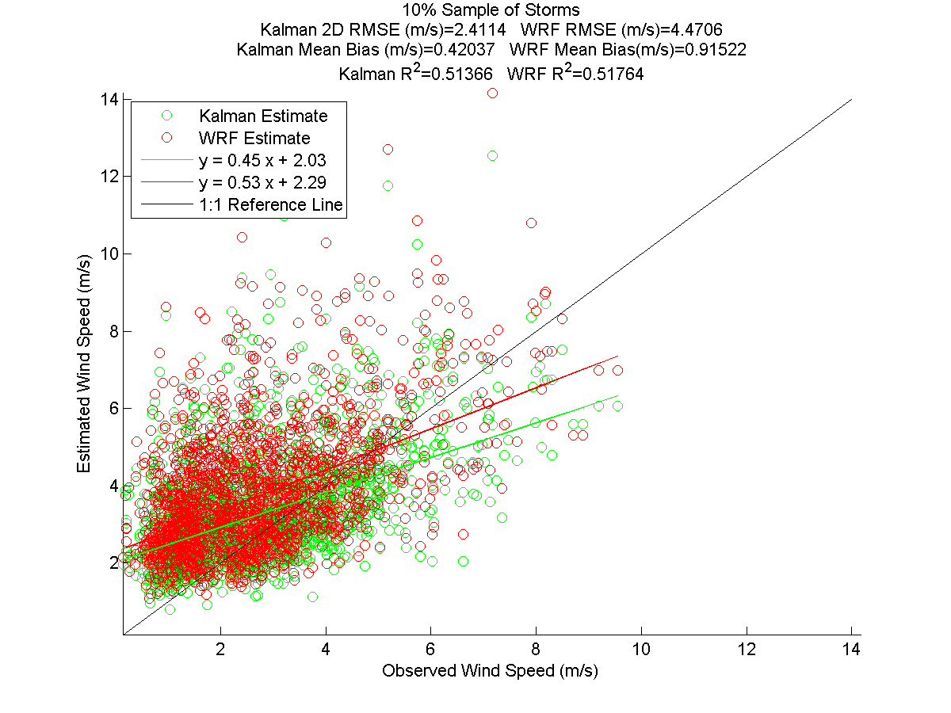
F:\Meth34Diff\M3Scatter.m“M03d26?”
Reads WM files NOT Bias so It absolutely should be different because it is being compared to Kalman Precictions
F:\Meth34Diff\ByStatCVDiff.m
F:Meth34Diff\BiasTC13Diff.m
F:\Meth34Diff\KrInMadHTDiff.m
F:\Meth34Diff\KrInMetHTDiff.m

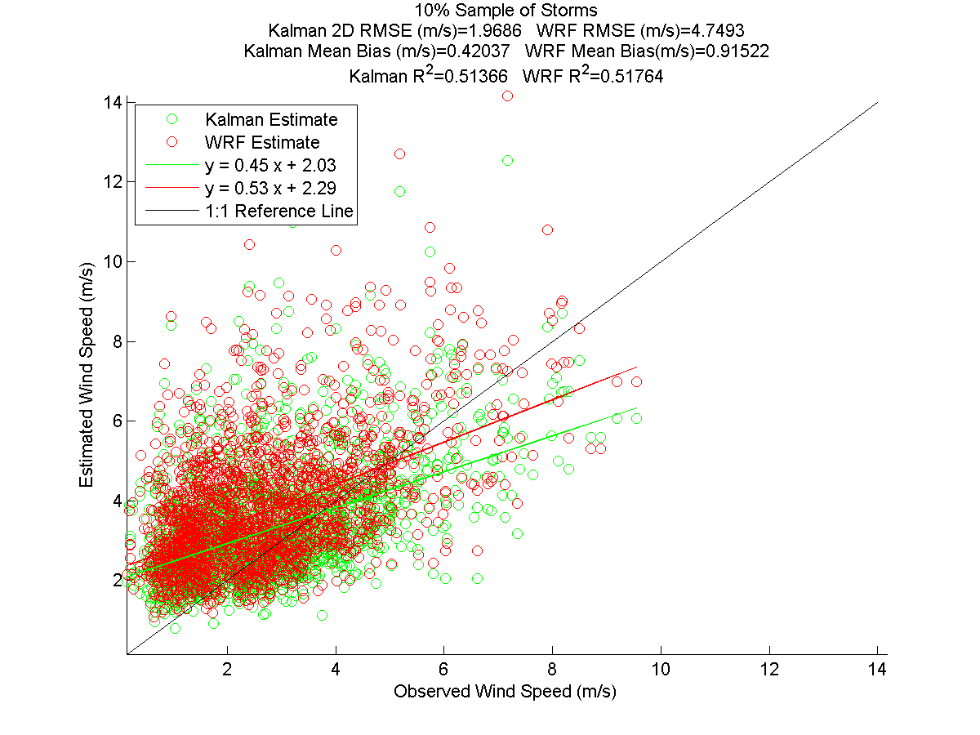

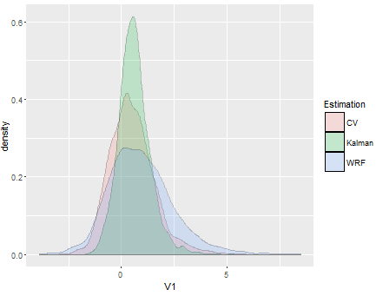
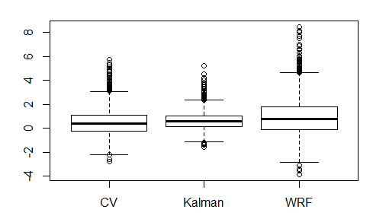

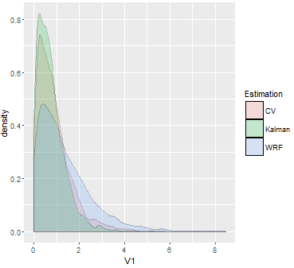

F:\Meth34Diff\Histograms.R
F:\Meth34nBase\Big3.m
F:\Meth34nBase\RMSEfilprARR.m

F:\Meth34nBase\Big3.m
F:\Meth34nBase\RMSEfilprARR.m

END RESULTS M1M3
F:/Meth34Diff/HistoM1M3.R
F:/Meth34nBase/B3LOIM3m1.m
F:/Meth34nBase/RMSEm1m3.m

Transition M1 UK->Kal
F:/Meth34Diff/HistoM1ukf.R
F:/Meth34nBase/Big3kfloi.m
F:/Meth34nBase/RMSEm1ukf.m

M3LOI
F:/Meth34Diff/TempM3ukLOI.m
F:/Meth34Diff/BSCVGCloi.m
F:/Meth34nBase/RMSELOIM3.m
F:/Meth34nBase/B3LOI.m
*pdf plotted with M1KF on same pdf
*scatters produced for a side by side with LOO, almost identical

LOIM3<>KFM1
F:/Meth34nBase/RMSEm3m1.m
F:/Meth34nBase/B3LOIM3m1.m
F:/Meth34Diff/Histom1m3.R

LOIukM1<>KFM1
…Storm3Test/RMSEm1ukF.m
F:/Meth34nBase/Big3kfloi.m
F:/Meth34Diff/Histom1UKF.R

LOO ukwind
F:/CV62015Cast/BSukCVAR.m
…Storm3Test/RMSEm1pdf12.m
F:/Meth34nBase/Big3m1.m
F:Meth34Diff/Histukm1.R

LOI ukwind
F:/CV62015Cast/LOIRMSE.m
F:/CV62015Cast/BSCVARfixloi.m
F:/CV62015Cast/ISKrigW.m

Kalman Filter Line Plots:
KFRF/KalFinAnG.m
HElimreads
Obs. Hist. Reads
F:/CV62015Cast/WindTCm1KARR.m
F:/CV62015Cast/HELIMCOPY.m
…Storm3Test/percfin#.R

M3 111 Full:
F:/Meth34nBase/Bias111eval.m
F:/Meth34nBase/BiasTC111.m
Or F:/Meth34nBase/BiasTC111M3.m
F:/ Meth34nBase /M3uk111.m

10/31/2016
Jaemo txt’s for overall bias and RMSE maps
C:\Users\alex\Desktop\Storm3Test\MesoMap.m
Takes CV workspaces and isoloates the Matrices Required
C:\Users\alex\Desktop\Storm3Test\MesoMap.R
Takes matrices and provides rowise averages for available storms
RMSE and Bias 6 outputs
C:\Users\alex\Desktop\Storm3Test\MesoNaOmit.R
Eliminates Stations that do not exist for the
NOTE AS A BIPRODUCT OF MAKING THE OUTPUTS I TESTED AVG MOD-0BS ASSUMPTION FOR THE FIRST STORM using F:\CV62015Cast\BSCVARmb.m
Storm3Test\RMSEreadlist.m is a junkcode used to make sure missing value(s) at end weren’t a bad MetMad Fileread

LOI Data:
…/Storm3Test/MesoLOINaOm.R
…/Storm3Test/MesoMapLoi.R
Rest of files can backtrack through searching “MatBloiUK.txt” in F:/CV62015Cast/

Running 111
F:/Meth34nBase/B3111v2.m
F:/Meth34nBase/RMSE111v6.m (Azula, Laptop version is RMSE111v3 NOTE not capable of large datasets without freezing, even Azula required breaking into three sections)
F:/Meth34Diff/BSCVGC111.m
F:/Meth34nBase/Meth3KO111.m
F:/Meth34nBase/HMad111.m
F:/Meth34nBase/M3KOMet111.m
F:/Meth34nBase/HMet111.m
F:/Meth34nBase/Bridge111v2.m
F:/Meth34Diff/Histo111.R

Very Good Results that follow exact expected behavior
Validaiton Procedure Run:
F:/Meth34nBase/RMSE111m3.m
F:/Meth34Diff/BSCVGC111.m

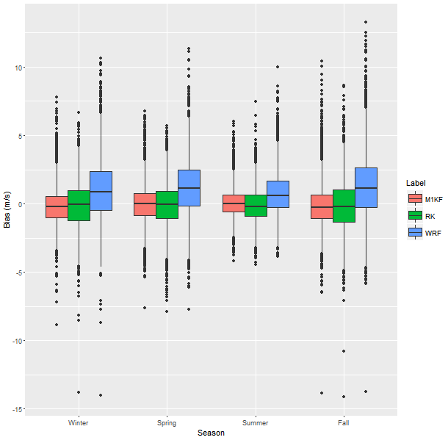
107 Many results
Storm3Test/M1M2DiffGCfix.R
Title
KalmanCV
New folder
Seasonality
F:/Meth34nBase/Seas111.m
F:/Meth34nBase/bridgeSeas.m
F:Meth34nBase/B3Div.m
F:/Meth34nBase/B3Wi.m
F:/Meth34nBase/B3Sp.m
F:/Meth34nBase/B3Su.m
F:/Meth34nBase/B3Fa.m

Box:
…/Storm3Test/BoxPlotsSeas.R
Excel to add titles
F:/Meth34nBase/BoxUn111.m

