**PROBABILITY PROJECT #2 – CONDITIONAL PROBABILITY**

**NAME:**

**CLASS:**

**DATE**: June 8, 2019

**PART A – CONDITIONAL PROBABILITY**

A1 Go to <https://www.mathsisfun.com/data/probability-events-conditional.html> and review. Define the following concepts and give a unique example for each.

Independent Events:

>

Dependent Events:

>

Replacement:

>

A2 Continue down the same page.

How do you translate P(E)?

>

How do you translate P(E|F)?

>

What does it mean if P(E|F) = P(E)?

>

Provide an example for the above.

>

A3 Visualize the experiment “Drawing two cards from a well shuffled deck without replacement”. If you are unfamiliar with a standard deck of cards, watch the short video <https://www.youtube.com/watch?v=vbFWfmIyr3Q> or examine the image below. Let E be the event of drawing a Queen on the 1st draw and let and F be the event of drawing a Queen on the 2nd draw.

Translate and calculate P(E).

>

Translate and calculate P(F|E).

>

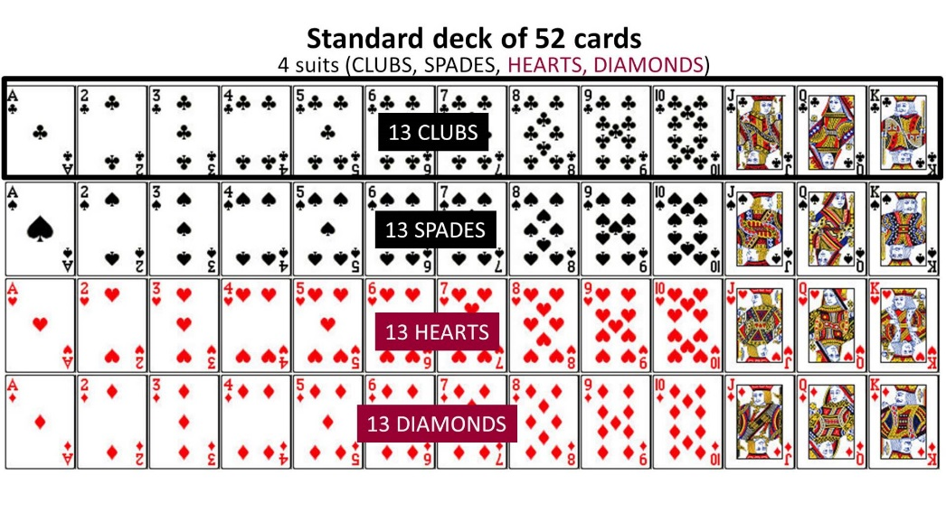

A4 Now let’s try to answer the question, “What is the probability of drawing 2 Queens from a well shuffled deck of cards without replacement?”. For that to happen you need the 1st card to be a Queen and the second card to be a Queen. As before, let E be the event of drawing a Queen on the 1st draw and let and F be the event of drawing a Queen on the 2nd draw.

Translate P(E∩F).

>

Looking back to the 3rd example on <https://www.mathsisfun.com/data/probability-events-conditional.html>, what is the formula given to calculate P(E∩F)?

>

Calculate P(E∩F).

>

A5 Click on the link “Tree Diagram” at the bottom of the page which takes you to <https://www.mathsisfun.com/data/probability-tree-diagrams.html>. Review the page.

What should you do along the branches?

>

What should you do down the columns?

>

What is a good way to check your Tree Diagram?

>

A4 Draw and label a big tree diagram for the experiment “Flipping a fair coin 3 times”.

A5 Based on your tree diagram:

How many outcomes are there?

>

Are these outcomes equally likely? Why or why not?

>

What is the probability of getting 3 heads?

>

What is the probability of getting 2 tails?

>

Which columns add up to 1?

>

**PART B** **– ROLL 2 FAIR DICE (CRAPS)**

B1 Consider the experiment of “Rolling 2 fair dice”. Circle one of the three sample spaces below that resonate with you for this experiment.

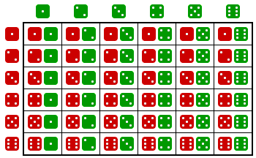 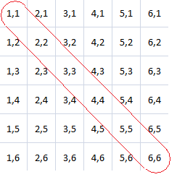 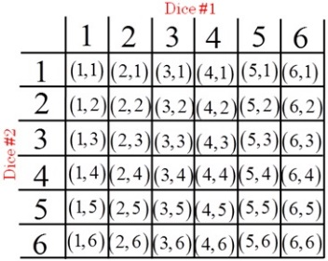

B2 How many outcomes are there?

>

Are they equally likely outcomes? Why or why not?

>

B3 Define “opaque”.

>

Website URL:

B4 Roll 2 fair dice **–** each under an opaque cup.

What is the probability that the first is a 4?

>

What is the probability that the second is a 4?

>

What is the probability that both are 4’s?

>

B5 Let E be the event of the 1st die being a 3 and F being the event that the 2nd die is a 3.

Translate and calculate P(E)

>

Translate and calculate P(F|E)

>

Are E and F independent? Why or why not?

>

Translate and calculate P(E∩F) showing the formula and work.

>

B6 Let A be the sum of both dice and B be the value of the 1st die.

Translate and calculate P(A=7).

>

Translate and calculate P(A=7|B=6).

>

Translate and calculate P(A≥7).

>

Translate and calculate P(A≥7|B=6).

>

B7 Roll 2 fair dice **–** each under an opaque cup.

Lift the 1st cup and record the value.

>

Let A be the sum of both dice. Let B represent that event that the 1st die was the value recorded above.

Translate and calculate P(A≥10|B).

>

Translate and calculate P(A≤2|B).

>

B8 Pick a number between 2 and 12 other than 7. Roll two dice simultaneously until you hit a sum of that number or a sum of 7.

Number picked?

>

Did your roll your number or 7 first?

>

What is the number of rolls it took?

>

Does this surprise you? Why or why not?

>

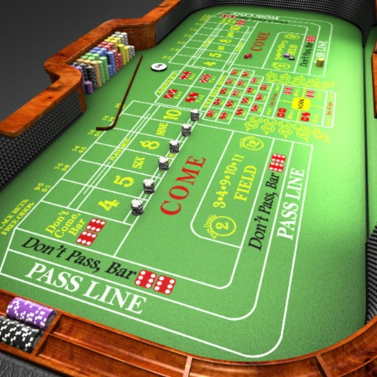

B9 Save this Word document as firstname.lastname.conditional and email to me.