**PROBABILITY PROJECT #3 – BAYES’ FORMULA**

**NAME:**

**CLASS:**

**DATE**: June 8, 2019

**PART A – TERMS**

A1 Go to <https://www.mathsisfun.com/data/probability-events-mutually-exclusive.html>. Define Mutually Exclusive.

>

Give an example of Mutually Exclusive Events.

>

Give an example of non-Mutually Exclusive Events.

>

Write the probability formula in the yellow box.

>

What assumption is made when using that formula?

>

If E and F are mutually exclusive events, what is P(E∩F)?

>

If E and F are mutually exclusive events, what is the formula to calculate P(EUF)?

>

Is this one of the three axioms?

>

If E and F are non-mutually exclusive events, what is the formula to calculate P(EUF)?

>

This formula is known as what rule?

>

A2 Visualize the simple card example “Draw a card from a well shuffled deck”.

What is the probability that it is a 7 and Jack?

>

What is the probability that it is an 8 or Queen?

>

What is the probability that it is a 4 or Heart?

>

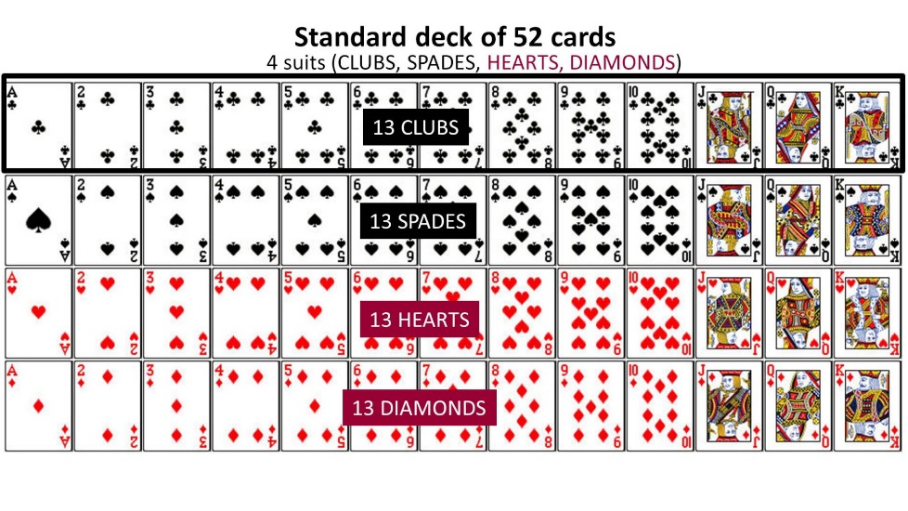

A3 Go to <http://www.dictionary.com/browse/sensitivity>. What is the 3rd definition at the bottom of the page under “sensitivity in Medicine”?

>

A4 Go to <http://www.dictionary.com/browse/specificity>. What is the 2nd definition at the bottom of the page under “sensitivity in Medicine”?

>

A5 Go to <https://en.wikipedia.org/wiki/Sensitivity_and_specificity> and review. Define the following terms.

Sensitivity:

>

Specificity:

>

True positive:

>

False positive:

>

True negative:

>

False negative:

>

A6 In terms of tests that screen people for disease, circle the result that

scares you for no reason. true positive ** false positive ** true negative ** false negative

Why?

>

Circle the result that is most dangerous.

true positive ** false positive ** true negative ** false negative

Why?

>

**PART B – BAYES’ FORMULA TEXTING AND DRIVING**

B1 Go to <https://www.dmv.org/distracted-driving/texting-and-driving.php>. What are the 3 types of driving distractions?

>

According to the site, what percent of teens say they have texted while driving?

>

B2 Go to <https://www.edgarsnyder.com/car-accident/cause-of-accident/cell-phone/cell-phone-statistics.html>. According to the site, what percent of car accidents in the USA is caused by texting while driving?

>

According to the site, what percent of teen drivers admit to texting while driving?

>

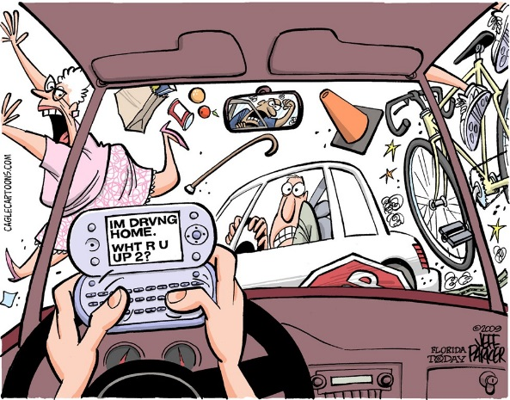

B3 Let T represent texting while driving and A represent accident. Therefore, Tc represents not texting while driving, and Ac represents no accident. Assume P(T)=40%=0.4, P(A|T)=1%=0.01 and P(A|Tc)=0.1%=0.001.

Calculate the following using the Complement Rule.

P(Tc)=

P(Ac|T)=

P(Ac|Tc)=

B4 Draw a large Venn Diagram below. Cut the sample space in two with a vertical line. One side represents T and the other Tc. Draw a circle in the middle that represents A. Label the 4 regions symbolically.

B5 Draw a large Tree Diagram below. Let the first branch be T and Tc. Let the second branches be A and Ac. Label the branches symbolically and with percentages. Remember what we do along branches. Remember how to check our work along columns. Remember the Product Rule P(E∩F)=P(E)*P(F|E). Now, calculate the probabilities of the four outcomes: P(T∩A)=

P(T∩Ac)=

P(Tc∩A)=

P(Tc∩Ac)=

B6 We now want to try and answer the question P(T|A)=? Note that this is different from P(A|T) which we assumed earlier. To calculate this, we use Bayes’ Formula.

$$P\left(T | A\right)=\frac{P(T∩A)}{P\left(T∩A\right)+P(T^{c}∩A)}$$

In words, what does P(T|A) mean?

>

Calculate P(T|A) showing your work.

>

**PART C – BAYES’ FORMULA IN MEDICINE**

C1 Go to <http://pi.math.cornell.edu/~mec/2008-2009/TianyiZheng/Bayes.html>. Interpret the statement: “It is often used to compute posterior probabilities (as opposed to prior probabilities) given observations.”

>

C5 On the same page, review the first example. What is the probability a woman has breast cancer given that she just had a positive test?

Probability rounded to nearest %

>

Does this surprise you? Why or why not?

>

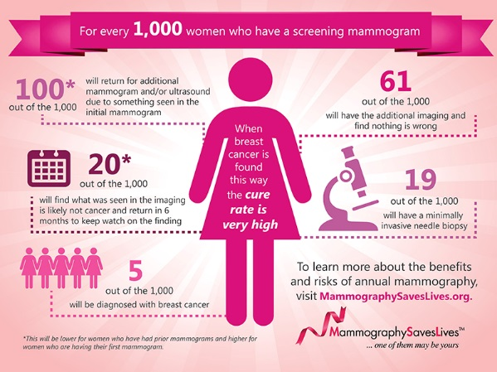

C6 Your turn. Pick a disease that interests you and that you can find some statistics on. Let D+ represent percent of population with disease and D- represent percent of population without the disease. Let T+ represent a positive test and T- represent a negative test. From your research, what are:

P(D+)=

P(T+|D+)= (this is the sensitivity)

P(T-|D-)= (this is the specificity)

Using the Complement Rule, you can calculate:

P(D-)=

P(T-|D+)=

P(T+|D-)=

 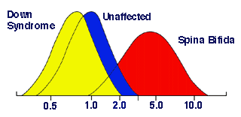 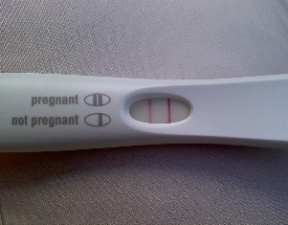

C7 Draw a large Tree Diagram below. Let the first branch be D+ and D-. Let the second branches be T+ and T-. Label the branches symbolically and with percentages. Calculate the probabilities of the four outcomes:

P(D+ ∩T+)=

P(D+∩T-)=

P(D-∩T+)=

P(D-∩T-)=

C8 We now want to try and answer the question P(D+|T+)=? To calculate this, we use Bayes’ Formula.

$$P\left(D^{+} | T^{+}\right)=\frac{P(D^{+}∩T^{+})}{P(D^{+}∩T^{+})+P(D^{-}∩T^{+})}$$

In words, what does P(D+|T+) mean?

>

Calculate P(D+|T+)

>

What does this tell you?

>

C9 Matching. Draw lines connecting words to symbols.

|  |  |  |
| --- | --- | --- |
| True Positive |  | T+|D+ |
| True Negative |  | T-|D+ |
| False Positive |  | T-|D- |
| False Negative |  | T+|D- |

C10 Save this Word document as firstname.lastname.bayes and email to me.