**SET PROJECT #2 – SHIRTS AND VENN DIAGRAMS**

**NAME:**

**CLASS:**

**DATE**: June 8, 2019

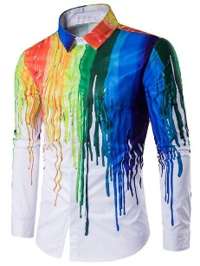

**PART A – SHIRTS**

A1 What is a shirt? Search the web and go to 3 different websites for their definitions.

Definition 1:

Website URL:

Definition 2:

Website URL:

Definition 3:

Website URL:

A2 Time to clean your closet! Take out ALL of your “shirts”. Think of different classifications such as color, material, sleeve length, etc. List 5 more classifications.

>

A3 Pick 2 classifications and organize all your shirts accordingly.

Classifications Chosen:

>

A4 Draw a 2 circle Venn Diagram and put the number of your shirts in each region.

>

A5 Take a picture of your shirts arranged on a table or on the floor and include below.

>

A6 Now, pick 3 classifications that you didn’t use previously and organize all your shirts accordingly.

Classifications Chosen:

>

A7 Draw a 3 circle Venn Diagram and put the number of shirts in each region.

>

A8 Take a picture of your shirts arranged on a table or on the floor and include below.

>

A9 Put away all your shirts. Consider donating the shirts you don’t wear to charity.

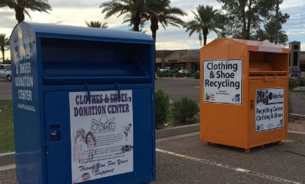

**PART B – POWERPOINT**

B1 Go to <https://products.office.com/en-us/what-is-powerpoint> and review the page.

What is PowerPoint?

>

What can you do with PowerPoint?

>

B2 Go to <http://www.garrreynolds.com/preso-tips/design/> and review.

From Tip 1, what is meant by “white space” or “negative space”?

>

From Tip 2, what should you never, ever do?

>

From Tip 6, list the 4 types of charts and what they should be used for?

>

From Tip 7, define “ubiquitous”.

>

Website URL:

From Tip 7, for a failsafe presentation where you don’t know the room characteristics (light, size, etc.) where you will be presenting, what would be a good choice for text and background colors? Why?

>

From Tip 8, what is the difference between a Serif font and a Sans-Serif font?

>

Continuing on Tip 8, change “Mary had a little lamb” below to your favorite Serif font and Sans-Serif font and list the names of the fonts chosen. Explore the many options in the Word pull-down menu under the Home tab above. It is easy to do.

Serif Font/Name: Mary had a little lamb

Sans-Serif Font/Name: Mary had a little lamb

B3 Go to <http://www.businessinsider.com/8-tips-for-great-powerpoint-presentations-2015-1#-41> and review.

Do you like this site or the previous one as far as tips go? Why?

>

Do you agree with all the tips? Explain.

>

What is meant by “infographics”?

>

Website URL:

B4 Go to <http://www.hnhsd.org/teachers/wp-content/uploads/2013/08/PowerPoint_Rubric.pdf> and review the rubric.

Do you think this is a good rubric for evaluating PowerPoint presentations? Explain.

>

Would you be comfortable with me using it to grade your PowerPoint presentation?

>

Would you be comfortable with your peers using it to provide you with feedback?

>

B5 Save this Word document as firstname.lastname.shirts and email to me.