**23MCA132**

**Object Oriented Programming Lab**

*Report Submitted By*

**ALEX ABRAHAM**

**AJC23MCA-2009**

In Partial Fulfilment for the Award of the Degree of

MASTER OF COMPUTER APPLICATIONS (MCA TWO YEAR)

NBA ACCREDITED

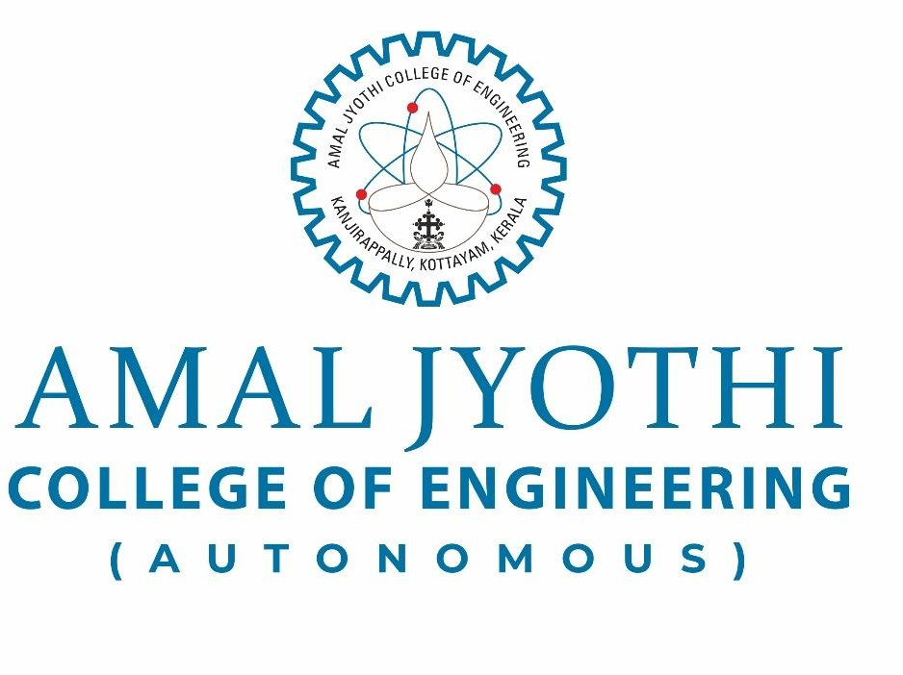

**[Affiliated to APJ Abdul Kalam Technological University, Kerala. Approved by AICTE, Accredited by NAAC. Koovappally, Kanjirappally, Kottayam, Kerala – 686518]**

2023-2024

**CERTIFICATE**

This is to certify that the lab report, “**23MCA132-OBJECT ORIENTED PROGRAMMING LAB”** is the bonafide work of **ALEX ABRAHAM (AJC23MCA-2009)** in partial fulfilment of the requirements for the award of the Degree of Master of Computer Applications under APJ Abdul Kalam Technological University during the year **2023-24.**

Exam Date:

Student Signature: Date: 29/05/2024

Ms. Shelly Shiju George Fr. Dr. Rubin Thottupurathu Jose Lab in- Charge Head of the Department

Internal Examiner:

External Examiner: Dept. Seal

