Alex Abramson

12/13/16

Econometrics

Inclusionary Zoning: Does it Work?

**Introduction**

Housing affordability has become one of the most pressing concerns of the past decade, with many cities seeing rising prices put stress on middle and low income households. In the week of this paper’s writing, headlines feature the tragic consequences of the housing affordability crisis, from record high numbers of individuals homeless to 32 deaths at a poorly maintained off-the-books dwelling in Oakland. Inclusionary Zoning (IZ) policies are becoming increasingly popular methods of addressing this problem. These obligate developers of new housing units to sell or rent a certain percentage of them at below market rates.

IZ rests on the idea that developers making profits from escalating real estate prices ought to compensate the potential low and middle income households displaced by the rising prices. However, basic economic theory suggests several problems with IZ’s use as a mechanism to increase housing affordability. These critics note that IZ acts as a tax on new housing, pushing up its price and reducing the quantity of new housing supplied. They also note that while the residents of subsidized units might get a better deal, the costs of this subsidy will likely be borne by other households looking for housing units, and that the poorest of these households will ultimately suffer the most pressure. Proponents counter that the market-distorting effects of IZ are not that severe, and that their costs can be outweighed by the affordable housing directly created by the IZ program.

The aim of this paper is to test these competing hypotheses and determine whether IZ programs are associated with worsening or improving affordability for low and middle income households. To accomplish this, this study will analyze a subset of 183 municipalities in the Boston area over the years 2010 through 2014. Specifically, the model will address whether the presence of IZ is associated with more or less affordability to low and middle income households, and, if so, the exact relationship between tenure of IZ program and rate of change in affordability.

Ultimately, this study finds that IZ is not only effective at increasing affordability for low income households, it is increasingly effective over time. The study also finds that IZ has ambiguous but tentatively positive effects on the affordability of housing to middle class households. This suggests that theory on IZ’s unalloyed benefits for subsidized households is correct, and that possible detriment to middle class households’ housing access is questionable, but not blatantly disastrous.

This study will first provide an overview of the existing literature on IZ programs, before elaborating on the economic theory behind the debate over IZ’s efficacy. Following an overview of the details and limitations of the dataset used, an OLS regression model is used to ascertain findings regarding the utility of IZ as a tool to effect positive affordability outcomes. Finally, conclusions of this analysis are reiterated and contextualized.

**Literature Review**

Many scholars have attempted to assess, through theoretical and empirical means, the effect of IZ on housing supply and affordable housing unit production; yet to date no consensus has been reached in either of these impacts. Some find the burden on developers to lead to less development overall, either through increased land costs or focus on a higher income market segment. Others find developers to be relatively insensitive to price of development, and the rate of housing development largely unaffected by inclusionary zoning mandates. Others find mixed results, with success varying by city, and most interestingly, by length of time in which the program has been in place (Schuetz, Meltzer, Been, 2007).

The anti-IZ case rests on the argument that IZ produces “few affordable units”, increases prices of new homes, and “drastically decreases” amount of new homes constructed; instead they suggesting the elimination of extant restrictive zoning codes instead (Powell, Stringham 2004, p.4; Means, Stringham, 2012; Ikeda, Sanford, 2015; Mitchell, 2004; Uhler, 2016, Ellickson, 1980, p.49-51). The extreme extension of this line of thought is expressed by Ellickson (1980) as cited in (Powell, Stringham, 2005, p. 473), that “inclusionary zoning... makes housing less affordable; thus, it should be called exclusionary rather than inclusionary.” Some simply believe that IZ would be ineffective in its goal of increasing affordable housing due to the elasticity of demand for housing (Glaeser, 2002, p.21; Uhler, 2016). Others found that developers did not slow construction of new housing units, but did pass costs on to consumers through smaller units or higher prices (Bento, Lowe, Knaap, Chakraborty, 2009, p.14).

Those most supportive of IZ take issue with this primarily theoretically based argument, arguing that it has “no chilling effect” on housing markets empirically and its capacity to compel the construction of affordable housing units “underestimated” (Mukhija, Regus, Slovin, Das, 2010; Rosen, 2004, p.9). The 2004 study by Powell and Stringham is, in fact, directly challenged by critics of its methodology (Basolo, Calavita, 2004). Others highlight the variation in structure of IZ approaches that, they say, allows policymakers to minimize potential harms to the housing market. They find that success of IZ varies based on the age and strength of the program, the type of triggers employed, the level of enforcement, the presence of in-lieu payments and similar alternatives, and the state’s regulatory background (Schuetz, et.al., 2009, 2010; Brunick, 2004; Mukhija, et.al, 2015).

The approaches taken by researchers most influential to my analysis typically take the form of multivariate regression analyses. Schuetz et. al (2009, 2011) combine numerous datasets for multiple regions to examine the number of affordable units created by different policies. Their municipality dataset pertaining to Massachusetts is one which I will be using for my own research. Means and Stringham (2012), drawing heavily on research by Powell, are perhaps the strongest voices against IZ; they conduct first difference models on the impact to market rate housing quantity and price. Rosen (2004, p. 42) uses land residual analysis, again considering panel data from California jurisdictions. Mukhija et. al. (2010) analyzed productivity and market effects of IZ using multivariate regression analysis and, like Rosen found broadly supportive evidence for IZ. To a large extent, I aim to replicate and expand upon the research of Schuetz et. al. (2011), Means and Stringham (2012) and Mukhija et.al. (2010), by applying multivariate regression analysis to panel data to find impacts to affordability decades after IZ policy introduction.

The reliance on panel data gathered by hand accords with the observation by Mukhija et. al. (2010) that “inclusionary zoning-related data are not easily accessible”. To get around this, I use extant data on IZ adoption and consider a more broadly defined dependent variable. Where Mukhija et. al. directly measured affordable housing production as a dependent variable, Means and Stringham looked at average sales prices, and Bento et. al. looked at “percentage change in housing starts”, which caused significant difficulty and inconsistency in gathering data, I look at overall long term outcome in terms of a municipality’s overall affordability to low and middle income groups (Means, Stringham, 2012, p.10; Bento et. al., 2009, p.16).

Table 1.

Most Influential Studies

|  |  |  |  |  |
| --- | --- | --- | --- | --- |
| Author, Date | Data Type | Data Years | Econometric Method | Primary Findings |
| Schuetz, Meltzer, Been (2011) | Panel Data | 1972-2004, 1973-2006 | “reduced-form models” | Amenable to IZ, find that effects on housing market can vary widely by and be mitigated by variation in implementation |
| Schuetz, Meltzer, Been (2009) | Panel Data, Cross Section | 1994-2009 | Survey, overview | Amount of affordable housing varies by region and municipality, large potential for customization |
| Stringham, Means (2012) | Panel Data | 1980-2000 | OLS, First difference model | IZ results in higher prices and lower quantities of housing units built |
| Powell, Stringham (2004, 2005) |  |  | Descriptive, Theoretical | Outlines case against IZ on the grounds of economic theory |
| Mukhija, et. al. (2010) | Panel Data | 1998-2005 | “multivariate regression analyses” | IZ does not reduce quantity of housing supplied, can be a productive method of producing affordable housing |
| Bento, et. al. (2009) | Panel Data | 1988-2005 | “multivariate statistical analysis” | Quantity of housing unaffected, but IZ translates to upward pressure on price of housing |
| Rosen (2004) | Panel Data, Cross Section | 1981-2001 | “land residual value analysis” | “no chilling effect” on quantity of housing supplied |

**Theory**

Almost all observers agree that IZ functions as a tax on new development. This is because in any given development, the difference between the cost of the unit and the artificially low affordable price of the unit needs to be covered by markups on the remaining market rate units. This added cost should discourage some new housing construction, as marginally viable developments can’t break even with the higher costs, and increase the cost of the remaining housing units built. Graphically, this is represented below as an inward shift of the supply curve, as fewer housing units can be built at any given price, with a new intersection at lower equilibrium quantity of housing and a higher equilibrium price of housing.

Figure 1.

Housing Market with Additional Costs to Supply

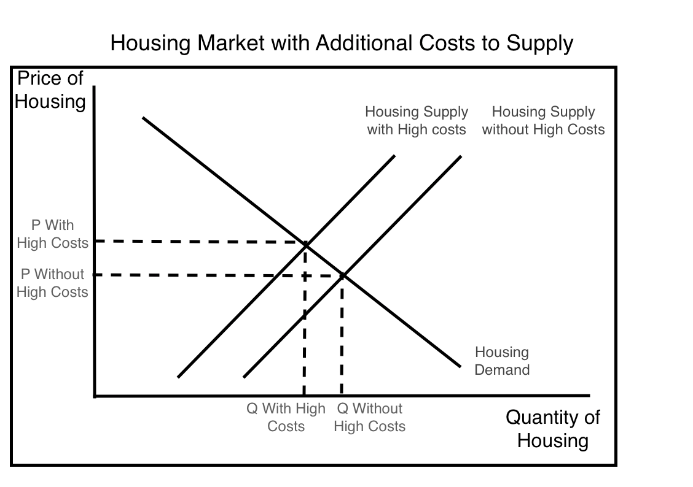

This will benefit incumbent homeowners, who derive a certain monopoly rent from their possession of the now scarcer and pricier housing units in addition to the few poor homeowners-to-be who receive subsidized units; however, this stands to punish most poor homeowners-to-be, who get no subsidized housing but face a higher price in marketplace, and most landowners who aim to develop, a purpose for which the land is now worth less. It will also likely push some developers out of the industry as the higher tax curtails development activity in the housing market, however, Powell and Stringham contend that the construction industry, which is highly competitive, will not bear the brunt of these increased costs, as firms can easily enter and exit the housing construction market, and that costs are passed on to either landowners or consumers of market rate housing. The exact distribution of these costs will likely depend on the price elasticity of demand for housing and the price elasticity of supply for land (Powell, Stringham, 2005, p.478).

Proponents accept that these effects on the market are theoretically valid, but counter that the loss to the unsubsidized homeowners-to-be are small in magnitude compared to the gains of the subsidized homeowners-to-be (Mukhija, et. al., 2010). Implicit in this opinion are the beliefs that 1) housing construction is not a perfectly competitive industry, and can afford to bear some higher costs without a reduction in output or increase in prices, 2) that supply of housing is so inelastic with regards to price that quantity will not be constrained, or 3) that demand for housing is so inelastic that quantity demanded will not fall (Powell, Stringham, 2005, p.478). Neither the proponents nor the opponents of IZ can be proven wrong on a theoretical basis, and empirical tests such as those conducted in this study are necessary to determine which predictions are closer to the market data.

To answer this question empirically, we aim to directly test the relationship between the presence and tenure of a municipality’s IZ program and the affordability of the municipality to low income and middle income households. We take as our hypothesis the outcomes projected by economic theory, namely, that the imposition of a IZ policy on new development will result in increased affordability to low income households, who are most likely to be qualified for, and to take advantage of, the subsidized housing units, and decreased affordability to middle income households, who are more likely to purchase market rate households, and who are, among consumers of market rate housing, the most sensitive to increases in price.

To represent affordability to low income households, we use the percent of the municipality’s population which lives below the poverty line. This tells us how much of a municipality’s housing units are affordable to households living below the poverty line.

To represent affordability to middle income households, we construct a proxy variable out of municipalities’ median and mean income values which we call Median Mean Income. This ratio of median income over mean income tells us about the distribution of income among the municipalities’ households. If median income is similar to mean income, then the municipality has a heavy middle income representation, with few wealthy outliers. If the median income is significantly less than the mean income, this suggests a heavily positively skewed distribution of income, with many households possessing extreme wealth and comparatively smaller representation of middle income households.

To represent the impact of IZ, we use two different variables depending on the model at hand. The first is Presence of IZ, which simply tells whether or not the municipality has ever instituted an IZ policy. The second is Years Since Implementation, which represents the years in which an IZ policy has been active and presumably impactful in the municipality. If the hypothesis that IZ improves affordability for poor, subsidized households at the expense of middle income unsubsidized households is true, this should be positively related to Percent Below Poverty and negatively related to Median Mean Ratio.

We also implemented several control variables, to distinguish the effects of the IZ policy themselves from shared characteristics among the municipalities which implemented IZ. These include the Affluence of the municipality, represented by a ratio of the municipality’s median income relative to the average median income of all municipalities in the area, Education, represented by the percent of the population with a Bachelor’s degree or higher, Race, represented by the percent of the population recorded as black/African American, and Inequality in the municipality, represented by GINI coefficient figures for each municipality. We expect Affluence and Education to be negatively correlated with Percent Below Poverty and ambiguously correlated with Median Mean Income. Given the prevailing socioeconomic patterns in the Boston area, we expect Percent Black to display the opposite signs. Inequality is expected to be positively related to Percent Below Poverty and negatively related to Median Mean Income.

To test these hypotheses, we constructed several OLS multivariate regression analyses. In testing the impacts on low and middle income affordability, we begin with simplified cross sectional analyses, using all data points for the year 2014 and Presence of IZ as our chief independent variable. We then move on to models including all five years in our panel data, and limited for the sake of precision to the 83 municipalities which have adopted IZ and for whom and adoption date is known. These take the rough forms of:

Preliminary Models:

*Percent Below Poverty = f(Presence of IZ, Affluence, Education, Race, Inequality)*

*Middle Income Representation = f(Presence of IZ, Affluence, Education, Race, Inequality)*

Full Models:

*Percent Below Poverty = f(Years Since Implementation, Affluence, Education, Race, Inequality, First Wave, Interact First Wave)*

*Middle Income Representation = f(Years Since Implementation, Affluence, Education, Race, Inequality, First Wave, Interact First Wave)*

**Data Summary and Limitations**

My data on dates of adoption and other characteristics of IZ programs came from the Local Housing Regulation Database, assembled by the Pioneer Institute for Public Policy and the Rappaport Institute for Greater Boston in 2004. This was the most comprehensive source of IZ data on communities in the Boston area; additionally, this was the same dataset upon which Schuetz et. al. based their 2011 analysis, allowing for increased comparability. All other data was taken from American Community Survey 5 Year Estimates of the years 2010 through 2014. These provided credible, comprehensive information on the municipality level at frequent time intervals, and were crucial for constructing useful dependent and control variables.[1]

Unfortunately, several of the jurisdictions which have implemented IZ policies were unable to specify a date of adoption, rendering them unusable for the purpose of the broad panel data analyses which form the centerpiece of this study. However, I do use a cross section of all municipalities’ “Presence of IZ” variables for a preliminary regression, to confirm that the dynamics of the dataset with and without these municipalities are not drastically different.

The inherent heterogeneity of IZ programs poses a larger and more existential problem for this analysis, and one for which I don’t have a perfect response. IZ programs vary widely in strictness and structure of both design and enforcement, and one IZ program might have drastically different effects than the others. Classifying IZ programs by their characteristics is also a largely subjective exercise resting on individual reading and judgment of municipalities’ bylaws. By including the policies of 83 municipalities in the final regression, I hope to determine the impact of an IZ policy which is generally representative of those enacted within this group of municipalities; however, I strongly advise that these numerous caveats be considered in interpretation of these findings.

The construction of indices also represents another area of potential concern. The indicator for middle class representation, for example, is constructed so as to measure inequality within the town itself; it does not account for the differences between different municipalities’ financial definitions of middle class. This is partly a function of semantic vagueness; “middle class” is a term with varied definitions and any definition chosen would likely fail to satisfy at least several readers’ interpretation of middle class. This looseness is important to keep in mind in interpreting the results of the models concerning middle income affordability.

A summary of these observations is presented below for the different subsets of data used for the preliminary and thorough models. The two subsets differ in time periods, municipalities, and variables included. Specifically, the preliminary subset includes all municipalities and “Presence of IZ” for the year 2014, while the full model subset includes all years of data for municipalities which have IZ policies with known start dates, a more detailed “Years since Implementation” variable, and introduces an additional dummy variable and interact term for municipalities whose IZ programs were introduced prior to the mid-1990’s.

Table 2.

Summary Statistics for Preliminary Regression

|  |  |  |  |  |  |
| --- | --- | --- | --- | --- | --- |
| Variable | Obs | Mean | Std. Dev. | Min | Max |
| Percent Below Poverty Line | 187 | 4.362567 | 3.753005 | 0 | 26.1 |
| Middle Class -- Median/Mean Ratio | 187 | 0.8065138 | 0.0657483 | 0.5233388 | 0.9528652 |
| Presence of IZ | 187 | 0.5347594 | 0.5001294 | 0 | 1 |
| Affluence (Median Income Ratio) | 187 | 0.9990568 | 0.2876528 | 0.371573 | 2.167222 |
| Education (Percent with Bachelor’s or higher) | 187 | 25.89947 | 7.029121 | 6.8 | 41.6 |
| Race (Percent Black) | 187 | 0.0283251 | 0.0477221 | 0 | 0.3910173 |
| Inequality (GINI Coefficient) | 187 | 0.423484 | 0.0409367 | 0.3193 | 0.5643 |

Table 3.

Summary Statistics for Full Regressions

|  |  |  |  |  |  |
| --- | --- | --- | --- | --- | --- |
| Variable | Obs | Mean | Std. Dev. | Min | Max |
| Percent Below Poverty Line | 415 | 3.529639 | 2.636563 | 0 | 17.4 |
| Middle Class -- Median/Mean Ratio | 415 | .8083377 | .0679626 | .6466873 | .9620689 |
| Years Since Implementation | 415 | 15.08434 | 7.471693 | 6 | 42 |
| Affluence (Median Income Ratio) | 415 | 1.067816 | .2970638 | .4966191 | 2.057629 |
| Education (Percent with Bachelor’s or higher) | 415 | 28.02771 | 6.335189 | 12.3 | 42.1 |
| Race (Percent Black) | 415 | .0210916 | .0231005 | 0 | .126147 |
| Inequality (GINI Coefficient) | 415 | .4217573 | .0452374 | .325 | .5543 |
| First Wave | 415 | .373494 | .4843154 | 0 | 1 |
| Interact First Wave | 415 | 1.299036 | 2.522287 | 0 | 17.4 |

**Analysis**

**Low Income Affordability**

Table 4.

Low Income Affordability Preliminary Model Results

|  |  |
| --- | --- |
|  | (1) |
| VARIABLES | percentbelowpovertyline |
|  |  |
| Presence of IZ | 0.584 |
|  | (0.385) |
| Affluence | -4.500*** |
|  | (0.947) |
| Education | -0.156*** |
|  | (0.0411) |
| Race | 23.94*** |
|  | (4.247) |
| Inequality | 30.25*** |
|  | (4.911) |
| Constant | -0.914 |
|  | (1.929) |
|  |  |
| Observations | 187 |
| R-squared | 0.569 |

I begin by conducting a preliminary regression using a cross section of data from 2014, and asking the simple question of whether adopting an IZ policy improves affordability, including our complement of control variables. All of the signs are as expected, including that of Presence of IZ (+), the significance of which is satisfactory for a preliminary analysis. This suggests that adopting an IZ program increases the affordability of housing in the jurisdiction to low income households.

With encouraging results from our preliminary regressions, I moved on to the full model with all five years of data and a limited set of municipalities. Notably this change in data subset changes the question at hand: our original question was whether or not jurisdictions adopting IZ policies saw more success in creating affordable housing outcomes than jurisdictions that did not; our new question is whether, among those jurisdictions which have adopted IZ, the IZ policy has succeeded in creating affordable housing. While narrower in scope, this might allow us to flesh out the relationships among impacts of IZ for those towns which have already decided to seriously consider IZ. Notably, this also corrects for any unobserved homogeneous characteristics among municipalities which choose to adopt IZ versus those which did not, and allows us to single out the impact of length of tenure of policy, rather than mere presence of policy. As such, we remove the control municipalities with no IZ policies in addition to the jurisdictions with IZ policies for which no date of implementation was specified.

At this point I also ran a Hausman test between a Random Effects model and a Fixed Effects model. The Hausman test was inconclusive and while I include both sets of values, I base my analysis on the Random Effects model.

Table 5.

Low Income Affordability Full Model Results

|  |  |  |  |
| --- | --- | --- | --- |
|  | (1) | (1) | (1) |
| VARIABLES | Percentbelowpovertyline (Pooled) | Percentbelowpovertyline (FE) | Percentbelowpovertyline (RE) |
|  |  |  |  |
| Years Since Implementation | 0.0827*** | 0.0862*** | 0.0827*** |
|  | (0.0217) | (0.0238) | (0.0217) |
| Affluence | -2.574*** | -2.524*** | -2.574*** |
|  | (0.529) | (0.878) | (0.529) |
| Education | -0.0484** | -0.0262 | -0.0484** |
|  | (0.0212) | (0.0266) | (0.0212) |
| Race | 2.393 | -20.58*** | 2.393 |
|  | (4.980) | (6.320) | (4.980) |
| Inequality | 8.371*** | 5.525 | 8.371*** |
|  | (2.489) | (3.350) | (2.489) |
| First Wave | -3.850*** | - | -3.850*** |
|  | (0.484) |  | (0.484) |
| Interact First Wave | 0.824*** | 0.981*** | 0.824*** |
|  | (0.0671) | (0.0927) | (0.0671) |
| Constant | 3.175*** | 2.488 | 3.175*** |
|  | (1.116) | (1.977) | (1.116) |
|  |  |  |  |
| Observations | 415 | 415 | 415 |
| Number of municipality | 83 | 83 | 83 |
| R-squared |  | 0.344 |  |
| chi2 | 352.37 |  | 352.37 |

Running the full regression, we find highly encouraging coefficients for Years Since Implementation (+), First Wave (-), and Interact First Wave (+). Notably, these three coefficients are entirely significant, and suggest that among IZ-implementing municipalities, 1) IZ is effective at increasing affordability to low-income households, that 2) municipalities with older programs had greater affordability challenges to begin with, but that 3) IZ’s effectiveness is greater for municipalities with these older programs.

**Middle Income Affordability**

Table 6.

Middle Income Affordability Preliminary Model Results

|  |  |
| --- | --- |
|  | (1) |
| VARIABLES | medianmeanratio |
|  |  |
| Presence of IZ | 0.00283 |
|  | (0.00477) |
| Affluence | 0.00204 |
|  | (0.0117) |
| Education | 0.000298 |
|  | (0.000509) |
| Race | 0.0877* |
|  | (0.0526) |
| Inequality | -1.455*** |
|  | (0.0608) |
| Constant | 1.409*** |
|  | (0.0239) |
|  |  |
| Observations | 187 |
| R-squared | 0.785 |

Our models testing the relationship of middle class affordability to length of tenure of IZ policy suggest that, contrary to our hypothesis, IZ policies not only fail to harm affordability to middle class households, but actually marginally increase affordability for this group. However, given the exceedingly high p-values for Years Since Implementation, as well as affluence and education, the validity of these results is questionable. At the very least, this suggests that there is no unambiguously negative relationship between IZ implementation and affordability to middle income households.

Table 7.

Middle Income Affordability Full Model Results

|  |  |  |  |
| --- | --- | --- | --- |
|  | (1) | (1) | (1) |
| VARIABLES | Medianmeanratio (Pooled) | Medianmeanratio (FE) | Medianmeanratio (RE) |
|  |  |  |  |
| Years Since Implementation | 0.000692 | 0.000137 | 0.000692 |
|  | (0.000496) | (0.000580) | (0.000496) |
| Aflfuence | 0.0303*** | 0.190*** | 0.0303*** |
|  | (0.0106) | (0.0214) | (0.0106) |
| Education | 0.000108 | 0.000518 | 0.000108 |
|  | (0.000451) | (0.000648) | (0.000451) |
| Race | 0.157 | 0.170 | 0.157 |
|  | (0.103) | (0.154) | (0.103) |
| Inequality | -1.478*** | -1.305*** | -1.478*** |
|  | (0.0513) | (0.0817) | (0.0513) |
| First Wave | -0.0118 | - | -0.0118 |
|  | (0.00989) |  | (0.00989) |
| Interact First Wave | 0.00199 | 0.00272 | 0.00199 |
|  | (0.00136) | (0.00226) | (0.00136) |
| Constant | 1.384*** | 1.132*** | 1.384*** |
|  | (0.0216) | (0.0482) | (0.0216) |
|  |  |  |  |
| Observations | 415 | 415 | 415 |
| Number of municipality | 83 | 83 | 83 |
| R-squared |  | 0.602 |  |
| Chi2 | 966.13 |  | 966.13 |

We again move on to a full model utilizing all years of data and subset of municipalities for which IZ policies have been implemented at a known time. We once again run a Hausman test which turns out to be inconclusive and while I include both sets of values, I base my analysis on the Random Effects model.

The full model gives us coefficients on our Years Since Implementation (+), First Wave (-), and Interact First Wave (+) which largely reaffirm the results of the preliminary model but which contradict our hypothesis. These signs signify that IZ programs actually slightly increase affordability for middle income households, and that while municipalities with the oldest programs were less affordable to middle income households to begin with, they benefit more strongly in terms of affordability from IZ programs. However, these results should be treated with skepticism; while not wildly insignificant, their effects are slight in magnitude.

**Robustness**

In assessing the robustness of this analysis, we began by looking at our residuals. On the whole, there was nothing exceedingly objectionable here. Those of the models concerning middle class affordability were almost perfectly distributed, while those of the models concerning low income affordability were somewhat clustered, but still fairly normally centered. None of the residuals indicated a need to test for multicollinearity, serial correlation, nonstationarity, or endogeneity. While the shape of the low income affordability residuals suggests a possible omitted variable; however, on the whole, the results do not seem to warrant suspicion, and I feel confident in proceeding with these results, subject of course, to the caveats outlined in the data section.

**Conclusion**

Given the severity of the housing affordability crisis in many American cities and the stress that housing instability imposes on households, potential methods to ameliorate this burden are a topic of pressing concern. One of the methods favored by an increasing number of municipalities is IZ. However, IZ’s efficacy has yet to be definitively proven, theoretical concerns regarding the underlying structure of the program abound, and research in the field is tentative and often contradictory. The main innovation of this analysis is to measure the success of IZ programs, not in terms of housing prices and stocks, nor in affordable housing units directly attributable, but in terms of broad-based affordability outcomes decades in the future.

This analysis finds with great certainty that IZ is effective at increasing affordability for low income households. It also finds that IZ’s effect on affordability to middle class households is negligible and perhaps even slightly positive. Furthermore, it finds that the effectiveness of IZ programs generally increases with time, confirming the findings of Schuetz, et. al (2007).

What is clear is that there is more work to be done in this area. Future analyses could benefit from more detailed distinction between different types of IZ policies and between different levels of severity of enforcement, from more well defined and numerous income classes, and a host of other data collection improvements. Ultimately, this analysis represents a small but hopefully informative contribution to the conversation, and hopefully grounds for future study.

References

Basolo, V., & Calavita, N. (2004). A critique of the reason foundation study on inclusionary housing policy in the san francisco bay area.

Been, V., Meltzer, R., & Schuetz, J. (2007). The effects of inclusionary zoning on local housing markets: Lessons from the san francisco, washington DC and suburban boston areas. *Furman Center for Real Estate & Urban Policy, Working Paper,* , 07-05.

Bento, A. M., Lowe, S., Knaap, G., & Chakraborty, A. (2009). Housing market effects of inclusionary zoning. *Cityscape: A Journal of Policy Development and Research, 11*(2), 7.

Brunick, N. (2004). The inclusionary housing debate: The effectiveness of mandatory programs over voluntary programs. *Zoning Practice, 9*(1), 1-7.

Ellickson, R. C. (1980). Irony of inclusionary zoning, the. *S.Cal.L.Rev., 54*, 1167.

Glaeser, E. L., & Gyourko, J. (2002). *The Impact of Zoning on Housing Affordability,*

Ikeda, S., & Washington, E. (2015). How land-use regulation undermines affordable housing. *Mercatus Center, George Mason University,*

Means, T., & Stringham, E. P. (2012-01-01). Unintended or intended consequences? the effect of below-market housing mandates on housing markets in california. *Journal of Public Finance and Public Choice/Economia Delle Scelte Pubbliche, 30*(1-3), 39.

Mitchell, J. L. (2004). Will empowering developers to challenge exclusionary zoning increase suburban housing choice? *Journal of Policy Analysis and Management, 23*(1), 119-134.

Mukhija, V., Das, A., Regus, L., & Tsay, S. S. (2015). The tradeoffs of inclusionary zoning: What do we know and what do we need to know? *Planning Practice and Research, 30*(2), 222-235.

Mukhija, V., Regus, L., Slovin, S., & Das, A. (2010-01-01). Can inclusionary zoning be an effective and efficient housing policy? evidence from los angeles and orange countries. *Journal of Urban Affairs, 32*(2), 229.

Powell, B., & Stringham, E. P. (2004). Housing supply and affordability: Do affordable housing mandates work? *Reason Foundation Policy Study, 318*, 1-45.

Powell, B., & Stringham, E. P. (2005). The economics of inclusionary zoning reclaimed: How effective are price controls? *Florida State University Law Review, 33*, 471.

Rosen, D. (2004). Inclusionary housing and its impact on housing and land markets. *NHC Affordable Housing Policy Review, 3*(1), 38-46.

Schuetz, J., Meltzer, R., & Been, V. (2009). 31 flavors of inclusionary zoning: Comparing policies from san francisco, washington, DC, and suburban boston. *Journal of the American Planning Association, 75*(4), 441-456.

Schuetz, J., Meltzer, R., & Been, V. (2011). Silver bullet or trojan horse? the effects of inclusionary zoning on local housing markets in the united states. *Urban Studies, 48*(2), 297-329.

Uhler, B. (2016). Perspectives on helping low-income californians afford housing. *LAO Brief (Legislative Analyst’s Office,*

Appendix

Figure 2.

Low Income Affordability Preliminary Model Residuals

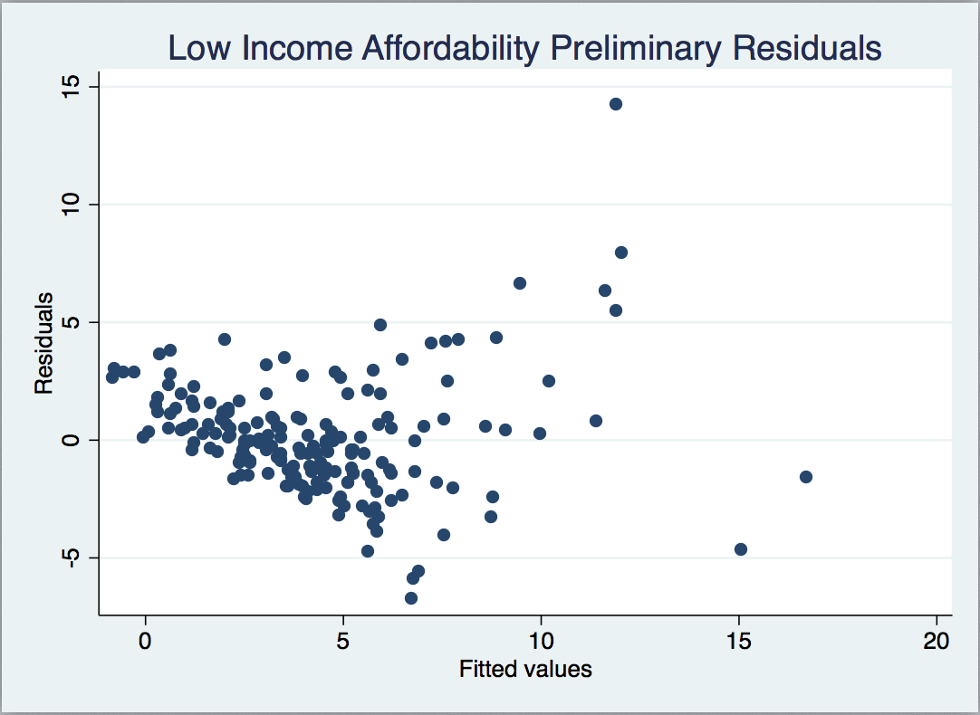

Figure 3.

Low Income Affordability Full Model Residuals

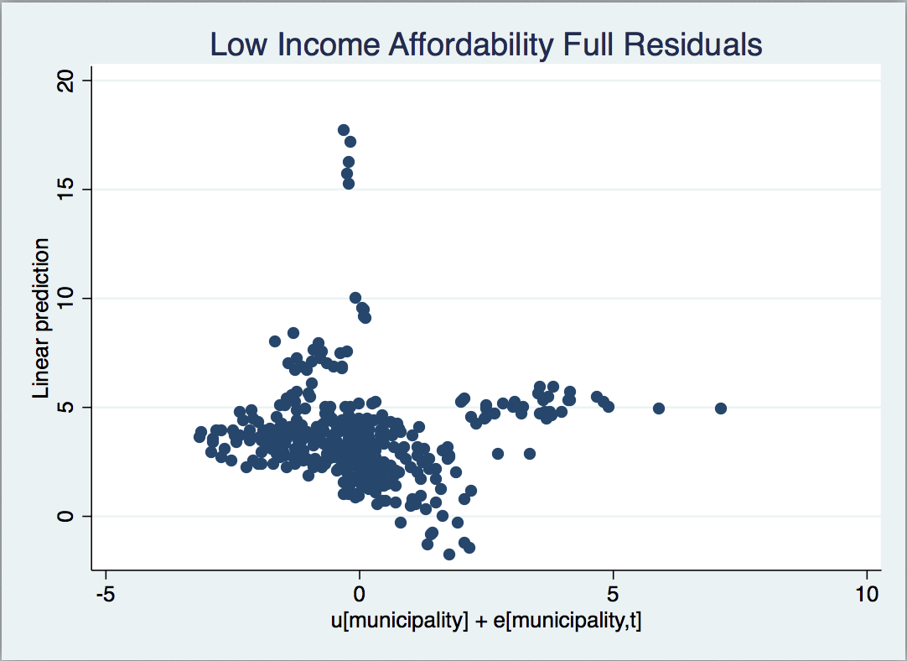

Figure 4.

Middle Income Affordability Preliminary Model Residuals

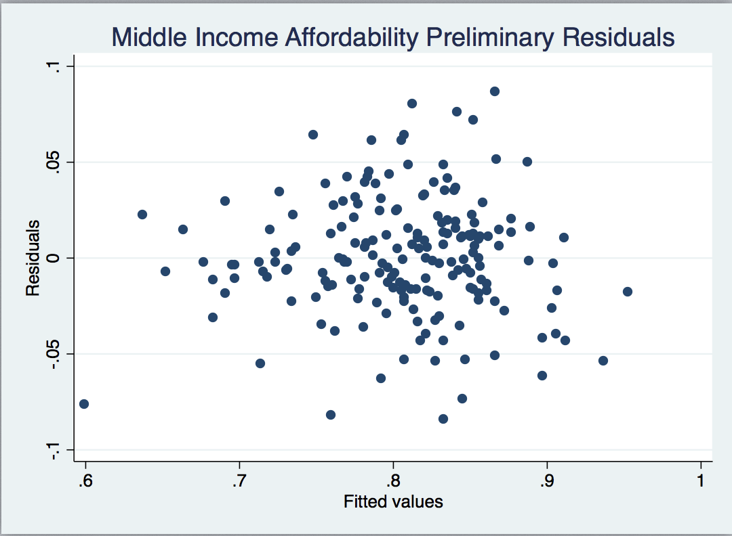

Figure 5.

Middle Income Affordability Full Model Residuals

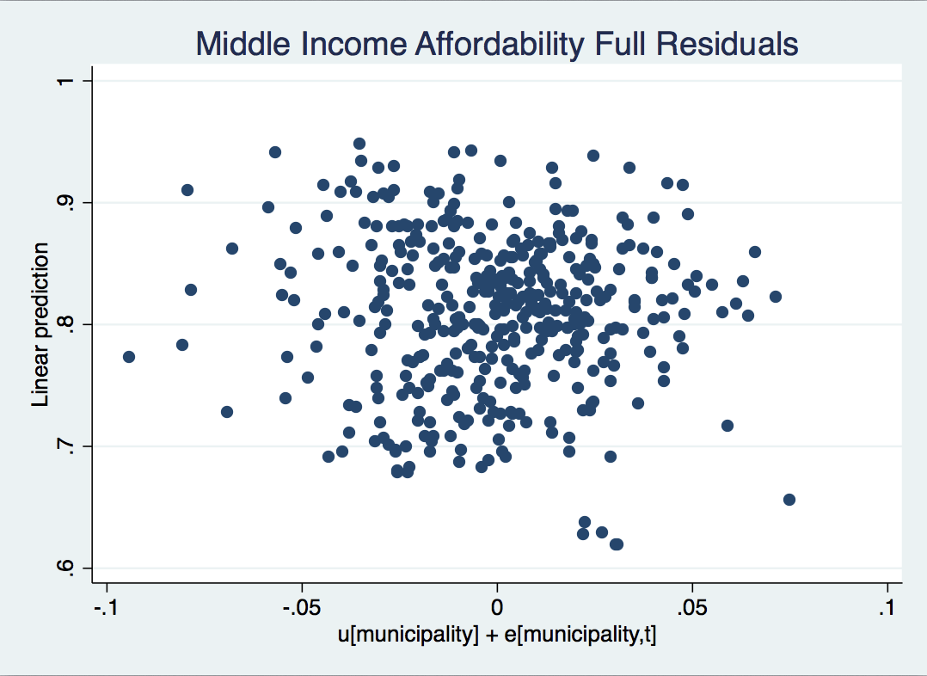

1. For more detail on data, see attached file “Data Details”