**Cycle-1**

1. Print your name to the screen with every letter being a different heading size
2. Display the following text:

H2O

12th April 2016

HTML stands for ~~High Text Markup Language~~

He said <**I am fine**>

1. Print a paragraph with 4 - 5 sentences. Each sentence should be a different font.
2. Print a paragraph that is a description of a book, include the title of the book as well as its author. Names and titles should be underlined, adjectives should be italicized and bolded
3. Print two lists with any information you want. One list should be an ordered list, the other list should be an unordered list.
4. Prints 10 names with a line break between each name. The list should be alphabetized, and to do this place a subscripted number next to each name based on where it will go in the alphabetized list. (Example: Alan1). Print first, the unalphabetized list with a subscript number next to each name, then the alphabetized list. Both lists should have an <h1> level heading

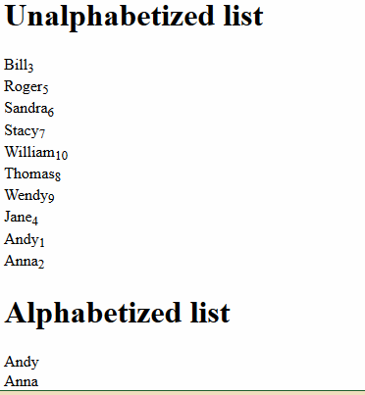

1. Print the squares of the numbers 1 - 20. Each number should be on a separate line, next to it the number 2 superscripted, an equal sign and the result

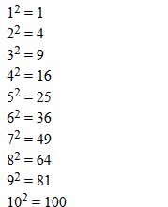

1. Print a definition list with 5 items.
2. Display an image that has a border of size 2, a width of 200, and a height of 200.
3. Print ten acronyms and abbreviations of your choosing, each separated by two lines. Specify the data that the abbreviations and acronyms represent

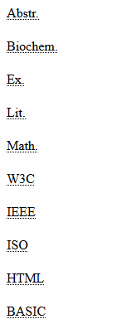

1. Print two addresses in the same format used on the front of envelopes (senders address in top left corner, receivers address in the center

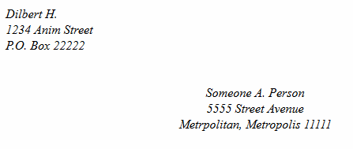

1. Create an HTML page with the following contents:

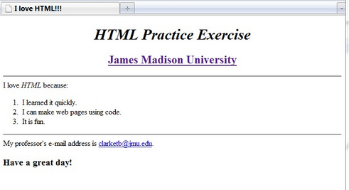

1. Create the following table

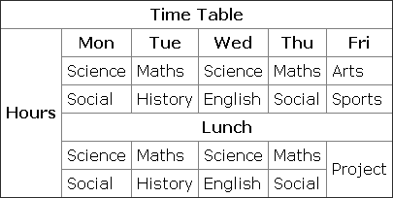

1. Create a HTML Page which looks like the one given below

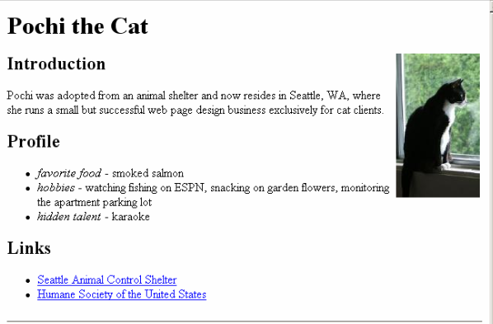

**ANSWERS**

**1) Print your name to the screen with every letter being a different heading size**

**<html>**

**<head>**

**<title>html</title>**

**</head>**

**<body style="background-color: #ff0000">**

**<h1>A</h1>**

**<h2>L</h2>**

**<h3>E</h3>**

**<h4>X</h4>**

**</body>**

**</html>**

**OUTPUT**

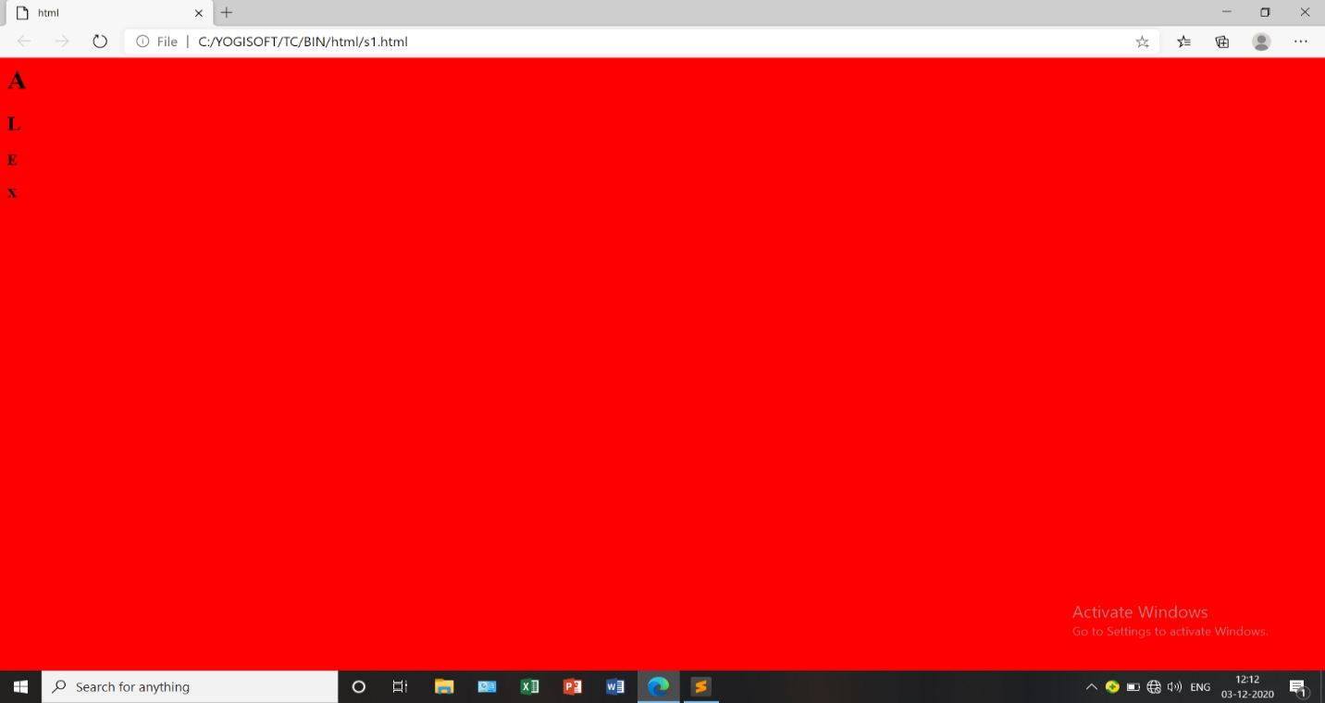

**2) Display the following text:**

**H2O**

**12th April 2016**

**HTML stands for ~~High Text Markup Language~~**

**He said <I am fine>**

**<html>**

**<head>**

**<title>html</title>**

**</head>**

**<body>**

**<h4>H<sub>2</sub>O</h4>**

**<h4>12th April 2016</h4>**

**<h4>HTML stands for <strike>High Text Markup Language</strike></h4>**

**<h4>He said I am fine</h4>**

**</body>**

**</html>**

**OUTPUT**

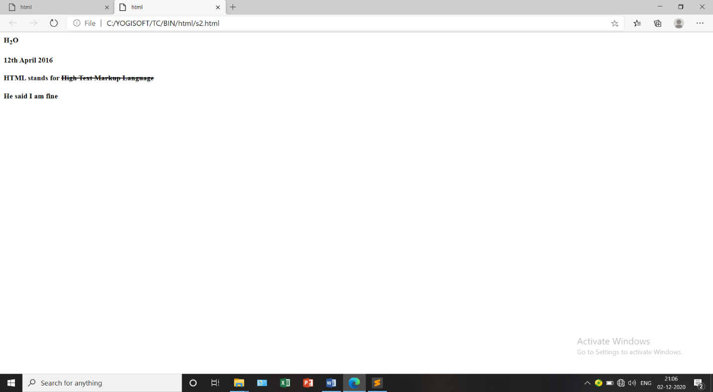

**3) Print a paragraph with 4 - 5 sentences. Each sentence should be a different font.**

**<html>**

**<head>**

**<title>html</title>**

**</head>**

**<body>**

**<font style="font-family: Verdana";font size=2px;font color=red>**

**<p>The first step in developing the system is analyzing the problem.</p>**

**</font>**

**<font style="font-family: Arial";font size=5px;font color=green>**

**<p>Before developing a system the problem should be well defined.</p>**

**</font>**

**<font style="font-family: MS Sanserit";font size=3px;font color=blue>**

**<p>Identify the need for a new information system and launching an investigation and a feasible study must be done to check whether the software is visible for the organisation.</p>**

**</font>**

**<font style="font-family: sans-serif";font size=4px;font color=yellow>**

**<p>This unit we have done this study.</p>**

**</font>**

**</body>**

**</html>**

**OUTPUT**

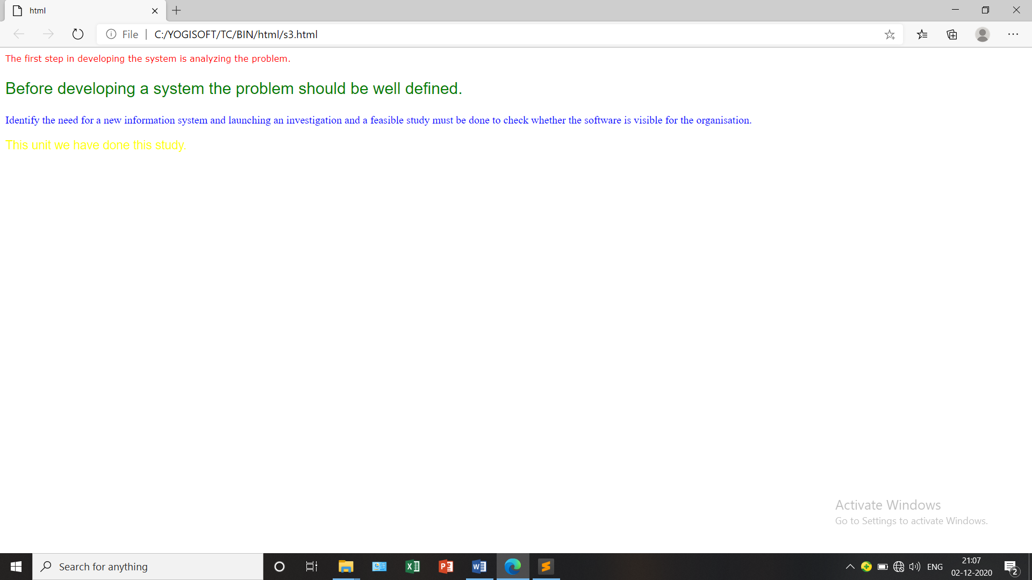

**4) Print a paragraph that is a description of a book, include the title of the book as well as its author. Names and titles should be underlined, adjectives should be italicized and bolded**

**<html>**

**<head>**

**<title>html</title>**

**</head>**

**<body>**

**<u><B><i>The Gift of the Magi</i></B></u> is a short story by <u><B><i>O.Henry</i></B></u> first published in 1905.The story tells of a young husband and wife and how they deal with the challenge of buying secret christmas gifts for each other with very little money.**

**</body>**

**</html>**

**OUTPUT**

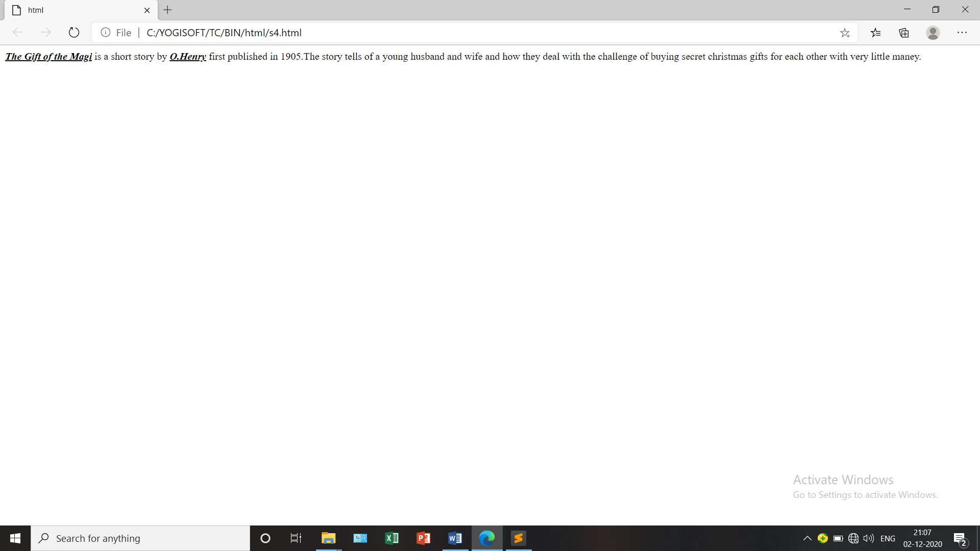

**5) Print two lists with any information you want. One list should be an ordered list, the other list should be an unordered list**.

**<html>**

**<head>**

**<title>html</title>**

**</head>**

**<body>**

**<h1>List</h1>**

**<ol style="list-style-type: lower-roman">**

**<li>Processor</li>**

**<li>RAM</li>**

**<li>Hard disk</li>**

**<li>Monitor</li>**

**</ol>**

**<ul style="list-style-type: circle">**

**<li>Operating system</li>**

**<li>Front-end</li>**

**<li>Database</li>**

**<li>server</li>**

**</ul>**

**</body>**

**</html>**

**OUTPUT**

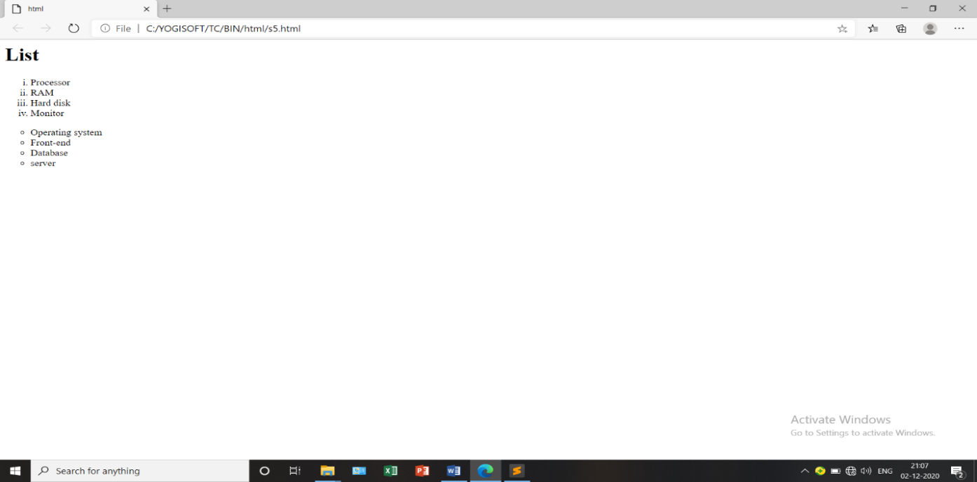

**6) Prints 10 names with a line break between each name. The list should be alphabetized, and to do this place a subscripted number next to each name based on where it will go in the alphabetized list. (Example: Alan1). Print first, the unalphabetized list with a subscript number next to each name, then the alphabetized list. Both lists should have an <h1> level heading**

**<html>**

**<head>**

**<title>html</title>**

**</head>**

**<body>**

**<h1>Unalpahetized list</h1>**

**<br>bill<sub>3</sub>**

**<br>roger<sub>5</sub>**

**<br>sandra<sub>6</sub>**

**<br>stacy<sub>7</sub>**

**<br>william<sub>10</sub>**

**<br>thomas<sub>8</sub>**

**<br>wendy<sub>9</sub>**

**<br>jane<sub>4</sub>**

**<br>andy<sub>1</sub>**

**<br>anna<sub>2</sub>**

**<h1>Alpahetized list</h1>**

**<br>andy**

**<br>anna**

**<br>bill**

**<br>jane**

**<br>roger**

**<br>sandra**

**<br>stacy**

**<br>thomas**

**<br>wendy**

**<br>william**

**</body>**

**</html>**

**OUTPUT**

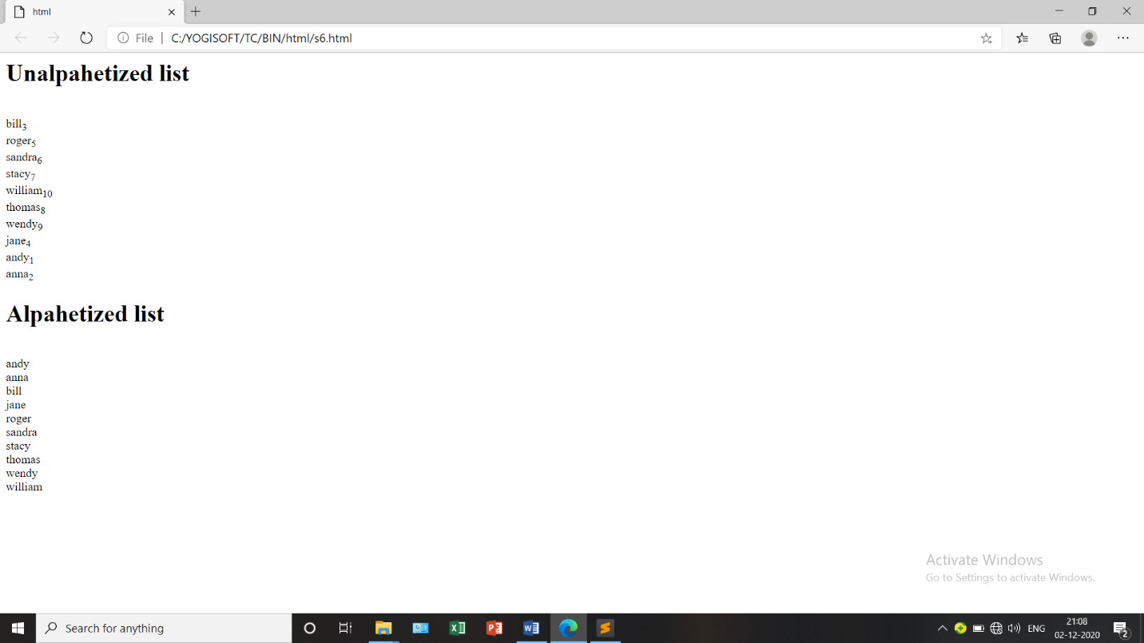

**7) Print the squares of the numbers 1 - 20. Each number should be on a separate line, next to it the number 2 superscripted, an equal sign and the result**

**<html>**

**<head>**

**<title>html</title>**

**</head>**

**<body>**

**1<sup>2</sup>=1**

**<br>2<sup>2</sup>=4**

**<br>3<sup>2</sup>=9**

**<br>4<sup>2</sup>=16**

**<br>5<sup>2</sup>=25**

**<br>6<sup>2</sup>=36**

**<br>7<sup>2</sup>=49**

**<br>8<sup>2</sup>=64**

**<br>9<sup>2</sup>=81**

**<br>10<sup>2</sup>=100**

**<br>11<sup>2</sup>=121**

**<br>12<sup>2</sup>=144**

**<br>13<sup>2</sup>=169**

**<br>14<sup>2</sup>=196**

**<br>15<sup>2</sup>=225**

**<br>16<sup>2</sup>=256**

**<br>17<sup>2</sup>=289**

**<br>18<sup>2</sup>=324**

**<br>19<sup>2</sup>=361**

**<br>20<sup>2</sup>=400**

**</body>**

**</html>**

**OUTPUT**

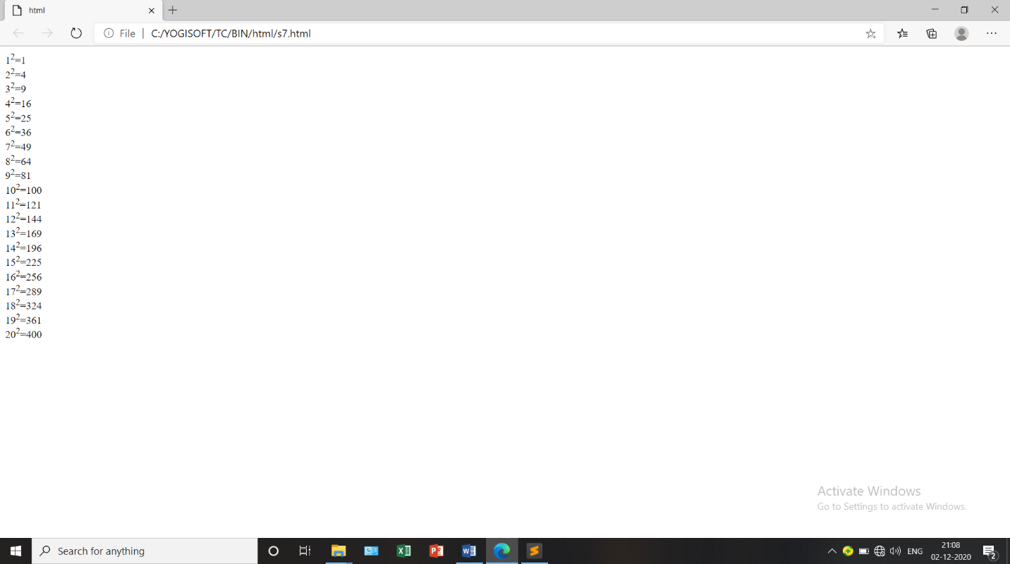

**8) Print a definition list with 5 items**

**<html>**

**<head>**

**<title>Definition list</title>**

**</head>**

**<body>**

**<dl>**

**<dt>Computer</dt>**

**<dd>Computer is an electronic device.it accepts data as an input,processes it and produces information as an output.</dd>**

**</dl>**

**<dl>**

**<dt>HTML</dt>**

**<dd>HTML is a formatting language for web pages.It is used to create structure of a webpage.</dd>**

**</dl>**

**<dl>**

**<dt>CSS</dt>**

**<dd>CSS adds design asthetics to web pages.It is used to stylize the webpages,and make it appealing.</dd>**

**</dl>**

**<dl>**

**<dt>Javascript</dt>**

**<dd>Javascript is a scripting language used to add behavior to webpages.</dd>**

**</dl>**

**<dl>**

**<dt>PHP</dt>**

**<dd>PHP is a general purpose scripting languge especially suited to web development.</dd>**

**</dl>**

**</body>**

**</html>**

**OUTPUT**

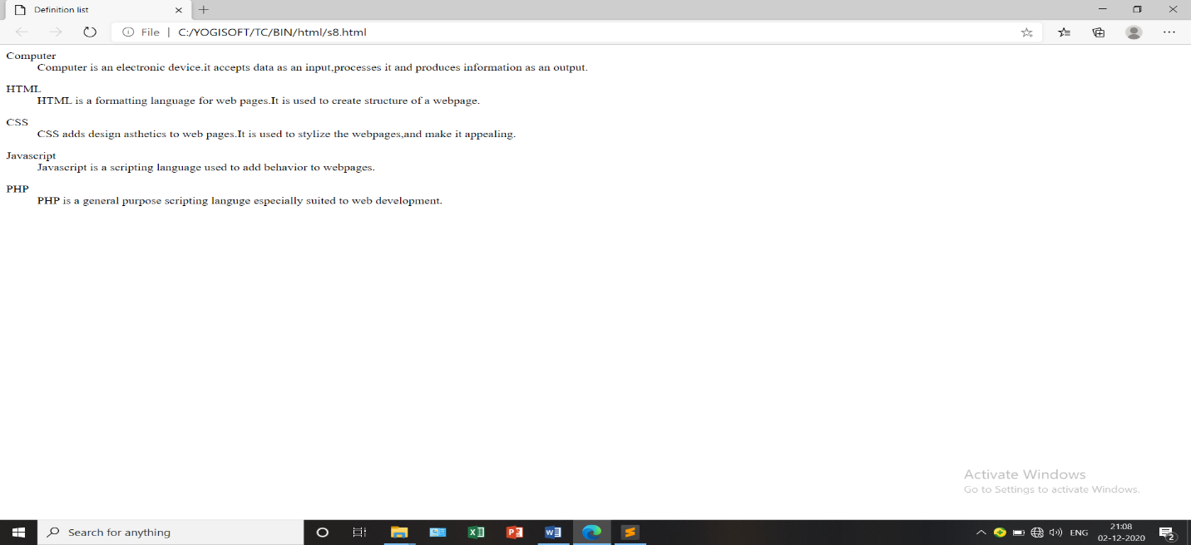

**9) Display an image that has a border of size 2, a width of 200, and a height of 200.**

**<html>**

**<head>**

**<title>html</title>**

**</head>**

**<body>**

**<img src="pic.jpg" alt="pic" border="2" width="200" height="200">**

**</body>**

**</html>**

**OUTPUT**

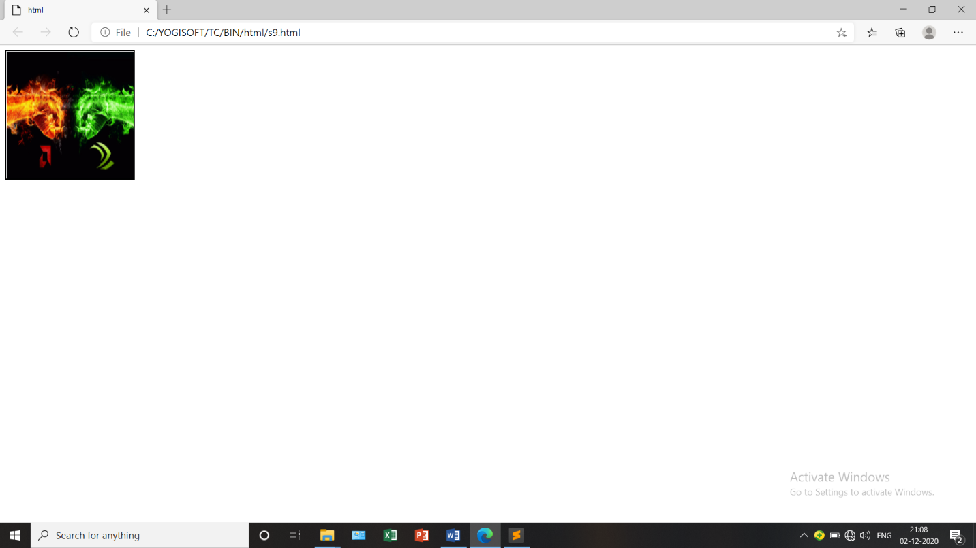

**10) Print ten acronyms and abbreviations of your choosing, each separated by two lines. Specify the data that the abbreviations and acronyms represent**



**html>**

**<head>**

**<title>html</title>**

**</head>**

**<body>**

**<abbr title="Abstract">Abstr.</abbr><br>**

**<abbr title="Biochemistry">Biochem.</abbr><br>**

**<abbr title="Example">Ex.</abbr><br>**

**<abbr title="Literature">Lit.</abbr><br>**

**<abbr title="Mathematics">Math.</abbr><br>**

**<acronym title="World wide web consortium">w3c</acronym><br>**

**<acronym title="Institute of Electrical and Electronic Engineers">IEEE</acronym><br>**

**<acronym title="International standards organisation">IBO</acronym><br>**

**<acronym title="Hyper Text Markup Language">HTML</acronym><br>**

**<acronym title="Beginners all purpose smbolic instruction code">BASIC</acronym><br>**

**</body>**

**</html>**

**OUTPUT**

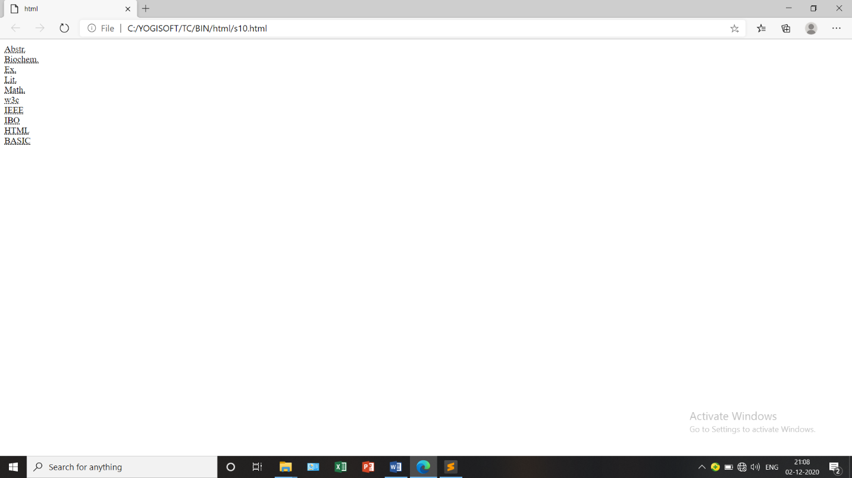

**11) Print two addresses in the same format used on the front of envelopes (senders address in top left corner, receivers address in the center**

**<html>**

**<head>**

**<title>html</title>**

**<style>**

**.a{**

**position: absolute;left: 300px;top: 150px;**

**}**

**</style>**

**</head>**

**<body>**

**<i>Dilbert H.<br>**

**1234 Anim street<br>**

**P.O. Box 22222**

**</i>**

**<div class="a">**

**<i>**

**Someone A.person<br>**

**5555 Street Avenue<br>**

**Metroplitan,metropolis 1111**

**</i>**

**</div>**

**</body>**

**</html>**

**OUTPUT**

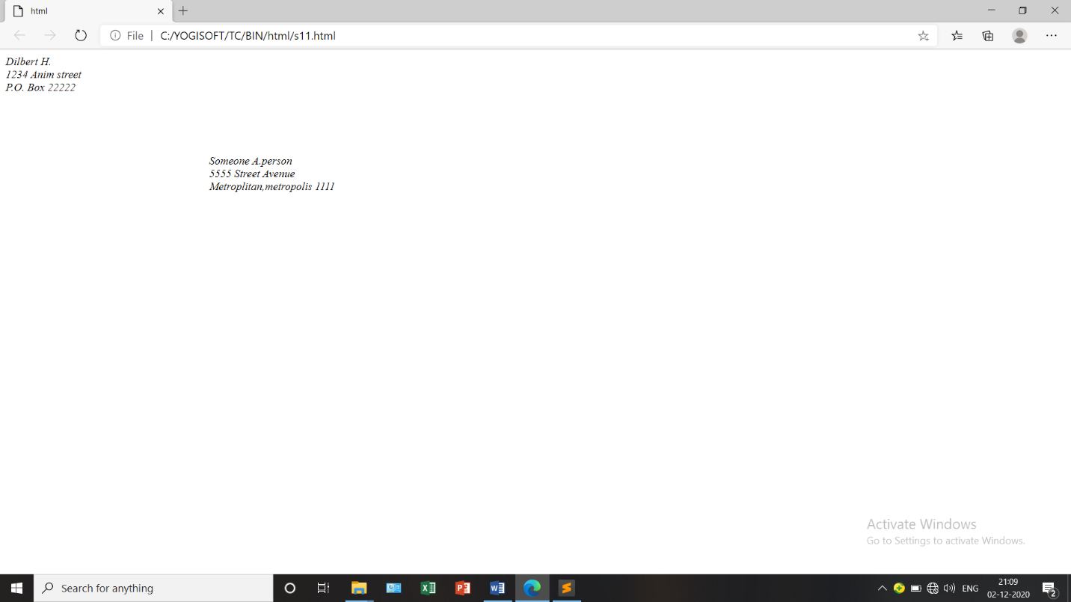

**12) Create an HTML page with the following contents:**

**<html>**

**<head>**

**<title>html</title>**

**</head>**

**<frameset rows="30%,30%,*">**

**<frame name="frame1" src="frame1.html"/>**

**<frame name="frame2" src="frame2.html"/>**

**<frame name="frame3" src="frame3.html"/>**

**</frameset>**

**</html>**

**frame1.html**

**<html>**

**<head>**

**<title>html</title>**

**</head>**

**<body>**

**<center><h1><B>HTML Practice Exericse</B></h1>**

**<h3 style="color: pink;"><u>James Madison University</u></h3></center>**

**</body>**

**</html>**

**frame2.html**

**<html>**

**<head>**

**<title>html</title>**

**</head>**

**<body>**

**<h3>I love HTML become:</h3>**

**<ol>**

**<li>I learned it quickly</li>**

**<li>I can make web pages using code</li>**

**<li>It is fun</li>**

**</ol>**

**</body>**

**</html>**

**frame3.html**

**<html>**

**<head>**

**<title>html</title>**

**</head>**

**<body>**

**<h4>My professor's email address is <a href="clarkb@jmu.edu.">clarketb@jmu.edu.</a></h4>**

**<B><h2>Have a great day!</h2></B>**

**</body>**

**</html>**

**OUTPUT**

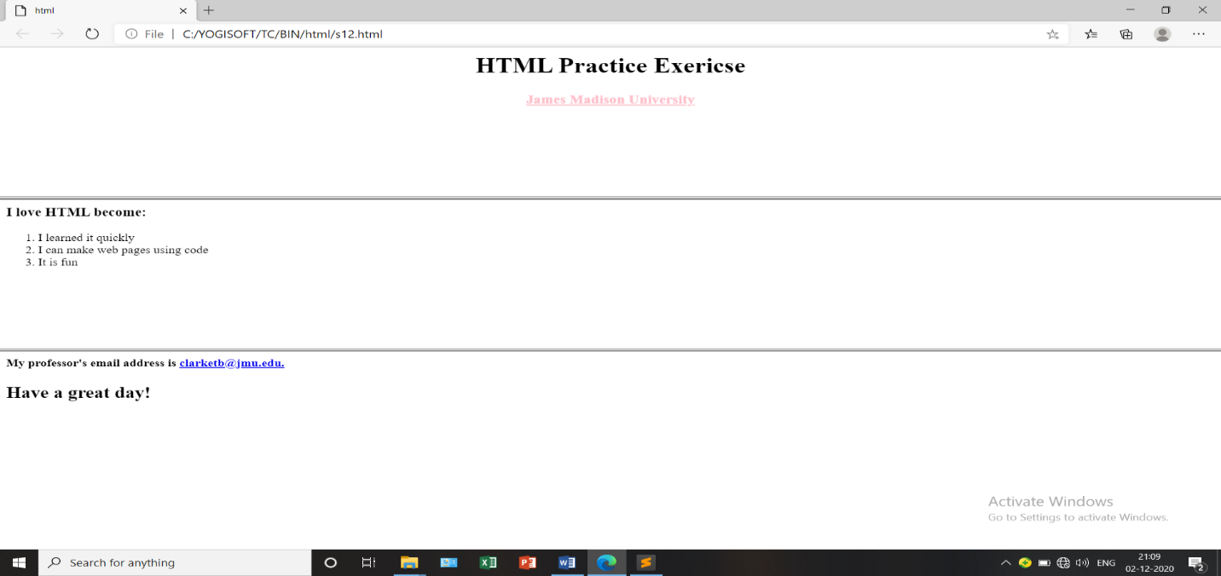

**13) Create the following table**

**<html>**

**<head>**

**</head>**

**<body>**

**<table border="2">**

**<tr><td colspan="6" align="center"><B>Time table</B></td></tr>**

**<tr><td rowspan="6"><B>Hours</B></td>**

**<td><B>Mon</B></td><td><B>Tue</B></td><td><B>Wed</B></td><td><B>Thu</B></td><td><B>Fri</B></td></tr>**

**<tr><td>Science</td><td>Maths</td><td>Science</td><td>Maths</td><td>Arts</td></tr>**

**<tr><td>Social</td><td>History</td><td>English</td><td>Social</td><td>sports</td></tr>**

**<tr><td colspan="5" align="center"><B>Lunch</B></td></tr>**

**<tr><td>Science</td><td>Maths</td><td>Science</td><td>Maths</td><td rowspan="2">Project</td></tr>**

**<tr><td>Social</td><td>History</td><td>English</td><td>Social</td></tr>**

**</table>**

**</body>**

**</html>**

**OUTPUT**

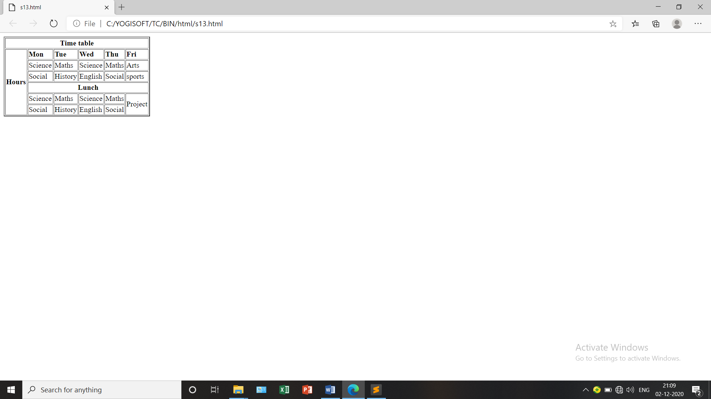

**14) Create a HTML Page which looks like the one given below**

**<html>**

**<head>**

**<title>html</title>**

**</head>**

**<body>**

**<font size="5">**

**<h1><B>Pochi the Cat</B></h1>**

**<img src="pic2.jpg" alt="picture" width="300" height="400" align="right">**

**<h3>Introduction</h3><br>**

**<p>pochi was adopted from an animal shelter and now resides in seattle,WA, where she runes a small but succesful web page design business exclusively for cat clients.**

**</p>**

**<h3>Profile</h3>**

**<ol style="list-style-type: disc;">**

**<li>favorite food - smoked salmon</li>**

**<li>hobbies - watching fishing on ESPN,snacking on garden flowers,monitoring the apatment parking lot</li>**

**<li>hidden talent - karaoke</li>**

**</ol>**

**<h3>Links</h3>**

**<ol style="list-style-type: disc;">**

**<li><a href="">seattle Animal Control Shelter</a></li>**

**<li><a href="">Humane Society of the United States</a></li>**

**</ol>**

**</font>**

**</body>**

**</html>**

**OUTPUT**

